PhD Thesis redaction

Planning:

Chapter 1 : Why existing accounts of post apartheid boundary disputes are not satisfactory? ( 23 Feb 2008 to 23 May 2008)

Data collection for the three case studies: (23 May 2008 to 23 June 2008: Preparation … Setting appointments and gathering logistics)

Data collection: (23 July – October 2008)

Chapter 2 : Case study 1 : Bushbuckridge
Chapter 3 : Case study 2 : Matatiele
Chapter 4 : Case study 3 : Khutsong
Chapter 5 : The socio political explanation
Chapter 6 : Conclusion

Chapter 1 : Introduction

- from Richard Tomlinson and Mark Addleson, Regional restructuring under apartheid: Urban and Regional policies in contemporary South Africa, 1987

South Africa's Regional Political Economy: A critical analysis of Reform Strategy in the 1980s by William Cobbet, Daryl Glaser, Doug Hindson and Mark Swilling

Riekert commission (1979)
The strategy of “orderly urbanization”
Buthelezi commission
The “total strategy”

“ From influx control to the Group Areas Act to the creation of 'homelands', the implementation of apartheid has disrupted and physically fragmented the fabric of South african society” xv.

“ the historical context of contemporary state policy reflects the abandoning of what Hindson calls “territorial apartheid” in favour of a new regionalism”xvi

“ the development regions are percieved as having been created to support a move towards a federal constitutional structure and the actual delimitation of regions is taken to reflect emerging labour supply patterns” xvii
“ though agreeing with Cobbet et al.'s explanation of state policy as operating within an increasingly regionalised framework, they adopt a typically liberal line in their paper, presenting the policy as a means of attempting to attain greater legitimacy amongst blacks and not of satisfying capital's interests . Instead, the interests of capital are seen as imposing constraints on the state in its policy adaptations” xix

- South Africa's Regional Political Economy: A critical analysis of Reform Strategy in the 1980s by William Cobbet, Daryl Glaser, Doug Hindson and Mark Swilling

“ the fluidity of political conditions in South Africa is such that state strategy is the subject of open debate and contestation, and is unusually susceptible to official reconsideration and reformation. Nevertheless we believe it is possible to identify the major contours of an emerging strategy which has been pursued with increasing determination by reformers at the upper levels of the state since late in 1984” 2

“ this offensive is significant in that it goes well beyond the policy package associated with the 1979 Wiehahn and Riekert Commission reports, the Koornhof Bills, the new constitution, and the confederation of ethnic states -it goes beyond the “Total Strategy” formulated by P.W Botha in the late 1970s. In contrast to these policies, it is based on an abandonment of the political and territorial premises of apartheid, though not necessarily of race or ethnicity, and envisages the eventual reincorporation of the bantustans into a single national South African state” 2

“ these changes are a ruling class response to escalating township struggle, the determined resistance of squatter communities to removal, the dogged efforts of unions to unite migrants and locals and mass rejection of glacial forces which have produced a concentration of industry and population in and around South Africa's metropolitan industrial and commercial centres. The development of metropolitan-centred and wider regional sub-economies over a decade and more, we argue, has eroded the primary division between the “white” and bantustan areas on which apartheid was constructed; and has thus eroded the dualistic spatial framework on which South Africa's political economy was based” 3

“ all attempts thus far have failed to give effect to the basic Riekert strategy of dividing the African population into insiders and outsiders and implementing the legislation necessary to maintain this division ( Hindson and Lacey, 1982)”

“The fundamental flaw of the urbanization strategy set out by the Riekert Commission of 1979 was that it failed to address the twin issues of the urbanization of the bantustans and African rural impoverishment inside and outside the bantustans. The success of its strategy of strengthening influx controls and segregating urban African 'insiders' from 'outsiders' in the bantustans hinged above all on securing the economic viability and independence of the bantustans as well as the legitimacy of their political systems” 6

“ The state's current urban policy which acknowledges the inevitability of African urbanization, but seeks to control it, has been called “orderly urbanization”. This policy does envisage the incorporation of some previously excluded sections of the African urban population into the administrative and financial ambit of the new metropolitan regions. But its aim is far from allowing unregulated rural-urban migrations and settlement. Rather it aims to limit the growth of established townships in the core metropolitan areas and encourage homeless township families as well as some squatter families to move to new residential areas, called deconcentration areas, which are being established on the peripheries of the metropoles. These residential areas are to be linked to deconcentrated industrial and commercial centres which are intended to provide employment opportunities for the local residents” 7

“ the concept of “orderly urbanisation” thus seeks to replace bantustan policy with measures designed to regulate population movement and settlement within newly defined spatial units which are centered on the metropolitan areas and embrace neighbouring bantustans or parts of bantustans deemed to fall within their labour supply catchment areas. The objective of this policy is to link such residential areas to industrial deconcentration points not subject to the stringent wage and health regulations and high tax structure of the core metropolitan areas and to promote the growth of employment and income through the fostering of informal sector activities.” 8

Total strategy
orderly urbanisation

“ industrial decentralisation policy has sought for decades to lend economic and political credibility to the bantustans, and was as such predicated on the geographical division between “white” South Africa and bantustans.When, in 1975, the physical planning branches of the state divided South Africa into 44 planning regions deemed to be geographically and economically “functional”, they were still forced to take as a starting point the continued centrality of bantustans development policy” 9
In 1981, however, Prime Minister Botha unveiled a regional development plan premised on a division of South Africa into eight (now nine) development regions -the boundaries of which cut across bantustan boundaries, as part of what the Buthelezi Commission termed the 'soft-borders' approach. This entailed the planning of economic development within coherent regions free of the constraints imposed by political borders. Its corollary was the creation of the 'multilateral' decision-making structure to coordinate development between South Africa and the Transkei-Bophuthatswana-Venda-Ciskei (TBVC) states; the setting up of the Development Bank of Southern Africa; and the establishment of Regional Development Advisory Committee (RDACs) to identify planning priorities within regions” 9

“ the nine regions are more than mere abstractions superimposed on the map of South Africa. Rather, they attempt to correspond to changes in the geographical patterns of capital location and labour settlement that have been developing since the late 1960s. These changes are, in part, the unintended result of previous decentralisation policies which, more from practical necessity than philosophical conviction, promoted suburban industrial development in places such as Hammarsdale, Brits and Rosslyn. They are also the legacy of the classical apartheid policy of limiting African urban settlement in 'white' South African , and promoting growth of towns behind bantustan boundaries.” 9
“ State planners intended the new approach to regional development to provide the basis for the future political and economic map of South Africa, whether defined in federal or confederal terms. As the Buthelezi Commission remarked, “... through its new approach to regional development the government is taking the economic route to power sharing rather than the political one, which is unacceptable to its constituency' (vol. 2 6.2.2). 11

“ we argued that a consensus has emerged within the reformist elite about the need to implement changes that go well beyond the “total strategy” initiative of the late 1970s and early 1980s. In part this further metamorphosis of the reform process is the outcome of increasingly intense conflict between the regime and its opponents -in particular its failure to establish legitimacy for the new black local authorities and the tricameral parliament and, more recently, its inability to curb the wave of popular demonstrations, boycotts, strikes, and other civil disturbances that began early in 1984.

It was these events which forced the government to include Africans in the RSCs, to re-examine the question of African political participation in the central state, and to consider substantial modifications to its influx control policies.

However, we also argue that the necessity for, and direction being taken by, state restructuring in these areas can only be fully understood if it is related to changes in South Africa's spatial reproductive economy. By this we mean the development of new patterns of capital and labour location, in particular the dispersal of capital from metropolitan heartlands to metropolitan peripheries and to other regions; the enmeshing of certain bantustan labour supply areas into the process of metropolitan urbanisation; and the crystallisation of regional economies and regional proletariats. These processes, which have drained of meaning the conventional dichotomies of bantustan/white South Africa and urban/rural, have informed thinking about the RSC concept as well as debates around second tier regional structures in a future federation. They have also directly shaped the regional development strategies. Finally, the have influence aspects of the emerging

“ Faced by increasing sophisticated techniques of cooption, popular organizations will have to rethink their own tactical and strategic responses. Under these circumstances it will be more important than ever to reiterate the demand for democratically determined social welfare priorities, and for services that address the needs of the poorest regions and social strata within regions. These demands will have to be backed up by an increasing articulate call for strategies to promote economic recovery in ways that are not detrimental to the interests of the working class” 23

“ Reformers in the state cannot satisfy popular demands for democratic political representation. While accompanied by talk about the devolution of power, the reorganization of the state system involves a combination of centralizing and decentralizing tendencies.

2. A periodisation of South Africa’s Industrial Dispersal Policies by Daryl Glaser

“ the damming up of populations behind Bantustan boundaries , the expansion of dormitory townships in the Bantustans, and the attendant growth of cross-border commuting, are often viewed simply as the products of apartheid’s spatial engineering. Yet, as we have seen, these developments also dovetailed in some respects with capital’s own deconcentration tendencies.Some dormitory townships, especially in Bophuthatswana, were both made possible by, and in turn provided a labour pool for, deconcentrated industrial areas. Bantustan urbanization, capital deconcentration and cross-border commuting in turn resulted in the formation of new metropolitan-centered urban economic complexes cutting across the boundaries between ‘white’ areas and portions of Bophuthatswana, KwaZulu and Ciskei –a phenomenon that would influence regional planning and constitutional thinking from the later 1970s” 36

“ While the border industry programme occupied a central place in the state’s spatial economic planning during the 1960s, another set of regional planning initiatives took place in the shadow of that programme during the period under review. In 1964 a department of Planning was set up to coordinate the activities of all state departments concerned with economic and regional planning . The new department, which replaced the NRDC, was a continuation of the technocratic thread in spatial planning that went back to the SEPC of the 1940s: it sought a ‘scientific’ basis for intervening to manage and reshape South Africa’s economic geography –not only in respect of the Bantustans and border industry areas, but right across the country’s spatial surface. “

“Moreover, it was the Department of Planning which first gave expression to the idea of dividing the country’s land surface into functional regional on the basis of ethnic, physiographic, hydrographic and other, mostly technical, criteria. “ 37

“ The State decided, in 1967, to employ capital coercion –bureaucratic regulation of capital flows –to force capitalists to conform to the objectives of its industrial dispersal policies. Section 2 of the Physical Planning Act made provision for limiting the use of industrial land in metropolitan areas in order to drive up land prices there. The better known Section 3 of the Act empowered the Minister of Planning to control the establishment and extension of factories in 37 magisterial districts specified in 1968. Durban-Pinetown was left uncontrolled while the toughest approach was adopted towards the PWV.” 37

“ Perhaps the most important product of the physical planning organs in this period was the National Physical Development Plan (NPDP), completed in 1975 after several years of work by the PAC and the Department of Planning. The NPDP concerned itself with the distribution of economic activity across the spatial surface as a whole, rather than exclusively with the Bantustans and their surrounds. It divided South Africa into “ manageable planning units” organized around nodal cores and the distribution of population, infrastructure, natural resources and types of economic activity” 42

“ Both the formulation and reception of the NPDP reflect the continuing relative weakness of the physical planning branches during the early and middle 1970s. In the first place, its 38 planning regions left Bantustan boundaries inviolate. The NPDP’s stated objective of reorganizing economic planning around “functionally” defined regions stood in contradiction ( or coexisted at best uneasily) with the continued centrality within economic planning practice of “ politically” defined Bantustan units. “ 42

“ It was articulated most strongly at a meeting of the officials and academics attached to the National Regional Economic Advisory Committee in 1981-82, which argued that the geographical fragmentation accompanying Bantustan ‘independence’ posed an obstacle to integrated economic planning. Proceeding from one of the premises of the NPDP, the Good Hope plan divides the South African land surface into development regions. However, in the case of the Good Hope only eight (and later nine) regions are specified, and they cut across both ‘self-governing’ and ‘independent’ Bantustans, whose borders are considered ‘soft’ for purposes of economic planning. Incentives are graded between and within these ‘functional’ regions, depending on the degree of priority attached to them by the state” 43

“ Our periodisation has shown the complex range of political and economic pressures that have, at different times, shaped the South African state's industrial dispersal policies. In this concluding section it is argued that political, rather than economic, factors constitute the primary determinants of policy shifts. Nonetheless, the capitalist economy and its reproduction requirements exert a powerful influence on the form and content of industrial dispersal policy and practice” 48

“ In pointing to the primacy of political determinants we are not endorsing the conventional criticism that these policies are “irrational” and distort essentially rational economic processes. On the contrary, they may spring from eminently “rational” ( which does not necessarily mean correct) calculations about how best to advance the particular sectional or institutional interests hegemonic within the state system at a given time” 48

“ The Good Hope programme, unveiled in 1981, came to be seen as a way of laying the basis for an ethnic confederation and, later, for a federal-confederal constitutional model based on a combination of ethnic and regional units that would draw Africans more fully, albeit still in a subordinate way, into the central political process.” 49

To look for :
Cobbett, W, et al.(1985), “Federalism, Regionalisation and the Reconstruction of the South African State”, South African Labour Bulletin, 10, 5, pp. 87 – 116

Glaser, D., (1983), “ The regional Strategies of the South African State: A proposed Periodisation”, mimeo

Is the State's Regional Policy in the Interests of Capital?
Richard Tomlinson and Mark Addleson

“ Our view is that the Marxists are largely correct in explaining current regional policy in terms of the state's attempts to achieve legitimacy; but incorrect in positing any direct benefits for capital.” 55

“ If one accepts the rather obvious assertion that the “general interest” of capital consists of making profits and maintaining capitalism – in Poulantzas's terms, “economic exploitation and political domination”, then one has to ascertain how the state functions to safeguard these interests” 57

“ Marxists differentially emphasize four roles attributed to the state. These are: repression; the pursuit of ideological hegemony; an economically pro-active role in “reproducing the general conditions of production of surplus value; and the function of mediating between fractions of capital, and between capital and labour” 57

“ What is known, they agree, is that capital accumulation must continue and that the State depends on that capital accumulation for its survival. For that reason it must mediate both differences among individual capitals and the struggle between capital and labour. (Carnoy, 1984, p.143, ) 58

“It is the distinctly racial character of South African capitalism which exacerbates the legitimacy shortcomings of the state, threatens it, and creates the need for geographically specific and changing legislation and institutions”60

“Historically, though, capital has not seen fit to object to the racist and Afrikaner-serving elements in state policy, for so long as “there were ample opportunities to create wealth... businessmen seemed happy to do just that”(Oppenheimer, 1979, p.3) 60

“ That is, we view their paper as describing marvellously well the regional content of the state's search for legitimacy, but as failing to explain why the anticipated changes serve capital, or why they serve capital better than an alternative response to the current economic and social strains” 61

“ Influx control and the labour bureaux system lend a geographic content to South Africa's “industrial reserve army” or, more simply, to much of the two million or so of the country's unemployed (Roukens de Lange, 1984) 62

“ ...If businessmen hesitate to call for the immediate phasing out of influx control, it is for reasons other than their economic or production interest” 62

“ wage levels are not just a consequence of supply and demand but of political organization” 63

“ the most obvious application of this position would be the claim that capital is taxed less than would be the case if the state had to supply services more equitably” 63

“ Instead, given our view of the interests of the South African state, we argue that the restrictions reflect the political ambitions of the state, and that changes in the restrictions are entwined with the state's second role -the attempt to achieve greater legitimacy”63

“ We do not see why vigorous State economic intervention to restrain the tendency for industry, commerce and people to concentrate in South Africa's metropolitan centres, and to encourage a more even geographical distribution of jobs, income and welfare” 64

“ One still looks, though, for reasons why 'the demarcation of new spatial boundaries for purposes of administering and planning labour supplies'(p.104) will facilitate capital accumulation.”65

“ Critics of planning within capitalist social formations have contended that state planning serves the interest of capital at the expense of the working class. Nevertheless, business groups frequently oppose state planning : implying either that they misperceive their own interests or that in fact planning does not necessarily benefit them. (Fainstein and Fainstein, 1985)” 70

“ The state's regional economic policies slow down growth. Most certainly they do not reproduce the general conditions of production of surplus value. Ultimately, the policies contribute to the current crisis ; popular movements confront repression, and inept mediation is a result of Botha consulting his appointed black 'leaders'.

It is another thing altogether to argue that white capital does not benefit directly from the the regional policies. The policies are necessary to ensure continued white domination and, thereby, the allegiance to capitalism. But to impute this supposed indirect benefit to capital is to adopt the position noted above -namely, that capital misperceives its interests. There is no mistaking the fact that capital is calling for the reform of the state's regional policies” 70

Orderly urbanisation and influx control : from territorial apartheid to regional spatial ordering in South Africa
Doug Hindson

“ By registering employment contracts and issuing and withholding residence permits, the labour bureaux have become the primary mechanisms concerned with the monitoring and policing of African movement, settlement and employment at local and district level” 76

“ the reversal of African urbanization through outright removal of settled urban populations to the bantustans. This bill, the Bantu Laws Amendment Bill, which marks the high tide of legislative apartheid, failed to pass into legislation”77

“ In some instances, such as Umlanzi, near Durban, existing black townships were simply incorporated into the bantustans by redefining political boundaries. In other cases there was physical relocation, involving the demolition of existing townships and the forced removal of their populations to the bantustans. The effect of these moves was to bring into being a new official category of black labour: the so-called cross-border commuter” 78

“ It did not occur to the Commission that the large-scale urbanization of black people within the bantustans in areas situated near to the white-controlled metropolitan centres of the country, and their independence on employment within the metropolitan areas, had already effectively undercut the basis and rationale for traditional territorial apartheid.”81

“ In accepting the premises of territorial apartheid the Riekert Commission was prevented from giving due consideration to fundamental changes that had taken place in South Africa's economic reproductive system in the three decades since the adoption of apartheid. Like most analysts of contemporary South Africa, both liberal and radical, it accepted a dualistic conceptual framework grounded in the historical division of the country into white and black areas, with capitalist and pre-capitalist forms of production respectively.” 82

“ In opposition to approaches which have explained the pass system simply as a mechanism designed to reproduce migrant labour, I have argued that it was refashioned after the Second World War, and deployed in such a way as to promote the reproduction of a differentiated African working class: on the one hand a settled work-force servicing the demands of industry and commerce for semi-killed labour, and on the other hand migratory labour to perform unskilled heavy manual work in town ( Hindson, 1983, especially chapter 4)” 82

“One crucial result of this process of industrial dispersal has been the integration of commuter populations into metropolitan-centres labour markets, thereby dissolving and rendering economically spurious political boundaries which demarcate bantustans from the rest of South Africa” 83

“ The ruling class's search for more radical solutions to the deepening economic and political crisis of the mid-1980s has finally led to an abandonment of the traditional aims of territorial apartheid, and an acceptance of the need to reintegrate the bantustans into some form of single national system, albeit one constituted on the basis of ethnic-cum-regional federal /confederal units” 88

“ on this basis it recommends the adoption of a strategy of “orderly” or “planned” urbanisation. The essence of this strategy entails the following changes in the means of control over the movement and settlement of population:

- the replacement of traditional pass and influx controls with (formally) racially neutral measures such as squatter, slums and health regulations;
- a shift away from direct prohibitions over movement, physical presence, residence and employment in designated areas, to the use of indirect measures, notably regionally differentiated financial penalties and incentives designed to influence settlement patterns;
- the substitution of economically integrated metropolitan and development regions for the bantustans as the spatial bases of population settlement planning.
If this strategy is to be understood and associated, it is essential to examine not only each of its parts but to grasp it as a whole. This is what I set out to do in the remainder of the paper. 89

“ The signaficance of these regions lies in the fact that they encircle and in some cases cut across the borders of the bantustans to form integrated planning and administrative units. Since 1982 these development regions have provided a framework within which certain state institutions, notably the Development Bank and Regional Development Advisory and Liaison Committees, have already been operating. There is speculation that these regions, or spatial entities approximating them, may provide the geographical units of a future federal or confederal order ( Cobbet, et al. , 1985)
A recent Act of parliament provides for the demarcation of one or more metropolitan regions within each of these development regions and the creation of third tier governmental structures called Regional Services Councils (RSCs) to administer the metropolitan areas. This legislation is based on the recommendations of the Croeser Working Group's report”90

“ This approach, as we have already shown, has sparked off violent confrontation between the communities on the one hand and Board officials, police and, since the declaration of the State of Emergency, the military forces on the other. Without considerable application of further repressive force the policy is no more likely to succeed in the near future than it has in the recent past” 92

“ These new development regions cut across, encircle and fragment the bantustans, thereby integrating their populations into new planning units centred on the metropolitan areas” 93

“ The PC report falls far short of demanding what it ultimately essential if the pass system is to be done away with and, moreover, if the mass of the people are to believe that it has been done away with: the abolition not only of ways but of the bureaucratic machinery of pass control; the dismantling, reconstruction and reorientation of all these institutions towards new purposes in a newly constituted society”95

The resilience of territorial conflict in an era of globalisation, by David Newman, Department of Politics and Government, Ben Gurion University, Beer Sheva, Israel 84105, email: newman@bgumail,bgu.ac.il

Unfrozen Ground: South Africa’s Contest Spaces

Maano Ramutsindela
University of the North, South Africa

‘As we shall see below, the reconstructuring of local government in South Africa was strongly contested between 1993 and 2000.’ p16

‘Boundaries constitute social and cultural practices which are sourced of meanings and interpretation (Paasi, 1996).’ p16

‘Thus, the reconstruction of “race” was conveniently and inconsistently employed to divide the land between black and white people, while at the same time , being to employed as a tool to mobilize Afrikaner identity.’p26

‘In the 1990s as in the 1960s, conservative Afrikaners seek to protect their identity in isolation in the form of a Volktaat (Ramutsindela, 1998).’ p31

‘In this context, the NP proposed a regional demarcation that encapsulates both federalism and the respect for regionally based identities.’ p32

‘Marks (1995,p.2 ) has argued that “ at common sense level ,the non-racialism propagated by the ANC is the demand that an individual’s citizenship , legal rights ,economic entitlements and live chances should not be decided on the basis of racial ascription.” The non –racialism espoused in the Freedom Charter has been adopted as a preamble to the new constitution (ANC, 1994).’p32

‘This begs the question of how a non –racial society can be built in a country characterized by very different material conditions. As the then Deputy and now President Mbeki (1998a) pointed out, a major component part the issue of reconciliation and nation building is defined by and derives from the material condition in our society which have divided our country into two nations, the one black and the two other white .We therefore…say that South Africa is a country of two nations.’ p32

‘For instance, the DP (1998 ) argues that it is immoral and impractical to try to redress racial imbalances by taking steps that will entrench race consciousness.’p33

‘This, according to Guelke (1994, p.473), is the reflection of the presence of some society wild loyalties.’p35

‘However, it would be wrong to assume that the apparent patriotism has put the national identity problem to rest, state-driven processes such as land reform (chapter 4 ), the redemarcation of provincial and local government boundaries (chapter 5 ) , continue to impinge upon racial and ethnic consciousness.’p35

‘Its de-tribalizing principle is underwritten by the recognition of the community- not a “tribe “-as a group of persons who wish to have rights to or in particular territory (South Africa 1996).’p41

‘However, much of what South Africa could offer as a model depend very much on the pathways and results of a national programmes that aim to transform the state and society.’p42

References (pp53-56)

Beinart,W. (1994 ), Twenties-century South Africa ,Opus, London.

Benson,M.(1985 ), South Africa: Struggle for a birthright, International defence and Aid fund for Southern Africa, London .

Binswanger,H.P.and Deininger, K.(1993) , ‘South Africa land policy : the legacy of history and current options’ ,World Development , Vol .21, pp1451-75.

Brown, L. (1998), ‘WESSA’s concerns over Makuleke claim addressed’, African Wildlife, vol.52, p9.

Carruthers,J.(1995), The Kruger National Park: A social and political history. University of natal Press, Pietermaritzburg.

Citizen. (1998), 16 December, p.1, Johannesburg.

Cooper,K.(1998), ‘Editorial’, African Wildlife, vol.52,p.7.

Christopher,A.J.(1994), ‘Indigenous land claims in the Anglophone World’, Land Use Policy,vol.11,pp31-44.

De Villiers,B.(1999),Land claims and national parks :the Makuleke experience .Pretoria: Human Sciences Research council .

De Wet,C.(1997),” Land reform in South Africa: A vehicle for justice and reconciliation ,or a source of further inequality and conflict ?” Development Southern Africa, vol.14, pp.335-62.

Dicke, B.H. (1926) ‘The first voortrekkers to the Northern Transvaal and the massacre of the Van Rensburg Trek’, South African Journal of Science, vol.23, pp.1006-1021.

Department of Minerals and Energy. (1997), Submission to the department of Land Affairs, Pretoria.

Electronic Mail and Guardian. (1995), 18 August, Johannesburg (www.mg.co.za ).

Financial Times. (1998), 27 March, p.52, Johannesburg.

Guelke,A.(1996) ‘Dissecting the South Africa miracle : African parallels’, Nationalism and Ethnic Politics ,vol.2,pp.141-54.

Harries, P. (1987)” A forgotten corner of the Transvaal”: reconstructing the history of a relocated community through oral testimony and song’In B.Bozzoli (ed), Class, community and conflict: southern African perspectives, Ravan Press, Johannesburg, pp.93-134.

Letsoalo,E.M. (1992) , Restoration of land right : problems and prospects, Paper presented to the Southern African Political Economy Series (SAPES) Conference,18-22August, Cape Town .

Levin,R. and weiner, D.(1996), ‘ the politics of land reform in South Africa after apartheid: perspectives, problems and prospects’, Journal of Peasant studies, vol.23,pp93-119.

Lonsdale,J.(1992) , ‘The conquest state of Kenya , 1895-1905’ In B. Berman and J. Lonsdale, Unhappy valley ( Book Two ) , James Currey, London, pp.13-44.

Mamdami,M . (1996), Citizen and subject: contemporary Africa and the legacy of late colonialism, Princeton University Press, Princeton, N.J.

Marais, H. (1998), South Africa limits to change: The political economy of transformation, Zed Books, London.

Mouton, B.F.1996) Makuleke’s location, district of Zoutpansberg , Northern Province. Report No 115/95, Department of Land Affairs, Pretoria.

National Park Board. (1997), Submission to the Regional Land Claims Commissioner, Pretoria.

Nel, M. (1996), ‘Kruger Land Claim: South Africa’s premier national park faces a major challenge’, African Wildlife, vol.50, pp.6-9.

O’Laughlin, B. (1995), ‘Past and present options: Land reform in Mozambique’, Review of African Political Economy, vol. 63, pp.99-106.

Pankhurst,D.(1996), A resoluble conflict ? The politics of land in Namibia. Peace Research Report No 36, University of Bradford.

Simon, D. (1993), ‘The communal land question revisited’, Third World Planning Review, vol.15, pp.iii-vii.

South Africa. (1991), Minerals Act, Government Printer, Pretoria.

South Africa. (1995), Communal Association Bill, Government Printer, Pretoria.

South African Institute of race relations. (1995), ‘Freehold key to land reform’, Frontiers of Freedom, vol.5, pp7-9.

South African of race relations. (1997), ‘Give the people their land’, Frontiers of Freedom, vol.12, pp18-20.

Smit,D.W.J.(1996) ‘Leave this “ diamond” unmined’ , Conserva,vol.12,pp.11-13.

South African National Defence Force. (1996), Submission to the department of land Affairs, Pretoria.

South African National Parks. (1998), Media Release, 25 March, Pretoria.

Sunday Times. (1998), 31 May, p. 4, Johannesburg.

Wildlife and Environment Society of South Africa. (n.d), ‘The fight against mining in the Kruger National Park’, African Wildlife (Special Issue).

Wildlife and Environment Society of South Africa.(1996), Submission to the Regional Land Claims Commissioner, Pretoria.

Wildnet Africa. (1996), 29 October, Wilnetafrica.co.za.

Wildnet Africa. (1996), 18 November, Wildnetafrica.co.za.

Wildnet Africa (1997), 9 May, Wildnetafrica.co.za.

Williams,G.(1996), ‘Setting the agenda : A critique of the World Bank’s rural restructuring programme for South Africa’ , Journal of Southern African Studies, vol.22.pp139-66.

Williams,G., Ewert,J.,Hamann,J. and Vink,N. (1998), ‘ Liberalizing markets and reforming land in south Africa’ , Journal of Contemporary African Studies, Vol.16,pp.65-94.

‘There anti-urbanism was directed specifically to Africans, coloreds and Indians were seen through racist lenses as a social pest . As Bickford- Smith (1989,p.49) commented: Throughout the nineteenth century , social mobility of other than whites threatened the dominant belief that social order should coincide with racial order , if not be actually achieved via the latter.’p58

‘The new political dispensation aims to dismantle that racial order by changing the apartheid city through spatial integration, the restructuring of urban governance and the redistribution of resources.’p58

‘The demarcation of the envisaged region was contested because boundaries are not mere physical lines , but are embedded with, and reflect socio-political meanings and have profound impact on the distribution of power and resources.’’p60.

‘Thus the Gauteng demarcation board finalized the boundaries of the Johannesburg Metropolitan Council in 1995, in preparation for the local government elections in November that year.’p61

‘Chapter 7 of the final constitution considers local government as a sphere of government in its own right without interference by national and provincial governments (South Africa, 1996)’p61

‘It also links local government to the constitutional principle of co – operative government between tiers (Fig 5.1) , the aim being to shift the roles of local government from mere administration to those of development – a developmental local government (DLG) model.’p61.

‘The first of these is that “Metropolitan Government creates a basis for equitable and socially just metropolitan governance” (South Africa, p59)’p61

‘It should be noted that neither the provincial nor the national government could impose changes at the local level; to do so would have been unconstitutional.’p66.

‘Groblelsdal was located in Mpumalanga while contesting African settlements were in Northern Province.’p67

‘The LTGA did not make provision for cross-border TLCs. Furthermore, the provincial boundaries had already been recognized in the constitution.’p67.

‘A “stand alone” TLC was problematic in that it would have been a perpetuation of (territorial and economic) racial segregation – the very problem that local government restructuring aimed to address.’p69.

‘The first step was to proclaim the town of Groblersdal as a part of its administrative Bushveld district through Proclamation 30 of 1996 (Northern Province, 1996)’p69

‘The plan was to bring the administration of Groblersdal under Northern Province so that the disputed areas of Groblersdal town , Motetema and Tafelkop should fall under one province ,in order for that province to handle the disputes areas together.’p69

‘The presence of Northern Province administrators in Groblersdal formented protests by Africans and whites who did not want to belong to Northern Province.’p69.

‘The pro-Mpumalangagroup disrupted a rally (at Tafelkop) which was supposed to be addressed by the Northern Province MEC for local Government, Mr R.J. Dombo, on 9 November 1996.’p69

‘In the same month, the new administrators were forced out of office by protesters, leading to the out break of violence in the area.’p69.

‘Protests by the town council were more of a legal nature. As the council had resolved that Groblersdal should remain in Mpumalanga, it successfully requested the Supreme Court to nullify the appointment of the new administrators (Case no. 24293/96) on 22 November 1996.’p70.

‘One of the mistakes made by Northern Province in attempting to incorporate Groblersdal into its territory was to proclaim the town as part of that province without involving the demarcation board and the town council , as required by the Transition Act.’p70.

‘At the time of writing (i.e. October2000) the problem of local government restructuring appeared to have been solved through a cross –border municipality that straddle the boundary between Mpumalanga and Northern Province.’p70.

‘Such effort, at best, represent the quest by the new states to infuse new meanings to the territorial organization in line with the policies and vision of those states.’p70

‘Conceptually, the model of local government restructuring adopted by the post –apartheid government attempts to devolve powers from central government while, at the same time, seeking to drive local agenda from the centre.’p70.

References (p.72)

Keith,M and Cross,M. (1993), “Racism and the postmodern city”, In M.Cross and M. Keith (eds) , Racism, the city and the state , Routledge, London,pp.1-30.

Lemon,A.(1996), “the new political geography of the local state in South Africa” Malaysian Journal of tropical geography,vol.27, pp.35-45.

Mabin,A.(1995), “ On the problems and prospects of overcoming segregation and fragmentation in Southern African cities in the postmodern era”, In S.Watson and K. Gibson (eds)Postmodern cities and space, Blackwell,Oxford,pp.187-98.

Mabin, A (1999), “From hard top to soft serve: demarcation of metropolitan government in Johannesburg”, In R. Cameron, A tale of three cities, Van Schaik, Pretoria, pp.159-200.

‘Vosloo at al (1974) observed that a regional authority consisted of all chiefs and other heads of tribal authorities in the region as ex-officio members.’p76

‘Regional authorities performed “the general function of advising and making representation to the government on all matters affecting the general interest of blacks within their specific jurisdictions (South Africa, 2000, p.10)’p76.

‘

‘The Pro-Gauteng Co-ordination committee mobilized mass actions based on Ndebele identity , to demand the exclusion of the former KwaNdebele into Gauteng for economics benefits.’p78

‘The demand was opposed by the Intando Yesizwe Party (IYP) on the grounds thst the historical and cultural base of the Ndebele is in Mpumalanga (Saturday weekend Argus, 13/14 January 1996, p.20)’ p.78

‘Arguably, the IYP did not want the area to be in Gauteng for fear of competing for seats in highly-charged political region , as underlined by the following statement from the party: “ we also note that we are the only people with hereditary kingdom placed in a highly urbanized [ Gauteng] region” ( IYP 9 August 1993,p.6)’p.78

‘Historical connections aside, the IYP evoked Ndebele history in order to mobilized political support along ethnic lines.’p.81

‘Those Ndebele in Northern Province demanded reincorporation into Mpumalanga in order to strengthen their constituency ther.’p.81

‘There were also claims of a split in the ANC ranks on the issue of allocating the Tafelkop/ Motetema/ Groblersdal area to a particular province (Sowetan 9 May 1996, p.4; Interview, Vickus Coetser, 25 September 1997, Pietersburg).’p82

‘Thus, the provincial preferences in these areas assume racial, ethnic and political dimensions.’p.82

‘Consequently, most rural areas had neither capacity nor resources for development.’p.83

‘The redemarcation of municipalities in 1999 / 2000 is set to address these problems.’p.83

‘For their part traditional leaders see the re- demarcation of municipalities as a process that “will incorporate tribal land and leave them with no power or influence” (Sowetan, 27 October 1999, p.2).’p.83

‘The further maintains that, the government and the Municipal boundaries Demarcation board must at all costs no traditional authority territorial area is divided between more than one municipal council. Should such division occur it will be seen as a diminution of the tribal land concerned and an addition to another traditional authority territorial area. We take as nonsense the suggestion that municipal boundaries will not affect the jurisdiction of traditional authorities even they straddle tribal authorities (Mail and Guardian, 11-17February 2000b, p.29)’p.84

‘The implication of opposing the redemarcation is that the core areas of Bantustans and the power of chiefs should be maintained and retained .Hendricks and Ntsebeza (cited in Mail and Guardian, 18 to 24 February 2000c, p.33) consider the retention of “tribal” areas and their chiefs in post-apartheid South Africa as a “return to the homeland system preferably with a form of Bantu Authorities in charge of local government”.’p.84

References (p.86)

Hendricks,F. and Ntsebeza,L. (1999) , ‘Chiefs and rural local government in post-apartheid South Africa’,African Journal of political science, vol.4,pp.99-126

Ramutsindela, M.F.(1997), ‘ The making of territories : a case study in South Africa’ In A. Awotan and N.Teymur ( eds) , Traditional, Location and Community: place making and development , Avebury , Aldershot,pp.225-33

Vosloo,W.B. et al .(1974) , Local government in Southern Africa, Academia, Pretoria.

‘ It is against this background that the new state not only focused on land reform , but also embarked on the process of re-drawing internal boundaries.’p.90

‘As shown in chapters 5 and6, apartheid boundaries were / are incompatible with the vision of non racial, democratic South Africa. Unsurprisingly, the redrawing of provincial boundaries ensued in 1993 as an attempt to overcome racial and ethnic divisions in that country.’p.90

‘Attempt to achieve the same goals on a smaller scale were made through the re – demarcation of local government boundaries in 1994 /5. All these effort are bound up with the broader aim of reconstructing the post-apartheid state to achieve a non-racial political dispensation.’p90

‘Thus, the de-racialization of the local state in Groblersdal did not succeed during the transition period (1994-1999), making Groblersdal the only apartheid municipality in the country.’p.91

‘The failure of restructuring there is partly blamed on conflict of interests among the African communities adjacent to Groblersdal’p.91

‘That is, in Groblersdal there is the (re)emergence of racial, ethnic and political alliances that define the axis of local politics.’p.91

g

Literature on the meaning of boundaries

- Ansi Paasi, Territories, boundaries and consciousness, the changing geographies of the finish-russian border, 1996

*Social space : “what permits fresh actions to occur, while suggesting and prohibiting yet others” 18

*According to Lefebvre ( ), there are three forms of spatial practice:
- physical and material flows
- representations of space
- representational spaces which refer to mental “inventions” that imagine new meanings or possibilities for spatial practices…

*We find in Harvey’s work(1989) four new dimensions which facilitate understanding of Lefebvre’s basic dimensions:
- accessibility and distanciation
- appropriation and use of space
- domination and control of space
- the production of space

The setting of boundaries has taken place as much through force as through negociations

*Some keywords from Harvey’s synthetic frame:
1. the production and reproduction of state and administrative divisions of space
2. the representation of space and exploitation of various ‘territorial ideologies’ in this construction (e.g. regionalism, nationalism, federalism, etc)

*Spaces of fear … the construction of otherness

*Geography and power :
Foucault says that each society has its regime of truth. Truth does not operate out of power and is not lacking in power… This is particularly true for Geography given its role in establishing control and social integration…

The geography helps to organize the political and strategic power relations of the world. The ways space is imagined, structured, demarcated… helps to set the basic structure of power…

“the exclusion of the other and the inclusion , incorporation and administration of the Same turned out to be of essential geopolitical importance” 19 ( Dalby 1988)

Spatial organization = shaped by the idea of property – territories regarded as goods or commodities
Space understood as divided into pieces, the boundaries of which are defined mathematically and astronomically
Reification of Space… this leading to the social and political distinctions between “them” and “us”
Signs and texts(maps, cartography, rules on the use of the territory, on the functions of the territory…) that illustrate and visualize this ‘geography’ (this space of geopolitics)= social and political instruments of power in the division of space…
The division of space shaped by power and reflects power relations…- door open to manipulations of every kind. – maps =/mirrors but cultural texts =/reproduction of the world but construction of it.
Geography draws and visualizes the abstract and invisible boundaries of power emerging from social practices and inherent human relations…
“the mechanisms that construct boundaries are one part of the process through which individual subjects are constituted and through which society is reproduced”20
Foucault says power is everywhere
We can also say that geography is everywhere… social life is a practice of demarcation, making social and cultural distinctions… the exercise of power over people necessarily involves the creation of geographies…(boundaries, distinctions…etc… )21 ( Johnston 1986, 364)
Many disciplines originated from the practical interests of the State… but geography used by the state to document a picture of the world from the perspective of a particular state… it has to produce and reproduce territoriality, to create and establish boundaries, and establish the basis for the stories of creating a distinction between us and the other (Cf Agnew 1987, 74)
All these purposes facilitated by maps(in the modern western society) which became crucial for the maintenance of state power (its boundaries, its commerce, its internal administration, its control over populations and its military strength (Harley 1989, 12)

Geographers have been used for national purposes. Such geography necessary for the production and reproduction of socio-spatial consciousness and spatial representations….
Geographers engaged in the construction of territorial representations and demarcations, in order to produce time- and space- specific truths for the needs of individuals and groups possessed of power.(truths of the power holders prevail…hegemonic imposition of stories).
This done mostly in exploiting both the language of difference and the language of integration… ( How geographies (the setting of boundaries, distinctions) are shaped by power? Both the discipline… and its use by power holders… geographies establish a basis for state power…)

International boundaries and national boundaries
Boundaries (definite line of separation) Borders inwardly oriented = frontiers (zone of contact) outwardly oriented. Boundaries are marks and limits of jurisdiction…

- Boundary maintenance : is a function common to all social systems
- Definition of spatial limits of membership
“to establish and institute something, giving it a social definition or identity, means at the same time the establishment of boundaries” 27
* boundaries and their iconographies = human creations, manifestations of a more general principle of territoriality exploited and manipulated by various social groups and classes in the control of space

- in the making of a region, four stages are of importance:
- the constitution of territorial space
- symbolic shape
- institutions
- the establishment of the territorial unit in the regional structure and social consciousness… (Paasi 1986a, 1991a, Figure 2.2)

- distinction between producers and reproducers of regions (some are very active in producing and others just reproducing…)
- Social practices, spatial practices, institutional practices…
- The “we” or community aspect of territories…
- Distinction between ideal and factual community… the first in the mouth of politicians and journalists, and the second is measured looking at actual associations….
- “the production of territorial units always reflects the social division of labour and associated power relations” 37
- States versus Sub-states entities
- “The State is the central apparatus through which important social practices, e.g. legitimation, take place and in which the economic, administrative and political prerequisites for the constitution of various sub-states territories are created. Likewise, many of the integrative forms employed in continuous nation building and the creation of social order and consciousness on various spatial scales –e.g. the ideas of nationalism, regionalism or territorial identities – are created by State – engendered practices through the political socialization system” 37 this last statement is controversial. What about other non-State agents that intervene or drive in the creation of such territorial identities… Territorial identities: how are they built… how regionalism, federalism relate to nationalism?
- The construction of territoriality: a process of production and reproduction of mental representations which arises on the basis of diverging social and material practices and interests.
- It is important that any study of territory and boundary construction be based on a solid conceptualization of diverging territorial ideologies and their construction…

- Nation building is time-space specific and context dependent
- State functions historically contingent …the state as a territorial context…The State responds to need for identity, stimulation and security. It is not clear why the State and not other social structures. The state (over other territorial contexts) has obvious advantages: the monopoly of violence
- One of the aim of the book… No 3 : Analyse how people living in the border area of Finland experience and produce, reproduce and transform the meanings of various territorial and social boundaries in their day-to-day life>
- “Socio-cultural construction of socio-spatial communities” : the we, communities, boundaries constructed through language, discourse, social imaginary (including mythologies or presuppositions), and intervention in the landscape =socio spatialization (Shields, 1991) ( it “allows us to name an object of study which encompasses both the cultural logic of the spatial and its expressions and elaboration in language and more concrete actions, constructions and institutional arrangements”7 Shields focused on the social construction of spatial images and identities… Paasi wants to look at the socio cultural process of territorialisation of space (the construction and signification of demarcations and boundaries)
- Aim of the book:
-Analyze the construction of boundaries between various social systems, especially states (changing idea of geography helps to understand various dimensions of regional transformation…what is the role of boundaries in the tradition of geographical thought? A culturally based interpretation of boundaries which explain them as essential in the construction of territoriality? What is the role of boundaries in the construction of nationalism, what are the mechanisms constitutive of symbolic communities(in particular the role played by education in the national socialisation?
-how various narrative accounts have been exploited in the production, representation and reproduction of territorial units and their boundaries?
-how the construction of we/the other and here/there has taken place as a historical process?
-how state boundaries –among other ‘smaller-scale’ socio-spatial distinctions and demarcations- manifest themselves in the stories emerging from the everyday life of people living in border areas?

Quotations:

“ even if the loyalty structures of individuals and groups are becoming both spatially and socially more complicated, one essential dimension of the regional transformation still appears to be the perpetual restructuring of various demarcations and boundaries, and the struggle over the rights and means to define the new ones as part of a system of control maintained over the state or some sub-state entity(Cf. Brunn 1984, 162-3) 6 ( affirmation that restructuring of boundaries is part of a recurring feature in region transformations… and that the process of re-demarcation is a controversial and contentious one…)

“ A struggle over the redefinition of space is always an expression of the restructuring of economic, political and administrative practices, and also of the restructuring of the contents of social consciousness, inasmuch as one obvious aim of various ethno-regional groups is to establish a territorial counterpart for social boundaries (Barth 1969, 15). 6 ( in the event of a boundary disputes, one has to ask: what are the economic, political and administrative practices that are being restructured? Why are they being restructured? To the benefit of which group? ) ( The assertion that any demarcation change involves the restructuring of economic, political and administrative practices…How such restructuring is perceived by stakeholders must form part of the investigation that wants to account for the change or the dispute over the change.)

“ It has been emphasized that the process of restructuring is not a pure mechanism of adjustment but a politically contested and determined process enacted by governments and organizations” 6
Assertion that boundary changes are not just adjustments. If they were, they would not be so contested…

Attention will be given to concepts of region and place. “we will argue that these categories are of crucial importance for understanding the social construction of spatiality and the particular boundaries between social collectivities” “as far as the construction of social communities is concerned, the idea of social spatialisation is doubtless important, but so is the idea of spatial socialization: the process through which individual actors and collectivities are socialized as members of specific territorially bounded spatial entities and through which they more or less actively internalize collective territorial identities and shared traditions” 8

“ Analysis of the rhetoric hidden in accounts of the social world is hence a challenge for any critical social science” 8

‘researchers probably cannot avoid at least some forms of rhetoric, since they are always operating in normative social contexts. Social research in particular,
Brown(1987,89) writes, is constructed rhetorically and can be understood as a set of meanings established in response to specific problems that emerge in different political and historical contexts. Analysis of the rhetoric hidden in accounts of the social world is hence a challenge for any critical social science’ 8

‘According to Carr(1986), a social community exists wherever a narrative account exists of a we which has continuous existence through its experiences and activities at any level of size or degree of complexity whatever’9

Discursive construction of space
‘in his book Anderson demonstrates that discourses represent or signify not just boundaries but various communities as coherent socio-spatial units. This view may lead, when such discourse is reproduced, to these places being taken as ‘real’, particularly when they are signified and legitimized by legal means. Such is the case with nation-states, where identity construction or nation building always occurs against the background of an external other. Hence the social ideal of community, a deeply historical and theory-laden category, has functioned in the course of time as an ideology in various socio-spatial scales and social contexts, particularly at times of crisis(cf. Mosse 1982). All political and territorial identities are, in a sense, fictional identities which are connected with ‘imagined communities’(Hassner 1993) 11

Clark and Dear stressed the role of language in the construction of social world and the active role of state in this process…

‘a spatial dimension is usually inherent in the definition of the Other, in the fact that the Other typically lives somewhere else, there’ 13

Territory and region
‘Territory, for instance, is doubtless a geographical notion, but as Foucault(1980) remarks, it is first and foremost a juridico-political one –an area controlled by a certain kind of power. Region, for its part, is originally a fiscal, administrative and military notion’17

‘it was realized that space is fundamental to any form of communal life and to any exercise of power (cf. Foucault 1980a). During this spatialisation process, as Harvey (1989) states, geographical knowledge became a valued commodity in a society which was shaped by profit seeking. The importance of geopolitics also became apparent in this connection and territories became more effectively divided, contested and ruled. The exclusion of the Other and the inclusion, incorporation and administration of the Same turned out to be of essential geopolitical importance (Dalby 1988)

‘Here I shall treat the concepts of region and place as historically constructed, created and recreated categories which can be understood in connection with the construction of territories and boundaries. Regions and places are thus merely tools of the present analysis, but theoretical and conceptual fixed points of analysis, fixed points which, I hope, provide full information for the following concrete analysis of territories and boundaries and for a search for a kind of regional geography (Cf Wallerstein 1990)

Three geographies :
- geography as creating ‘space of geopolitics’ (geographical knowledge became a valued commodity in a society which was shaped by profit seeking) 19
-geography as the basis for creating distinctions, demarcations between individuals, groups and states etc
-geography as a set of social and linguistic practices which in principle exceed the national scientific institutions

2.2. the question of boundaries in geographical thought
‘ pressures for change in territorial structures emerge from social, economic and political action, new representations and the struggle to create new stories, new significations for social communities. These trends are also paralleled with developments in academic human geography and the social sciences’ 23

‘ a new cultural perspective put emphasis on the multidimensional character of divergin social, spatial and cultural frontiers and boundaries. As Morin
(cited in Bennington 1990, 121) writes, the frontier is both an opening and a closing: ‘All frontiers, including the membrane of living beings, including frontier of nations, are, at the same time as they are barriers, places of communication and exchange. They are the place of dissociation and association, of separation and articulation’ 24

2.2.1 frontiers and boundaries in the tradition of political geography

‘ by tradition, geographers have been interested in the influence of geographical factors on the location of boundaries and the reciprocal influence of the boundary, once established, on the development of the landscape through which it has been drawn’ 25

‘As regards the definitions and practice of political geography, even if boundaries and frontiers have been employed at times as though they were synonymous, there prevails today a thorough agreement that whereas a frontier is a zone of contact, an area, a boundary is a definite line of separation – and not merely a line demarcating legal systems but a line of contact between power structures which at least partly manifest themselves in territorial frames (Jones 1959, 253)’25

‘In order to overcome the problems of the traditional approaches, which are commonly regarded as descriptive and empiricist, some authors have recently identified a need to appreciate border landscapes as explicit products of a set of cultural, economic and political interactions and processes occurring in space(see the articles in Rumbley and Minghi 1991b)26

2.3. boundaries in the production of territories

‘a boundary typically has a physical existence, which results from its demarcation and the construction of the buildings, defences and systems of communication. Prescott(1965,91) points out that the appearance of any boundary in stringency with which they are applied. Boundaries also have an influence on the attitudes of the border inhabitants, as well as on the policies of the states concerned’ 27

‘the idea of boundary will not be understood here from the perspective of a static ‘territorial line’ but rather from a broader , socio-culturally grounded perspective. Such an approach stresses the production and reproduction of the idea of territories and the boundaries and their symbolic meanings in various institutional practices. It puts emphasis both on social spatialisation and spatial socialization’ 27

2.3.1 Boundaries, ideologies and hegemony

2.4. The institutionalization of regions

‘As Knight (1982,517) reminds us, ‘territory is not; it becomes, for territory itself is passive, and it is human beliefs and actions that give territory meaning’ 32

‘As far as the parameters of regional transformation are concerned, I have referred to the construction of territories in my previous publications(Paasi 1986a, 1991a) as the institutionalization of regions, an abstraction which aims at rendering ‘visible’ certain key dimensions of regional transformation’ 32

‘the institutionalization of a region is always a manifestation of the spatial divisions of labour and power relations that are embedded within it. Hence some individuals, groups and classes are always more active in the production of regions, while most people tend to be reproducers’ 35

‘The roles of boundaries thus vary greatly. In the case of nation-states they are commonly strictly defined, symbolized and sanctioned, but in the case of smaller localities they can be much more diffuse and less influential – hardly visible in everyday life.’ 34

Structures of expectations…
Process of institutionalization of a region
‘the distinction between the identity of the region and the regional identity of the inhabitants is crucial for understanding the (analytical)difference between the historical construction of a region and the life-histories of its inhabitants. Furthermore this distinction makes it clear that it is essential to problematize the distinction between the production and the reproduction of space and collective representations, how this takes place through various institutional practices, how material and mental spatial ‘fix’ will be created through these practices, how various spatial groupings are created and defined, how ‘we’ are distinguished from ‘them’, and so on (Paasi 1986a)

‘ accordingly, regional transformation consists of an institutionalization of regions taking place continually on various spatial scales and potentially having different forms on different scales. The production of territorial units always reflects the social division of labour and associated power relations. Since the institutionalization of regions is part of this continual regional transformation, it always means the institutionalization of some other territorial units , i.e. the change in the importance of various institutional practices through which the region exists(cf. Paasi 1991a). It should be noted that regional transformation takes place simultaneously on all spatial scales, e.g at the local, regional, national and global levels. Hence regional identities are also organized hierarchically. In regional transformation some of these identities, and their material and symbolic base, can be thought of as being in danger because ‘their’ identities are expanding into ‘our’ territory. This situation can create conflicts between territorial units, whether states or sub-states entities’ 37

‘the state is the central apparatus through which important social practices, e.g. legitimation, take place and in which the economic, administrative and political prerequisities for the constitution of various sub-state territories are created’ 37

‘ on the grounds of the above discussion it is now easy to discern that the constructin of territoriality is essentially a process of production and reproduction of mental representations which arises on the basis of diverging social and material practices and interests. The production and reproduction of territoriality and identities are part of the continual struggle over social classifications, a struggle ‘over the monopoly of power to make people see and believe legitimate stories’, to make them know and recognize’, to create ‘the legitimate definition of the divisions of the social world’, and thus to ‘make and unmake social groupings’(Bourdieu 1991, 221). The production and reproduction of space are at the same time the construction of social distinctions and more or less marked, visible or invisible boundaries between social groupings and classes. These distinctions can then have a more or less explicit territorial basis’ 38

Maps, texts, boundaries are constitutive of reality rather than mimicking it’ 38
‘They are not merely neutral or mirror-like reflections of the shapes and physical-cultural landscapes of territories and their boundaries…but fabrications that people have engendered to reflect past and present socio-cultural relations which for their part evince diverging forms of ideologies and aim at signifying and legitimating the distinctions between us and them, our culture and way of life and theirs’ 38

‘ this points of departure implies that the construction of territories and boundaries cannot be understood in terms of empiricism by limiting the analysis merely to visible phenomena. Thus an essential task in any study of territory and boundary construction is the conceptualization of diverging territorial ideologies and their construction’ 38

- Time, space and consciousness: constructing nationalism and communicating boundaries
‘spatial units become territories only when boundaries are used to affect behaviour by controlling access (Sack 1986, 19)’ 40
3.2. social integration and spatial scales

‘collective interpretations are representations that are created by human beings and are effectively only through human action’ 43

The question of scale : about the role and the production of scales as part of the territorial organization of the world…
‘one example of the former is the division between imposed, overtly political hierarchcies, e.g. district, city, country, state, and those which arise from everyday life, e.g. household, street, neighborhood, community (Webb 1976, cited in Bird 1989, 37)
‘societies not only produce space but they also produce scales, which are produced and contested in social practice(N. Smith 1990, 1993)’ 44

More theoretically grounded discussions of scales with Taylor (1993b) and Agnew (1987) p.45

‘although for most of their everyday lives people are not conscious of their ‘community’ perspective, the ‘matrix’ or ‘order of things’ provided by the community constitutes the self-evident framework which shapes their experience of the community and influences their action towards other communities (Hummon, 1990, 11)’

3.3. the changing roles of nationalism
‘Hence, Lofgren points out, nationalism contains ‘political dynamite’ and can be exploited both to mask class interests or to fight them’ 48

3.3.1. Aims and strategies of nationalism in the territorialisation of space

‘Nationalism is always a product of a particular set of political , economic and cultural circumstances –it is contingent (Johnson et al. 1988,11). In principle, nationalistic thought is not interested in local or regional variation and particularites in landscape or in the social composition of the nation, unless these are a ‘barrier’ to nation building. As far as the history of nation building is concerned, nationalism has typically witnessed the absorption of smaller regions into larger units of territorial , political and economic organization. The aim has been the redefinition of boundaries and the reorganization of internal social and territorial divisions so that loosely federated societies and territories could be transformed – with varying success- into functioning socio-geographical units that would possess as high a degree of cultural homogeneity as possible. This redefinition has taken place as much ‘through force as through negotiation’ (Mac Laughlin 1986, 300)

‘it is impossible to achieve a feeling of identity and culture without inscribing personal life experiences into a discourse defining the story of a recognized homeland (Cf. A. Smith 1979, 3). The aim of nationalism is typically to create a national identity which is not based on the boundaries of language, race, tribe or religion but on state boundaries’ 51

‘ nationalism is two-faced with respect to space, as Anderson(1986) writes. It looks inwards in order to unify the nation and its constituent territory, and it looks outwards to divide one nation and territory from another. Williams and Smith (1983) claim that whatever else nationalism may be, it is always concerned with a struggle over the control of land’ 51

‘One part of the principle of territoriality is the marking and communication of boundaries. This points to the second important dimension of territoriality, classification by area (Sack 1986, 32). Nevertheless, territoriality is not merely a means of creating and maintaining social order, but is, as Sack (1986, 219) writes, ‘a device to create and maintain much of the geographic context through which we experience the world and give it meaning’. Since it is a fact that the territorial system of states is in continual transformation, the boundaries of a territory and the means by which they are communicated are similarly not unalterable’53

3.4. National socialization
‘while the social construction of the spatial has been labeled social spatialization(Shields 1991), now we will analyse the process which may in turn be labeled spatial socialization : the discourse in which inhabitants become members of specific products of social spatialisation –that is territorially bounded spatial units- and adopt specific modes of thought and action’54

‘socialisation, including national socialisationi, is a process which continues throughout life. In the process of producing meanings, signs and values, the ideological forces creating collective consciousness aim at homogenizing it’ 58

3.5. National stereotypes and the other

Charles Gore, 1984: Regions in question, space, development theory and regional policy,

  - theories of social and economic change which treat societies and economies as if they were some spaceless aggregate are at best incomplete, and at worst misleading…
  - object of the book: relationship between space and society
  - Theories which have been used to rationalize regional planning practice in developing countries are shown to be more and more illogical
  - So., what is the rationality of regional planning
(Reconceptualization of the relationship between space and society)

- three disciplines:
-regional science : Man’s relation to physical environment
-regional economics: Man’s economic behaviour in space (what economic activity is where, why and so what? )
-theoretical geography: …

“ even the most pure spatial theorist, if he is to be an effective theorist, must be a regional scientist” Isard 9

- Regions : “ broad geographic areas significant for the human race” “areas that would acquire a concrete form and character with respect to a pressing situation of reality” 9
- Isard : … a single “true” set of regions which are the most meaningful, in terms of ‘the broad welfare objectives of society’… but yes there are many different regions relevant to regional scientists
- “any given region is not an arbitrarily demarcated area, however. Rather, it is ‘an area which is meaningful because of one or more problems associated with it which we, as regional scientists, want to examine and solve’ (Isard, 1975)
- Familiar division into three types of region: homogeneous regions, nodal or functional regions, programming regions…
- Defining “what is a region?” is a nightmare… resort on working with “administrative regions”
“What regions actually are, how they are formed and why they are important in regional development theory cannot be fully analysed”11

- Locations enters spatial analysis twice: “the objective is not just to explain the locational properties of social phenomena, but also to use spatial variables to explain these properties” 15
- The spatial separatist asks the question : ‘Why does this occur here?’ rather than “why does this occur”
- This book examines the spatial separatist theme … and its weaknesses

Organisation of the argument:
- rural-urban disparities and other spatial problems –Need for regional planning
- Theoretical bases of rival regional planning strategies…
-anglo-american regional development theory is, within its own terms, illogical
3. The way out :
-change the way space and development is conceptualized … ends and means of regional planning as political choices… which support or damage the interests of particular groups…

Charles Gore’s argument
There has been a spatial separatism in the conceptualization of space within regional planning theories (Spatial separatism = conceptualization of space without). Those theories include “urban growth poles theories”(functional approach to regional planning) and “neo-populist theories”(territorial approach to regional planning). Both approaches have serious weaknesses which prevent them from constituting a useful conceptual framework in fully understanding regional planning practices.
Regional planning policies, Gore argued, have to be conceptualized as “ political choices” reflecting on going social and political struggles, and a battleground for conflicting groups’ interests. Government has interest in presenting regional policies as “neutral”, based on scientific knowledge, as promoting the national interest. This is part of the political rhetoric needed in order to legitimate regional policies which by their very nature support or damage some group’s interests. Yet their ideological character. Gore admits that regional policies can play an important role in reaching some important political goals ( eradication of poverty, decrease of regional disparities, etc…).

‘Regions are simple generalizations of the human mind.’ Walter Isard
‘The region of the geographers is the military region(from regere, to command)…’

Michel Foucault
Ross and Cohen, 1974
Gunnar Myrdal, Economic Theory and Underdeveloped regions
Albert Hirschman, The strategy of Economic Development
Friedman & William Alonso, Regional development and Planning
Friedman & Weaver, 1979
Walter Isard (the founding father of regional science in 1954 in the USA)
Walter Isard, Location and Space economy (1956)
Walter Isard, Methods of regional analysis (1960)
E.A. Johnson, the organization of space in developing countries(1970)
Rondinelli and Ruddle (1978)

Introduction
Getting into space
‘Regional planning has become a necessity in most countries. But nobody seems to know quite what it is, and no nation seems to know how to do it’1

‘But certainly political rhetoric and plan documents are now much more concerned with the allocation of power and resources between places than they were twenty years ago. And if following Friedman(1966) we catholically define regional planning as ‘planning concerned with the where of development’, then there has been a remarkable upsurge in the activity’
‘the paradox of the moment, in which there is proliferation of regional planning in poor countries while many theoreticians confess the poverty of regional theory, is the context of this book’2

‘to make this argument the book focuses upon the Ango-American theoretical tradition, which underpins regional planning in capitalist developing countries. It has been suggested that this is the dominant intellectual tradition in regional development planning(Friedman and Weaver 1979)

Walter Isard: regional science limits itself to problems for which a spatial or regional focus is central

‘this battery of computational devices was designed to solve such problems as the efficient location of specific industries, individually or in interrelated groups; the improvement of the welfare of the population of a region; the reduction in the cyclical sensitivity of economic activity within a region; the planned industrial development of a region with rich resources; or the planned use of resources in a region with a poor natural endowment’ 5

Regional economics : ‘the study of man’s economic behaviour in space’ by Siebert, 1969
‘ what economic activity is where, why –and so what?’ by Meyer 1963

‘ regional analysis apparently has filled a void by developing tools applicable to economic planning problems at a time when economic planning has been increasing in favour in many circles and governments’ 6

-Theoretical geography…new geographers promoting human geography as science, and focusing on spatial variables and spatial systems

The displacement of the region
These sciences are more concerned about space than about regions….
“As Isard puts it, ‘even the most pure spatial theorist, if he is to be an effective theorist, must be a regional scientist’ (pp. 18-19)
“Such regions are said to be ‘broad geographic areas significant for the human race’, areas that ‘would acquire a concrete form and character with respect to a pressing situation of relaity’ (p.26). But what makes a region significant for humanity or what constitutes ‘a pressing situation of reality’ is left undiscussed. Isard considers the possibility that there is a single ‘true’ set of regions which are the most ‘meaningful’ in terms of ‘the broad welfare objectives of society’(p.19)” p.9

“ there are many different regions which are relevant to regional scientists. Any given region is not an arbitrarily demarcated area, however. Rather, it is ‘an area which is meaningful because of one or more problems associated with it which we, as regional scientists, want to examine and solve” (Isard, 1975, p.1)

What is a region? No clear answer in the regional science literature…11
“ this is because its displacement is related to a much more deep-rooted tendency in the three mother disciplines –that is, the way in which the relationships between space and society are conceptualized – and until the nature of this tendency is identified, what regions actually are, how they are formed and why they are important in regional development theory cannot be fully analysed” 11

The dominance of the spatial separatist theme

The example of labour supply reserves

“this book examines the spatial separatist theme at work within Anglo American regional development theory and the logical weaknesses which arise from the way in which space is conceptualized within the field…But it is significant that Friedman and Alonso(1964) in their pioneering reader, proposed that ‘the problem of regional development may be reduced to one in spatial organisation’(p.20). A major aim of the book is to show just how extensive such a reduction in perspective is within the field and to deduce the logical weaknesses in regional development theory which follow from it” 17

Assumptions that development requires a certain desirable spatial organization has not been scientifically proved.

Scientific knowledge and the rationalization of regional planning

Regional science, regional economics, geography… regarded as scientific knowledge “which the positivist and the instrumentalist construct, and that allows one to decide what must be done if one wishes to prevent the occurrence of an event which is not desired or if one wishes to bring about an event which is desired. Because it provides the grounds for making conditional predictions, it offers a basis for what Popper(1975) has called ‘piecemeal social engineering’. It intimates the steps open to us if we want to achieve certain results. And it does so in a way which excludes emotion and opinion. With such knowledge, one may formulate plans of action which are technically rational” Pretentions of scientificness and rationality…

“this book thus examines the spatial separatist theme at work within Anglo-American regional development theory. But it does so within a particular frame of reference. It considers Anglo-american regional development theory as a body of scientific knowledge which offers a technical basis for the rationalization of regional planning activities”

Two elements: Scientific nature & technical expertise for planning decisions
“ at the outset, therefore, I shall accept the view that positivist and instrumentalist scientific knowledge offers a neutral, technical basis for choosing the best means to achieve given ends, and consider, in the body of the argument, whether this view can be sustained for Anglo-American regional development theory, given the adherence to spatial separatism” 19

“the final chapter offers a way out of this impasse by changing the way in which the relationship between ‘space’ and ‘development’ is conceptualized, and by examining both the ends and the means of regional planning as political choices, that is, as choices which support or damage the interests of particular groups in society. In this reinterpretation, the region is brought back to the centre of analysis. But regional development theory, as a separate field of knowledge, ceases to exist. The task of understanding the spatiality of change in developing countries becomes a task for development theorists” 21

Part one: Common regional policy objectives

1 Regional imbalance as a policy problem
“ the stated objective of regional policy in many developing countries is to alleviate one, or more, of these problems –that is, to reduce interregional and rural-urban disparities and to curb the growth of the national metropolis”

Three common policy problems: regional disparities in development, the excessive size of the national metropoli, and rural-urban inequality. 25

“ For although it is usually implicit, the use of equilibrium as a norm to judge spatial patterns and to characterize some patterns as problems is, I believe, deeply ingrained in regional development theory, and also, as I shall argue, highly misleading” 26

The nature of general spatial equilibrium

Bertil Ohlin and interregional income equalization
  - interregional and international trade… each market as a region… geographical division of labour

August Losch and hierarchical order in the ideal economic
Book: The economics of Location
What is the ‘rational location’? “No. The real duty of the economist is not to explain our sorry realit, but to improve it. The question of the best location is far more dignified than determination of the actual one” (Losch, 1954, p.4)

What exactly is the best location? R/ the state of spatial equilibrium
Losch suggests that general spatial equilibrium is characterized by five conditions:
- the location of every individual must be as advantageous as possible, and so entrepreneurs must have located production in the most profitable places and consumers must have maximized their utility.
- The points where production occurs must be so numerous that the entire area is occupied, and so all the population is served

- There must be no abnormal profits

- Areas of supply, production and sales must be as small as possible

- At the boundaries of market areas consumers must be indifferent to which of two neighbouring production points they get their supply from

“there are many other ways in which the nature of general spatial equilibrium may be defined(see Bramhall, 1969, for a good introduction), but the contrasting models of Ohlin and Losch illustrate some of the difficulties which inevitably arise if spatial equilibrium is used as a norm to define a spatial pattern as a social and economic problem”
“for a start, it is apparent that equilibrium, or balance, is not equivalent to equality. It is true that in Ohlin’s framework, if various assumptions are made, then spatial equilibrium will be characterized by equal average per capita incomes in different regions. But one of the most important conclusions of Losch’s work is that even if natural resource differences are eliminated, there will be systematic disparities in the spatial arrangement of productive units at equilibrium. As he dramatically puts it when he describes the final result of his analysis: “ we suddenly have crowds of economic areas on a plain we deprived of all spatial inequalities at the outsell”34-35

“ this means there is no simple test for identifying spatial equilibrium and that the mere existence of regional economic disparities does not signal a state of disequilibrium” 36

“ what, for example, does spatial equilibrium look like in Brazil or India? And if it cannot be specified, is it meaningful to say that those countries are characterized by ‘regional imbalance’? Regional disparities, perhaps; or regional inequality. But not regional imbalance” 36

Gunnar Myrdal and cumulative causation

“ that there is a tendency inherent in the freeplay of market forces to create regional inequalities and that this tendency becomes more dominant the poorer a country is, are two of the most important laws of economic development and underdevelopment under laissez-faire” 36

Key to Myrdal’s argument : Circular and cumulative causation. Social systems are not self equilibrating but characterized by a process of circular and cumulative causation.

Growth centre, spread effects from centres of economic expansion
The net effect of interregional interaction then depends on the combined impact of backwash and spread effets.

The relative strength of backwash and spread effects varies according to the level of development of a country…
“ And thus Myrdal concludes ‘the free play of market forces in a poor country will work more powerfully to create regional inequalities and to widen those which already exist” 38

John Friedman’s case for regional policy (1966)

Deepens Myrdal analysis, and applies it for regional policy in developing countries…
Friedman centers on ‘the spatial transformations engendered by economic growth’… taking development to mean a process of change from agricultural to industrial and post industrial society…
“ in industrial economies, those in which industry makes up 25-50 per cent of GNP, regional policy is ‘vestigial’, only concerned with alleviating problems in depressed areas and making adjustments to common market organizations. But in the transitional phase, during take-off in Rostow’s terminology, regional policy is ‘critical’”39

“it is ‘because normal equilibrating forces are too weak to rectify the centre-periphery imbalance within a reasonable period’ that regional policy must be introduced in transitional economies. For while changes in spatial structure are a function of economic growth, growth is itself conditioned by spatial structure. As Friedmann puts it, ‘Interregional balance and an hierarchical system of cities are essential conditions for national development’ 9p.37). A lasting centre-periphery relation ‘leads to extreme inequities in welfare among regions… encourages the underutilization of natural resources… is conducive to the inefficient location of industry … has politically destabilizing effects … contributes to the problems of rapid concentrated urbanization at a single centre… and tends to restrict development of a consumer market on a national scale” 41

Spatial equilibrium and spatial integration

Rejection of ‘the invisible hand’ of the market by Myrdal and Friedman
The bankruptcy of the equilibrium model as a basis for policy prescription
“Friedman does say that the centre-periphery structure is unfair, and it is likely to promote political grievances, to which the central government may respond by redistributing resources ‘in an unprincipled way’(p.13). But one searches Friedmann’s text in vain for the economic case why the the centre-periphery structure may strangle growth” 43 Indeed, other parts of his book complicate the picture further for he asserts that the concentration of investment in a few localities allows the realization of agglomeration economies, and thus creates the potential for even greater growth 43

Transition to industrialism is hindered by the centre-periphery structure: because such structure lasts, because of misallocation of resources, … that why he writes that ‘interregional balance and a hierarchical system of cities are essential conditions for development’43

What is the optimal regional pattern(as far as growth is concerned)? Friedman cannot specify. But he notes this direction of improvement: “the goal of integration is essential for a nation initiating its drive to industrial maturity. It has in view the breakdown of a pattern of regionalized economies partly closed to commerce with one another and holding on a steady course toward an interdependent national system, based on the principle of comparative advantage.”43

A deliberate regional policy should aim at :
-the gradual elimination of the periphery on a national scale by substituting for it a single interdependent system of urban regions
-the progressive integration of the space economy by the extension, on a national scale, of efficient commodity and factor markets (friedmann)

Imperfect relationship between centre and periphery versus full integration of the space economy

“the term ‘spatial integration’ is as elusive as the term ‘regional balance’ , having positive political and social overtones” 44

But the equilibrium idea is still used a norm in detecting spatial problems, even if no longer used as an explanatory tool.

The irrelevance of spatial equilibrium as a norm

“ we must show that ‘regional balance’ in the sense of general spatial equilibrium is in fact neither desirable nor attainable, and thus that it is irrelevant as a norm for diagnosing spatial patterns as socio-economic problems and for guiding public policy” 44

“ this said, however, general equilibrium is Pareto optimal in the sense that resources are allocated in a way which maximizes the social product as measured by the value of total output, and no individual can improve his or her position without making another individual worse off”

Pareto optimum can give rise to very unfair situations… when a spatial dimension is added to the analysis even more caveats. For there is good reason to believe that spatial economic equilibrium is not even Pareto optimal.

Externalities: when an activity generates side-effects which are not reflected in costs and prices
“The presence of externalities seriously weakens the argument that the invisible hand of the market will lead to an optimum, for the market mechanism cannot allocate resources efficiently when externalities are present”

“the conclusion that the spatial equilibrium which is attained through the free play of market forces is not an optimum seriously weakens the case for using it as a norm for evaluating spatial patterns”47

“spatial equilibrium is therefore not just ‘ a false analogy’ for the analysis of spatial patterns, but also an inadequate guide for regional policy. In these terms, regional imbalance is not a policy problem. There is no state of balance. And if there were, it would not be an optimum”

- Growth, income distribution and spatial inequality

One may use other norms (other than equilibrium): efficiency and equity of spatial distributions

“ an efficient spatial pattern will be taken to be one that maximizes the national growth rate, and an equitable spatial pattern as one that promotes a fair distribution of income” 50

The trade off between aggregate efficiency and interregional equity

All people should have equal share regardless of where they live…
But any policy that reduce the spatial concentration of investment will lead to a less efficient location pattern for economic activities.
Interregional equity versus aggregate efficiency
Questions debated in applied industrial location theory…

The primary city providing the hospitable seedbed
In the short run…. In the long run…
“ although the inclusion of a time dimension is necessary in any adequate analysis of the trade –off between aggregate efficiency and interregional equity, there are deep logical problems in the way that the trade-off is presented, which apply to both short-run and long-run analyses. And the existence of these logical problems implies that policies to reduce regional economic disparities are not necessarily bought at the expense of aggregate efficiency, and that the pursuit of interregional equity is not necessarily a desirable goal” 52

1st logical problem: everything function of the most efficient growth strategy (there is an assumption that development means industrialization, but through which industrial strategies? Not clear…)

Albert Hirschman (1958), the strategy of economic development: plea for creating regional centres of economic strength, sectoral bottlenecks with big investment push in a few leading industrial sectors
“ interregional inequality of growth is an inevitable concomitant and condition of growth itself” Albert

What interregional equity means?

…there are no standard spatial units which may be defined as the right regions for measuring the differences which indicate inequity. This means that whether or not greater ‘interregional equity’ is being attained in a country depends on the regional boundaries which are selected 53

“ a statistical measure of the dispersion of incomes among the regions would show exactly opposite results from one set of regions to the other. But which set of regions is correct? There may be a political justification for adopting a particular set of regions, if the aim is to placate regionalist movements expressing grievances about their neglect by showing evidence that ‘their’ region is doing better. But the only technical justification why one set of regions may be preferred to another is that an improvement of interregional equity measured for those regions represents an improvement in social equity” 53

This only makes sense, in technical terms, if there a relationship between spatial equity and social equity. Such a relationship doubtlessly exist. But to assume that a reduction in interregional inequality is equivalent to a reduction in interpersonal inequality is to commit what logicians call an ecological fallacy 54

“as Hoover (1975) has noted, ‘attacking human hardship and lack of opportunity through place prosperity might be like using a shotgun to kill flies’(p.260). In the absence of analyses of the relationship between spatial equity and social equity, the pursuit of interregional equity becomes a meaningless goal” 55

The Large city problem

“Municipal boundaries provide the easiest one, and often population statistics can only be obtained for cities defined in that way. But it may be argued that such administration boundaries do not coincide with the real extent of the city as a working economic unit” 57

Urban primacy from a national perspective

It may be, as Richardson (1972) has argued, that in larger cities ‘the burden of social costs falls on those too poor to evade them, while the benefits of urban productivity are not equally shared but accrue to owners of urban land. Business corporations and other monopoly groups’ 59

“ And Rondinelli and Ruddle (1978) have argued that equitable growth cannot be achieved without ‘balanced spatial development’. As they put it “ the problem is that in many countries essential components of the spatial hierarchy, especially at the middle levels, are missing, underdeveloped or poorly distributed and that the linkages and interactions among settlements are absent or not well-developed. The majority of the population, especially the rural poor, live in scattered villages too small to support basic services and facilities and too isolated to benefit from the growth of large urban places” 61

According to these scholars, the proper spatial organization of the landscape can provide incentives that will induce people to do their very best to maximize the productive capacity of an economic region 62
Two clear justifications: the reduction of primacy is associated with development and a rank-size distribution is associated with an integrated space economy62

“the reader may be wondering how the mere manipulation of the settlement pattern to achieve an ideal hierarchical and spatial distribution of cities would engender such changes in economic organization” 66. See E.A. Johnson, the organization of space in developing countries(1970) : development of agrarian commercialization and of a network of conveniently located central places where efficient exchange of goods and services can occur…

“the spatial policy must be directed towards creating not just the ideal urban hierarchy, but also the ideal functional relationships between urban centres and between centres and their hinterlands” 67

The Thesis of urban bias

“’rural-urban balance’ may be achieved once the spatial and hierarchical distribution of services conforms to the pattern of maximum packing-in of service distribution points predicted by central place theory, when no areas are left unserved and all service units are economically viable(Wanmali and Khan 1970)” 68

Michael Lipton’s thesis of urban bias in Why poor people stay poor
(1977)

“ ‘bias’ is not simply that more resources go to urban centres rather than rural areas, but that the pattern of allocation has slowed down the rate of growth and, at the same time, increased welfare disparities” 68

“Lipton has common-sense view of equity which takes a fair distribution to be one in which areas and sectors should receive resource allocations in proportion to their population. For example, inequity is evident in that ‘less than 20 per cent of the investment for development has gone on the agricultural sector, although over 65 per cent of people living in less developed countries and over 80 per cent of the really poor depend for a living on agriculture” 69

“ Indeed, Lipton goes as far as to argue that rural-urban inequality is causally interrelated with both intra-rural and intra-urban inequality, and so ‘an initial assault on rural-urban inequality is likely to be strategic in a campaign to shift the benefits of growth to the poor as a whole” 69

“the thesis of urban bias, therefore, just like the argument that interregional economic inequalities are a necessary condition for growth, is rooted in a particular view of the best development strategy” 72

“What is important is that the most sophisticated attempt to argue that rural-urban inequality reduces the rate of growth and increases disparities in welfare cannot be sustained with a purely spatial definition of the rural and the urban” 73

The nationalist rhetoric of spatial reorganization

Current spatial organization set to serve colonial interests. It is time to redesign to foster national development…(In SA, such rhetoric will have transformation overtones given the manipulation of territoriality by the apartheid government …)

Is it because the spatial organization was designed by colonial system that it necessarily hinders the achievement of equitable national growth? R/ Not necessarily.

“that it was located to serve a colonial design does not mean that it is now misplaced. ‘Spatial reorganisation’ implies that new infrastructural investments should be made in areas in which the colonizers were not interested, instead of incremental investments in the locations where there is an existing momentum of capital accumulation. Whether such a strategy will promote greater growth and equity or not has to be analysed, not asserted through rhetoric” 74

“if spatial structure is considered cause, it is open to manipulation by planning to achieve desired goals” 76

“All the problems noted in the previous paragraph would disappear, and the danger of making conclusion on implicit, untested assumptions would be avoided, if the focus of analysis was not spatial patterns, but processes of social and economic change, and questions were asked about the spatiality of those processes…”

There may be an administrative rationale for regional planning
But the technical justification is hollow
“From this perspective, the impulse to adopt some form of regional policy cannot be seen as a technical necessity, but rather must be interpreted in political terms” 77

There may be grievances expressed by social groups in connection with spatial organization… “ the mere existence of grievances is not a technical justification for regional policy to meet them. Rather, such grievances are part of a political process in which resources are allocated between different groups in society. And crudely, the greater the threat which regional and local groups make to the stability of the state, the greater the political justification for regional policy” 78

Part two
Rival regional planning strategies

- Urban-industrial growth pole strategies and the diffusion of modernization

-Spatial organization and development… Is there any link? How to understand such relationship?
-IN SA, It was all about the spatial organization that better serves the transformation agenda?
What policies were taken, why, to what effects ?

“the argument of the first part of this book suggests that common regional policy objectives can only be understood in political terms. But this does not imply that planning interventions designed to achieve political objectives can have no technical rationality” 81

Some rival regional planning strategies, and their theoretical underpinnings

“the simplest rationale for such a strategy, which channels development resources and development efforts to a few favoured places, is that it is impossible to develop everywhere at once” 82

The original meaning of the growth pole concept

“ these models postulate an aggregate production function, which in its most basic form, Y=f(K,L), relates the level of output in any economy to the level of inputs of capital (K), and labour(L), at a given level of technology, and which, through calculus, is converted into a growth equation”84

Perroux, 1961
Keynes
Schumpeter
The dominant effect in economic life…growth pole, pole de croissance

The transformation of the growth pole concept in regional theory
“by the early 1970s, “reliance on growth pole analysis” was ‘a dominant characteristic of operational regional planning in both developed and developing countries” (Richardson and Richardson, 1974, p.163).

What a growth pole is ? p.88

The semantic confusion makes it difficult to say precisely what a growth pole strategy really is.

Two false starts

The pure strategy of polarized development

The urban-industrial growth pole strategy…derived from Perroux, elaborated by Boudeville(1966)

Boudeville idea of a polarized development, an urban industrial growth pole is abstract… the behaviour of the regional economy detached from its national and international setting. “there is thus every likelihood that a planner following this blueprint will merely create ‘an industrial monument raised to the glory of future regional industrialisation’ to use Paelinck’s graphic description (quoted in Hansen, 1967, p. 724)

Albert Hirshman: the interregional transmission of growth

Boudeville’s analysis does not provide adequate explanation of how regional and rural growth occurs.
In The strategy of economic development, Hirshman advocates an ‘unbalanced growth strategy’ : development occurs through growth being communicated from the leading sectors of the economy to the followers, from one industry to another, from one firm to another’ 95

“ the account begins with the axiom ‘that economic progress does not appear everywhere at the same time and that once it has appeared powerful forces make for the spatial concentration of economic growth around the initial starting point” 95

“ Hirshman does suggest that spatially concentrated growth can induce growth in other places. But ultimately, in Hirshman’s analysis, it does so because the state authorities are induced to change the spatial distribution of public investment” 97
“the idea that an urban-industrial growth pole strategy can achieve regional development objectives must be based on some explanatory theory of how cities, regions and rural localities ‘develop’.” 97

The USA as an ideal type: (1) Jeffrey Williamson

The USA as an ideal type: (2) John Friedman (1966)

Douglas North : regional exports and economic growth

Harvey Perloff: industrial location, natural resources and regional growth

Theodore Schultz: urban-industrial growth and agricultural incomes
Friedman’s synthesis

Eight propositions about the spatial incidence of economic growth:
- Regional economies are open to the outside world and subject to external influence
- regional economic growth is externally induced
- successful translation of export sector growth into growth of the residentiary sector depends on the socio-political structure of the region and the local distribution of income and patterns of expenditure
- local leadership is decisive for successful adaptation to external change. Yet the quality of leadership depends on the region’s past development experience
- regional economic growth may be regarded, in part, as a problem in the location of firms
- economic growth tends to occur in the matrix of urban regions. It is through this matrix that the evolving space economy is organized
- Flows of labour tend to exert an equilibrating force on the welfare effects of economic growth. But contradictory results may be obtained
- Where economic growth is sustained over long periods, its incidence works toward a progressive integration of the space economy 108

“Friedman is quite sanguine about the prospects of the periphery developing spontaneously through market forces. Policy intervention is necessary to break down the centre-periphery structure” 108

Strategy: replication of what happened in USA: activation of other core regions
Core regions: ‘metropolitan areas with high propensity for economic growth and for filtering this growth to other parts of the economy. (Friedman, 1966, p.217)

Rank order of core region
First: national metropolis
Second: regional capital
Third: sub-regional centre
Fourth: local service centre

“ in each case, this(activation of core regions) may be done through public investment policies which create ‘environmental conditions so favourable that they will induce individual firms to choose, on pure economic grounds, a location within them’(p.214)

The usa as an ideal type: (3) Brian Berry

“Berry’s argument is based on the assertion that: “growth centers’ developmental role involves the simultaneous filtering of innovations that bring growth down the urban hierarchy and the spreading of the benefits occurring from the resulting growth, both nationally from core to hinterland regions and within these regions from their metropolitan centres outwards to the inter-metropolitan periphery” (Berry, 1971b, p.108)

“The governments of developing countries need to pursue policies which sustain the national growth rate. Otherwise, there would be no growth to trickledown. But at the same time, ‘programs of decentralization into new growth centres’ should be pursued (p.142). This will ‘bring new or under-utilized resources into the development process’ and create ‘alternative magnets for migrants’ and in the end will enable ‘the “natural” filtering process to reassert itself’ (p.143).

The dualist perspective and the geography of modernization

“growth centre doctrine is quite useless as a tool of regional development (p. 175)”
Why chosen literature is of interest to my project?

In “Regions in question: space, development theory and regional policy”, Charles Gore shows how various regional development theories and economic models have grappled with the question of spatial reorganization as a crucial developmental component. Regional disparities in the distribution of resources, the rural-urban divide, and the growth of the national metropolis have long been regarded as problems to be addressed by regional policies. Gore’s controversial argument states that on purely technical ground there is no “scientific” or “neutral” justification for spatial restructuring. On his account, most regional and economic theories that have attempted to technically justify specific regional policies have proved deficient. Predominant regional planning theories have taken either a functional or a territorial approach to spatial reorganization (Friedman and Weaver, 1979). The functional paradigm conceives regions as functional node in a larger network of units whose interactions are driven and designed from a few centers of power. Theories underlying such centralized regional decisions claim universal validity and are presented as neutral and scientific. On the other hand, a territorial approach treats regions as specific historically defined territories which have to own the process of regional planning policies that affect them. This model also “emphasizes equity through seeking a general improvement of the quality of living for all the people in the area” (Gore, p. 160).
Several functional regional theories have unsuccessfully put forward advanced a technical case for spatial policies. Driven by an undefined norm of region equilibrium, regional theorists have advocating for regional policies that produce “interregional income equalization”(Bertin Orlin) and even spatial distribution of “production points”(August Losch). Yet, on rigorous analysis, “there is no simple test for identifying spatial equilibrium and that the mere existence of regional economic disparities does not signal a state of disequilibrium”( Gore, 36). Gore concludes that spatial equilibrium is a false analogy for spatial patterns and an inadequate guide for spatial organization. Technically, regional imbalance is not a policy problem since it is impossible to arrive at an equilibrium state that maximizes welfare. Contrary to the goal of regional equilibrium, many theorists have postulated that a country’s economic growth is dependant upon the creation of “growth pole centers” (Perroux, Boudeville) or “urban industrial growth pole” (Albert Hirshman) whose spread effects would trickle down to its surroundings. Diffusion of development from few selected initial urban industrial growth centers erected within a hierarchical system of cities, it was argued, would in the long run reduce spatial disparities between the core region and the periphery, either through market’s own mechanisms or through State’s interventions (Albert Hirschman, Friedman, Myrdal). In the 1970s, the growth pole strategies were almost rejected in Latin America and India for failing to deliver on its promises. Based on different assumptions on how regional development occurs, other theories claimed to be more adequate for providing technical justification for regional restructuring in developing world.

There has been a spatial separatism in the conceptualization of space within regional planning theories (Spatial separatism = conceptualization of space without). Those theories include “urban growth poles theories”(functional approach to regional planning) and “neo-populist theories”(territorial approach to regional planning). Both approaches have serious weaknesses which prevent them from constituting a useful conceptual framework in fully understanding regional planning practices.
Regional planning policies, Gore argued, have to be conceptualized as “ political choices” reflecting on going social and political struggles, and a battleground for conflicting groups’ interests. Government has interest in presenting regional policies as “neutral”, based on scientific knowledge, as promoting the national interest. This is part of the political rhetoric needed in order to legitimate regional policies which by their very nature support or damage some group’s interests. Yet their ideological character. Gore admits that regional policies can play an important role in reaching some important political goals ( eradication of poverty, decrease of regional disparities, etc…).
Taylor, N. (1998) Urban Planning Theory Since 1945, London: Sage Publishing.

Healey, P. (1997) Collaborative Planning: Shaping Places in Fragmented Societies,
Hampshire: Macmillan. Chapter 1: traditions of planning thought

Mabin, A. and Smit, D.(1997) Reconstructing South Africa’s cities? The Making of urban planning 1900-2000, Planning Perspectives, 12, 193 – 223

Harrison, P. (1998) Re-imaging planning: An engagement with postmodernism and pragmatism, Unpublished PhD Thesis, University of Natal. Chapter 6

Healey, P. (2002) On creating the ‘City’ as a collective resource, Urban Studies, 39(10): 1777 -1792

Innes,J.(1998) Information in Communicative Planning, APA Journal, winter: 52-63

Sandercock, L. (2003) Out of the Closet: The importance of Stories and storytelling in planning practice
Healey, P.(1993) Planning through Debate: The communicative turn in planning theory in F. Fisher and J. Forester (eds) The argumentative turn in Planning Theory, Durham: Duke University Press.

Davidoff, P. (1965) Advocacy and Pluralism in Planning, Journal of the American Institute of Planners, vol.31, November, 227 – 297

Fainstein, S and Fainstein, N. (1996) City planning and political values: An updated view in S. Campbell and N. Fainstein (Eds), Readings in Planning Theory, Cambridge: Blackwell Publishers, 264-287

Sandercock, L. (1999), translations: from insurgent planning practices to radical planning discourses, Plurimondi 2, July-December 1999, edizioni Dedalo, 37 – 46

Abers, R. (1999), Practical democracy: lessons from Brasil, Plurimondi 2, July-December, edizioni Dedalo, 67 – 81

Egan, A and Wafer, A (2006), Dynamics of a Mini-Mass movement: Origins, Identity and Ideological pluralism in the Soweto electricity crisis committee in voices of protest: social movements in post-apartheid South Africa, R. Ballard, A. Habib, and I. Valodia (eds), university of Kwazulu-Natal Press, 111-132

Harvey, D. (1999), Frontiers of insurgent planning, Plurimondi 2, July-December 1999, edizioni Dedalo, 269-286

Rangan, H. (1999), Bitter-Sweet Liaison in a Contentious Democracy: Radical planning through State Agency in Postcolonial India, Plurimondi 2, July-December 1999, edizioni Dedalo, 47 – 66

Harrison, P (2006) Integrated Development Plans and Third way Politics, in U. Pillay, R. Tomlinson, and J. du Toit, (eds) Democracy and Delivery: Urban policy in South Africa, HSRC Press

Friend, J.K (1997) Planning Under pressure: The strategic choice approach, Oxford: Butterworth-Heinemann

Flyvbjerg, B. (1998) Rationality and Power, Chicago: University of Chicago Press. Introductory and concluding chapters

Flyvbjerg, B. and Richardson, T. (2002) Planning and Foucault: In Search of the Dark Side of Planning in P. Allmendinger and M. Tewdwr-Jones (eds) Planning Futures: New Directions for Urban Planning, New York: Routledge

Richardson, T. (1996) Foucauldian Discourse: Power and Truth in Urban and Regional Policy Making, European Studies, 4(3): 279 – 292

Sack R.D. (1980), Conceptions of Space in Social Thought: A geographic perspective, The Macmillan Press Ltd, London, Uk.

Harrison P. (1998), Regional Policy : South Africa challenges and global networks, paper prepared for the centre for Development and Enterprise, Pretoria.

Todes A, (1993), Regional planning in south Africa – An Alternative Approach, SAGJ, 75 1, 22-28

Fair T.J.D(1982), South Africa, Spatial Frameworks for Development, Juta & Co., Cape Town

Gottdiener, M. (1985), The social production of Space, University of Texas Press, Austen, USA

Municipal Systems Act 32 of 2000, Pretoria, RSA Government Printers 2000
Municipal Systems Act 32 of 2000, -Regulations, Pretoria, RSA Government Printers 2000 cfr www.dplg.gov.za

Todes A, (2004), Urban spatial policy, school of Architecture, Planning and housing, University of Kwazulu Natal, unpublished Paper

Vocabulary

-The term’s meaning is impregnated with power
-Stringency
-Boundaries and their iconographies
-Ideologically loaded
-Pred compresses this idea neatly when he argues that…
-From the cradle to the grave
-crude Darwinism
-Repositories
-a cursory examination
-It does not encompasses all the problems, let alone provide the solutions
-recurring, recurrent
-the text book that served as the educational vanguard of the new geography…
-clumsy discussion
-the need to carve out an independent academic territory…
-within this frame of reference… within this paradigm
-the main thrust of scientific activity is to understand the world as it is…
-the attempt to construct objective knowledge will be called into questions
-closer scrutiny
-alleviation of these problems
-the question of the best location is far more dignified than determination of the actual one
-this has no relationship whatsoever
-real world processes
-Isard’s clumsy comment… is a telling factor..
-Friedman raises the spectre of a poverty trap

A fraught experience
family as an institution under tremendous strain
Friends who become leeches
There was an intense nostalgia and romanticisation of hillbrow
It is a vibe
There was a pool of residents who were committed…
This is a barometer of their attachment to the neighborhood
The only fully-fledged professional pre-school
Gina came across as somebody who could look after herself…
The neighborhood has crumbled
Ellen’s description of the lack of privacy and resultant conflict is reminiscent
Outstanding debts
Far-sighted – short-sighted
Give credence to this accusation
Buildings were umkempt
ineptitude
Blinkered view of the situation
Efforts to haul in slum landlords
We only give to those who are financially sound
It is no use putting money into the bond when the area is up against the wall
Poverty-stricken
Poverty-ridden
To be impregnable
The area will continue to be plagued by insecurity
The wretched situation of most ‘illegal’ tenants
Boost each other morale
Swop news about the latest raids
To take on the might of the apartheid government
A pivotal tactic
Short-sighted policies
Cornerstone of apartheid
Illegal tenants will bear the full force of the law
He went on to say
More ominously
To weaken the resolve of the gov
The judgement heralded a new era in mixed areas…
Compelled to vacate…
Their plans thwarted by the court
The NP has gone soft on Group areas
The police started placing the onus for the enforcement of the Group Areas Act on the landlords
Began to pressurize landlords
They are carrying out witch-hunts
Blustering
Feel cowed
White numerical dominance severely eroded…
Influx control was being tightened rather than relaxed
After the scrapping of the immorality act…
With the lifting of influx control…
A more contentious reason…
A snap survey has revealed that…
The gov stemming black movement into jhb
Long-term spells of poverty
Welfare dependency
He walks past a homeless person…
Female headed households
Not unexpectedly
Landlords… these are sharks
The attitude of landlords towards their tenants and properties does differ, as does the ability of landlords to maintain their investment
Hoboes
Drinking sprees
Things have come to a standstill
He went on to lambast Actstop
and by hook or by crook you can’t get an increase
they came in to break everything from top to toe.
Arrears
Plough in assets
Cripple
Hasten
To fail dismally
I am on the brink where I am ruined financially
Owners more prone to maintain…
Halt the decline
Expound on that theme
A spiral of decline
It is often the final nail in the coffin
An agent contended…
Prior to the scrapping of the group Areas act
If some other were giving loans in an unconstrained fashion and if there were many financial institutions to choose from…

Bibliography

Y.G. Muthien and M.M. Khosa, ‘The Kingdom, the Volkstaat and the New South Africa: Drawing South Africa’s New Regional Boundaries’, Journal of Southern African Studies, 21, 2(June 1995), pp. 3003-322

M.M. Khosa and Y.G. Muthien , ‘The expert, the public and the politician: drawing South Africa’s New Provincial Boundaries”, South African Geographical Journal, 79, 1 (April 1997), pp. 1-12

M.M. Khosa and Y.G. Muthien (eds), Regionalism in the new South Africa (Adershot, Ashgate, 1998)

E. Ritchken, ‘Leadership and conflict in Bushbuckridge: struggles to define moral economies within the context of rapidly transforming political economies’ (Phd thesis, University of the Witwatersrand, 1994)

Van Warmelo, Preliminary survey of the Bantu Tribes of South Africa (Pretoria, Government Printer, 1935)

R. Fox, ‘Regional proposals : their constitutional and geographical significance’, in A. Lemon (ed), the Geography of change in South Africa (Chichester, Wiley, 1995), pp. 19-41

Maano & Simon , the politics of territory and place in post apartheid South Africa, Vol 25, No 3
Journal of Southern African studies

Mcebisi Ndletyana, in State of the nation 2007, uses the municipal elections of 2006 to explore protests, independent candidates and tensions around cross-border municipalities

V.G Hiemstra, ‘Hiemstra Commission. Report on transborder clashes between subjects of Gazankulu and Lebowa (Pretoria 1985)

Ramutsindela, “the survival of apartheid’s last town council”

Patrick Bond, Local economic development and the municipal services crisis in Post-apartheid South Africa, the case of Stutterheim, Urban Forum 9(2), 159-196

Cameron, RG, The democratization of South African local government, A tale of three cities, Pretoria, JL Van Schaik,
Cox, K, territoriality, politics, and the urban, Political geography 20, 745-762

Resilient geographies: land, boundaries and the consolidation of the former bantustans in post-1994 South Africa

The Geographical Journal
Volume 173 Issue 1 Page 43 - March 2007
MAANO RAMUTSINDELA* *Department of Environmental and Geographical Science, University of Cape Town, Cape Town, South Africa E-mail: maano@enviro.uct.ac.sa
Department of Environmental and Geographical Science, University of Cape Town, Cape Town, South Africa E-mail: maano@enviro.uct.ac.sa
KEY WORDS: South Africa, resilience, land reform, post-apartheid
This paper was accepted for publication in November 2006

UNFROZEN GROUND: South Africa's Contested Spaces
Ramutsindela, Maano
Examining state-driven programmes of land reform, this book studies the transformation process in post-apartheid South Africa at both national and local levels. BNS, 98pp, UK. ASHGATE PUBLISHERS, 0754614530
2001 hardback

Literature on the localities

- Levin, R M (1996) “ Politics and land reform in the Northern Province: a case study of the Mojapelo land claim”, in M Lipton, M de Klerk and M Lipton (eds) Land, Labour and Livelihoods in Rural South Africa, Volume Two: KwaZulu-Natal and Northern Province. Durban: Indicator Press
- Baumann, T (1998) “Mlala Development Centre –local economic development: a civil society perspective”, in Case studies on LED and Povert. Pretoria: Department of Constitutional Affairs
- National Land Committee (1990) The Bantustans in Crisis, Johannesburg: Westro Publications
- Walt, E(1982) South Africa –A land divided. Durban: Black Sash.
- Sagie Narsiah and Brij Maharaj, Borders of dissent in South Africa: the Bushbuckridge saga

Literature on the process of demarcation

- Yvonne G. Muthien and Meshack M. Khosa, ‘The kingdom, the Volkstaat and the new south Africa’: Drawing South Africa’s New regional Boundaries , in Journal of Southern African studies, vol 21, No 2 June 1995

Literature on regional planning(political geography)
- Gore C (1984) Regions in Question: Space, development theory and regional policy. London : Methuen
- Slater, D (1989) “Peripheral capitalism and the regional problematic”, in R Peet and N Thrift(eds) New Models in Geography volume two. London : Unwin Hyman
- Slater, D(1997) “spatial politics/social movements:questionsof (b)orders and resistance. London: Routledge

Literature on Social movements

- Mayer, M (1995) “ social movement research in the United States : a European perspective”, in S M Lyman (ed) social move,n,n,n,n,n,n,n,n,n,n,n,,,ments: critiques, concepts, case studies. London: Macmillan.
- Foweraker, J(1995) Theorizing social movements. London: Pluto Press
- Escobar, A and S Alvarez (1992) “Introduction : theory and protest in Latin America today”, in Escobar and S Alvarez(eds) The making of Social Movements in Latin America: identity, strategy and democracy. Boulder: Westview Press
- Cohen, JL (1985) “strategy or identity: new theoretical paradigms and contemporary social movements”, Social Research 52
- Addison, G(1997) “ The politics of exclusion”, Leadership, August.
- Shefner, J (1995) “Moving in the wrong direction in social movement theory”, theory and society 24
- Touraine, A (1985) “An introduction to the study of social movements”, Social Research 52

Literature on democratic participation
Newham, G (1996) “Fortune smiles on sunshine province”, in Democracy in action 10(3)

Pile, S and M Keith (1997) “introduction”, in S pile and M Keith (eds) Geographies of Resistance. London: Routledge

Courts cases on similar disputes

Legislation on the subjects

Republic of South Africa (1996) Constitution of the Republic of South Africa Fourth Amendment bill. Pretoria: government Printer

In the newspaper

Griggs, R (1997) “Voting makes a lot more sense”, Mail and Guardian, July 25

On the internet

Documents
Bushbuckridge Border Crisis Committee (1997) An open letter to the State President: Nelson Mandela

Theoretical framework

- geographical identity imposed by the state
- Competing meanings of territoriality (BBR wants to impose its meaning of territoriality)
- The failure for the political promise to translate into an administrative decision …this is what happened in the BBR case.

Competing interpretations of boundary disputes:
- “ it has been the contention of this paper that the struggle of the people of BBR is rooted in the material conditions of their existence” Sagie Narsiah and Brij Maharaj, Borders of Dissent in South Africa, Transformation 40 1999, p. 51
- “the refusal of the state to revisit the issue of boundaries is a clear indication of its intention to freeze spatial meanings and to impose its own conception of space” Sagie Narsiah and Brij Maharaj, Borders of Dissent in South Africa, Transformation 40 1999, p. 51
- What does the story of BBCC tell us about localized social movements? It would seem that the success of localized social movements is highly dependant upon the devolution of the state power ,,, localized social movements successful when the state power is itself localized..50
- Spatial justice

Research proposal

Title: Local communities’ clash with the post apartheid government over provincial location
Case studies of Bushbuckridge, Khutsong and Matatiele

Interpreting the clash between local communities and the post apartheid government over provincial locations
Case studies of Bushbuckridge, Khutsong and Matatiele

Questions:

We are also interested in the conditions (factors) of success or failure of local communities mobilization around these issues? We will be engaging with the literature on social movements. This is important as resistance to government’s legislation has been an organized one. This will even shade more light on how responsive and flexible are government structures in the face of organized civil society?
Does ethnicity play a role in provincial preferences?
Does ethnicity play a role in the government positions?
Does ethnicity play a role in the mobilization against government?

Aim of the study

Methodology

Rationale

- There has been no attempt to look at such clashes over provincial locations in a comparative way, and beyond one local case. A synoptic and comparative study of the causes, the manifestations, the unfolding and the resolution of the clashes would ground better understanding of the national government and local communities’ logic in the conflict.

- As far as Khutsong and Matatiele are concerned: lack of rigorous inquiry into the unfolding of their dissent with the national government. As for Bushbuckridge, the existing social research literature is silent on Bushbuchridge position after the court failure. Why BBCC has failed to use the court to secure the right of the communities to a provincial location they choose. How to account for BBCC inefficient action for incorporation into Mpumalanga? Is its current provincial location a legitimate situation? And why? What are the views of the main community stakeholders? Why Matatiele has won where Bushbuckridge lost?

- Obscurity on how far local communities have to participate to national government decisions, or decisions that affect their lives. There is a boundary problem : When such local involvement is sufficient, and what is the status of local communities voice…When such involvement is deemed sufficient, What in their voice has to be taken into account especially in cases of dissent with their delegates or the national government view?

Literature review

- Clash between local communities and national government reflect deep conflict between the representative and participatory aspects of the South African democratic system.
That is why I will have to explore the literature on participatory democracy, deliberative democracy, popular or direct democracy and representative democracy with particular attention to instances of combination of representative and participatory democracy, and how to handle tensions arising from their juxtaposition.

Bibliography

Pending questions:
- 11 provincial boundaries were declared disputes boundaries after adoption of the constitution of 1993. What are they? And how was the dispute resolved?

Cfr this part of the constitution:

Chapter 9 Provincial Government
Section 124 Establishment of provinces
(1) The following provinces are hereby established, which for the purposes of this Constitution, but subject to Subsection (2), shall be recognized as the provinces of the Republic:
(a) Eastern Cape;
(b) Eastern Transvaal;
(c) Natal;
(d) Northern Cape;
(e) Northern Transvaal;
(f) North-West;
(g) Orange Free State;
(h) Pretoria-Witwatersrand-Vereeniging; and
(i) Western Cape: Provided that Parliament shall at the request of a provincial legislature alter the name of a province in accordance with the request of such legislature.
(2) The areas of the respective provinces shall be as defined in Part 1 of Schedule 1: Provided that the establishment of the Northern Cape as a separate province, the establishment in the area of the Eastern Cape of one province, and the inclusion of the areas specified in Paragraphs (a) to (f) and (i) to (n) of Part 2 of Schedule 1 within the provinces as defined in Part 1 of Schedule 1, shall be subject to alteration in accordance with this section.
(3)(a) A referendum may be held in terms of this section in each of the areas specified in Paragraphs (a) to (n) of Part 2 of Schedule 1 (hereinafter referred to as an affected area) to determine the views of the voters ordinarily resident in such area regarding an issue referred to in Subsection (5) or (6).
(b) A referendum referred to in Paragraph (a) shall be held in an affected area within three months of the lodging with the Secretary to Parliament of a petition signed by persons entitled to vote and ordinarily resident in such area.
(c) The number of signatures on such a petition shall be at least equal in number to such percentage of the votes recorded in terms of Subsection (4) in respect of the affected area in question, as may be determined by the Independent Electoral Commission.
(d) The Independent Electoral Commission shall not be dissolved in terms of the Independent Electoral Commission Act, 1993 (Act 150 of 1993), after the first election held under this Constitution until it has made a determination in terms of Paragraph (c) in respect of all the affected areas.
(e) Such a petition shall be lodged with the Secretary to Parliament within a period of six months of the commencement of this Constitution or a period referred to in subsection (10), whichever period expires first.
(4) In the first election of the National Assembly and the provincial legislatures held under this Constitution, votes cast in each of the affected areas shall be counted separately and recorded for use for the purposes of this section.
(5) Subject to Subsection (7), the object of a referendum in respect of an area referred to in Paragraph (e), (f), (g) or (h) of Part 2 of Schedule 1, shall be the determination of the views of voters ordinarily resident in such an area, concerning, as the case may be:
(a) the continued inclusion of the area referred to in the said Paragraph (e) in the provincial territory of the Eastern Cape, or its inclusion in the provincial territory of Natal;
(b) the continued inclusion of the area referred to in the said Paragraph (f) in the provincial territory of Pretoria-Witwatersrand-Vereeniging, or its inclusion in the provincial territory of the Eastern Transvaal;
(c) the continued existence of the area referred to in the said Paragraph (g) as one province, or its division into two separate provinces on either side of the line forming the eastern boundaries of the districts of Venterstad, Steynsburg, Hofmeyr, Tarka, Fort Beaufort, Albany and Bathurst; or
(d) the continued existence of the area referred to in the said Paragraph (h) as a separate province, or its discontinuance as a separate province, in which event those districts of the said area north of the Orange River shall be included in the provincial territory of the North-West, and those districts south of the Orange River shall be included in the provincial territory of the Western Cape: Provided that in the case of a referendum
regarding an issue referred to in:
(i) Paragraphs (a) and (b) of this subsection, a majority of votes cast shall be required to sanction the inclusion of the areas in question in the provincial territories of Natal or the Eastern Transvaal, as the case may be;
(ii) Paragraph (c) of this subsection, a majority of at least 60 per cent of the votes cast in either of the two blocks mentioned in Paragraph (g) of Part 2 of Schedule 1 shall be required to sanction the division of the said area into two separate provinces; and
(iii) Paragraph (d) of this subsection, a majority of at least 60 per cent of the votes cast shall be required to sanction the discontinuance of the Northern Cape as a separate province.
(6) Subject to Subsection (7), the object of a referendum in respect of an area referred to in Paragraph (a), (b), (c), (d), (i), (j), (k), (l), (m) or (n) of Part 2 of Schedule 1, shall be the determination of the views of the majority of the voters ordinarily resident in such an area, concerning:
(a) in the case of the area referred to in the said Paragraph (a), the continued inclusion of such area in the provincial territory of the Northern Transvaal, or its inclusion in the provincial territory of the Eastern Transvaal;
(b) in the case of the area referred to in the said Paragraph (b), the continued inclusion of such area in the provincial territory of the Northern Cape, or its inclusion in the provincial territory of the Western Cape;
(c) in the case of the area referred to in the said Paragraph (c), the continued inclusion of such area in the provincial territory of the Eastern Transvaal, or its inclusion in the provincial territory of the Northern Transvaal;
(d) in the case of the area referred to in the said Paragraph (d), the continued inclusion of such area in the provincial territory of the Eastern Cape, or its inclusion in the provincial territory of Natal;
(e) in the case of the area referred to in the said Paragraph (i), the continued inclusion of such area in the provincial territory of the Eastern Transvaal, or its inclusion in the provincial territory of Pretoria-Witwatersrand-Vereeniging;
(f) in the case of the area referred to in the said Paragraph (j), the continued inclusion of such area in the provincial territory of the Orange Free State, or its inclusion in the provincial territory of Pretoria-Witwatersrand-Vereeniging;
(g) in the case of the area referred to in the said Paragraph (k), the continued inclusion of such area in the provincial territory of the Western Cape, or its inclusion in the provincial territory of the Northern Cape;
(h) in the case of the area referred to in the said Paragraph (l), the continued inclusion of such area in the provincial territory of Natal, or its inclusion in the provincial territory of the Eastern Cape;
(i) in the case of the area referred to in the said Paragraph (m), the continued inclusion of such area in the provincial territory of the Northern Cape, or its inclusion in the provincial territory of the North-West; or
(j) in the case of the area referred to in the said Paragraph (n), the continued inclusion of such area in the provincial territory of the North-West, or its inclusion in the provincial territory of Pretoria-Witwatersrand-Vereeniging.
(7)(a) The Independent Electoral Commission shall be competent to make regulations or give directions concerning the implementation of this section, including:
(i) the formulation of the question to be put before the electorate in any particular referendum;
(ii) the determination of the sequence of referendums with reference to a province in respect of which more than one petition contemplated in Subsection (3)(e) or (10) is received; (iii) the drawing up and registering of party lists for an affected area; (iv) the identification of persons entitled to vote in a referendum or election held in terms of this section; (v) procedures relating to the drawing up of petitions for the purposes of this section; and
(vi) any other matters which it considers necessary for such implementation.
(b) This subsection shall come into operation on the date of promulgation of this Constitution.
(8) A party or parties representing a majority of voters in an affected area may within a period of one month of the date of the first election under this Constitution of members of the provincial legislature of the province within which such area falls in terms of Part 1 of Schedule 1, petition the Independent Electoral Commission to publish a notice in terms of Subsection (9).
(9) If a petition is lodged with the Independent Electoral Commission in terms of Subsection (8), requesting that an affected area be altered as contemplated in Subsection (5) or (6), and the Independent Electoral Commission is satisfied that the petition has the support of a party or parties representing a majority of voters in that affected area, it shall forthwith cause to be published in the Gazette, notice of the fact that it has received such a petition.
(10) Within five months of the date of publication of a notice referred to in Subsection (9) a petition may be lodged with the Secretary to Parliament, calling for a referendum contemplated in Subsection (3) to be held in the area in respect of which such notice was published.
(11) If a petition for a referendum as provided for in Subsection (10) is lodged with the Secretary to Parliament, the petition lodged with the Independent Electoral Commission under Subsection (8) will lapse, and the result of the referendum in respect of such area will be decisive.
(12) If a petition for a referendum as provided for in Subsection (10) is not lodged with the Secretary to Parliament within the period referred to in that subsection, the Independent Electoral Commission shall, upon the expiry of that prescribed period, forthwith cause to be published in the Gazette, notice of that fact, and the alteration contemplated in the notice published in terms of Subsection (9) shall thereupon be implemented in accordance with Subsection (13).
(13)(a) For the purpose of implementing an alteration in terms of Subsection (12), or an alteration pursuant to a referendum held in terms of Subsection (3), the Independent Electoral Commission shall, if it considers it necessary to do so as a result of an alteration to be made, give directions concerning:
(i) the establishment of a new provincial legislature or the reconstitution of an existing provincial legislature;
(ii) the holding of an election of a new or reconstituted provincial legislature;
(iii) the allocation of seats within such new or reconstituted provincial legislature; and
(iv) the names of the persons who will become or remain members of such provincial legislature.
(b) The Independent Electoral Commission shall for the purposes of any directions under Paragraph (a) have regard to:
(i) representations made to it by political parties who will or may be affected by any such directions;
(ii) party lists compiled by parties for the purpose of the election of the provincial legislatures which will be dissolved or reconstituted;
(iii) party lists compiled pursuant to any regulation made or directions given by it in terms of Subsection (7);
(iv) the provisions of Schedule 2 (without necessarily being bound thereby in regard to the sequence in which seats are to be awarded or forfeited); and
(v) all other factors which in its opinion are relevant to such directions: Provided that if it is of the opinion that any particular alteration does not require an existing provincial
legislature to be reconstituted, it may direct that notwithstanding such alteration, such provincial legislature shall not be reconstituted. (c) If a Premier, member of the Executive Council of a province, senator or other officer has been elected, appointed or nominated in terms of this Constitution by the members of any provincial legislature affected by directions given by the Independent Electoral Commission in terms of Paragraph (a), the Independent Electoral Commission may also give directions that new elections, appointments or nominations be made, in which event such elections, appointments or nominations shall be carried out in accordance with this Constitution, and within such times as the Independent Electoral Commission may prescribe.
(14) The President shall by proclamation in the Gazette, to take effect on such date as may be determined by the Independent Electoral Commission, amend Subsection (1) and Schedule 1 to give effect to any alteration made in terms of this section.
(15) Notwithstanding the provisions of Section 62, Parliament may by a majority of votes in each House, effect consequential amendments to this Constitution arising out of any alterations to provinces or provincial boundaries, or directions given by the Independent Electoral Commission in terms of this section.
1. the establishment of Northern Cape as a separate province
2. Whether to create one or two provinces in the area of Eastern Cape
3. Demarcations contestations:

- The legislation on the scrapping of cross boundary municipalities specially affected 17 municipalities? What are they ? And how was the decision welcome in each municipality?

Research proposal outline

Provisional title: Interpreting border clashes (disputes) between local communities and the post apartheid government
Case studies of Bushbuckridge, Khutsong and Matatiele

1. Background

As South Africa made its transition from Apartheid to Democracy, redrawing internal boundaries constituted an essential task aimed at eliminating apartheid spatial segregation, enhancing social, political and economic integration and fostering the country’s reconstruction. The burden of this important enterprise was entrusted to the Commission on Demarcation/Delimitation of regions (CDDR). After limited consultation with political parties, local communities, and interested groups, the Commission recommended to the Negotiating Council of the Multi party Negotiating process a new South Africa’s regional division. The latter, on whom lied the final decision on the matter, brought further politically motivated modifications to the commission’s proposal and adopted a final resolution on 10th August 1993.
As some local communities contested their new provincial incorporation, the 1993 interim Constitution recommended a settlement of the conflict by the possibility of organizing a referendum within six months after the first elections. Bushbuckridge strongly resisted incorporation into the Northern Province against its preference for being part of Mpumalanga. Instead of implementing the constitutional provision on “disputed demarcation”, the ANC lead government approached the issue with a view to finding a political solution with local communities outside the recommended referendum. Trapped in the ANC led political game which unfolded from the first elections period until late 1998, the Bushbuckridge community found itself obliged to accept the ANC national leadership decision that it had to remain in the Northern Province. After the political settlement of the dispute has proved to be deceiving and disregarding of the local community’s interests, the frustrated community unsuccessfully embarked in a last resort move to have the Pretoria high court issue an order to the government for their incorporation into Mpumalanga.
As for Khutsong and Matatiele, local residents’ clash with the government has erupted as a result of the scrapping of the legislation on cross boundary municipalities on the 5 December 2005. Earlier on, the Municipal demarcation board, established by “the local government: Municipal Demarcation Act, 1998”, had shown the desirability of “cross boundary municipalities” in areas where communities existing in adjoined provinces were “ so closely linked and socially and economically interdependent that the establishment of a single functional municipality will require the determination of a municipal boundary across the provincial boundary in question” ( The constitution of the Republic of South Africa second amendment act, 1998). The constitution insisted that a cross-boundary municipality could only be established with the concurrence of the provincial governments concerned and the authorization of the national assembly. This act effectively gave birth to sixteen cross boundary municipalities falling into five provinces. Yet, the category of “cross boundary munipality” did not have long life. As “numerous problems have been experienced in administering these municipalities” (Constitution of the Republic of South Africa twelth amendment bill), the special presidential coordinating council resolved that the notion of cross-boundary municipalities should be eliminated and that provincial boundaries should be reviewed so that all municipalities fall within one province or the other. In accordance with the above resolution, the minister of provincial and local government requested the Municipal Demarcation Board to re-determine the boundaries of certain municipalities. As from 2 September 2005, the Minister’s request was published in the media in terms of section 26 of the Demarcation Act, 1998, inviting the public to submit written views and representation to the Board. On 7 and 13 October 2005 the Board met to deal with written views and representations received. The process culminated in the 5 December 2005 adoption by the national assembly legislation of the constitution amendment twelfth bill and the cross boundaries repeal act. Both these pieces of legislation effectively eliminated the reality of “cross boundary municipalities” and demarcated affected municipalities in one province or the other. Khutsong, a township of the Merafong munipality, falls into North West rather than the preferred Gauteng province. Matatiele municipality has been demarcated into Eastern Cape whereas residents prefer Kwazulu Natal where the municipality belonged before the new legislation. Both communities have strongly resisted their new provincial locations. Various local organisations have mobilised residents into opposing the national assembly‘s new territorial dispensation. As the March 2007 local government elections approached, Khutsong and Matatiele residents staged protests campaigns and violent actions to highlight their grievances. Khutsong’s residents boycotted the local elections, and the Matatiele community has gone as far as to win the constitutional challenge on the State’s compliance with constitutional procedures relating to boundaries demarcation. Boosted by the constitutional ruling on the Matatiele’s case, Khutsong residents have also recently opted for the constitutional route in resisting the national government.

(include indications of public hearings that happen in Gauteng… mention the Moutse case)
2. Research Question
The present Phd project intends to critically investigate socio-political dynamics around such confrontations between local communities and the South African government. The core question may be formulated in the following way: What is a social scientific interpretation of these clashes? To facilitate the emergence of such interpretation, multiple sub-questions tap into various plausible hypotheses: Are they manifestations of the saliency of ethnicity or instances of ethnic resistance to the new South African effort to foster the national identity? Are they remnants of the post-apartheid tensions between political organisations’ competing options for either unitary or federal form of State? Are they reflections of the underlying conflict between the representative and the participatory aspect of the South African democratic system? Do they constitute a grassroots call for direct democracy as an alternative to deficiencies attached to the current one party dominant representative democracy? Are they rebellions against centralization of power in government’s hands in total ignorance of local communities’ involvement? Are they mainly driven by economic and developmental concerns? Do they stem from genuine experience of poor service delivery and informed expectations of better governance by the preferred province? How is the constitution used in both sides of the spectrum either in order to claim a constitutional right to provincial location or in order to resist local communities? To what extent is the clash fuelled or shaped by intestine party or alliance divisions? Has the conflict been exacerbated by “political maneuvering” or “politicking” lead by personal or group interests?

3. Aim of the research
4. Rationale
5. Methodology
6. Literature review
7. Outline of chapters
8. Questionnaire & Semi structured interviews
9. Bibliography

2. Interpreting border clashes

- Ethnic interpretation
“with the proclamation of the Bantustans in the early 1970s, the regime introduced the parameter of ethnic nationalism which had never existed before” Maharaj 41 A little contradiction with Maano article…

- Economic interpretation

- “ it has been the contention of this paper that the struggle of the people of BBR is rooted in the material conditions of their existence” Sagie Narsiah and Brij Maharaj, Borders of Dissent in South Africa, Transformation 40 1999, p. 51

“ this article aims to analyse the nature of the border dispute, particularly the role of the BBCC in this regard, and will demonstrate that the dispute derives from historically-constituted material conditions of life in the area” 38

“ the dispute in Bushbuckridge concerns the struggle of a community to access resources, to have their basic needs satisfied while at the same time waging a battle to determine their own geography in terms of attaching meanings to lines which exist on a map” 40

“residents of BBR believe that the Northern Province is too poor to provide for their development” Maharaj 42

“ While the people of BBR languish in a spiral of underdevelopment, the white component of the area, Hoedspruit, continues to reap the fruits of a democratic dispensation in the form of increased tourism and development… significantly, Hoedspruit is not lobbying to be included in Mpumalanga and is content to be part of the Northern Province” Maharaj 43 ( it is not where they are that matter, but how they are… that’s what makes them resist…)

- Clash between the ANC unitary State option and locals’ need for regional identity( federal-Unitary tensions)

“although there have been such calls from some quarters, the BBCC is not motivating for a separate regional entity. Recently, however, after the loss of its court battle with the state, there were isolated calls for the declaration of a “People’s Republic of Bushbuckridge” 45

“Historically, the ANC which has a virtual monopoly on power in the region, has never favoured a regional dispensation. The policy inclination of the ANC has been that of a unitary state” Maharaj 47

- Service delivery based conflict

“services in that area came to a virtual standstill.” This state of affairs existed until 1997, with the BBR not being included in the budgets of either province. It is little wonder therefore that the people have been so vociferous at their marginalization” 43

- Conflict between communities that want participation, and a government that wants to impose its decisions… Story of frustrated claims for democratic participation in the face of a government that has already opted for a top-down mode of decisions making process. ( It is about frustrated calls for democratic participation)

geographical identity imposed by the state
Competing meanings of territoriality (BBR wants to impose its meaning of territoriality) … Transformation 40

- “the refusal of the state to revisit the issue of boundaries is a clear indication of its intention to freeze spatial meanings and to impose its own conception of space” Sagie Narsiah and Brij Maharaj, Borders of Dissent in South Africa, Transformation 40 1999, p. 51
- “South africa’s democratically constituted new regional dispensation” has failed to foster ‘spatial consensus’

“ the dispute in Bushbuckridge concerns the struggle of a community to access resources, to have their basic needs satisfied while at the same time waging a battle to determine their own geography in terms of attaching meanings to lines which exist on a map” 40

“ South Africa is a new democratic dispensation and it is important to the laity that decisions which are perceived to impact directly on their lives be infused with democratic content.” 40

“ this decision was accompagnied by eloquent enunciations of the right of the people to determine their own destiny” Maharaj 45

“ the BBCC is conceptualized by its members as providing an alternative to the geographical identity imposed by the state, one couched in a communal construction/determination of the region of which the people of BBR want to be a part. In so doing, the people of BBR –through the surrogate of the BBCC – are attempting to impose their meanings of territoriality. In such a way the map engineered by a panel of experts is being infused with local democratic content. The apartheid state never allowed black people to engineer space in this way” Maharaj 46

- Intra ANC or Intra Alliance battle (divisions, incompetence, unresponsiveness, lack of accountability, lack of grassroots involvement in party or alliance policies)

“ the premiers of the Northern and Mpumalanga provinces came to Bushbuckridge and came out against a referendum on the grounds that it was a purely political issue and thus could be solved via political mechanisms, would cause instability and be too costly” Maharaj 44

Meetings between the people of BBR and the premiers of both provinces accompanied by their executive committee members(MECs) resolved that no referendum would be held”.. Another meeting in the ANC structures in BBR ratified a common consensus of including bushbuckridge in Mpumalanga(BBCC 1997) Maharaj

-they were promised incorporation into Mpumalanga, and this promise has to be honoured based on good ethics. Maharaj, 46

“Indeed, it is the promises which were made to the people of BBR that formed the basis of a court battle between BBCC and the state. The BBCC had been threatening since 1997 to take the state to court. However, this did not materialize until October 1998, when the case came before the High Court in Pretoria. The decision to resort to the courts was prompted by two factors. One was the lack of progress towards an acceptable solution to the dispute while the second related to questions being raised by the community concerning the effectiveness of the BBCC and its leadership to manage funds which were collected from the community for the express purpose of taking the state to court” 46

“One of the problems arising out of this conflation of the identities of the BBR and the BBCC has been that those who are members of the BBCC as well as the African National Congress were instructed in 1998 by the ANC to step down from representing the interests of the crisis committee (City press, April 26, 1998). “

“this is primarily because in identifying and leading the struggle of the people of BBR for incorporation in Mpumalanga, the BBCC has identified the ANC-led government – in its national and regional forms- as its adversary” 47

“there was also conflict within the ANC caucus itself, specifically between representatives of the Northern Province and Mpumalanga. The conflict was highlighted by what many subsequently saw as a last-ditch attempt by Mpumalanga Premier Matthews Phosa to get the Senate to rule on the issue. In his address to the Senate, Phosa argued that: “ … the issue of the finalization of border disputes, and specifically the areas in question on the border of Mpumalanga and the Northern Province, needs to be addressed. We can no longer starve these communities of good governance and services. (Cited in Hansard August 22, 1996: 2807)48

- This is a constitutional problem. There are things that local communities ask, but that are constitutionally unfeasible. There are things that government allows himself to do, but that are not constitutionally defensible. The constitution constrains us … the constitutional interpretation of the conflict…

“ in 1997 when president Mandela signed the Final Constitution Act 108 of 1996, no provision was made for border changes. The absence of enabling legislation to facilitate boundary changes meant that the claims of the people of BBR had no constitutional basis. A new era of struggle thus began for the people of BBR” 45

- Political maneuvering…( individuals’ or groups’ interests…that get hided behind official stances of the party or the government)

“ the failure to resolve the border conflict can be traced to the political manoeuvring which took place between the provincial legislatures of Northern Province and Mpumalanga” 48

There was a straightforward mechanism on how to transfer BBR from Northern province to Mpumalanga… “after an agreement had been signed to effect the transfer in 1995, negotiations took place behind closed doors, where it was decided that the transfer of BBR be linked to a transfer of Groblersdal and Marble Hall from Mpumalanga province to the Northern Province” Maharaj 48

“ the events outlined above reveal that there were two different agendas relating to the incorporation of BBR into Mpumalanga. The agenda of the people of BBR was simply for the material conditions of their existence to be uplifted. However, at the regional governmental level, it was the politicking between the Northern Province and Mpumalanga which was the primary reason for the lack of progress on the issue with some members of both legislatures fearing they would lose their positions, some members of the legislatures opposed the BBCC” 49

by the national assembly of the cross boundary municipalities through the adoption the Twelve amendment of the constitution. Seventeen municipalities were affected by the legislation. Khutsong and Matatiele have strongly opposed their new municipal and provincial location. Khutsong residents have unequivocally shown their opposition to being excised from the affluent Gauteng and incorporated in the less developed North West. Matatiele community has even secured a court order declaring its new incorporation unconstitutional.
This Phd research project intends to critically investigate social and political dynamics around these confrontations between local communities and the government. How should we interpret such clashes? Are they instances of ethnic resistance to the South African national identity? Are they remnants of the post-apartheid tensions between a unitary and a federal form of State? Are they reflections of the underlying conflict between the representative and the participatory aspect of the South African democratic system? Are they manifestations of the centralization of power in government’s hands in total ignorance of local communities’ involvement?

Interpretations advanced in the existing literature and in medias and why they are insufficient?
Why restrict empirical research to three case studies? What are the reasons for choosing Bushbuckridge….Khutsong, and Matatiele?

Outline of chapters:

- Provincial and municipal demarcation in the post-apartheid South Africa(1993-2006)
- Local communities resistance to gov. territorial policies
- Interpreting border dissent: prevailing theories
- Description of case studies
- How are theories supported by collected data?
- Conclusion ….
Sagie Narsiah and Brij Maharaj, Borders of Dissent in South Africa : The Bushbuckridge Sage, in Transformation 40, 1999

“South africa’s democratically constituted new regional dispensation” has failed to foster ‘spatial consensus’ 36

“ since the reconstitution of the South African spatial matrix, there have been 14 such disputes over new regional boundaries, the most intense being in the Taung/Kuruman/Kudumane areas of the Northern Cape and North West provinces, the East Griqualand area presently in the eastern Cape province, but contained within Kwazulu-Natal province, and the Bushbuckridge (BBR) area of the Northern Province.” 36

Boundaries “create the territorial spaces in which we live, distribute power to people who influence our lives, determine where we vote, create tax bases, construct regional identities, facilitate or impede easy transport, and determine access to public services” ( Griggs, R(1997) ‘voting makes a lot more sense’, Mail and Guardian, July 25
“ It is all the more significant in that while the BBR issue is situated in the post-apartheid era, it represents an interplay between apartheid, geography and identity which has to be deconstructed if an acceptable solution is to be found” 37
“ this article aims to analyse the nature of the border dispute, particularly the role of the BBCC in this regard, and will demonstrate that the dispute derives from historically-constituted material conditions of life in the area” 38

Two schools in the social movement theory: an old and a new one.
The old school : society as an entity of more or less immutable structures and class relations that only great changes could significantly alter.
The new school : “ an era that was characterized by the division of political space into two clearly demarcated camps (the bourgeoisie and the proletariat) is being left behind. In the new situation, a multiplicity of social actors establish their presence and spheres of autonomy in a fragmented social and political space” (Escobar and alvarez (1992:3))

In the new school : -resource mobilization approach(american) and identity-oriented theory(European)
Resource mobilization model: based on the conflict model of collective action…: collective action is ubiquitious, with no great distinction between institutionalized and non-institutionalised relations…
The formation of social movements are not explained by their goals and grievances of the movement, but by changes resources, dense social-network organization, and opportunities for collective action(Cohen 1985, Foweraker 1995). Political opportunity structure…

Identity oriented social movements: social movements as collective identities. And this has two effects: broadening of ‘sociopolitical citizenship’ and secondly the transformation or the appropriation by the actors of the cultural field through their search for a collective identity and the affirmation of their difference and their specificity. (Jelin in Escobar and Alvarez 1992:4)

Author’s adherence to identity-oriented approach, but affirmation that BBR is unique.
“ the dispute in Bushbuckridge concerns the struggle of a community to access resources, to have their basic needs satisfied while at the same time waging a battle to determine their own geography in terms of attaching meanings to lines which exist on a map” 40

“ South Africa is a new democratic dispensation and it is important to the laity that decisions which are perceived to impact directly on their lives be infused with democratic content.” 40

“with the proclamation of the Bantustans in the early 1970s, the regime introduced the parameter of ethnic nationalism which had never existed before” 41 A little contradiction with Maano article…

“residents of BBR believe that the Northern Province is too poor to provide for their development” 42

“services in that area came to a virtual standstill.” This state of affairs existed until 1997, with the BBR not being included in the budgets of either province. It is little wonder therefore that the people have been so vociferous at their marginalization” 43

“ While the people of BBR languish in a spiral of underdevelopment, the white component of the area, Hoedspruit, continues to reap the fruits of a democratic dispensation in the form of increased tourism and development… significantly, Hoedspruit is not lobbying to be included in Mpumalanga and is content to be part of the Northern Province” 43

“ the town continues to prosper in a post-apartheid dispensation. Vast sums of corporate capital are being pumped into the area to take advantage of the huge demand for the ‘ African-Safari’ experience and more land is being enclosed by electric fences and communities are being shut out. It is a case of history repeating itself: “ the capitalization of land continues a process begun many years ago. When white miners and farmers moved into the area over a century back, indigenous people were impelled into wage labour and became habitual migrants working in mines and cities far away. The development of the Kruger Park accelerated this process, then came the forced resettlement of blacks into overcrowded homelands. Today the poor of this area are seeing land enclosed once again for animals. ( Addison The politics of exclusion, Leadership, August 1997: 106 )

“ When the CDDR demarcated the borders of Northern Province and Mpumalanga, it separated BBR from the white commercial farming and game ranching areas of Mpumalanga. The border looped Southward, following the old homeland borders(Addison 1997: 1001)44

“this spatial inscription left the chasm between rich and poor unadjusted” 44
“ the premiers of the Northern and Mpumalanga provinces came to Bushbuckridge and came out against a referendum on the grounds that it was a purely political issue and thus could be solved via political mechanisms, would cause instability and be too costly” 44

Meetings between the people of BBR and the premiers of both provinces accompanied by their executive committee members(MECs) resolved that no referendum would be held”.. Another meeting in the ANC structures in BBR ratified a common consensus of including bushbuckridge in Mpumalanga(BBCC 1997)

“ this decision was accompagnied by eloquent enunciations of the right of the people to determine their own destiny” 45

“ in 1997 when president Mandela signed the Final Constitution Act 108 of 1996, no provision was made for border changes. The absence of enabling legislation to facilitate boundary changes meant that the claims of the people of BBR had no constitutional basis. A new era of struggle thus began for the people of BBR” 45
The BBCC formed on 20 April 1997

“although there have been such calls from some quarters, the BBCC is not motivating for a separate regional entity. Recently, however, after the loss of its court battle with the state, there were isolated calls for the declaration of a “People’s Republic of Bushbuckridge” 45

“ the BBCC is conceptualized by its members as providing an alternative to the geographical identity imposed by the state, one couched in a communal construction/determination of the region of which the people of BBR want to be a part. In so doing, the people of BBR –through the surrogate of the BBCC – are attempting to impose their meanings of territoriality. In such a way the map engineered by a panel of experts is being infused with local democratic content. The apartheid state never allowed black people to engineer space in this way” 46

What are the meanings of territoriality that the people of BBR want the state to acknowledge?
-Under apartheid Lebowa was labour reserve, GAsankkulu viewed as corrupt and inefficient
-BBR claims are based on their material conditions
-they were promised incorporation into Mpumalanga, and this promise has to be honoured based on good ethics

“Indeed, it is the promises which were made to the people of BBR that formed the basis of a court battle between BBCC and the state. The BBCC had been threatening since 1997 to take the state to court. However, this did not materialize until October 1998, when the case came before the High Court in Pretoria. The decision to resort to the courts was prompted by two factors. One was the lack of progress towards an acceptable solution to the dispute while the second related to questions being raised by the community concerning the effectiveness of the BBCC and its leadership to manage funds which were collected from the community for the express purpose of taking the state to court” 46

“One of the problems arising out of this conflation of the identities of the BBR and the BBCC has been that those who are members of the BBCC as well as the African National Congress were instructed in 1998 by the ANC to step down from representing the interests of the crisis committee (City press, April 26, 1998). “

“this is primarily because in identifying and leading the struggle of the people of BBR for incorporation in Mpumalanga, the BBCC has identified the ANC-led government – in its national and regional forms- as its adversary” 47

“Historically, the ANC which has a virtual monopoly on power in the region, has never favoured a regional dispensation. The policy inclination of the ANC has been that of a unitary state” 47

“there was also conflict within the ANC caucus itself, specifically between representatives of the Northern Province and Mpumalanga. The conflict was highlighted by what many subsequently saw as a last-ditch attempt by Mpumalanga Premier Matthews Phosa to get the Senate to rule on the issue. In his address to the Senate, Phosa argued that: “ … the issue of the finalization of border disputes, and specifically the areas in question on the border of Mpumalanga and the Northern Province, needs to be addressed. We can no longer starve these communities of good governance and services. (Cited in Hansard August 22, 1996: 2807)48

“ the failure to resolve the border conflict can be traced to the political manoeuvring which took place between the provincial legislatures of Northern Province and Mpumalanga” 48

There was a straightforward mechanism on how to transfer BBR from Northern province to Mpumalanga… “after an agreement had been signed to effect the transfer in 1995, negotiations took place behind closed doors, where it was decided that the transfer of BBR be linked to a transfer of Groblersdal and Marble Hall from Mpumalanga province to the Northern Province” 48

“ the community at Groblersdal formed the Eastern Transvaal Joint Forum Alliance, which motivated aggressively against inclusion into the Northern Province” 49

“ the events outlined above reveal that there were two different agendas relating to the incorporation of BBR into Mpumalanga. The agenda of the people of BBR was simply for the material conditions of their existence to be uplifted. However, at the regional governmental level, it was the politicking between the Northern Province and Mpumalanga which was the primary reason for the lack of progress on the issue with some members of both legislatures fearing they would lose their positions, some members of the legislatures opposed the BBCC” 49

“finding itself in a catch 22 situation, government has basically resorted to a constitutional position, namely that the boundaries as agreed upon prior to the Final Constitution remain extant. In so doing, it has also tried to ensure that other communities in the region do not motivate for border changes” 49

“ in October 1998, the BBCC took the state to the High Court. It had decided to petition the courts to instruct parliament to support a motion to include BBR in Mpumalanga. The reason for this move was that the only way to change provincial boundaries was by a two-thirds majority parliamentary vote in favour of such a change. The move failed when the judge ruled it could not dictate what is essentially the prerogative of the parliament. Furthermore, because the political promise had not translated into an administrative decision, the court could not rule in favour of the BBCC” 50

What does the story of the BBCC tell us about localized social movements?
“localized social movements are perhaps most successful when state power itself is localized. Such movements, as the case of the BBCC illustrates, may also be disadvantaged through limited access to financial and other resources” 50

“ In November 1998 at a report-back meeting to the residents of Bushbuckridge, the BBCC was given a renewed mandate to explore other avenues to get the state to change the boundaries; indeed, the community called for an intensification of the struggles. The legitimacy of the movement therefore, has not been open to question and it continues as an advocate of the community on the issue of the boundary change” 50

“ the creation of these artificial spatial premise of the apartheid state’s four provinces and the nine ‘development regions’ of the 1980s.” 51

“ the BBR saga illustrates that the struggle for political liberation is not congruent with the struggle for ‘spatial liberation’, particularly at the local or regional level. The refusal of the state to revisit the issue of boundaries is a clear indication of its intention to freeze spatial meanings and to impose its own conception of space. In the process, it has marginalized and repressed voices at variance with its national view.” 51

“ the process of region demarcation has erased the ‘grand apartheid’ schema of Bantustan balkanization. However, the spatial inscription which prescribes the separation of areas of abject poverty from areas of affluence persists. It has been the contention of this paper that the struggle of the people of BBR is rooted in the material conditions of their existence. It is apparent that service provision in the area is highly inefficien and in many ways not different from their experience under apartheid” 51

“While BBC has largely failed in its primary objective, it has won some significant concessions from the state. Perhaps the most significant is the proposed provision of services across regional boundaries” 52

“ in effect, the entire process of regional demarcation has been shown to be a product of political expediency rather than democratic consultation” 52

Yvonne G. Muthien and Meshack M. Khosa, ‘The kingdom, the Volkstaat and the new south Africa’: Drawing South Africa’s New regional Boundaries , in Journal of Southern African studies, vol 21, No 2 June 1995

“ although the demarcation process was the most inclusive to date, the limited time allowed for the demarcation process, lack of effective participation from ordinary people, the technicist nature of the commission, and party political tinkering after the process had been completed, are some of the major weaknesses in the process which led to the drawing of the boundaries of the nine provinces” 303

“ the alterations of the proposed commission map, by political parties at the World Trade Centre behind closed doors, concealed vested white minority interests and ethnic claims, and reveal the complexity of meshing traditional and democratic structures” 303
“ moreover, separating tasks of delimiting boundaries, and of deciding the structures and powers of provinces was a serious flaw in the process” 303
“ any spatial policy which ignores economic production relations will fail, and add to uneven development which may se the scene for future confrontation and conflict” 303

“ built to last(regions) may prove highly resistant to change. Yet the foundations may shift or crack, the beams rot, roofs leak, the siding fall. And concerted human actions can raise the roof beams higher, knock out a constraining wall, or add an extension” ( A. Markusen, Regions: the Economics and Politics of Territory(Rowman and Littlefield Publishers, New Jersey, 1987)

“ there are no “natural” political boundaries: regional, national or political boundaries are produced by social and political processes” 304

M.M. Khosa and Y.G. Muthien , ‘The expert, the public and the politician: drawing South Africa’s New Provincial Boundaries”, South African Geographical Journal, 79, 1 (April 1997), pp. 1-12

“ the new south Africa faces two formidable political forces pulling apart: the one mobilizing for regional autonomy on the basis of ethnic self-determination, against the other attempting to build a unified nation from the fragments of a divided society. Regionalism can become an important axis of political mobilization within the context of differentiated regional political economies, an uneven distribution of resources and development opportunities, as well as the uneven distribution of power and political opportunities in a country” 1

Two paradigms on regionalism:
-the materialist conception of regionalism: insist on historical analysis and methodical patterns of capitalist expansion that drives regional prosperity unevenly
Three postures on regions: repudiation of regionalism, separation of regions, separatist demands….
-the localities and cultures paradigm
“ contrary to the materialist conception, Paasi argues that: ‘regional cultures, subcultures, and consciousness are partly formed by social practices and relations autonomous to the logic of capital’ (Paasi, 1991 deconstructing regions: notes on the scales of spatial life, Environment and Planning A, 23, 239-256)

“ the boundaries of a region are set by the particular nature of political, economic and social struggles. For Paasi(1991), the study of regionalism should focus on how regions emerge, are transformed, and disappear in the course of regional formation” 2

Institutionalization of regions ordered in multiple ways: stages: territorial shape, symbolic shape, institutions and establishment (Paasi, 1991)

M.M. Khosa and Y.G. Muthien , Demarcating the New Provinces: a critical reflection on the process, in Regionalism in the New South Africa, Ashgate

“ given the politicization of the regional debates and considerable polarization over a unitary versus a federal state form (Wittenberg and MCIntosh 1993, pp. 41-6; De Villiers and Sindane, 1993, pp. 32-69), as well as a volatile political climate marked by escalating violence, the Commission on the Demarcation/Delimitation of SPRs faced a daunting task” 26

“ there was a significant absence of black and community representation at the public hearings (Report of the commission on the Demarcation/Delimitation of SPRs, July 1993, p. 23).” P. 26

“the issues of homeland territory were complicated by historical claims to land, in the wake of colonial and apartheid land dispossession, as well as the symbolic appeal of and to ethnicity. Emotional appeals were made to restore ethnic kingdoms that had been split asunder by white conquest and apartheid engineering and extensive details were provided, which charted the history and migration of different ‘tribes’ and ethnic groups” 30

“ a considerable reluctance was expressed by representatives of white communities to be integrated with homelands, especially those that were not supportive of the existing government. Other whites were simply reluctant to carry the burden of a large black population” 30

“Regionalism may be transformed into nationalism, when the demands of a region escalate to the goal of secession and independent statehood or at least some measure of self-governance” (Markkusen, 1987, p. 17)

Motivations for the necessity to create a volkstaat: socio-cultural, identity based, ethnic (in Afrikans, eiesoortigheid, meaning likeness) 31

“You cannot change a Xhosa, Zulu, Afrikaner, Venda, Tswana, Swazi, etc. into a colourless homogenic human frame called a South African” ( from Oral evidence to CDDR, Pretoria hearing, 1 October 1993) 32

“ ethnicity that is not forced upon from the top and is not used to dominate other ethnic groups, could form a strong basis for society” citing Prof M. Wiechers 32

ANC : “there is no place in South Africa for a Volkstaat. The only alternative I propose is that we make Robben Island a Volkstaat” Cyril Ramaphosa, ANc general secretary, cited in Daily News, 28 February 1994. However, in order to bring the freedom Alliance into participating in the elections in April, the ANC made concessions for some form of self-determination. Robben Island was declared a national monument in 1997

The battle over Richards Bay between AWB and IFP linked to the project of creating a boerestaat….33

Battle over the provincial location of East Griqualand (in Natal or in East Cape…the majority black wanted East Cape, the minority white, Natal; the commission recommended the area to be demarcated in East Cape…) Cfr Steyn Commission during apartheid moved East Griqualand from the jurisdiction of the Cape province to Natal.

“vociferous opposition to the recommended demarcation came from black communities of the Northern Cape, who felt themselves part of the Western Cape, and in Kokstad the commission came under severe intimidation” 42 demonstration of farmers…

“a large number of delegations from all over the Northern Cape, led by the Surplus People’s Project, protested against their demarcation in the Northern Cape” 43

“like politicians, Inkatha has sought to harness the emotional appeal of ethnicity for its own end … While the king can play an important unifying role at a cultural, symbolic level, his entry into politics is extremely divisive” (Sunday Times, 27 February 1994)

Electoral politics greatly influenced the logic of demarcation.

Most political parties had reservations or did not like the proposal from the commission.
“ the commission was accused of having produced ‘a hastily conceived single map’, which given the time constraints was ‘unrealistic and dangerous’ and the negotiators were urged ‘not to impose an undemocratic map on the country’(The Star, 4 August 1993)

“The commission was unanimous in its criticisms of the time frame it was allowed. However, given the command of resources and the potential of the establishment groups to dominate the process, alongside a silent African minority on the level of establishment procedures, a longer period of public hearings could not by itself guarantee a voice to the majority on this issue. The commission itself recommended further investigation and consultation on contested demarcation boundaries”

“having presented its map to the public for scrutiny and satisfied no single party or interest group, the commission clearly came under considerable pressure from public opinion and the press…” 42

“ the realization that delimitation should preferably not be undertaken during periods of social and political upheavals led the commission to recommend soft and flexible boundaries for the regions” 43

Issues that faced the regions of the Northern and Western Cape:

Northern Cape:
-the viability of the region
-adding Kuruman, Hartswater and Postmasburg to the region of Northern Cape whereas they economically and functionally link to the Northwest region…
-Its continuation as separate province had to be decided through referendum…
-NP’s Archilles heel in the Northern Cape…

Easter Cape
-“votes in the Eastern Cape would be counted in two blocks to allow for a separation after the elections and votes in East Griqualand and Umzimkulu would be counted separately to allow for changes in demarcation”
- Should it remain one or two regions? ANC wants one, NP and DP wanted two.

Western Cape
ANC: 33% of the vote ( the African population constitutes 18%)
NP: 53% (the coloured population constitutes 60 percent of the population)

Mpumalanga
-the Ndebele and Tswana claims
-“by carving out the Northern part of the PWV(now renamed Gauteng), it potentially paves the way for separating Pretoria from the PWV, to satisfy volkstaat/right-wing claims” …make Pretoria a volkstaat… not the capital of the country
-Parts of Mpumalanga (Eastern Transvaal) claimed for a volkstaat… blacks 85% of the province, whites a mere 14%. Elections : ANC : 81%, NP: 9 % and FF=6 %

“ The new South Africa faces two formidable political forces pulling apart: the one mobilizing for regional autonomy on the basis of ethnic self-determination, against the other attempting to build a unified nation from the fragments of a divided society” 48

“ the final decisions on the regional map of South Africa were not in the commission’s hands, but were taken by political parties behind closed doors. The alterations also mask the considerable degree of vested interest, political horse-trading and electoral calculations of minority parties, including the National Party, the Democratic Party and homelands parties” 49

Weaknesses of the demarcation process:
- contradictory compendium of criteria used to determine boundaries
- limited time allowed for demarcation… more time would have allow to embark on a national popularization campaign to get local communities involved… as a first exercice in democracy, this would have demonstrated to ordinary people that their voices count in the new South Africa…
- Uneven participation: “most of the disadvantaged and disfranchised African communities were not aware of the delimitation process and did not request an opportunity to be heard. Established white organizations and privileged communities had access to substantial resources and hence dominated the process”
- Underrepresentation of African communities…
- underrepresentation and limited participation of the black communities have to be contextualized: their exclusion from mainstream institutional political processes under apartheid, lack of infrastructure to produce technical submissions (given illitacy and the commission’s inability to foster greater participation, also SA was standing at the threshold of far-reaching changes and to delay the first democratic electiosn with purist attitudes might have been considered trite under the circumstances” 50
- demarcation did not alter existing magisterial boundaries… did not alter the underlying relations of inequality in society…
- Political tinkering after the process has been completed by an independent professional commission acceptable to all political parties…
- “ the experience of the commission reflects the poverty of ‘public participation’ and democracy under the existing system as establishment groups continue to dominate the transition process, and painstaking public consultation makes way for political expediency or immediate trade-offs. The integrity and legitimacy of the demarcation process was certainly compromised by the political horse-trading between political parties”…

“ In contrast to the South African experience of drawing boundaries, the delimitation of boundaries in Namibia, according to David Simon, reflected ‘dispassionate analysis and local opinion” rather than ‘central political priorities’ (Simon, 1993, p. 74)

“ the conflicting claims on territory and land reveal the complexity of meshing traditional and democratic structures, but moreover, places on the agenda the urgency of land reform and restitution” 53

“the fundamental premise of redrawing the internal geography of a country should be the reduction of territorial disparities in the social and economic development; redistribution of resources between places/regions; geographical monitoring of macro-economic policy (as national economic plans can have differential regional outcomes); and the prevention of negative forms of competition between regions”53

“ besides, any spatial policy which ignores production relations will not only fail, but also add to uneven development, which may set scenes for more confrontations and conflicts in the future” 53

“with three centuries of land expropriation and plunder in South Africa, there are dangers that regional contestation might take on an ethnic and chauvinistic character. At the heart of drawing boundaries, the priority should be to facilitate the reconstruction and development of society and to ensure that the poorest, most marginalized people become beneficiaries in the new political and economic dispensation” 53

MUNICIPAL DEMARCATION BOARD

RE-DETERMINATION OF BOUNDARIES
OF
CROSS-BOUNDARY MUNICIPALITIES
AND
MUNICIPALITIES IN KZN AND EC

PRESENTATION: VUYO MLOKOTI: CHAIRPERSON: MDB

PARLIAMENTARY PORTFOLIO COMMITTEE
ON
PROVINCIAL AND LOCAL GOVERNMENT

18 OCTOBER 2005

The story behind the re-determination of cross-boundaries municipalities

- In terms of section 22 of the Local Government: Municipal Demarcation Act, 1998, the Municipal Demarcation Board may determine or re-determine municipal boundaries on its own initiative, on request by the Minister or a MEC for local government, or on request by a municipality with the concurrence of any other municipality affected by the proposed determination or re-determination.
- In August 2005 the Minister of Provincial and Local Government requested the MDB to re-determine the boundaries of certain municipalities. The Minister’s request was gazetted (Government Gazette No. 27937) for general information on 19 August 2005.

- As from 2 September 2005 the Minister’s request was published in the media in terms of section 26 of the Demarcation Act, 1998, inviting the public to submit written views and representation to the Board.
- On 7 and 13 October 2005 the Board met to deal with written views and representations received.

Principles:

MDB has no mandate to deal with provincial boundaries. Who holds that power?
MDB has the responsibility to take into account all views, representations, and applicable legislation, but ultimately it must perform its functions independently, impartially, and without fear, favour or prejudice.

Re-determinations of boundaries if CBMs are provisional, and subject to concurrence of provincial legislatures and authorisation by national legislation.
- MDBs re-determination need to be gazetted this week.
- 30 days will be allowed for objection.

Vocabulary

He summarizes it cogently
Demise of apartheid
Stringent limitations
It places the commission
White wings laid claims to parts of the regions…
Ripple effects

Why and how existing explanations are not satisfactory?

- single case oriented

- discontinuous over time

- absence of any scholarly analysis of the Matatiele and Khutsong cases

- failure to conceptualize demarcation and boundary disputes as political and strategic terrains

5. Why a socio-political explanation is needed? Why a cross-case studies is best suited to produce a socio-political explanation? An explanation that enveils systemic and structural challenges ….

6. Answers to these questions must lead me to state the object of the thesis, the approach, the methodology, the rationale, and the division of the work…)

Chapter 2 Case study 1 : Bushbuckridge

Chapter 3. Case study 2 : Matatiele

Chapter 4 . Case study 3 : Khutsong

Chapter 5. Socio political explanation ….
Overall design and organization of the argument

Inspiration drawn from
Rupert Taylor, Justice denied: political violence in Kwazulu-Natal after 1994, African Affairs (2002), 101, 473-508

1. “ to unravel post-apartheid political violence in Kwazulu-Natal, South Africa, three case studies are presented: ….”

“ to unravel post-apartheid boundary disputes in South Africa, three case studies are presented: ….”

2. statistics on consequences of disputes in terms of loss of human lives and other opportunities….? ( Use factual evidence of destruction as a way to state the problem…)

e.g. political violence has taken as many as 20 000 lives since 1984… Since 1994, 2000 people have been killed in political violence in KZN.

3. the view adopted by various actors : public commentators, the media, politicians, scholars, etc…
Violence… flashpoint….
“all too often the causes of this violence are seen to lie in multiple factors that are more often than not simply listed and not analyzed as an integrated matrix of factors…”

Violent incidents are separate events and cases…
No … the violence has to be understood in terms of a matrix of integrated issues that are rooted in what is a systemic problem (underlying all events and cases), in which the forces of law and order are implicated.

Thesis :

“ By focusing on high-profile case studies of post-apartheid political violence in KwaZulu-Natal, it will be shown that at a deeper level of analysis there is a common pattern in their underlying dynamics and outcomes that starkly reveals the nature of the problem : that post-apartheid political violence has systematically overdetermined, and fuelled, by a failure to confront past wartime divisions and their legacy. Cases of violence can be directly traced back to, and are contaminated by, and interconnected through, the “unofficial” war between Inkhata and the ANC. In fact, the spiral of the war between Inkata and the ANC has spawned complex networks of complicity that stretch from the lowest forms of organized crime to the highest echelons of the state. It is this matrix that has to be fully unraveled and confronted. “

Bibliography

Y.G. Muthien and M.M. Khosa, ‘The Kingdom, the Volkstaat and the New South Africa: Drawing South Africa’s New Regional Boundaries’, Journal of Southern African Studies, 21, 2(June 1995), pp. 3003-322

M.M. Khosa and Y.G. Muthien , ‘The expert, the public and the politician: drawing South Africa’s New Provincial Boundaries”, South African Geographical Journal, 79, 1 (April 1997), pp. 1-12

M.M. Khosa and Y.G. Muthien (eds), Regionalism in the new South Africa (Adershot, Ashgate, 1998)

E. Ritchken, ‘Leadership and conflict in Bushbuckridge: struggles to define moral economies within the context of rapidly transforming political economies’ (Phd thesis, University of the Witwatersrand, 1994)

Van Warmelo, Preliminary survey of the Bantu Tribes of South Africa (Pretoria, Government Printer, 1935)

R. Fox, ‘Regional proposals : their constitutional and geographical significance’, in A. Lemon (ed), the Geography of change in South Africa (Chichester, Wiley, 1995), pp. 19-41

Maano & Simon , the politics of territory and place in post apartheid South Africa, Vol 25, No 3
Journal of Southern African studies

Mcebisi Ndletyana, in State of the nation 2007, uses the municipal elections of 2006 to explore protests, independent candidates and tensions around cross-border municipalities

V.G Hiemstra, ‘Hiemstra Commission. Report on transborder clashes between subjects of Gazankulu and Lebowa (Pretoria 1985)

Ramutsindela, “the survival of apartheid’s last town council”

Patrick Bond, Local economic development and the municipal services crisis in Post-apartheid South Africa, the case of Stutterheim, Urban Forum 9(2), 159-196

Cameron, RG, The democratization of South African local government, A tale of three cities, Pretoria, JL Van Schaik,
Cox, K, territoriality, politics, and the urban, Political geography 20, 745-762

W.B. Stohr and D.R.F Taylor(eds), Development from above or Below? The Dialectics of Regional Planning in Developing countries (Chichester, Wiley, 1981)

D. Simon(ed), Third World Regional Development: a reppraisal(London, Paul Chapman, 1990)

Bello A (1995) ‘The boundaries must change’ West Africa 10 – 16 April, 546

Business Day (1997) ‘ANC will not back moves to change provincial boundaries’ 23 July (www.bday.co.za)

Christopher A J (1995) ‘Regionalisation and ethnicity in South Africa 1990-1994’ Area 27, 1-11

Cobbett W, Glaser D, Hindson D and Swilling M(1987) ‘South Africa’s regional political economy: a critical analysis of reform strategy in the 198os’ in Tomlinson R and Addleson M(eds) Regional restructuring under apartheid: urban and regional policies in contemporary south Africa (Ravan Press, Johannesburg), 1-27

Cranskshaw O and Hart T (1990) ‘the roots of homelessness: causes of squatting in the Vlafontein Settlement south of Johannesburg’ South African Geographical Journal 72, 65-70

Dorling D and Fairbairn D (1997) Mapping: ways of representing the world (Longman, Harlow)

Du Toit P J D (1982) ‘ Southern Africa’s regional industrial development policy for the 1980s: its possible role in regional development’ Development Studies Southern Africa 4, 249-67

Shlomo Hasson and Eran Razin, What is hidden behind a municipal boundary conflict, Political geography quarterly, vol. 9, No. 3, July 1990, 267-283

Resilient geographies: land, boundaries and the consolidation of the former bantustans in post-1994 South Africa

The Geographical Journal
Volume 173 Issue 1 Page 43 - March 2007
MAANO RAMUTSINDELA* *Department of Environmental and Geographical Science, University of Cape Town, Cape Town, South Africa E-mail: maano@enviro.uct.ac.sa
Department of Environmental and Geographical Science, University of Cape Town, Cape Town, South Africa E-mail: maano@enviro.uct.ac.sa
KEY WORDS: South Africa, resilience, land reform, post-apartheid
This paper was accepted for publication in November 2006

UNFROZEN GROUND: South Africa's Contested Spaces
Ramutsindela, Maano
Examining state-driven programmes of land reform, this book studies the transformation process in post-apartheid South Africa at both national and local levels. BNS, 98pp, UK. ASHGATE PUBLISHERS, 0754614530
2001 hardback

Publications
- Ramutsindela, M.2007 Transfrontier Conservation in Africa: At the Confluence of Capital, Politics and Nature. Nosworthy Way and Massachusetts: CABI.
- Ramutsindela, M. 2006 State restructuring and rural development in South Africa. In Behera, M.C. (ed) Globalising Rural Development: Competing Paradigms and Emerging Realities, pp. 78-91. New Delhi: Sage.
- Dixon, J. and Ramutsindela, M. 2006 Urban resettlement and environmental justice in Cape Town, Cities 23(2): 129-139.
- Ramutsindela, M. 2004. Parks and People in Postcolonial Societies: Experiences in Southern Africa. Dordrecht, Boston and London: Kluwer (Springer) (ISBN 1-4020-2842-3).
- Fairhurst, J., Ramutsindela, M. and Bob, U. 2004 Social movements, protest and Resistance.In Staeheli, L.A., Kofman, E. and Peake, L. (eds), Mapping Women,Making Politics: Feminist Perspectives on Political Geography, pp. 199-208. New York: Routledge.
- Meadows, M.E. and Ramutsindela, M. 2004 Conservation, preservation and Heritage. In Herbert, D.T. and Matthews, J.A. (eds), Unifying Geography: Common Heritage, Shared Future, pp. 305-317. London: Routledge.
- Ramutsindela, M. 2004 Glocalisation and nature conservation strategies in 21- century southern Africa, Tijdschrift voor Economische en Sociale Geografie, 95(1): 61-72.
- Ramutsindela, M. 2003 Land reform in South Africas national parks: a catalyst for the human-nature nexus, Land Use Policy, 20(1): 41-49.
- Ramutsindela, M. 2002 The perfect way to ending a painful past? Makuleke land deal in South Africa, Geoforum, 33(1): 15-24.
- Ramutsindela, M, 2002 The philosophy of progress and South African geography, South African Geographical Journal, 84(1): 4-11.
- Ramutsindela, M. 2001 Down the post-colonial road: reconstructing the post-apartheid state in South Africa, Political Geography 20(1): 57-84.
- Ramutsindela, M.F. and Simon, D. 1999 The politics of territory and place in post-apartheid South Africa: the disputed area of Bushbuckridge, Journal of Southern African Studies, 25(3): 479-498.
- Ramutsindela, M. 1998 The changing meanings of South Africas internal boundaries, Area, 30(4): 291-299.

Copyright 2006 Department of Environmental & Geographical Science | Template design by Nicolas Fafchamps

Literature on the localities

- Levin, R M (1996) “ Politics and land reform in the Northern Province: a case study of the Mojapelo land claim”, in M Lipton, M de Klerk and M Lipton (eds) Land, Labour and Livelihoods in Rural South Africa, Volume Two: KwaZulu-Natal and Northern Province. Durban: Indicator Press
- Baumann, T (1998) “Mlala Development Centre –local economic development: a civil society perspective”, in Case studies on LED and Povert. Pretoria: Department of Constitutional Affairs
- National Land Committee (1990) The Bantustans in Crisis, Johannesburg: Westro Publications
- Walt, E(1982) South Africa –A land divided. Durban: Black Sash.
- Sagie Narsiah and Brij Maharaj, Borders of dissent in South Africa: the Bushbuckridge saga

Literature on the process of demarcation

- Yvonne G. Muthien and Meshack M. Khosa, ‘The kingdom, the Volkstaat and the new south Africa’: Drawing South Africa’s New regional Boundaries , in Journal of Southern African studies, vol 21, No 2 June 1995
- Richard A Griggs, the security costs of party political boundary demarcations: the case of South Africa, in African Security review Vol 7 No 2 1998

R Griggs, The Boundaries of a New South Africa, Boundary and Security Bulletin, 2(4), Durham, January 1995.

Literature on regional planning(political geography)
- Gore C (1984) Regions in Question: Space, development theory and regional policy. London : Methuen
- Slater, D (1989) “Peripheral capitalism and the regional problematic”, in R Peet and N Thrift(eds) New Models in Geography volume two. London : Unwin Hyman
- Slater, D(1997) “spatial politics/social movements:questionsof (b)orders and resistance. London: Routledge

Literature on Social movements

- Mayer, M (1995) “ social movement research in the United States : a European perspective”, in S M Lyman (ed) social move,n,n,n,n,n,n,n,n,n,n,n,,,ments: critiques, concepts, case studies. London: Macmillan.
- Foweraker, J(1995) Theorizing social movements. London: Pluto Press
- Escobar, A and S Alvarez (1992) “Introduction : theory and protest in Latin America today”, in Escobar and S Alvarez(eds) The making of Social Movements in Latin America: identity, strategy and democracy. Boulder: Westview Press
- Cohen, JL (1985) “strategy or identity: new theoretical paradigms and contemporary social movements”, Social Research 52
- Addison, G(1997) “ The politics of exclusion”, Leadership, August.
- Shefner, J (1995) “Moving in the wrong direction in social movement theory”, theory and society 24
- Touraine, A (1985) “An introduction to the study of social movements”, Social Research 52

Literature on democratic participation
Newham, G (1996) “Fortune smiles on sunshine province”, in Democracy in action 10(3)

Pile, S and M Keith (1997) “introduction”, in S pile and M Keith (eds) Geographies of Resistance. London: Routledge

Courts cases on similar disputes

Legislation on the subjects

Republic of South Africa (1996) Constitution of the Republic of South Africa Fourth Amendment bill. Pretoria: government Printer

In the newspaper

Griggs, R (1997) “Voting makes a lot more sense”, Mail and Guardian, July 25

On the internet
- Don’t concentrate on Khutsong only, 01 March 2006
- Khutsong blanketed by police
- Khutsong voters urged to make their mark
- Election to go ahead in khutsong
- Khutsong, my personal hell: good
- Wikipedia… Khutsong (black township in the West Rand district of Gauteng… now transferred to the southern district municipality in the North West… actions to resist demarcation included a application to the pretoria high court, and more violent activities including petrol bombing the homes of African National Congress candidates [3], blocking roads [4], and destroying municipal property
- Khutsong protest case postponed 16 March 2007 (Sapa)
- Khutsong issue stable for now 5 March 2007 (Sapa)
- Khutsong violence condemned 8 March 2007 (Sapa)
- Khutsong learners expected back at school (5 March 2007)
- More people arrested for khutsong violence (04 March 2007)
- Masondo condemns violent protest in North West(03 March 2007)
- ANC denies divisions in Khutsong amid chaos(02 March 2007)
- Protesting khutsong learners dispersed(02 March 2007)
- Khutsong rioters out on bail (05 March 2007)
- ANC denies divisions amid chaos (2 March 2007) Sapa
- Merafong residents did not spur violence: Mogale (2 March 2007)
- ANC blames members for violent North West protests(01 March 2007)
- Angry residents petrol bomb homes in Khutsong (1 March 2007)
- Khutsong residents battle to stay part of Gauteng (26 February 2007)
- Violent protests break out in Khutsong (1 March 2007)
- Province of little hope (10 March 2007) Mail and guardian on line
- Government listens but does not always agree, Citizen (9 March 2007
- Gauteng, North West tackle cross-border disputes (4 March 2005- BuaNews)
- Khutsong: Government won’t budge (28 April 2006)
- Mufamadi welcomes Khutsong court challenge(16 March 2007 - Sapa)
- 24 December 2005 Capeargus online by Linda Daniels…SACP spokesperson reacting to the signing into law of the twelfth amendment and the repeal act…
- Khutsong residents call on Zuma to intervene…(02 March 2007-Sapa)
- Khutsong turns to constitutional court (24 April 2007-Sapa)
- Khutsong mass meeting expected this morning(20 April 2007)
- Unruly gang barricades roads, stones motorist in Khutsong, citizen 25 April 2007

Documents
Bushbuckridge Border Crisis Committee (1997) An open letter to the State President: Nelson Mandela

Matatiele Municipality and Others v President of the Republic of South Africa and Others (1)
CCT73/05
A Look Inside: | Full judgment 27 February 2006 (410 Kb)  Summary of judgment 27 February 2006  Full judgment 18 August 2006 (273 Kb)  Summary of judgment 18 August 2006  Directions by the Chief Justice  Heads of Argument  Pleadings & Documents

Digital Collections

Constitutional Court Cases & Judgments

Since 1995

2006

Matatiele Municipality and Others v President of the Republic of South Africa and Others

Pleadings & Documents

Notice of Motion

First Applicant's Founding Affidavit

Notice of Opposition

First to Third Respondents' Answering Affidavit

Applicants' Replying Affidavit

Second Applicant's Confirmatory Affidavit

Third Applicant's Confirmatory Affidavit

Fourth Applicant's Confirmatory Affidavit

Fifth Applicant's Confirmatory Affidavit

Sixth Applicant's Confirmatory Affidavit

Seventh Applicant's Confirmatory Affidavit

Eighth Applicant's Confirmatory Affiavit

Ninth Applicant's Confirmatory Affidavit

Tenth Applicant's Confirmatory Affidavit

Eleventh Applicant's Confirmatory Affidavit

Second Respondent's Supplementary Affidavit

Third Respondent's Supplementary Affidavit

Eighth Respondent's Supplementary Affidavit

Respondents' Supplementary Affidavit

Respondents' Supplementary Affidavit

Respondents' Supplementary Affidavit

Respondents' Supplementary Affidavit

Respondents' Supplementary Affidavit

Respondents' Supplementary Affidavit

Respondents' Supplementary Affidavit

First, Second, Third Respondents' Notice of Motion Application for Condonation

First, Second, Third Respondents' Founding Affidavit Application for Condonation

First, Second, Third Respondents' Confirmatory Affidavit Application for Condonation

Notice of Motion Application to Intervene

Founding Affidavit Application to Intervene

Confirmatory Affidavit Application to Intervene

Confirmatory Affidavit Application to Intervene

Applicants' Affidavit Application to Intervene

Second and Third Respondents' Supplementary Affidavit

KwaZulu Natal Legislature Supplementary Affidavit

Eastern Cape Legislature Supplementary Affidavit

KwaZulu Natal and Eastern Cape Legislatures Supplementary Affidavit

Applicants' Reply to Respondents' Supplementary Affidavits

Notice of Withdrawal of Action

Pre-hearing summary 14 February 2006

Pre-hearing summary 30 March 2006

help on how to view/download PDFs on the site
Download the Adobe .PDF reader here.

Theoretical framework

- geographical identity imposed by the state
- Competing meanings of territoriality (BBR wants to impose its meaning of territoriality)
- The failure for the political promise to translate into an administrative decision …this is what happened in the BBR case.

Competing interpretations of boundary disputes:
- “ it has been the contention of this paper that the struggle of the people of BBR is rooted in the material conditions of their existence” Sagie Narsiah and Brij Maharaj, Borders of Dissent in South Africa, Transformation 40 1999, p. 51
- “the refusal of the state to revisit the issue of boundaries is a clear indication of its intention to freeze spatial meanings and to impose its own conception of space” Sagie Narsiah and Brij Maharaj, Borders of Dissent in South Africa, Transformation 40 1999, p. 51
- What does the story of BBCC tell us about localized social movements? It would seem that the success of localized social movements is highly dependant upon the devolution of the state power ,,, localized social movements successful when the state power is itself localized..50
- Spatial justice

Research proposal

Title: Local communities’ clash with the post apartheid government over provincial location
Case studies of Bushbuckridge, Khutsong and Matatiele

Interpreting the clash between local communities and the post apartheid government over provincial locations
Case studies of Bushbuckridge, Khutsong and Matatiele

Questions:

We are also interested in the conditions (factors) of success or failure of local communities mobilization around these issues? We will be engaging with the literature on social movements. This is important as resistance to government’s legislation has been an organized one. This will even shade more light on how responsive and flexible are government structures in the face of organized civil society?
Does ethnicity play a role in provincial preferences?
Does ethnicity play a role in the government positions?
Does ethnicity play a role in the mobilization against government?

Aim of the study

Methodology

Rationale

- There has been no attempt to look at such clashes over provincial locations in a comparative way, and beyond one local case. A synoptic and comparative study of the causes, the manifestations, the unfolding and the resolution of the clashes would ground better understanding of the national government and local communities’ logic in the conflict.

- As far as Khutsong and Matatiele are concerned: lack of rigorous inquiry into the unfolding of their dissent with the national government. As for Bushbuckridge, the existing social research literature is silent on Bushbuchridge position after the court failure. Why BBCC has failed to use the court to secure the right of the communities to a provincial location they choose. How to account for BBCC inefficient action for incorporation into Mpumalanga? Is its current provincial location a legitimate situation? And why? What are the views of the main community stakeholders? Why Matatiele has won where Bushbuckridge lost?

- Obscurity on how far local communities have to participate to national government decisions, or decisions that affect their lives. There is a boundary problem : When such local involvement is sufficient, and what is the status of local communities voice…When such involvement is deemed sufficient, What in their voice has to be taken into account especially in cases of dissent with their delegates or the national government view?

Literature review

- Clash between local communities and national government reflect deep conflict between the representative and participatory aspects of the South African democratic system.
That is why I will have to explore the literature on participatory democracy, deliberative democracy, popular or direct democracy and representative democracy with particular attention to instances of combination of representative and participatory democracy, and how to handle tensions arising from their juxtaposition.

Bibliography

Pending questions:
- 11 provincial boundaries were declared disputes boundaries after adoption of the constitution of 1993. What are they? And how was the dispute resolved?

Cfr this part of the constitution:

Chapter 9 Provincial Government
Section 124 Establishment of provinces
(1) The following provinces are hereby established, which for the purposes of this Constitution, but subject to Subsection (2), shall be recognized as the provinces of the Republic:
(a) Eastern Cape;
(b) Eastern Transvaal;
(c) Natal;
(d) Northern Cape;
(e) Northern Transvaal;
(f) North-West;
(g) Orange Free State;
(h) Pretoria-Witwatersrand-Vereeniging; and
(i) Western Cape: Provided that Parliament shall at the request of a provincial legislature alter the name of a province in accordance with the request of such legislature.
(2) The areas of the respective provinces shall be as defined in Part 1 of Schedule 1: Provided that the establishment of the Northern Cape as a separate province, the establishment in the area of the Eastern Cape of one province, and the inclusion of the areas specified in Paragraphs (a) to (f) and (i) to (n) of Part 2 of Schedule 1 within the provinces as defined in Part 1 of Schedule 1, shall be subject to alteration in accordance with this section.
(3)(a) A referendum may be held in terms of this section in each of the areas specified in Paragraphs (a) to (n) of Part 2 of Schedule 1 (hereinafter referred to as an affected area) to determine the views of the voters ordinarily resident in such area regarding an issue referred to in Subsection (5) or (6).
(b) A referendum referred to in Paragraph (a) shall be held in an affected area within three months of the lodging with the Secretary to Parliament of a petition signed by persons entitled to vote and ordinarily resident in such area.
(c) The number of signatures on such a petition shall be at least equal in number to such percentage of the votes recorded in terms of Subsection (4) in respect of the affected area in question, as may be determined by the Independent Electoral Commission.
(d) The Independent Electoral Commission shall not be dissolved in terms of the Independent Electoral Commission Act, 1993 (Act 150 of 1993), after the first election held under this Constitution until it has made a determination in terms of Paragraph (c) in respect of all the affected areas.
(e) Such a petition shall be lodged with the Secretary to Parliament within a period of six months of the commencement of this Constitution or a period referred to in subsection (10), whichever period expires first.
(4) In the first election of the National Assembly and the provincial legislatures held under this Constitution, votes cast in each of the affected areas shall be counted separately and recorded for use for the purposes of this section.
(5) Subject to Subsection (7), the object of a referendum in respect of an area referred to in Paragraph (e), (f), (g) or (h) of Part 2 of Schedule 1, shall be the determination of the views of voters ordinarily resident in such an area, concerning, as the case may be:
(a) the continued inclusion of the area referred to in the said Paragraph (e) in the provincial territory of the Eastern Cape, or its inclusion in the provincial territory of Natal;
(b) the continued inclusion of the area referred to in the said Paragraph (f) in the provincial territory of Pretoria-Witwatersrand-Vereeniging, or its inclusion in the provincial territory of the Eastern Transvaal;
(c) the continued existence of the area referred to in the said Paragraph (g) as one province, or its division into two separate provinces on either side of the line forming the eastern boundaries of the districts of Venterstad, Steynsburg, Hofmeyr, Tarka, Fort Beaufort, Albany and Bathurst; or
(d) the continued existence of the area referred to in the said Paragraph (h) as a separate province, or its discontinuance as a separate province, in which event those districts of the said area north of the Orange River shall be included in the provincial territory of the North-West, and those districts south of the Orange River shall be included in the provincial territory of the Western Cape: Provided that in the case of a referendum
regarding an issue referred to in:
(i) Paragraphs (a) and (b) of this subsection, a majority of votes cast shall be required to sanction the inclusion of the areas in question in the provincial territories of Natal or the Eastern Transvaal, as the case may be;
(ii) Paragraph (c) of this subsection, a majority of at least 60 per cent of the votes cast in either of the two blocks mentioned in Paragraph (g) of Part 2 of Schedule 1 shall be required to sanction the division of the said area into two separate provinces; and
(iii) Paragraph (d) of this subsection, a majority of at least 60 per cent of the votes cast shall be required to sanction the discontinuance of the Northern Cape as a separate province.
(6) Subject to Subsection (7), the object of a referendum in respect of an area referred to in Paragraph (a), (b), (c), (d), (i), (j), (k), (l), (m) or (n) of Part 2 of Schedule 1, shall be the determination of the views of the majority of the voters ordinarily resident in such an area, concerning:
(a) in the case of the area referred to in the said Paragraph (a), the continued inclusion of such area in the provincial territory of the Northern Transvaal, or its inclusion in the provincial territory of the Eastern Transvaal;
(b) in the case of the area referred to in the said Paragraph (b), the continued inclusion of such area in the provincial territory of the Northern Cape, or its inclusion in the provincial territory of the Western Cape;
(c) in the case of the area referred to in the said Paragraph (c), the continued inclusion of such area in the provincial territory of the Eastern Transvaal, or its inclusion in the provincial territory of the Northern Transvaal;
(d) in the case of the area referred to in the said Paragraph (d), the continued inclusion of such area in the provincial territory of the Eastern Cape, or its inclusion in the provincial territory of Natal;
(e) in the case of the area referred to in the said Paragraph (i), the continued inclusion of such area in the provincial territory of the Eastern Transvaal, or its inclusion in the provincial territory of Pretoria-Witwatersrand-Vereeniging;
(f) in the case of the area referred to in the said Paragraph (j), the continued inclusion of such area in the provincial territory of the Orange Free State, or its inclusion in the provincial territory of Pretoria-Witwatersrand-Vereeniging;
(g) in the case of the area referred to in the said Paragraph (k), the continued inclusion of such area in the provincial territory of the Western Cape, or its inclusion in the provincial territory of the Northern Cape;
(h) in the case of the area referred to in the said Paragraph (l), the continued inclusion of such area in the provincial territory of Natal, or its inclusion in the provincial territory of the Eastern Cape;
(i) in the case of the area referred to in the said Paragraph (m), the continued inclusion of such area in the provincial territory of the Northern Cape, or its inclusion in the provincial territory of the North-West; or
(j) in the case of the area referred to in the said Paragraph (n), the continued inclusion of such area in the provincial territory of the North-West, or its inclusion in the provincial territory of Pretoria-Witwatersrand-Vereeniging.
(7)(a) The Independent Electoral Commission shall be competent to make regulations or give directions concerning the implementation of this section, including:
(i) the formulation of the question to be put before the electorate in any particular referendum;
(ii) the determination of the sequence of referendums with reference to a province in respect of which more than one petition contemplated in Subsection (3)(e) or (10) is received; (iii) the drawing up and registering of party lists for an affected area; (iv) the identification of persons entitled to vote in a referendum or election held in terms of this section; (v) procedures relating to the drawing up of petitions for the purposes of this section; and
(vi) any other matters which it considers necessary for such implementation.
(b) This subsection shall come into operation on the date of promulgation of this Constitution.
(8) A party or parties representing a majority of voters in an affected area may within a period of one month of the date of the first election under this Constitution of members of the provincial legislature of the province within which such area falls in terms of Part 1 of Schedule 1, petition the Independent Electoral Commission to publish a notice in terms of Subsection (9).
(9) If a petition is lodged with the Independent Electoral Commission in terms of Subsection (8), requesting that an affected area be altered as contemplated in Subsection (5) or (6), and the Independent Electoral Commission is satisfied that the petition has the support of a party or parties representing a majority of voters in that affected area, it shall forthwith cause to be published in the Gazette, notice of the fact that it has received such a petition.
(10) Within five months of the date of publication of a notice referred to in Subsection (9) a petition may be lodged with the Secretary to Parliament, calling for a referendum contemplated in Subsection (3) to be held in the area in respect of which such notice was published.
(11) If a petition for a referendum as provided for in Subsection (10) is lodged with the Secretary to Parliament, the petition lodged with the Independent Electoral Commission under Subsection (8) will lapse, and the result of the referendum in respect of such area will be decisive.
(12) If a petition for a referendum as provided for in Subsection (10) is not lodged with the Secretary to Parliament within the period referred to in that subsection, the Independent Electoral Commission shall, upon the expiry of that prescribed period, forthwith cause to be published in the Gazette, notice of that fact, and the alteration contemplated in the notice published in terms of Subsection (9) shall thereupon be implemented in accordance with Subsection (13).
(13)(a) For the purpose of implementing an alteration in terms of Subsection (12), or an alteration pursuant to a referendum held in terms of Subsection (3), the Independent Electoral Commission shall, if it considers it necessary to do so as a result of an alteration to be made, give directions concerning:
(i) the establishment of a new provincial legislature or the reconstitution of an existing provincial legislature;
(ii) the holding of an election of a new or reconstituted provincial legislature;
(iii) the allocation of seats within such new or reconstituted provincial legislature; and
(iv) the names of the persons who will become or remain members of such provincial legislature.
(b) The Independent Electoral Commission shall for the purposes of any directions under Paragraph (a) have regard to:
(i) representations made to it by political parties who will or may be affected by any such directions;
(ii) party lists compiled by parties for the purpose of the election of the provincial legislatures which will be dissolved or reconstituted;
(iii) party lists compiled pursuant to any regulation made or directions given by it in terms of Subsection (7);
(iv) the provisions of Schedule 2 (without necessarily being bound thereby in regard to the sequence in which seats are to be awarded or forfeited); and
(v) all other factors which in its opinion are relevant to such directions: Provided that if it is of the opinion that any particular alteration does not require an existing provincial
legislature to be reconstituted, it may direct that notwithstanding such alteration, such provincial legislature shall not be reconstituted. (c) If a Premier, member of the Executive Council of a province, senator or other officer has been elected, appointed or nominated in terms of this Constitution by the members of any provincial legislature affected by directions given by the Independent Electoral Commission in terms of Paragraph (a), the Independent Electoral Commission may also give directions that new elections, appointments or nominations be made, in which event such elections, appointments or nominations shall be carried out in accordance with this Constitution, and within such times as the Independent Electoral Commission may prescribe.
(14) The President shall by proclamation in the Gazette, to take effect on such date as may be determined by the Independent Electoral Commission, amend Subsection (1) and Schedule 1 to give effect to any alteration made in terms of this section.
(15) Notwithstanding the provisions of Section 62, Parliament may by a majority of votes in each House, effect consequential amendments to this Constitution arising out of any alterations to provinces or provincial boundaries, or directions given by the Independent Electoral Commission in terms of this section.
1. the establishment of Northern Cape as a separate province
2. Whether to create one or two provinces in the area of Eastern Cape
3. Demarcations contestations:

- The legislation on the scrapping of cross boundary municipalities specially affected 17 municipalities? What are they ? And how was the decision welcome in each municipality?

Research proposal outline

Provisional title: Interpreting border clashes (disputes) between local communities and the post apartheid government
Case studies of Bushbuckridge, Khutsong and Matatiele

1. Background

As South Africa made its transition from Apartheid to Democracy, redrawing internal boundaries constituted an essential task aimed at eliminating apartheid spatial segregation, enhancing social, political and economic integration and fostering the country’s reconstruction. The burden of this important enterprise was entrusted to the Commission on Demarcation/Delimitation of regions (CDDR). After limited consultation with political parties, local communities, and interested groups, the Commission recommended to the Negotiating Council of the Multi party Negotiating process a new South Africa’s regional division. The latter, on whom lied the final decision on the matter, brought further politically motivated modifications to the commission’s proposal and adopted a final resolution on 10th August 1993.
As some local communities contested their new provincial incorporation, the 1993 interim Constitution recommended a settlement of the conflict by the possibility of organizing a referendum within six months after the first elections. Bushbuckridge strongly resisted incorporation into the Northern Province against its preference for being part of Mpumalanga. Instead of implementing the constitutional provision on “disputed demarcation”, the ANC lead government approached the issue with a view to finding a political solution with local communities outside the recommended referendum. Trapped in the ANC led political game which unfolded from the first elections period until late 1998, the Bushbuckridge community found itself obliged to accept the ANC national leadership decision that it had to remain in the Northern Province. After the political settlement of the dispute has proved to be deceiving and disregarding of the local community’s interests, the frustrated community unsuccessfully embarked in a last resort move to have the Pretoria high court issue an order to the government for their incorporation into Mpumalanga.
As for Khutsong and Matatiele, local residents’ clash with the government has erupted as a result of the scrapping of the legislation on cross boundary municipalities on the 5 December 2005. Earlier on, the Municipal demarcation board, established by “the local government: Municipal Demarcation Act, 1998”, had shown the desirability of “cross boundary municipalities” in areas where communities existing in adjoined provinces were “ so closely linked and socially and economically interdependent that the establishment of a single functional municipality will require the determination of a municipal boundary across the provincial boundary in question” ( The constitution of the Republic of South Africa second amendment act, 1998). The constitution insisted that a cross-boundary municipality could only be established with the concurrence of the provincial governments concerned and the authorization of the national assembly. This act effectively gave birth to sixteen cross boundary municipalities falling into five provinces. Yet, the category of “cross boundary munipality” did not have long life. As “numerous problems have been experienced in administering these municipalities” (Constitution of the Republic of South Africa twelth amendment bill), the special presidential coordinating council resolved that the notion of cross-boundary municipalities should be eliminated and that provincial boundaries should be reviewed so that all municipalities fall within one province or the other. In accordance with the above resolution, the minister of provincial and local government requested the Municipal Demarcation Board to re-determine the boundaries of certain municipalities. As from 2 September 2005, the Minister’s request was published in the media in terms of section 26 of the Demarcation Act, 1998, inviting the public to submit written views and representation to the Board. On 7 and 13 October 2005 the Board met to deal with written views and representations received. The process culminated in the 5 December 2005 adoption by the national assembly legislation of the constitution amendment twelfth bill and the cross boundaries repeal act. Both these pieces of legislation effectively eliminated the reality of “cross boundary municipalities” and demarcated affected municipalities in one province or the other. Khutsong, a township of the Merafong munipality, falls into North West rather than the preferred Gauteng province. Matatiele municipality has been demarcated into Eastern Cape whereas residents prefer Kwazulu Natal where the municipality belonged before the new legislation. Both communities have strongly resisted their new provincial locations. Various local organisations have mobilised residents into opposing the national assembly‘s new territorial dispensation. As the March 2007 local government elections approached, Khutsong and Matatiele residents staged protests campaigns and violent actions to highlight their grievances. Khutsong’s residents boycotted the local elections, and the Matatiele community has gone as far as to win the constitutional challenge on the State’s compliance with constitutional procedures relating to boundaries demarcation. Boosted by the constitutional ruling on the Matatiele’s case, Khutsong residents have also recently opted for the constitutional route in resisting the national government.

(include indications of public hearings that happen in Gauteng… mention the Moutse case)
2. Research Question
The present Phd project intends to critically investigate socio-political dynamics around such confrontations between local communities and the South African government. The core question may be formulated in the following way: What is a social scientific interpretation of these clashes? To facilitate the emergence of such interpretation, multiple sub-questions tap into various plausible hypotheses: Are they manifestations of the saliency of ethnicity or instances of ethnic resistance to the new South African effort to foster the national identity? Are they remnants of the post-apartheid tensions between political organisations’ competing options for either unitary or federal form of State? Are they reflections of the underlying conflict between the representative and the participatory aspect of the South African democratic system? Do they constitute a grassroots call for direct democracy as an alternative to deficiencies attached to the current one party dominant representative democracy? Are they rebellions against centralization of power in government’s hands in total ignorance of local communities’ involvement? Are they mainly driven by economic and developmental concerns? Do they stem from genuine experience of poor service delivery and informed expectations of better governance by the preferred province? How is the constitution used in both sides of the spectrum either in order to claim a constitutional right to provincial location or in order to resist local communities? To what extent is the clash fuelled or shaped by intestine party or alliance divisions? Has the conflict been exacerbated by “political maneuvering” or “politicking” lead by personal or group interests?

3. Rationale:
This study is justified given the current gap in the literature on border dissents as well as in the face of the need for sustainable remedies to the on going violent protests(political strife…) in Khutsong. On theoretical level, the existing literature suffers from significant deficits. Newspaper reports, which form the bulk of this literature, tend to be sensational, underesearched, sectional, one-dimensional, and devoid of scientific rigour.
Medias : incidents driven… and avoid the why question, intentionally downplay the seriousness of the crisis especially at the wake of local elections…, provide unsubstantiated statements or interpretations as these ones: “ ….

Current Scholarly literature on this topic has been single case focused and discontinuous over time. Until 1999, scholars’ interest has uniquely focused on the Bushbackridge case (Maano & Simon, the politics of territory and place in post apartheid South Africa, Vol 25, No 3; Sagie Narsiah and Brij Maharaj, Borders of Dissent in South Africa, Transformation 40 1999). What happened to Bushbuckridge’s resistance to the government demarcation after their court failure in 1998 does not appear in the scholarly literature. In addition, this focus on one single case prevent the emergence of a broader picture of the relevant social and political dynamics at work in the border conflicts. A cross-national, synoptic and comparative analysis of border dissents is needed in order to ground better interpretation of these crises in which a single national government clashes with various local communities on the same issue.
The currently most burning crisis around Khutsong’s violent rejection of the national government demarcation and the Matatiele’s recent constitutional challenge to the State have not been subjects of a sustained scholarly investigation. An analytic and integrative account of all these recent cases would fill in the current outdated and sectional literature on border dissents.

Mcebisi Ndletyana, in State of the nation 2007, uses the municipal elections of 2006 to explore protests, independent candidates and tensions around cross-border municipalities

Journal of Southern African studies

As far as the Khutsong, Moutse and Matatiele local communities are concerned, no social scientific research has systematically examined their clashes with the South African government.

The importance of the conflicts: they have been heard in courts

Increasing social and economic costs of the conflict (especially in Khutsong and Matatiele) beg for better understanding in order to inform better solutions….

It is the aim of this study to fill in this gap in providing both a separate and integrative account of these conflicts. Looking at the case studies in a synoptic and comparative way, the study intends to weigh the general and contextual importance of hypothesized explanatory factors.

3. Aim of the research
In asking these questions, this research project aims at developing a social scientific interpretative framework that renders intelligible current border conflicts.

4. Rationale
5. Methodology
6. Literature review
7. Outline of chapters
8. Questionnaire & Semi structured interviews
9. Bibliography

2. Interpreting border clashes

- Ethnic interpretation
“with the proclamation of the Bantustans in the early 1970s, the regime introduced the parameter of ethnic nationalism which had never existed before” Maharaj 41 A little contradiction with Maano article…

- Economic interpretation

- “ it has been the contention of this paper that the struggle of the people of BBR is rooted in the material conditions of their existence” Sagie Narsiah and Brij Maharaj, Borders of Dissent in South Africa, Transformation 40 1999, p. 51

“ this article aims to analyse the nature of the border dispute, particularly the role of the BBCC in this regard, and will demonstrate that the dispute derives from historically-constituted material conditions of life in the area” 38

“ the dispute in Bushbuckridge concerns the struggle of a community to access resources, to have their basic needs satisfied while at the same time waging a battle to determine their own geography in terms of attaching meanings to lines which exist on a map” 40

“residents of BBR believe that the Northern Province is too poor to provide for their development” Maharaj 42

“ While the people of BBR languish in a spiral of underdevelopment, the white component of the area, Hoedspruit, continues to reap the fruits of a democratic dispensation in the form of increased tourism and development… significantly, Hoedspruit is not lobbying to be included in Mpumalanga and is content to be part of the Northern Province” Maharaj 43 ( it is not where they are that matter, but how they are… that’s what makes them resist…)

- Clash between the ANC unitary State option and locals’ need for regional identity( federal-Unitary tensions)

“although there have been such calls from some quarters, the BBCC is not motivating for a separate regional entity. Recently, however, after the loss of its court battle with the state, there were isolated calls for the declaration of a “People’s Republic of Bushbuckridge” 45

“Historically, the ANC which has a virtual monopoly on power in the region, has never favoured a regional dispensation. The policy inclination of the ANC has been that of a unitary state” Maharaj 47

- Service delivery based conflict

“services in that area came to a virtual standstill.” This state of affairs existed until 1997, with the BBR not being included in the budgets of either province. It is little wonder therefore that the people have been so vociferous at their marginalization” 43

- Conflict between communities that want participation, and a government that wants to impose its decisions… Story of frustrated claims for democratic participation in the face of a government that has already opted for a top-down mode of decisions making process. ( It is about frustrated calls for democratic participation)

geographical identity imposed by the state
Competing meanings of territoriality (BBR wants to impose its meaning of territoriality) … Transformation 40

- “the refusal of the state to revisit the issue of boundaries is a clear indication of its intention to freeze spatial meanings and to impose its own conception of space” Sagie Narsiah and Brij Maharaj, Borders of Dissent in South Africa, Transformation 40 1999, p. 51
- “South africa’s democratically constituted new regional dispensation” has failed to foster ‘spatial consensus’

“ the dispute in Bushbuckridge concerns the struggle of a community to access resources, to have their basic needs satisfied while at the same time waging a battle to determine their own geography in terms of attaching meanings to lines which exist on a map” 40

“ South Africa is a new democratic dispensation and it is important to the laity that decisions which are perceived to impact directly on their lives be infused with democratic content.” 40

“ this decision was accompagnied by eloquent enunciations of the right of the people to determine their own destiny” Maharaj 45

“ the BBCC is conceptualized by its members as providing an alternative to the geographical identity imposed by the state, one couched in a communal construction/determination of the region of which the people of BBR want to be a part. In so doing, the people of BBR –through the surrogate of the BBCC – are attempting to impose their meanings of territoriality. In such a way the map engineered by a panel of experts is being infused with local democratic content. The apartheid state never allowed black people to engineer space in this way” Maharaj 46

- Intra ANC or Intra Alliance battle (divisions, incompetence, unresponsiveness, lack of accountability, lack of grassroots involvement in party or alliance policies)

“ the premiers of the Northern and Mpumalanga provinces came to Bushbuckridge and came out against a referendum on the grounds that it was a purely political issue and thus could be solved via political mechanisms, would cause instability and be too costly” Maharaj 44

Meetings between the people of BBR and the premiers of both provinces accompanied by their executive committee members(MECs) resolved that no referendum would be held”.. Another meeting in the ANC structures in BBR ratified a common consensus of including bushbuckridge in Mpumalanga(BBCC 1997) Maharaj

-they were promised incorporation into Mpumalanga, and this promise has to be honoured based on good ethics. Maharaj, 46

“Indeed, it is the promises which were made to the people of BBR that formed the basis of a court battle between BBCC and the state. The BBCC had been threatening since 1997 to take the state to court. However, this did not materialize until October 1998, when the case came before the High Court in Pretoria. The decision to resort to the courts was prompted by two factors. One was the lack of progress towards an acceptable solution to the dispute while the second related to questions being raised by the community concerning the effectiveness of the BBCC and its leadership to manage funds which were collected from the community for the express purpose of taking the state to court” 46

“One of the problems arising out of this conflation of the identities of the BBR and the BBCC has been that those who are members of the BBCC as well as the African National Congress were instructed in 1998 by the ANC to step down from representing the interests of the crisis committee (City press, April 26, 1998). “

“this is primarily because in identifying and leading the struggle of the people of BBR for incorporation in Mpumalanga, the BBCC has identified the ANC-led government – in its national and regional forms- as its adversary” 47

“there was also conflict within the ANC caucus itself, specifically between representatives of the Northern Province and Mpumalanga. The conflict was highlighted by what many subsequently saw as a last-ditch attempt by Mpumalanga Premier Matthews Phosa to get the Senate to rule on the issue. In his address to the Senate, Phosa argued that: “ … the issue of the finalization of border disputes, and specifically the areas in question on the border of Mpumalanga and the Northern Province, needs to be addressed. We can no longer starve these communities of good governance and services. (Cited in Hansard August 22, 1996: 2807)48

- This is a constitutional problem. There are things that local communities ask, but that are constitutionally unfeasible. There are things that government allows himself to do, but that are not constitutionally defensible. The constitution constrains us … the constitutional interpretation of the conflict…

“ in 1997 when president Mandela signed the Final Constitution Act 108 of 1996, no provision was made for border changes. The absence of enabling legislation to facilitate boundary changes meant that the claims of the people of BBR had no constitutional basis. A new era of struggle thus began for the people of BBR” 45

- Political maneuvering…( individuals’ or groups’ interests…that get hided behind official stances of the party or the government)

“ the failure to resolve the border conflict can be traced to the political manoeuvring which took place between the provincial legislatures of Northern Province and Mpumalanga” 48

There was a straightforward mechanism on how to transfer BBR from Northern province to Mpumalanga… “after an agreement had been signed to effect the transfer in 1995, negotiations took place behind closed doors, where it was decided that the transfer of BBR be linked to a transfer of Groblersdal and Marble Hall from Mpumalanga province to the Northern Province” Maharaj 48

“ the events outlined above reveal that there were two different agendas relating to the incorporation of BBR into Mpumalanga. The agenda of the people of BBR was simply for the material conditions of their existence to be uplifted. However, at the regional governmental level, it was the politicking between the Northern Province and Mpumalanga which was the primary reason for the lack of progress on the issue with some members of both legislatures fearing they would lose their positions, some members of the legislatures opposed the BBCC” 49

by the national assembly of the cross boundary municipalities through the adoption the Twelve amendment of the constitution. Seventeen municipalities were affected by the legislation. Khutsong and Matatiele have strongly opposed their new municipal and provincial location. Khutsong residents have unequivocally shown their opposition to being excised from the affluent Gauteng and incorporated in the less developed North West. Matatiele community has even secured a court order declaring its new incorporation unconstitutional.
This Phd research project intends to critically investigate social and political dynamics around these confrontations between local communities and the government. How should we interpret such clashes? Are they instances of ethnic resistance to the South African national identity? Are they remnants of the post-apartheid tensions between a unitary and a federal form of State? Are they reflections of the underlying conflict between the representative and the participatory aspect of the South African democratic system? Are they manifestations of the centralization of power in government’s hands in total ignorance of local communities’ involvement?

Interpretations advanced in the existing literature and in medias and why they are insufficient?
Why restrict empirical research to three case studies? What are the reasons for choosing Bushbuckridge….Khutsong, and Matatiele?

Outline of chapters:

- Provincial and municipal demarcation in the post-apartheid South Africa(1993-2006)
- Local communities resistance to gov. territorial policies
- Interpreting border dissent: prevailing theories
- Description of case studies
- How are theories supported by collected data?
- Conclusion ….
Sagie Narsiah and Brij Maharaj, Borders of Dissent in South Africa : The Bushbuckridge Sage, in Transformation 40, 1999

“South africa’s democratically constituted new regional dispensation” has failed to foster ‘spatial consensus’ 36

“ since the reconstitution of the South African spatial matrix, there have been 14 such disputes over new regional boundaries, the most intense being in the Taung/Kuruman/Kudumane areas of the Northern Cape and North West provinces, the East Griqualand area presently in the eastern Cape province, but contained within Kwazulu-Natal province, and the Bushbuckridge (BBR) area of the Northern Province.” 36

Boundaries “create the territorial spaces in which we live, distribute power to people who influence our lives, determine where we vote, create tax bases, construct regional identities, facilitate or impede easy transport, and determine access to public services” ( Griggs, R(1997) ‘voting makes a lot more sense’, Mail and Guardian, July 25
“ It is all the more significant in that while the BBR issue is situated in the post-apartheid era, it represents an interplay between apartheid, geography and identity which has to be deconstructed if an acceptable solution is to be found” 37
“ this article aims to analyse the nature of the border dispute, particularly the role of the BBCC in this regard, and will demonstrate that the dispute derives from historically-constituted material conditions of life in the area” 38

Two schools in the social movement theory: an old and a new one.
The old school : society as an entity of more or less immutable structures and class relations that only great changes could significantly alter.
The new school : “ an era that was characterized by the division of political space into two clearly demarcated camps (the bourgeoisie and the proletariat) is being left behind. In the new situation, a multiplicity of social actors establish their presence and spheres of autonomy in a fragmented social and political space” (Escobar and alvarez (1992:3))

In the new school : -resource mobilization approach(american) and identity-oriented theory(European)
Resource mobilization model: based on the conflict model of collective action…: collective action is ubiquitious, with no great distinction between institutionalized and non-institutionalised relations…
The formation of social movements are not explained by their goals and grievances of the movement, but by changes resources, dense social-network organization, and opportunities for collective action(Cohen 1985, Foweraker 1995). Political opportunity structure…

Identity oriented social movements: social movements as collective identities. And this has two effects: broadening of ‘sociopolitical citizenship’ and secondly the transformation or the appropriation by the actors of the cultural field through their search for a collective identity and the affirmation of their difference and their specificity. (Jelin in Escobar and Alvarez 1992:4)

Author’s adherence to identity-oriented approach, but affirmation that BBR is unique.
“ the dispute in Bushbuckridge concerns the struggle of a community to access resources, to have their basic needs satisfied while at the same time waging a battle to determine their own geography in terms of attaching meanings to lines which exist on a map” 40

“ South Africa is a new democratic dispensation and it is important to the laity that decisions which are perceived to impact directly on their lives be infused with democratic content.” 40

“with the proclamation of the Bantustans in the early 1970s, the regime introduced the parameter of ethnic nationalism which had never existed before” 41 A little contradiction with Maano article…

“residents of BBR believe that the Northern Province is too poor to provide for their development” 42

“services in that area came to a virtual standstill.” This state of affairs existed until 1997, with the BBR not being included in the budgets of either province. It is little wonder therefore that the people have been so vociferous at their marginalization” 43

“ While the people of BBR languish in a spiral of underdevelopment, the white component of the area, Hoedspruit, continues to reap the fruits of a democratic dispensation in the form of increased tourism and development… significantly, Hoedspruit is not lobbying to be included in Mpumalanga and is content to be part of the Northern Province” 43

“ the town continues to prosper in a post-apartheid dispensation. Vast sums of corporate capital are being pumped into the area to take advantage of the huge demand for the ‘ African-Safari’ experience and more land is being enclosed by electric fences and communities are being shut out. It is a case of history repeating itself: “ the capitalization of land continues a process begun many years ago. When white miners and farmers moved into the area over a century back, indigenous people were impelled into wage labour and became habitual migrants working in mines and cities far away. The development of the Kruger Park accelerated this process, then came the forced resettlement of blacks into overcrowded homelands. Today the poor of this area are seeing land enclosed once again for animals. ( Addison The politics of exclusion, Leadership, August 1997: 106 )

“ When the CDDR demarcated the borders of Northern Province and Mpumalanga, it separated BBR from the white commercial farming and game ranching areas of Mpumalanga. The border looped Southward, following the old homeland borders(Addison 1997: 1001)44

“this spatial inscription left the chasm between rich and poor unadjusted” 44
“ the premiers of the Northern and Mpumalanga provinces came to Bushbuckridge and came out against a referendum on the grounds that it was a purely political issue and thus could be solved via political mechanisms, would cause instability and be too costly” 44

Meetings between the people of BBR and the premiers of both provinces accompanied by their executive committee members(MECs) resolved that no referendum would be held”.. Another meeting in the ANC structures in BBR ratified a common consensus of including bushbuckridge in Mpumalanga(BBCC 1997)

“ this decision was accompagnied by eloquent enunciations of the right of the people to determine their own destiny” 45

“ in 1997 when president Mandela signed the Final Constitution Act 108 of 1996, no provision was made for border changes. The absence of enabling legislation to facilitate boundary changes meant that the claims of the people of BBR had no constitutional basis. A new era of struggle thus began for the people of BBR” 45
The BBCC formed on 20 April 1997

“although there have been such calls from some quarters, the BBCC is not motivating for a separate regional entity. Recently, however, after the loss of its court battle with the state, there were isolated calls for the declaration of a “People’s Republic of Bushbuckridge” 45

“ the BBCC is conceptualized by its members as providing an alternative to the geographical identity imposed by the state, one couched in a communal construction/determination of the region of which the people of BBR want to be a part. In so doing, the people of BBR –through the surrogate of the BBCC – are attempting to impose their meanings of territoriality. In such a way the map engineered by a panel of experts is being infused with local democratic content. The apartheid state never allowed black people to engineer space in this way” 46

What are the meanings of territoriality that the people of BBR want the state to acknowledge?
-Under apartheid Lebowa was labour reserve, GAsankkulu viewed as corrupt and inefficient
-BBR claims are based on their material conditions
-they were promised incorporation into Mpumalanga, and this promise has to be honoured based on good ethics

“Indeed, it is the promises which were made to the people of BBR that formed the basis of a court battle between BBCC and the state. The BBCC had been threatening since 1997 to take the state to court. However, this did not materialize until October 1998, when the case came before the High Court in Pretoria. The decision to resort to the courts was prompted by two factors. One was the lack of progress towards an acceptable solution to the dispute while the second related to questions being raised by the community concerning the effectiveness of the BBCC and its leadership to manage funds which were collected from the community for the express purpose of taking the state to court” 46

“One of the problems arising out of this conflation of the identities of the BBR and the BBCC has been that those who are members of the BBCC as well as the African National Congress were instructed in 1998 by the ANC to step down from representing the interests of the crisis committee (City press, April 26, 1998). “

“this is primarily because in identifying and leading the struggle of the people of BBR for incorporation in Mpumalanga, the BBCC has identified the ANC-led government – in its national and regional forms- as its adversary” 47

“Historically, the ANC which has a virtual monopoly on power in the region, has never favoured a regional dispensation. The policy inclination of the ANC has been that of a unitary state” 47

“there was also conflict within the ANC caucus itself, specifically between representatives of the Northern Province and Mpumalanga. The conflict was highlighted by what many subsequently saw as a last-ditch attempt by Mpumalanga Premier Matthews Phosa to get the Senate to rule on the issue. In his address to the Senate, Phosa argued that: “ … the issue of the finalization of border disputes, and specifically the areas in question on the border of Mpumalanga and the Northern Province, needs to be addressed. We can no longer starve these communities of good governance and services. (Cited in Hansard August 22, 1996: 2807)48

“ the failure to resolve the border conflict can be traced to the political manoeuvring which took place between the provincial legislatures of Northern Province and Mpumalanga” 48

There was a straightforward mechanism on how to transfer BBR from Northern province to Mpumalanga… “after an agreement had been signed to effect the transfer in 1995, negotiations took place behind closed doors, where it was decided that the transfer of BBR be linked to a transfer of Groblersdal and Marble Hall from Mpumalanga province to the Northern Province” 48

“ the community at Groblersdal formed the Eastern Transvaal Joint Forum Alliance, which motivated aggressively against inclusion into the Northern Province” 49

“ the events outlined above reveal that there were two different agendas relating to the incorporation of BBR into Mpumalanga. The agenda of the people of BBR was simply for the material conditions of their existence to be uplifted. However, at the regional governmental level, it was the politicking between the Northern Province and Mpumalanga which was the primary reason for the lack of progress on the issue with some members of both legislatures fearing they would lose their positions, some members of the legislatures opposed the BBCC” 49

“finding itself in a catch 22 situation, government has basically resorted to a constitutional position, namely that the boundaries as agreed upon prior to the Final Constitution remain extant. In so doing, it has also tried to ensure that other communities in the region do not motivate for border changes” 49

“ in October 1998, the BBCC took the state to the High Court. It had decided to petition the courts to instruct parliament to support a motion to include BBR in Mpumalanga. The reason for this move was that the only way to change provincial boundaries was by a two-thirds majority parliamentary vote in favour of such a change. The move failed when the judge ruled it could not dictate what is essentially the prerogative of the parliament. Furthermore, because the political promise had not translated into an administrative decision, the court could not rule in favour of the BBCC” 50

What does the story of the BBCC tell us about localized social movements?
“localized social movements are perhaps most successful when state power itself is localized. Such movements, as the case of the BBCC illustrates, may also be disadvantaged through limited access to financial and other resources” 50

“ In November 1998 at a report-back meeting to the residents of Bushbuckridge, the BBCC was given a renewed mandate to explore other avenues to get the state to change the boundaries; indeed, the community called for an intensification of the struggles. The legitimacy of the movement therefore, has not been open to question and it continues as an advocate of the community on the issue of the boundary change” 50

“ the creation of these artificial spatial premise of the apartheid state’s four provinces and the nine ‘development regions’ of the 1980s.” 51

“ the BBR saga illustrates that the struggle for political liberation is not congruent with the struggle for ‘spatial liberation’, particularly at the local or regional level. The refusal of the state to revisit the issue of boundaries is a clear indication of its intention to freeze spatial meanings and to impose its own conception of space. In the process, it has marginalized and repressed voices at variance with its national view.” 51

“ the process of region demarcation has erased the ‘grand apartheid’ schema of Bantustan balkanization. However, the spatial inscription which prescribes the separation of areas of abject poverty from areas of affluence persists. It has been the contention of this paper that the struggle of the people of BBR is rooted in the material conditions of their existence. It is apparent that service provision in the area is highly inefficien and in many ways not different from their experience under apartheid” 51

“While BBC has largely failed in its primary objective, it has won some significant concessions from the state. Perhaps the most significant is the proposed provision of services across regional boundaries” 52

“ in effect, the entire process of regional demarcation has been shown to be a product of political expediency rather than democratic consultation” 52

Yvonne G. Muthien and Meshack M. Khosa, ‘The kingdom, the Volkstaat and the new south Africa’: Drawing South Africa’s New regional Boundaries , in Journal of Southern African studies, vol 21, No 2 June 1995 ( the intention here is to show three competing territorial dispensations for the post apartheid period)

“ although the demarcation process was the most inclusive to date, the limited time allowed for the demarcation process, lack of effective participation from ordinary people, the technicist nature of the commission, and party political tinkering after the process had been completed, are some of the major weaknesses in the process which led to the drawing of the boundaries of the nine provinces” 303

“ the alterations of the proposed commission map, by political parties at the World Trade Centre behind closed doors, concealed vested white minority interests and ethnic claims, and reveal the complexity of meshing traditional and democratic structures” 303
“ moreover, separating tasks of delimiting boundaries, and of deciding the structures and powers of provinces was a serious flaw in the process” 303
“ any spatial policy which ignores economic production relations will fail, and add to uneven development which may set the scene for future confrontation and conflict” 303

“ built to last(regions) may prove highly resistant to change. Yet the foundations may shift or crack, the beams rot, roofs leak, the siding fall. And concerted human actions can raise the roof beams higher, knock out a constraining wall, or add an extension” ( A. Markusen, Regions: the Economics and Politics of Territory(Rowman and Littlefield Publishers, New Jersey, 1987) on the flexibility of boundaries

“ there are no “natural” political boundaries: regional, national or political boundaries are produced by social and political processes” 304

M.M. Khosa and Y.G. Muthien , ‘The expert, the public and the politician: drawing South Africa’s New Provincial Boundaries”, South African Geographical Journal, 79, 1 (April 1997), pp. 1-12 ( the intention is to highlight the interaction between the three major actors in producing a new territorial dispensation)

“ the new south Africa faces two formidable political forces pulling apart: the one mobilizing for regional autonomy on the basis of ethnic self-determination, against the other attempting to build a unified nation from the fragments of a divided society. Regionalism can become an important axis of political mobilization within the context of differentiated regional political economies, an uneven distribution of resources and development opportunities, as well as the uneven distribution of power and political opportunities in a country” 1

Two paradigms on regionalism:
-the materialist conception of regionalism: insist on historical analysis and methodical patterns of capitalist expansion that drives regional prosperity unevenly
Three postures on regions: repudiation of regionalism, separation of regions, separatist demands….
-the localities and cultures paradigm
“ contrary to the materialist conception, Paasi argues that: ‘regional cultures, subcultures, and consciousness are partly formed by social practices and relations autonomous to the logic of capital’ (Paasi, 1991 deconstructing regions: notes on the scales of spatial life, Environment and Planning A, 23, 239-256)

“ the boundaries of a region are set by the particular nature of political, economic and social struggles. For Paasi(1991), the study of regionalism should focus on how regions emerge, are transformed, and disappear in the course of regional formation” 2

Institutionalization of regions ordered in multiple ways: stages: territorial shape, symbolic shape, institutions and establishment (Paasi, 1991)

M.M. Khosa and Y.G. Muthien , Demarcating the New Provinces: a critical reflection on the process, in Regionalism in the New South Africa, Ashgate

“ given the politicization of the regional debates and considerable polarization over a unitary versus a federal state form (Wittenberg and MCIntosh 1993, pp. 41-6; De Villiers and Sindane, 1993, pp. 32-69), as well as a volatile political climate marked by escalating violence, the Commission on the Demarcation/Delimitation of SPRs faced a daunting task” 26

“ there was a significant absence of black and community representation at the public hearings (Report of the commission on the Demarcation/Delimitation of SPRs, July 1993, p. 23).” P. 26

“the issues of homeland territory were complicated by historical claims to land, in the wake of colonial and apartheid land dispossession, as well as the symbolic appeal of and to ethnicity. Emotional appeals were made to restore ethnic kingdoms that had been split asunder by white conquest and apartheid engineering and extensive details were provided, which charted the history and migration of different ‘tribes’ and ethnic groups” 30

“ a considerable reluctance was expressed by representatives of white communities to be integrated with homelands, especially those that were not supportive of the existing government. Other whites were simply reluctant to carry the burden of a large black population” 30 (inequality and social segregation may be maintained if reluctance of wealthy to live away from poor is not challenged…

“Regionalism may be transformed into nationalism, when the demands of a region escalate to the goal of secession and independent statehood or at least some measure of self-governance” (Markkusen, 1987, p. 17)

Motivations for the necessity to create a volkstaat: socio-cultural, identity based, ethnic (in Afrikans, eiesoortigheid, meaning likeness) 31

“You cannot change a Xhosa, Zulu, Afrikaner, Venda, Tswana, Swazi, etc. into a colourless homogenic human frame called a South African” ( from Oral evidence to CDDR, Pretoria hearing, 1 October 1993) 32

“ ethnicity that is not forced upon from the top and is not used to dominate other ethnic groups, could form a strong basis for society” citing Prof M. Wiechers 32

ANC : “there is no place in South Africa for a Volkstaat. The only alternative I propose is that we make Robben Island a Volkstaat” Cyril Ramaphosa, ANc general secretary, cited in Daily News, 28 February 1994. However, in order to bring the freedom Alliance into participating in the elections in April, the ANC made concessions for some form of self-determination. Robben Island was declared a national monument in 1997

The battle over Richards Bay between AWB and IFP linked to the project of creating a boerestaat….33

Battle over the provincial location of East Griqualand (in Natal or in East Cape…the majority black wanted East Cape, the minority white, Natal; the commission recommended the area to be demarcated in East Cape…) Cfr Steyn Commission during apartheid moved East Griqualand from the jurisdiction of the Cape province to Natal.

“vociferous opposition to the recommended demarcation came from black communities of the Northern Cape, who felt themselves part of the Western Cape, and in Kokstad the commission came under severe intimidation” 42 demonstration of farmers…

“a large number of delegations from all over the Northern Cape, led by the Surplus People’s Project, protested against their demarcation in the Northern Cape” 43

“like politicians, Inkatha has sought to harness the emotional appeal of ethnicity for its own end … While the king can play an important unifying role at a cultural, symbolic level, his entry into politics is extremely divisive” (Sunday Times, 27 February 1994)

Electoral politics greatly influenced the logic of demarcation.

Most political parties had reservations or did not like the proposal from the commission.
“ the commission was accused of having produced ‘a hastily conceived single map’, which given the time constraints was ‘unrealistic and dangerous’ and the negotiators were urged ‘not to impose an undemocratic map on the country’(The Star, 4 August 1993)

“The commission was unanimous in its criticisms of the time frame it was allowed. However, given the command of resources and the potential of the establishment groups to dominate the process, alongside a silent African minority on the level of establishment procedures, a longer period of public hearings could not by itself guarantee a voice to the majority on this issue. The commission itself recommended further investigation and consultation on contested demarcation boundaries”

“having presented its map to the public for scrutiny and satisfied no single party or interest group, the commission clearly came under considerable pressure from public opinion and the press…” 42

“ the realization that delimitation should preferably not be undertaken during periods of social and political upheavals led the commission to recommend soft and flexible boundaries for the regions” 43

Issues that faced the regions of the Northern and Western Cape:

Northern Cape:
-the viability of the region
-adding Kuruman, Hartswater and Postmasburg to the region of Northern Cape whereas they economically and functionally link to the Northwest region…
-Its continuation as separate province had to be decided through referendum…
-NP’s Archilles heel in the Northern Cape…

Easter Cape
-“votes in the Eastern Cape would be counted in two blocks to allow for a separation after the elections and votes in East Griqualand and Umzimkulu would be counted separately to allow for changes in demarcation”
- Should it remain one or two regions? ANC wants one, NP and DP wanted two.

Western Cape
ANC: 33% of the vote ( the African population constitutes 18%)
NP: 53% (the coloured population constitutes 60 percent of the population)

Mpumalanga
-the Ndebele and Tswana claims
-“by carving out the Northern part of the PWV(now renamed Gauteng), it potentially paves the way for separating Pretoria from the PWV, to satisfy volkstaat/right-wing claims” …make Pretoria a volkstaat… not the capital of the country
-Parts of Mpumalanga (Eastern Transvaal) claimed for a volkstaat… blacks 85% of the province, whites a mere 14%. Elections : ANC : 81%, NP: 9 % and FF=6 %

“ The new South Africa faces two formidable political forces pulling apart: the one mobilizing for regional autonomy on the basis of ethnic self-determination, against the other attempting to build a unified nation from the fragments of a divided society” 48

“ the final decisions on the regional map of South Africa were not in the commission’s hands, but were taken by political parties behind closed doors. The alterations also mask the considerable degree of vested interest, political horse-trading and electoral calculations of minority parties, including the National Party, the Democratic Party and homelands parties” 49

Weaknesses of the demarcation process:
- contradictory compendium of criteria used to determine boundaries
- limited time allowed for demarcation… more time would have allow to embark on a national popularization campaign to get local communities involved… as a first exercice in democracy, this would have demonstrated to ordinary people that their voices count in the new South Africa…
- Uneven participation: “most of the disadvantaged and disfranchised African communities were not aware of the delimitation process and did not request an opportunity to be heard. Established white organizations and privileged communities had access to substantial resources and hence dominated the process”
- Underrepresentation of African communities…
- underrepresentation and limited participation of the black communities have to be contextualized: their exclusion from mainstream institutional political processes under apartheid, lack of infrastructure to produce technical submissions (given illitacy and the commission’s inability to foster greater participation, also SA was standing at the threshold of far-reaching changes and to delay the first democratic electiosn with purist attitudes might have been considered trite under the circumstances” 50
- Demarcation did not alter existing magisterial boundaries… did not alter the underlying relations of inequality in society…
- Political tinkering after the process has been completed by an independent professional commission acceptable to all political parties…
- “ the experience of the commission reflects the poverty of ‘public participation’ and democracy under the existing system as establishment groups continue to dominate the transition process, and painstaking public consultation makes way for political expediency or immediate trade-offs. The integrity and legitimacy of the demarcation process was certainly compromised by the political horse-trading between political parties”…

“ In contrast to the South African experience of drawing boundaries, the delimitation of boundaries in Namibia, according to David Simon, reflected ‘dispassionate analysis and local opinion” rather than ‘central political priorities’ (Simon, 1993, p. 74)

“ the conflicting claims on territory and land reveal the complexity of meshing traditional and democratic structures, but moreover, places on the agenda the urgency of land reform and restitution” 53

Emphasis on what demarcation policies have to pursue…(reduction of territorial disparities in the social and economic development, etc…productions relations to be taken into account,

“the fundamental premise of redrawing the internal geography of a country should be the reduction of territorial disparities in the social and economic development; redistribution of resources between places/regions; geographical monitoring of macro-economic policy (as national economic plans can have differential regional outcomes); and the prevention of negative forms of competition between regions”53

“ besides, any spatial policy which ignores production relations will not only fail, but also add to uneven development, which may set scenes for more confrontations and conflicts in the future” 53

“With three centuries of land expropriation and plunder in South Africa, there are dangers that regional contestation might take on an ethnic and chauvinistic character. At the heart of drawing boundaries, the priority should be to facilitate the reconstruction and development of society and to ensure that the poorest, most marginalized people become beneficiaries in the new political and economic dispensation” 53

Maano Ramutsindela & David Simon, the politics of territory and place in post apartheid South Africa : the disputed area of Bushbuckridge…

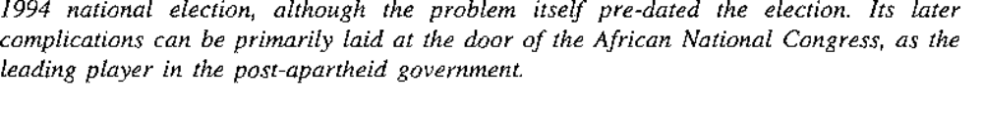
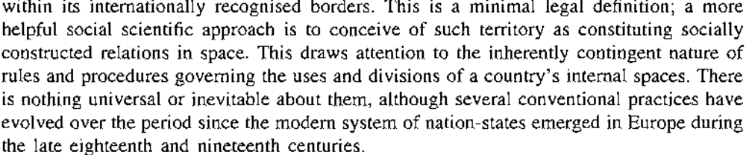

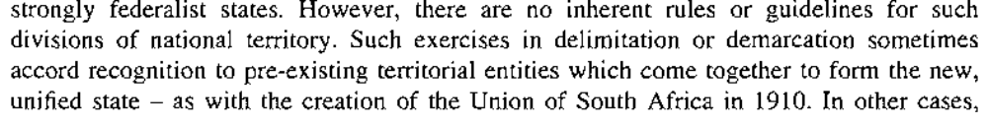
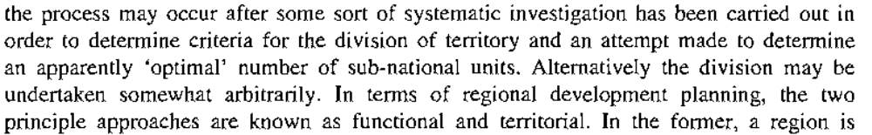

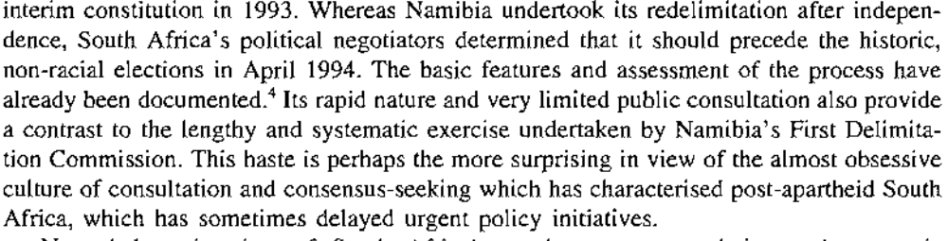

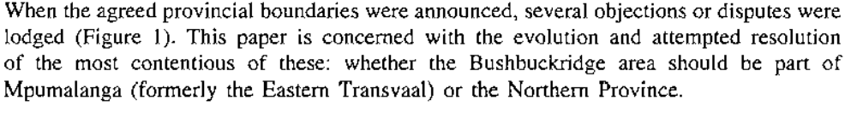
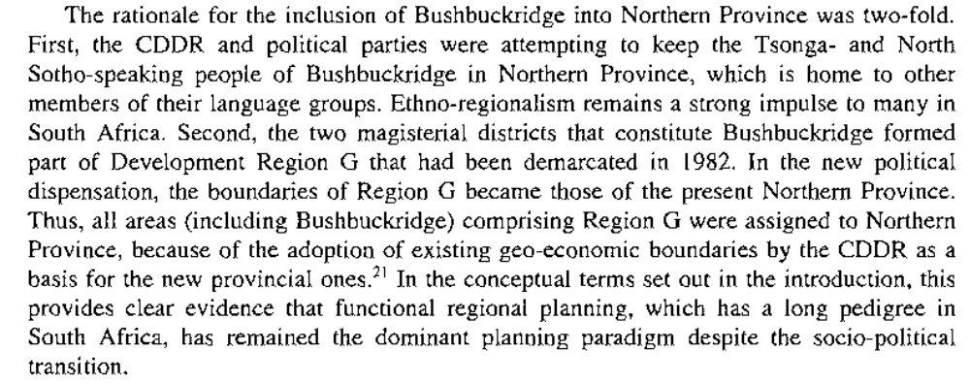

Ethno-regionalism considerations in demarcating… adoption of existing geo-economic boundaries by the CDDR as a basis for the new provincial ones…functional regional (rather than territorial…)planning the dominant planning paradigm…( what is the dominant territorial planning paradigm in South Africa ? ) (What are the key considerations for territorial planning… for territorial demarcation…)
What are the criteria used in subsequent demarcations (Magisterial demarcation, the formation of economic development regions, the interim constitution, the demarcation act, the twelfth amendment, etc…) what results have those considerations produced in the ground…
Shlomo Hasson and Eran Razin, What is hidden behind a municipal boundary conflict, Political geography quarterly, vol. 9, No. 3, July 1990, 267-283

“ examination of intra-national boundaries has been one of the traditional tasks of political geographers, who focused on establishing criteria for their delineation, studying processes of change which make boundaries inappropriate, and suggesting principles for boundary reforms (Prescott, 1978)” 269

“Barlow (1981) identified three basic criteria for delineating local government areas:
- the size and shape of government areas should be compatible with their functions, so as to assure efficiency in providing services
- the spatial extent of government areas should provide them with adequate fiscal capacity to perform their functions
- government areas should correspond to prevailing patterns of community” 269

“once boundary patterns of local government areas are established, organizations and political power tend to follow their lines, and evolving structures of interests often make it very difficult to change the boundaries” 269

“ boundary systems reflect, therefore, geographical conditions and historical-political situations at the time of their delineation” 269 e.g.
-the English local government structure reflected until 1974 circumstances of Victorian times (Richards, 1978)
-the Los Angeles boundary patterns can only be understood by referring to the issue of water supply in the first quarter of the 20th century (Nelson, 1983)

“ these spatial systems may become outmoded, as political, economic and geographical conditions change” 269

Calls for reform motivated by fiscal crises of central cities and by social justice arguments (Castells, 1979; Markusen, 1978)

“new local government structure introduced in England in 1974, emanated from pressures accumulating for decades. The reform was intended to solve service inadequacies, lack of coordination and tax-base problems resulting from excessive fragmentation, but was by itself a result of a specific political situation (Barlow, 1981)” 270

Basic principles that guided the commission:
-sensitivity and correspondence to demographic and socio-economic changes
-efficiency in the provision of services
-local autonomy and comprehensibility (system that could be easily understood … Redcliffe-Maud, 1969; Alexander, 1982)
-adherence to historical boundaries ( “ whenever the case for change is in doubt, the common interest, traditions and loyalties inherent in the present pattern, and the strength of existing services as going concerns, should be respected” (Redcliffe-Maud, 1969)
270
Most often.. conflict between criteria outlined for demarcation: sensitivity and correspondence which imply adaptation by boundaries to urban expansion, are likely to collide with the principle of respecting traditions and loyalties inherent in the present pattern…

“ we would certainly not hold to a boundary dividing independent areas that ought to be administered as one coherent unit. But we decided that, generally, we would propose boundaries for the new units differing from those of present authorities only when the advantage appeared unquestionable” (Recliffe-Maud, 1969) 270

“ Municipal-boundary delineation, as this short review clearly shows, is not a technical outcome rising from the implementation of some universal criteria. The spatial delineation represents a delicate interplay between forms of knowledge, already established criteria, frozen spatial-political patterns and new social processes, as well as search for local economic and political advantage” 270

“ the major interest of the involved actors was an economic one –that is, either to improve or to preserve their financial situation. The arguments advanced to justify the economic interest varied among the participants. The delegates of the development towns and the regional industries turned to normative justifications, such as social justice, fairness and reducing regional disparities. The regional councils, on the other hand, relied heavily on rational considerations, such as geographical, planning, legalistic and economic considerations(see table 3” 274

“ the various arguments advanced in the course of the present dispute clearly reflect political economic problems which beset Israeli society today” 278

“ underlying the four solutions opted for by the various actors(see table 5), there were some principles and values on which each party built its case. These principles and values were expressed in an idiosyncratic manner reflecting prevailing local knowledge and the particular culture of the involved participants. Nevertheless, the references to particularistic issues such as specific planning and ecological problems, commuting patterns, financial and administrative records and social inequality were largely in line with criteria used in other case concerning boundary delineation. Thus, commuting patterns are considered as a legitimate criterion (Douglas, 1968), and precedents can be found for the establishment of long narrow corridors, such as the well-known one in Los Angeles (Nelson, 1983). Tax base considerations are frequently present in boundary disputes, and the administrative record of government was mentioned in the past as a legitimate criterion(Richards, 1978). At a certain level of abstraction these particularistic criteria, which essentially stand for some universal principles and values, can be grouped into four general categories:
- Efficiency
- Effectiveness
- Social justice
- Legal/political/bureaucratic/cultural constraints

“the commission’s recommendation is not necessarily the final scene in this unfolding drama. Acceptance or denial of such recommendations by the minister of Interior depends much on the political setting, the balance of power and the vested interests of the political parties involved”… also examples from England… about political decisiveness 281

“In the structure of sub-national government, boundaries are not only spatial and geographic. They also delineate the allocation of functions and the distribution of political power”281

“ the case presented here further corroborates the political-economic significance of the redelineation of boundaries in a sub-national setting”281

“ unmasked attempt to obtain economic resources…”281

“these existing forms of knowledge do not view boundary redelineation as a proper means for the redistribution of resources in this particular case. The city is conceived among other things as an entity based on criteria of efficiency and effectiveness. Geographically, this implies that territorial size and shape should fit the ability to serve it. According to the current conventional wisdom a city should not spread over vast unpopulated areas, since it is not organized to manage and serve such areas effectively. Under these assumptions, the redelineation solution can not be regarded as a viable option, and the unavoidable conclusion is that a solution to the problem of redistribution should be anchored in revising tax policy in Israel. Thus, the political attempt to provide a geographical solution to the redistribution problem of property tax is conceived as an attempt to avoid confrontation with the issue of reassessing tax policy” 281-282

MUNICIPAL DEMARCATION BOARD

RE-DETERMINATION OF BOUNDARIES
OF
CROSS-BOUNDARY MUNICIPALITIES
AND
MUNICIPALITIES IN KZN AND EC

PRESENTATION: VUYO MLOKOTI: CHAIRPERSON: MDB

PARLIAMENTARY PORTFOLIO COMMITTEE
ON
PROVINCIAL AND LOCAL GOVERNMENT

18 OCTOBER 2005

The story behind the re-determination of cross-boundaries municipalities

- In terms of section 22 of the Local Government: Municipal Demarcation Act, 1998, the Municipal Demarcation Board may determine or re-determine municipal boundaries on its own initiative, on request by the Minister or a MEC for local government, or on request by a municipality with the concurrence of any other municipality affected by the proposed determination or re-determination.
- In August 2005 the Minister of Provincial and Local Government requested the MDB to re-determine the boundaries of certain municipalities. The Minister’s request was gazetted (Government Gazette No. 27937) for general information on 19 August 2005.

- As from 2 September 2005 the Minister’s request was published in the media in terms of section 26 of the Demarcation Act, 1998, inviting the public to submit written views and representation to the Board.
- On 7 and 13 October 2005 the Board met to deal with written views and representations received.

Principles:

MDB has no mandate to deal with provincial boundaries. Who holds that power?
MDB has the responsibility to take into account all views, representations, and applicable legislation, but ultimately it must perform its functions independently, impartially, and without fear, favour or prejudice.

Re-determinations of boundaries if CBMs are provisional, and subject to concurrence of provincial legislatures and authorisation by national legislation.
- MDBs re-determination need to be gazetted this week.
- 30 days will be allowed for objection.
Internal regional boundaries prior to 1993

The National Party government stripped the provinces of their powers in 1986 and replaced them with the short-lived system of regional councils.

From R Griggs, The Boundaries of a New South Africa, Boundary and Security Bulletin, 2(4), Durham, January 1995.

the Commission of Enquiry into the Taung/Kuruman/Kudumane Border Dispute filed their report recommending a limited referendum.¹⁷ NP spokespeople for Namaqualand (and certain other areas of the Northern Cape south of the Orange River) said in 1996 that they would demand incorporation into the Western Cape if the boundary along the Northwestern Province and Northern Cape was changed. Namaqualand was one of the `affected areas' outlined in the 1994 Constitution and if Taung and Kudumane. From R Griggs, The Boundaries of a New South Africa, Boundary and Security Bulletin, 2(4), Durham, January 1995.

Republic of South Africa, Report of the Commission of Enquiry into The Taung/Kuruman/Kudumane Border Dispute, April 1997.
Trengore commission (Matatiele…): option of a referendum ruled out…

Maano F Ramutsindela, The changing meanings of South Africa’s internal boundaries, in Area (1998) 30.4, 289-299

“ a change in the political system, with whose meanings and values maps are shot through, is likely to be reflected in the restructuring of the state and a re-mapping of political geography, in accordance with the political aspirations, needs and priorities of the new order (Harley 1988)”

“ at the negotiating table, where the ruling National Party (NP) and the unbanned African National Congress (ANC) were the main players, the apartheid internal map, designed to foster the balkanization of the country, was the subject of much debate. The aspirations of the national liberation movement (led by the ANC) required changes in the internal map of the country” 291

“ the third section examines some of the evidence of new meaning attached to territorial restructuring, and shows the importance of such interpretations to the theorizing of, and solutions to, boundary disputes in selected case studies” 292

“ the apartheid state turned boundaries into geopolitical instruments for creating racial and tribal areas, and presented these boundaries as ‘protective shells’ for the ‘different nations’ found in the country” 292

Acknowledgement of the failure of the Bantustan policy… “ Following this acknowledgement, nine development regions were demarcated, which transcended the boundaries of the four provinces of the Cape, Natal, Orange Free State and the Transvaal.” 292

“ although the state presented these regions as necessary for economic growth, job creation and the provision of basic needs (Du Toit 1982; Thomas 1986; Lemon 1987), the political motive was to lay the foundation for a confederation of states( South Africa 1983) 292

“ Other motives behind the establishment of these regions included the search for strategies to incorporate blacks, coloureds and Indians within central state institutions, while retaining race and ethnic identity as the basis for political representation ( Cobbett et al 1987)” 292

“ The NP demarcated the nine development regions in order to lay a foundation for regionalization in post apartheid South Africa ( Khosa and Muthien 1997)” 292

“ The attempt by the NP to entrench regionalization was in direct conflict with the creation of a unitary state, as envisaged by the ANC. The political ambitions of these two major political parties influenced the process and nature of debates on the redrawing of provincial boundaries” 292

“ the transformation process was intended to replace the devolution of power on the basis of race with one based on geographical regions, while strengthening the process of nation-building (Christopher 1995, 3) 292

“ the adoption of the 1982 development regions as a geographic base for new provinces resulted in a spatial resemblance of both apartheid regions and post apartheid provinces (figure 1)”293

Demarcating on the basis of apartheid development provinces led to these consequences :
- ethnic groups in most of the Bantustans were enclosed into new provinces, without changing the pattern of (African) population composition and distribution; as evidenced by the concentration of the zulu in the new province of KZN, the xhosa in Eastern Cape, the Tswana in North West, and the Sotho in the Free State. Furthermore, the Bantustan character - low levels of urbanization and high unemployement – is visible in provinces such as Kwazulu-Natal, Eastern Cape, Northern Province, North West and Mpumalanga, which carry a greater proportion of former Bantustans(see Table 1) 292
- CDDR claimed to have avoided dismantling African ethnic spaces, because it was instructed … to respect the geographic coherence of language groups (Muthien and Khosa 1995, 1997)…. New radical map not possible within six weeks….as CDDR maintained the geographic status quo of those ethnic groups that were already consolidated in apartheid Bantustans. Ex Bushbuckridge case, Groblersdal (Northern province) and Kuruman and Taung (North West)
- Notwithstanding multi-ethnic provinces such as the Northern Province, the new provinces became ethnolinguistic enclosures and transformed the post apartheid state to a democratic quasi-federal one ( Christopher 1995)

Empirical evidence of new meanings of internal boundaries

“ though the new provinces replicate apartheid regional development boundaries, they have assumed new meanings as the second tier of government in a democratic south Africa, and reflect the principle of non-racialism embodied in the new constitution”

- provinces used to launch 1994 first democratic elections
- provinces used to build political base for political parties (ANC and premiers deployed in provinces of their origin…
- Right wingers Afrikaners nationalists wanting to use provinces to realize the idea of a volkstaat ( e.g From Pretoria to Western Cape
- IFP using KZN as it political power base
- Provinces seen as providing opportunities for, and constraints to, development, self-determination , political ambitions, so forth ( ex Bushbuckridge “ for various reasons that have been highlighted in this paper, they see the new political dispensation as an opportunity to relocate their area from Northern province to the nearest province of Mpumalanga. The attempt to transfer Bushbuckridge to Mpumalanga has great significance to the reconceptualisation of boundaries in South Africa, because residents in the area (Bushbuckridge) want to be geographically disassociated from their ethnic group membership in the Northern Province.
- At local gov levels, boundaries have an important role as catalyst in the process of nation-building (knitting together … new terrain for local politics in TLCs, TMCs)and the delivery of services

“ Whites in the town of Groblersdal in the Northern province refusing to form a transitional local council with sourrounding black areas…”

The implications of boundary changes
“ the way in which boundary changes are conceptualized affects, to a large extent, the theoretical approach to boundary disputes and the way these should be resolved” 295

“ Griggs’s observation that the “new shape and lines that distribute South Africa’s wealth and power pose new opportunities and problems” (Griggs 1995, 85)

“ Post apartheid boundary disputes, for instance, are ascribed to cultural and economic faultlines” (Saturday Weekend Argus 1996) 295

New provinces…not as new as they are said to be… but what is new… new functions they perform, new meanings they have assumed…295

14 boundary disputes caused by ‘new lines’… the Bushbuckridge case relates to many factors:
- perceived entrenchment of apartheid location of Bushbuckridge in the new SA
- perceived prospects for development in Mpumalanga rather than in Northern Province
-ANC must keep its elections promises of transferring it in Mpumalanga… ( promise not fulfilled partly because of the internal politics of the ANC)

-politicians from BB would be affected by the transfer
-the reluctance of the gov to resolve boundary disputes through constitutional means
“ Since these measures have not been used, and the final (1996) constitution is silent about them, the responsibility for resolving disputes lies with the national government” 296
-Horse-trading provision in that dispute…

“ changes in the internal map of South Africa have theoretical implications for research about the role of boundaries in socio-political transformation” 296

“ To what extent would the politically driven project of nation-building change the apartheid political ambition to establish a segregated society? Post apartheid provincial boundaries -and boundary disputes- are part of the ‘arithmetic’ required to answer this question

“ Mechanisms required to resolve post-apartheid boundary disputes are perceived differently by affected local communities and the government” 297 local communities: referendums, ANC gov : internal boundaries do not matter, those disputes are not important…

“ it could, in this context, be argued that the government has little interest in solving boundary disputes. Communities affected by these boundaries feel that boundary disputes should be resolved. A proper framework for resolving these disputes requires a reconceptualization of boundaries –by government and the public- in order to read the text that these disputes offer” 297

The gov has started to rethink the implications of boundaries as evidenced by the 1998 municipal demarcation bill which aims to re-drawing boundaries in order to integrate areas and ensure a single tax base (south Africa 1998)… no extension to provincial boundaries even though R40 million –worth damage caused by BB provincial protesters.

“ these disputes could be possibly resolved if the government reviews its position that ‘provincial boundaries do not matter” (Minister VAlli Moosa, quoted in Sunday Times 1997, 25), and commit the process of resolving them to constitutional mechanisms” 297

“ A framework for solving internal boundary disputes in south Africa should acknowledge the importance of boundaries to communities affected by, or adjacent to, boundaries. To ignore internal boundary disputes as irrelevant in ‘one country’, as was the government position in 1997, is, at best, to ignore the emerging meanings attached to the evolving space(s), and the concerns of those communities that are subject to transformation” 297

Meanings of boundaries beyond the mere existence of a line, to encompass rituals, metaphors and images (Radcliffe 1990, Paasi 1996)

“Disputes over boundaries are generally a reflection of complex factors, which include the interpretation of written and/or unwritten histories, contested territories and identities, the manipulation of political, social , religious and economic spaces, and so forth”

Boundary disputes: case of re-emergence of local identities, local struggles… “ the people of Bushbuckridge are engaged in a struggle to determine and perhaps to rediscover their own geographical identity, brutally destroyed under apartheid” 298

What conditions the search for new identities?
In what sense do these boundaries matter ?
And what politics are behind the disputes?

(research agenda on the implications and effects of political, social and economic transformation in post apartheid SA…Implications and effects of boundary changes in SA)

Applicants’s heads of argument

Both acts : amendment and repeal act… signed into law and gazetted on 23 December 2005

Claim for urgent and direct access…
The two acts are inextricably interlinked

Matatiele case affect two districts : Sisonke district and Alfred Nzo Municipality

The problem goes to the setting of provincial and municipal boundaries…

“it is submitted that the applicants acted with expedition and without undue delay in approaching this court shortly prior to the promulgation of the acts. Although the acts were published for public comment on 26 August 2005, a municipal demarcation process was underway and yielded provisional determination on 20 Oct 2005. That process was subsumed by the approval of the acts by Cabinet and Parliament by 14 December 2003”

Applicants : Matatiele/Maluti Mass action committee comprising the municipal council and a spectrum of businesses, educators, associations and non-governmental entities resident in the Matatiele area….

“The core of the complaint is that the Constitution establishes a procedure for municipal demarcation which, in the case of Matatiele, was circumvented.”

“The independent body referred to in section 155(3)(b) is the Municipal Demarcation Board established through the Local Government: Municipal Demarcation Act, No. 27 of 1998.”

“This Court has previously had to consider where the power to establish municipal boundaries vested. It concluded that such power was constitutionally vested in an independent authority and not in provincial or national government. The context in which it did so was in the light of a challenge by two provinces to national legislation dealing with the establishment of municipalities.”
Cfr Executive Council, Western Cape v Minister of Provincial Affairs and Constitutional Development and Another; Executive Council, KwaZulu-Natal v President of the Republic of South Africa and Others 2000 (1) SA 661 (CC).

“[50] The purpose of s 155(3)(b) may well have been to guard against political interference in the process of creating new municipalities and to this extent the function of determining municipal boundaries is entrusted to an independent authority.”⁷

“I conclude therefore that the scheme for the allocation of powers relating to the structure, functioning and establishment of municipalities contemplates that the Demarcation Board should determine the boundaries in accordance with the criteria and procedures prescribed by the legislation contemplated by s 144 (2) and (3) and that it should be able to do so without being constrained in any way by the national or provincial governments.”⁸ (Emphasis added.)

If s 6(2) were to have any meaning, it subjects the decision of the Demarcation Board in relation to the municipal boundaries to the discretion of the Minister. This, in my view, is impermissible. To the extent that s 6(2) of the Structures Act gives the Minister a discretion whether to accept the boundaries determined by the Demarcation Board in respect of categories of municipality, it is inconsistent with ss 155(2) and (3) of the

but is of no relevance to Matatiele because it was not a cross-boundary municipality. Although a small portion of Matatiele fell in the Eastern Cape, that land, being a collection of 8 farms without a town or village, was proclaimed in the Interim Constitution to be a part of KwaZulu-Natal.¹⁰ Consequently, Matatiele was not a municipality stretching across a provincial boundary. Neither was it administered by two provinces. Accordingly, it was not a cross-border municipality as envisaged in section 155(6A) of the Constitution.

The national legislation contemplated in section 155(3) is the Municipal Demarcation Act. This Act was one of three “envisaged to transform local government and [establish] municipalities throughout the country.”

Section 24 specifies demarcation objectives, which include establishing an area
that would inter alia enable effective municipal governance including the delivery of services in an equitable and sustainable manner and the provision of democratic and accountable government for local communities.

Section 25 specifies criteria to be considered in determining a municipal boundary. Those criteria include a range of factors, including but not limited to:
(a) “the interdependence of people, communities and economies as indicated by –
(i) existing and expected patterns of human settlement and migration;
(ii) employment;
(iii) commuting and dominant transport movements;
(iv) spending;
(v) the use of amenities, recreational facilities and infrastructure; and
(vi) commercial and industrial linkages”;
(b) provincial and municipal boundaries;
(c) “existing and proposed functional boundaries, including magisterial districts, voting districts, health, transport, police and census enumerator boundaries”; and
14
(d) existing and expected land use, social, economic and transport planning; and
(e) a range of other social, economic and developmental considerations relating to existing and future patterns of human settlement.

The Municipal Demarcation Board may determine and re-determine boundaries either of its own accord or at the request of a municipality or a MEC or Minister for local government. In each instance a public participation process is specified in section 21 and sections 26 to 30.

It is common cause on the papers that Parliament may change provincial boundaries. This follows from the provisions of sections 74(3)(ii) and 44(1)(a)(i) read with 103.

Noting that local government was to be “established for the whole of the territory of the Republic,”¹⁴ it follows that a change in a provincial boundary will probably affect municipal boundaries

In addition, section 44(4) of the Constitution provides:
“When exercising its legislative authority, Parliament is bound only by the Constitution, and must act in accordance with, and within the limits of the Constitution.”

The second respondent requested the Municipal Demarcation Board to exclude Matatiele from Sisonke District Municipality and to include it in the Alfred Nzo Municipality in the Eastern Cape Province.¹⁶ This request was gazetted on 19 August 2005.¹⁷

The process embarked on by the Municipal Demarcation Board was not followed through to completion. Instead, in the interim, the two Bills were published for comment on 26 August 2005 and the applicants delivered comprehensive comments on them to the offices of the second respondent and to the Portfolio Committee

Sisonke- Umzinkulu- Alfred Nzo

The Repeal Bill first “deemed” such re-demarcations to be demarcations in terms of the Municipal Demarcation Act.²⁴ That language was later removed in the published Bill²⁵ and the new demarcations are now to be “regarded as” demarcations in terms of the Municipal Demarcation Act.

That notwithstanding, the Demarcation Board then issued its “demarcations” on 27 and 28 December 2005.²⁶ Those demarcations differed from its provisional demarcations and effectively followed the second respondent’s request for the re-dermarcation of Matatiele and the Sisonke and Alfred Nzo District Municipalities.

The memorandum accompanying the first version of the Cross-Boundaries Municipalities Laws Repeal and Related Matters Bill described the position of Matatiele as follows:
“1.2 The Bill also seeks to address challenges related to the provincial boundary between the Eastern Cape and KwaZulu-Natal Province in a manner that would avoid going through a process of first establishing cross-boundary municipalities in order to address these challenges. (In this regard, the provisions of the Bill must be read with the provisions of the Twelfth Constitution Amendment Bill, 2005) In order to ensure a smooth transition in dealing with these challenges, provision has been made for the following transitional arrangements:
(a) The Bill seeks to dispense with the provisions of the Local Government: Municipal Demarcation Act ... and the Local Government: Municipal Structures Act ... by allowing proposed demarcations of particular municipalities as reflected in Schedule 4 of the Bill, to be deemed to be the demarcation of municipalities that reflect a new composition or location in a particular province...”²⁸
42.
Paragraph 1.2 above was removed in the final published version of the Bill.
43.
²⁸ Founding Affidavit: Annexure D, Explanatory Memorandum, paragraph 1.2
.
23
Manifestly therefore, the aim in so far as Matatiele was concerned was to re-demarcate Matatiele, to excise it from the KwaZulu-Natal Province and in essence to treat it as a cross-border municipality which it was not.

Whatever the position in respect of other municipalities might have been, it is submitted that the clear aim in the treatment of Matatiele was to short-circuit the municipal demarcation process in respect of Matatiele and to deal with it as if it were a cross-boundary municipality. This meant that the processes for municipal demarcation in the Constitution and the Municipal Demarcation Act and the provisional re-demarcation determined pursuant thereto could simply be ignored.

Applicants contend that their submissions to the second and seventh respondents were ignored.³¹ This is contrary to the principles of co-operative governance³² which required, at the very least, that the views of the applicants were taken into account by the first, second and third respondents.

That these views were significant and weighty is proved by the fact that it persuaded the Municipal Demarcation Board that the second respondent’s proposals could not be supported on the merits after all relevant stakeholders had been heard and all relevant and competing factors considered.

It is submitted that the process adopted in the re-demarcation of Matatiele was therefore contrary to the provisions of the Constitution, contravened the principles of legality and the principles of co-operative governance.

More significantly, the Municipal Demarcation Board does not explain why it felt that its processes had to yield to the processes in the Bills in respect of Matatiele when no consent was necessary from provincial or national governments because no cross-border municipality was implicated. In effect, the stance of the Municipal Demarcation Board is that it knew that its determinations in respect of Matatiele would be over-ridden and it was willing to accept such an outcome without alerting the applicants to the fact that they were ultimately wasting their time.

In addition, it is submitted that the Municipal Demarcation Board is incorrect in asserting that it gazetted “its decisions” after the Acts had been proclaimed in terms of section 21(5) of the Demarcation Act.³⁵ That determination as we have demonstrated merely followed the determination requested by the Minister and as specified in the Repeal Act. It is submitted that this cannot be said to be a true determination of the Demarcation Board.

At present, the only considerations applicable to the demarcation of municipalities are those set out in the Constitution and the Demarcation Act

The report prepared for the President did not indicate any problems associated with cross-border municipalities in respect of Matatiele. To the contrary, while noting that the issue was sensitive, it stated that there was “... good cooperation between municipalities across the provincial boundary post December 2000.”³⁸

None of the reports describing problems with cross-border municipalities presented any difficulty with the position of Matatiele in KwaZulu-Natal, nor did these reports include any motivation for its excision from KwaZulu-Natal or need to be included in the Eastern Cape. In fact, the report prepared by the Demarcation Board during July 2003 recommended that Matatiele be consolidated with areas in the Eastern Cape with which it shared functional linkages while remaining in KwaZulu-Natal.³⁹
61.
Consequently, we submit that the historical and other issues pertaining to cross-border municipalities had little or no relevance to the position of Matatiele and its re-demarcation.

Consequently, we submit that the historical and other issues pertaining to cross-border municipalities had little or no relevance to the position of Matatiele and its re-demarcation.

The applicants do not dispute that the Amendment Act was properly passed but contend that it is unconstitutional to the extent that it re-demarcates Matatiele to the exclusion of the process contained in section 155(3)(b).

It is accordingly submitted that not only is it evident from the maps referred to in the Amendment Act, the foregoing references in the Repeal Act make it abundantly clear that Matatiele is to be re-demarcated.

Accordingly, it is submitted that the effect of the Amendment Act and the Repeal Act is to re-demarcate the Matatiele municipality. This process occurred without due cognisance of the process in section 155(3)(b) of the Constitution requiring municipal demarcations to be conducted by the Demarcation Board.

In the result, we submit that the Amendment Act and the Repeal Act both directly and in effect contravene the provisions of section 155(3)(b) of the Constitution in so far as it relates to Matatiele. The process followed by the Demarcation Board in the re-demarcation of Matatiele was effectively abandoned and substituted by legislative and executive decree.

In so far as the respondents attempt to contend that the Demarcation Board carried out its functions after the Acts were passed, we submit that it is clear that the “demarcations” by the Demarcation Board after the enactment of the Acts were nothing more than what was required by the Acts and what had been requested of it by the second respondent. The demarcation of Matatiele was presented as a fait accompli

It cannot therefore be said that the Demarcation Board applied itself independently to the demarcation issues once the Acts had been promulgated.

In the result, we submit that the applicants have demonstrated enforceable rights, that is the rights which inure to them by virtue of section 155(3)(b). They do not claim a right to be located in KwaZulu-Natal but claim a right to have decisions over their re-demarcation made by an independent body as contemplated in section 155(3)(b) and to have that body make decisions independently of any interference from other organs of state.

The fact that the respondents attempt to describe what has happened as a provincial boundary change does not affect the rights vested in the applicants by virtue of section 155(3)(b) and related Municipal Demarcation Act.

First applicant’s founding affidavit

Applicants complain that the municipality of Matatiele has been removed from KwaZulu-Natal and placed in the Eastern Cape Province by legislative decree which has circumvented the constitutional and procedural rights of the people of Matatiele.

It is contended that the path chosen by the First, Second and Third Respondents is unconstitutional and ultra vires and the steps taken by them should be set aside.

The further Respondents are joined because of their interest in the application, but against whom no orders are sought nor costs asked for unless they or any of them oppose this application.

7.5 For years, however, since the creation of the former Transkei, there has been a bubble of land around the village of Umzimkulu which has intruded into the province of KwaZulu-Natal, but which has been part of the Eastern Cape Province.
7.6 Nearby Matatiele, over the provincial boundary in the Eastern Cape is the settlement of Maluti, which has, despite its position over the border, always existed as an adjunct to Matatiele.

8.8 In brief, and without setting out the procedure in full, I understand that the Board may make a quick re-determination if the MEC for Local Government and all the affected municipalities have indicated in writing that they have no objection thereto.
13
8.9 That is not the case here. Matatiele Municipality has refused to consent in writing to any re-determination.

The re-determination implicit in Schedule 1A is defective, flawed and without legality because it was not the result of the prescribed process; only the Municipal Demarcation Board has the power to re-determine boundaries. This power does not reside with the Executive (either National or Provincial) nor Parliament nor the Provincial Legislatures;

The re-determination process is under way by the Municipal Demarcation Board and uncompleted. It has not been cancelled or withdrawn, but it has been purportedly destroyed by the actions of Parliament.

The Executive has failed to comply with the principles of co-operative government.

It is incompetent and unconstitutional to deal with Matatiele as if it was a cross-boundary municipality when it is clearly not one.
9.13 It will be seen that the result favoured by the Executive is that Matatiele Municipality (and the Maluti area) will, from the effective date of the legislation, be placed in the Eastern Cape Province.
9.14 This is contrary to the wishes of the overwhelming majority of the people in Matatiele and Maluti.

10.3.1 the constitutionality of the Constitutional Amendment Bill;
10.3.2 the failure of Parliament (by passing the legislation) and the President (by signing it) in fulfilling a constitutional obligation to demarcate municipalities in the method prescribed by the Constitution in the case of Matatiele;
10.3.3 the constitutionality of the Cross-Boundary Municipalities Laws Repeal Bill when applied to Matatiele.
THE VIEWS OF APPLICANTS
11.1 The views of Applicants have been set out fully and submitted to the relevant authorities.

22
11.2 Matatiele Municipality made representations to the Municipal Demarcation Board dated 5th September 2005 which representations resulted in the provisional re-demarcation which is annexed “B” hereto. These representations are annexed hereto marked “F”. These representations were drawn up on behalf of the Municipality by the Municipal Manager, Errol Putzier on the directions of the Municipal Council.
11.3 Matatiele Municipality also responded to the publication of the Cross– boundary Municipalities Laws Repeal Act 2005 by sending comment to Second Respondents’ Department (Adv. Shami Kholong) and Third Respondent’s Department (Mr Labuschagne) including the Municipality’s views on the proposals. This document is annexed hereto marked “G”.
11.4 A written submission was prepared for the portfolio committee of Parliament on the said Repeal Bill, which includes the Municipality’s views on incorporation into the Eastern Cape. This is annexed hereto marked “H”. I also attended the Committee session on 18th October 2005 and addressed the Portfolio Committee on these views.
11.5 The Municipality has also sent representations and views to Seventh Respondent’s Department.

23
11.6 It will be seen that the matters dealt with in the representations are those relevant to a demarcation in terms of the Demarcation Act (especially Section 25).
11.7 The decisions taken by the Executive are not apparently based on any merit factors but political or ulterior factors which, on the spirit of the Demarcation Act have no place in the debate.
11.8 Applicants, and especially the Municipality reasonably believe that the views of the Municipality itself have been ignored by the Executive, who have chosen to circumvent the Constitutional procedure because the Second Respondent’s proposal could not be supported on the relevant merits.
11.9 The applicants cover a representative cross – section of the people who live and work in Matatiele and Maluti. First Applicant is without any doubt that it is representing the overwhelming majority of the Matatiele Municipality residents in making this application. About 19 000 people of the area signed the petition supporting the terms of the provisional re-determination which is set out in Annexure “B” within the 30 day period mentioned therein. Six Tribal Authorities have also signed a document of support for this view.

BACKGROUND FACTS
12.1 Without purporting to be exhaustive, I furnish the following background facts to supplement what is stated above.
12.2 In May 2003 the Municipality received a circular from the Chairperson of the Municipal Demarcation Board advising the Municipality how to deal with the demarcation process and advising of the procedure and the relevant factors. This is a reference to the procedure set out in the Demarcation Act. This is marked “I”.
12.3 On 13th October 2004 the Municipality received a letter from the Chairperson of the Municipal Demarcation Board attaching a request from the African National Congress (ANC) of the Alfred Nzo Region of the Eastern Cape. (This request was inter alia that Matatiele be transferred to the Eastern Cape). Reference is again made to the process following the process of the Demarcation Act. This is annexed hereto marked “J”.
12.4 In due course the Municipality was requested to submit its representations, which it did.

25
12.5 Unbeknown to the Municipal Council and the administration at the time, and while the Municipality was engaged in a democratic and transparent process within the Municipal Demarcation Board to re-determine boundaries, it is clear that the Executive had already decided the fate of inter alia Matatiele Municipality, irrespective of the conclusions of the Municipal Demarcation Board. The Municipality has since that time received two letters which deal with this foregone conclusion. On 19th August 2005 the Joint Operational and Intelligence Structure of the South African Police Service wrote to various Commissioners, including the Commissioner for KwaZulu-Natal and told him that an announcement would be made on 22nd August 2005, that inter alia Matatiele Municipality would be moved to the Eastern Cape. I annex hereto a copy thereof marked “K”. On the same day the Divisional Commissioner wrote to all Provincial Heads of Crime/Intelligence RSA to advise that an announcement of proposed boundary changes was about to be made and advising of possible “… protest or other de-stabilizing actions…” This is annexed hereto marked “L”.
12.6 On 24th August 2005 the Municipal Demarcation Board advised that proposed boundary changes would be published shortly thereafter, in order to eradicate cross–boundary municipalities. The letter contained information and assurances of consultation and public participation. This is annexed hereto marked “M”. Attached thereto were the proposed

26
changes, which included the transfer of Matatiele Municipality into the Eastern Cape. We were dismayed by this in the Municipal Council.
12.7 On 25th August 2005 I attended the office of the MEC for Local Government (KwaZulu-Natal) to meet with him together with the entire municipal councils and municipal managers of Matatiele and Sisonke. We were requested to sign a consent in terms of Section 21 (1) of the Demarcation Act. We considered the matter and the Matatiele Council gave no such consent.
12.8 On the next day, 26th August 2005, I wrote to the Chairperson of the Municipal Demarcation Board indicating that the Matatiele Municipal Council did have an objection to the proposed transfer of Matatiele to the Eastern Cape. The letter is annexed hereto marked “N”. In the letter I proposed that the Board follow the procedure set out in Section 26 of the Demarcation Act because insufficient prior consultation was an issue and public consultation and expression was important in this issue.
12.9 On 26th August 2005 the two Bills referred to above were published for comment.
12.10 There has been no public consultation whatsoever. The Municipality has made the necessary representations on every occasion. The Municipality

27
has also officiated at some protest marches by the people of Matatiele against incorporation in the Eastern Cape.
12.11 I have called the relevant stakeholders (including the Applicants hereto) to meetings to discuss views on three occasions.
12.12 The unanimous mood in the Matatiele Municipality is that the people who live and work there have very strong and heartfelt feelings about staying part of KwaZulu-Natal. The people of Maluti have also supported this fully, whether or not they join Matatiele in KwaZulu-Natal.
12.13 On August 24, 2005 the chairperson of the Municipal Demarcation Board announced that the Board was hoping for “quick agreements” between provincial governments, municipalities and communities. This is clearly a reference to Section 21 (1) of the Demarcation Act. This was reported in the Mercury of 25th August 2005, a copy of which is annexed hereto in extract form marked “O”.
12.14 The Second Respondent also made an announcement on the issues. In the Sowetan of 26th August 2005 the following in relation to Second Respondent was stated :-
“asked what would happen if a community was at odds with the MDB’s proposal for their area Mufamadi said such views should be immediately communicated. He said communities would play

28
an important role in shaping the final decision of law makers regarding the proposed changes. However, the communities would need to make sure they were heard.”
I annex hereto a copy of an extract from this newspaper article marked “P”.
12.15 The difficulty with this kind of issue is that most people, however literate or articulate, know their minds well and are able to express themselves by a vote or at a meeting, but find it difficult to write letters or representations.
12.16 The Municipal Demarcation Board advertised for responses to the proposal of Second Respondent. These had to be furnished by 26th September 2005.
12.17 In addition to the representations furnished to the Municipal Demarcation Board by the Matatiele Municipality the Mass Action Committee referred to above delivered representations to the Board on 22nd September 2005. These included 3248 individual representations and a petition of over 10000 signatures. I annex hereto a copy of a receipt thereof by the Municipal Demarcation Board marked “Q”.
12.18 On 20th October 2005 the Municipal Demarcation Board issued a press release which explained the provisional re-determination that it had made and the reasons therefore. This is annexed hereto marked “R” and

29
manifestly was followed by the provisional re-determination annexed hereto marked “B”.
12.19 This re-determination has not been withdrawn or cancelled. It is contended therefore that there is an existing uncompleted constitutional process under way which the Bills referred to above seek to circumvent.
12.20 Once the provisional re-determination was published in the Eastern Cape Government Gazette on 18th October 2005 the Traditional Leaders of the Maluti area sent a statement of support for the provisional re-determination (which put their areas of Maluti into KwaZulu-Natal) to the Municipal Demarcation Board. A copy thereof is annexed hereto marked “S”.
12.21 Applicant responded to the invitation in Annexure “B” by submitting 19348 submissions supporting the provisional redetermination to the Municipal Demarcation Board on 18th November 2005. I annex hereto the receipt that we obtained from the Municipal Demarcation Board in respect thereof marked “T”.
12.22 Applicants and especially the Matatiele Municipality have taken every opportunity to respond to calls for submissions or representations. We have also visited Second Respondent (Minister Mafumadi) in his office in

30
Pretoria. This meeting took place on 13th October 2005. The Minister listened to our group and urged us to make our feelings clear in a peaceful way. He urged us to address the merits through proper channels.
12.23 Applicants regard the Municipal Demarcation Board to be the “proper channel”.
12.24 On the contrary the Executive has moved with great haste to pass the constitutional amendments and the Cross-Boundary Municipalities Laws Repeal Bill through Parliament and the National Council of Provinces. A vote of approval has also been passed in the Provincial Legislatures in KwaZulu-Natal and the Eastern Cape.
12.25 The Matatiele / Maluti Mass Action Committee including First Applicant attended the Portfolio Committee meetings in Cape Town when they debated the Bills. I addressed the Portfolio Committee.
12.26 On 25th November 2005 members of our group had meetings with Seventh Respondent at his office in Durban. He told us that the National Government was dealing with this and we concluded that he could not assist the Matatiele Municipality.

31
12.27 On 28th November 2005 the KwaZulu-Natal Provincial Legislature resolved in favour of the constitutional amendment Bill by 39 votes to 33.
12.28 We have been told that on 7th December 2005 the Cabinet of the National Government approved the Bills that were to be put before Parliament.
- 12.29 By 14th December 2005 the Bills had passed through Parliament and the National Council of Provinces but had not yet been promulgated or brought into operation.
- 12.30 I have been advised that the First Respondent will sign the Bills on 21st December 2005.
- 12.31 We do not have the Bills in published Act form. In order not to delay this matter by reason of such publication Applicants annex hereto the final versions of the Bills. Second Respondent’s Department provided these copies by e-mail to Applicants’ attorneys.

12.32 The Constitution Twelfth Amendment Bill is annexed marked “U” and the Cross-Boundary Municipalities Laws Repeal and Related Matters Bill is annexed marked “V”.
12.33 Applicant further annexes hereto General Notice 1998 of 2005 which was published in the Government Gazette on 31st October 2005 and which is

32
referred to in Schedule 1A to the Constitution Twelfth Amendment Bill. It is marked “W”.
13.
CO-OPERATIVE GOVERNMENT
13.1 In terms of Sections 40 and 41 of the Constitution all spheres of government are under an obligation to observe and adhere to the principles of co-operative government.
13.2 This applies to the First Applicant and all the Respondents.
13.3 First Applicant has, on what has been set out above, done everything in its power to engage any or all parties in a relevant debate about the future of Matatiele, and followed the usual and accepted methods to do this.
13.4 First Applicant has also, as an ANC dominated council (80%) adhered to the principles of proper political engagement.
13.5 The Executive have resorted to changing the Constitution and changing the law to achieve their objectives, while all the time advising Applicants to make our views heard.

33
13.6 Applicants, and especially First Applicant, have no alternative than to resort to this Honourable Court to have our rights upheld.

First to third respondents answering affidavit

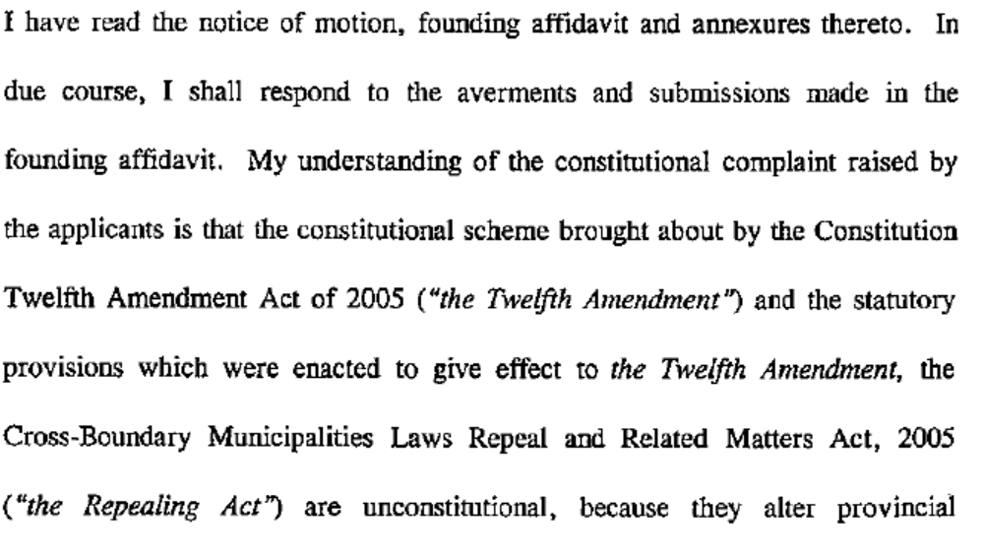
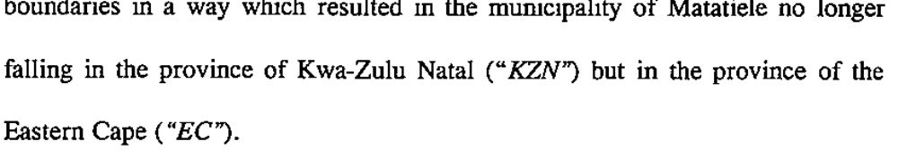

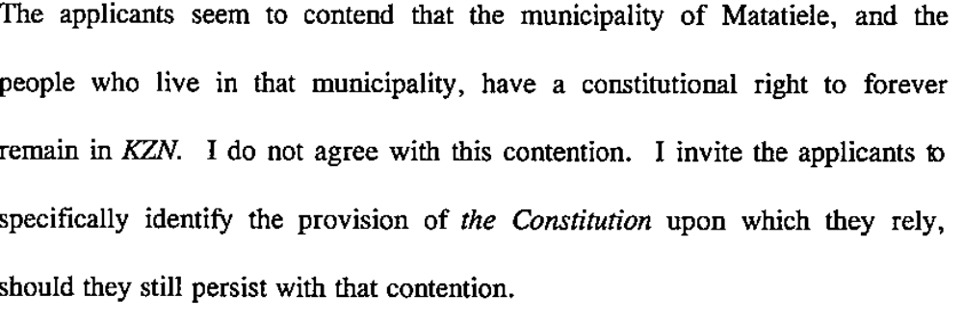
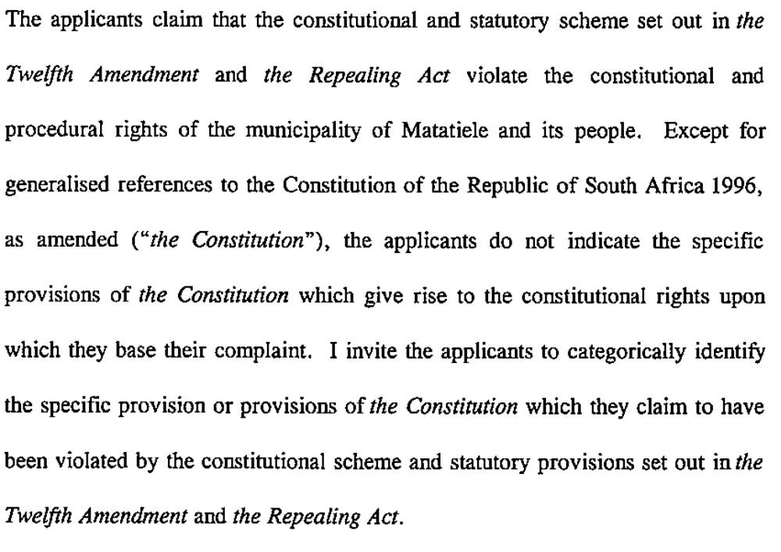
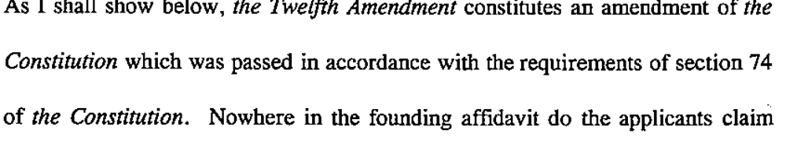
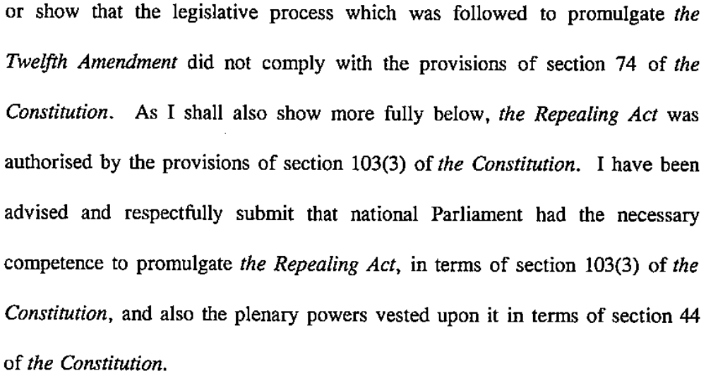
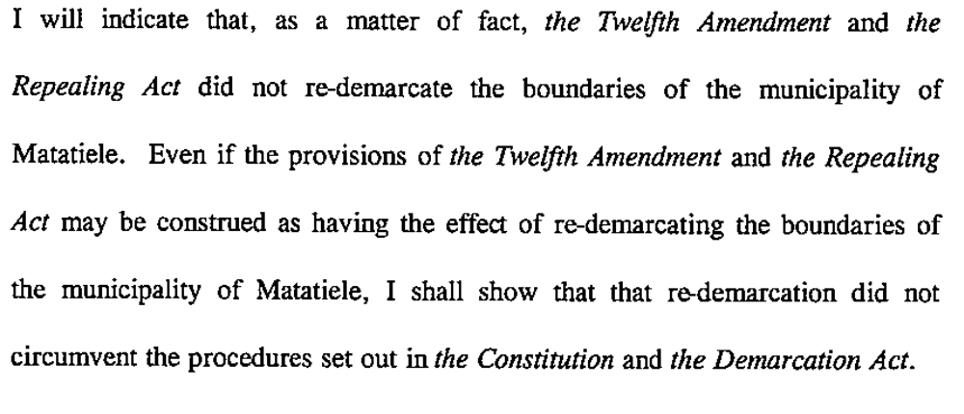

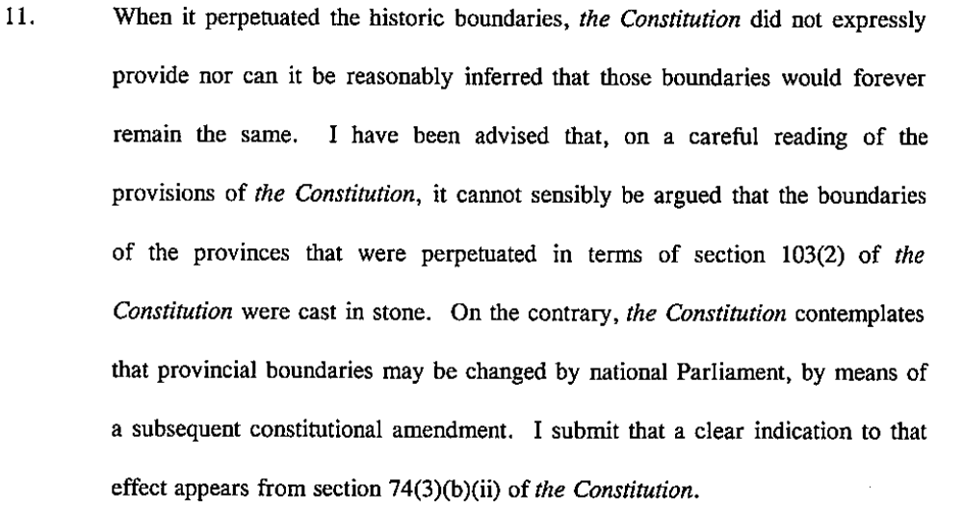

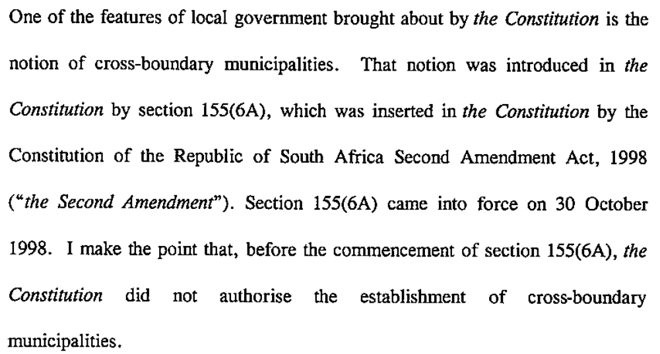

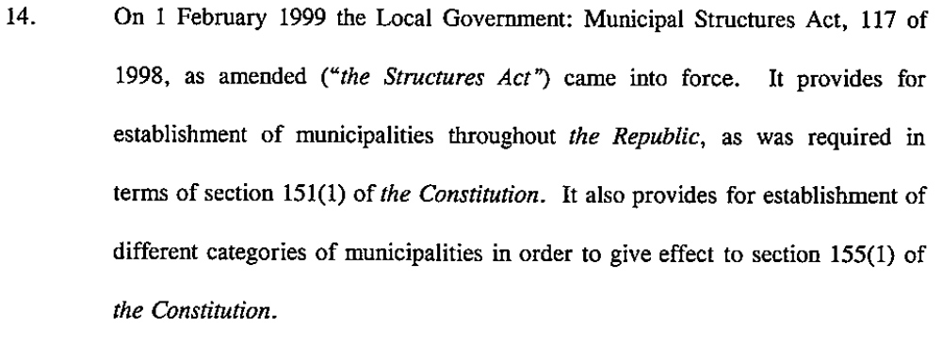
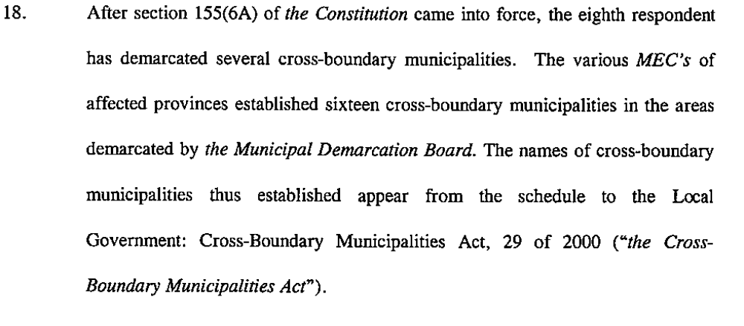
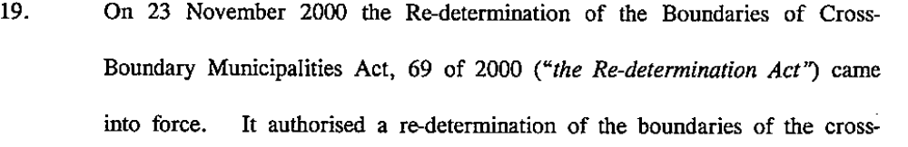
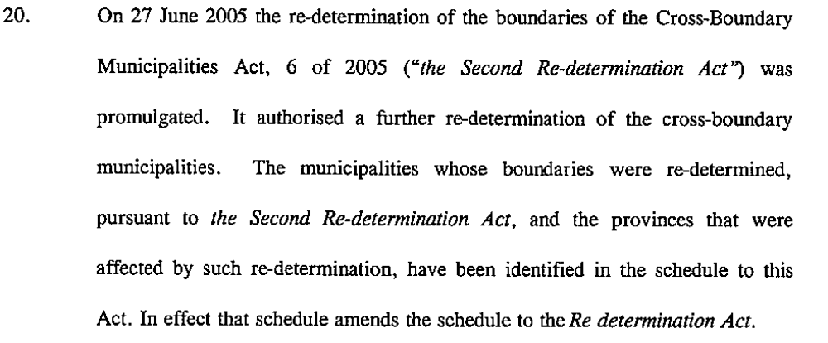

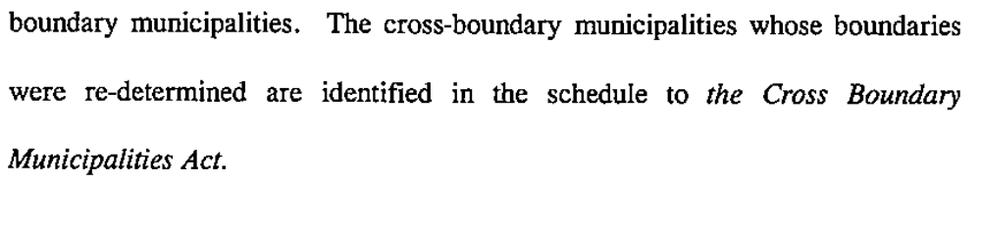

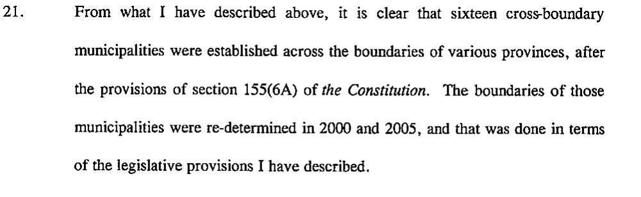
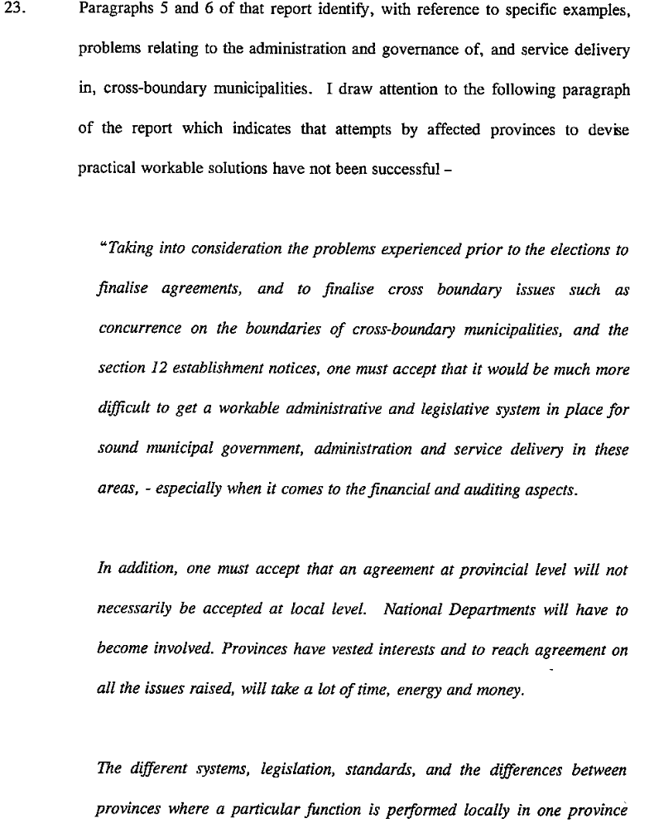
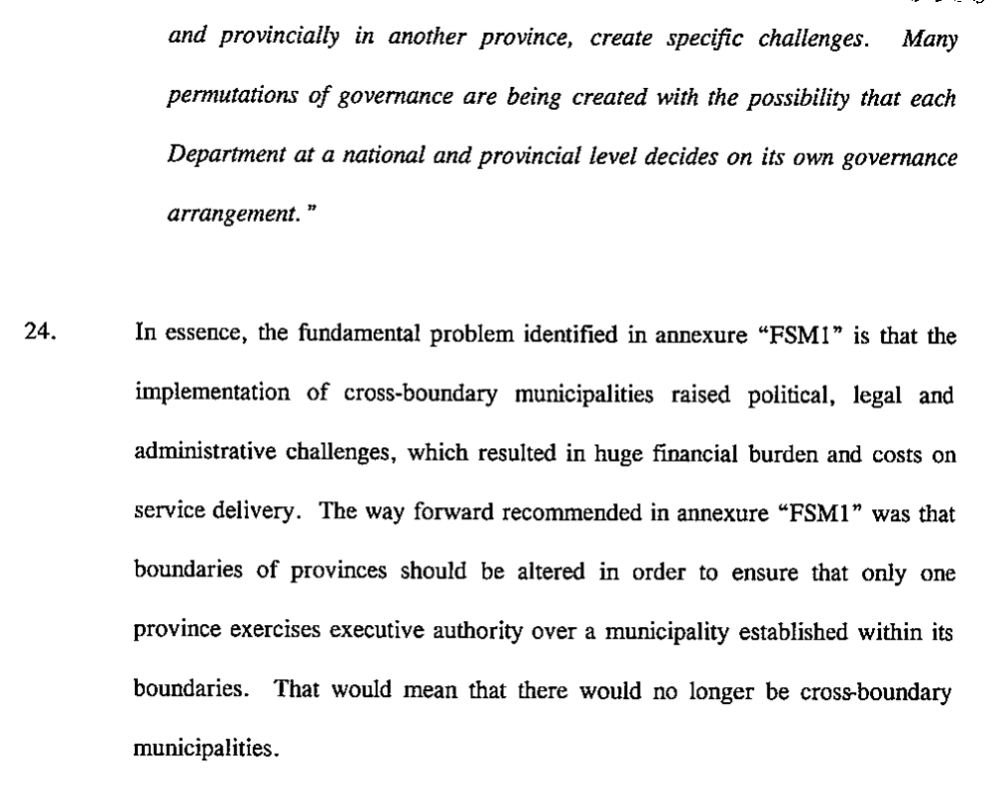
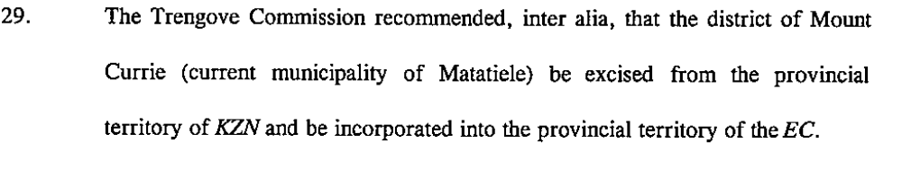
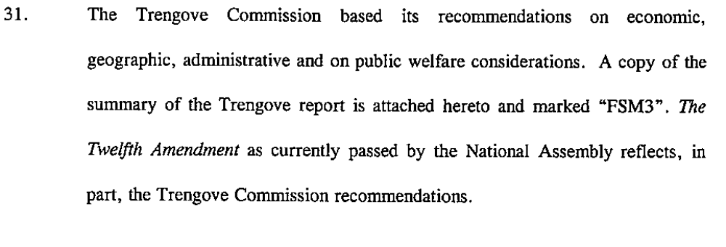

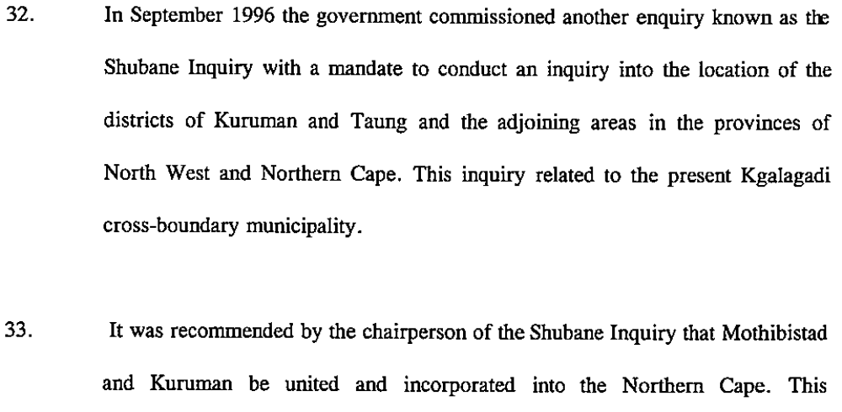
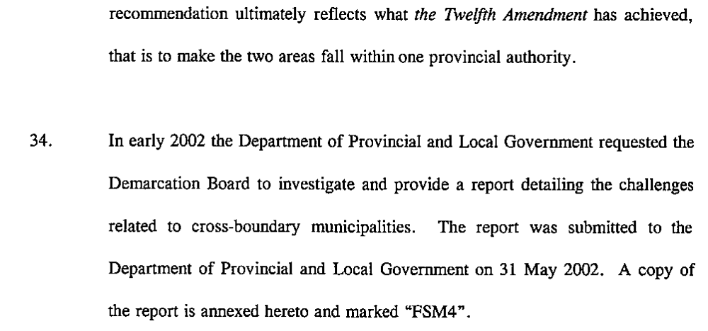

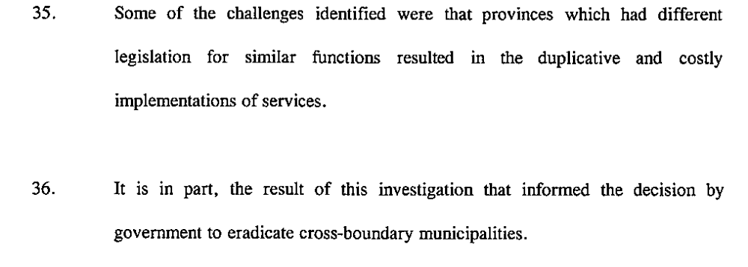

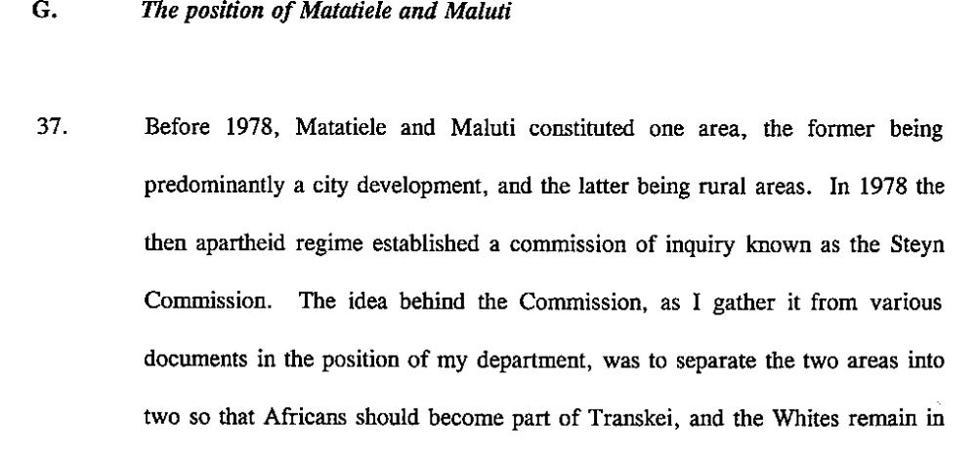
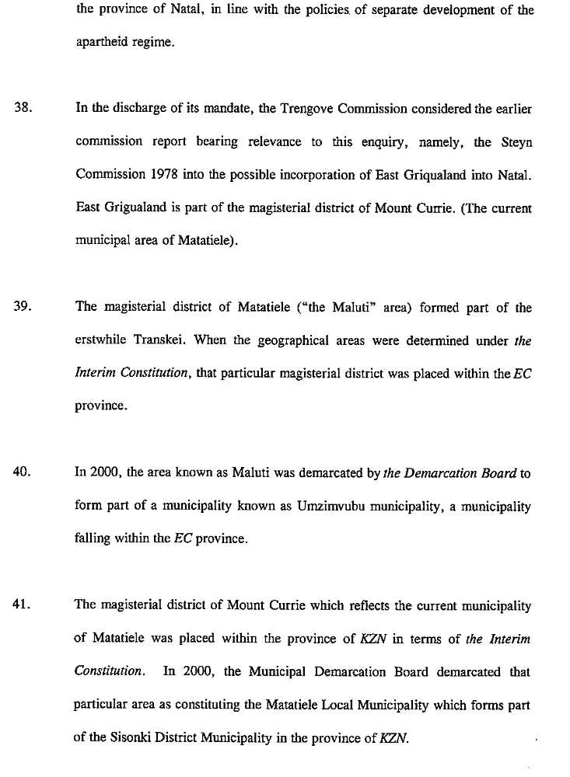

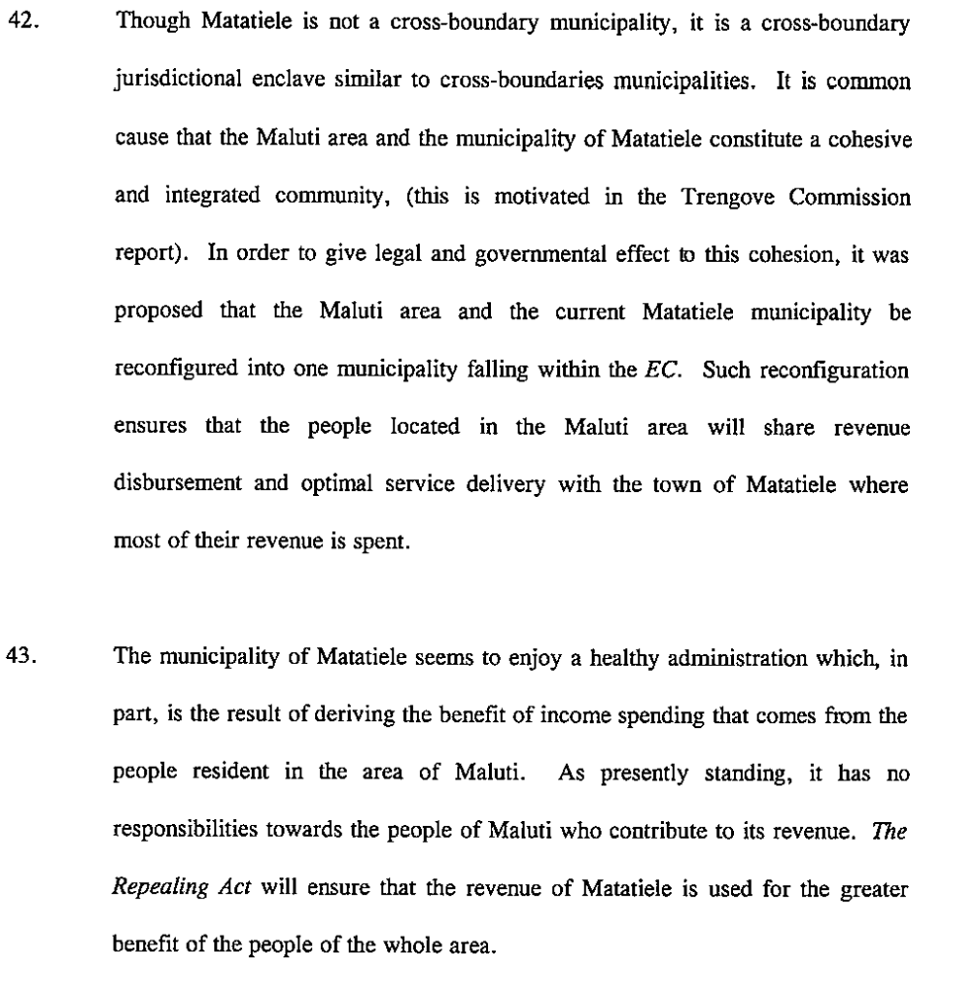

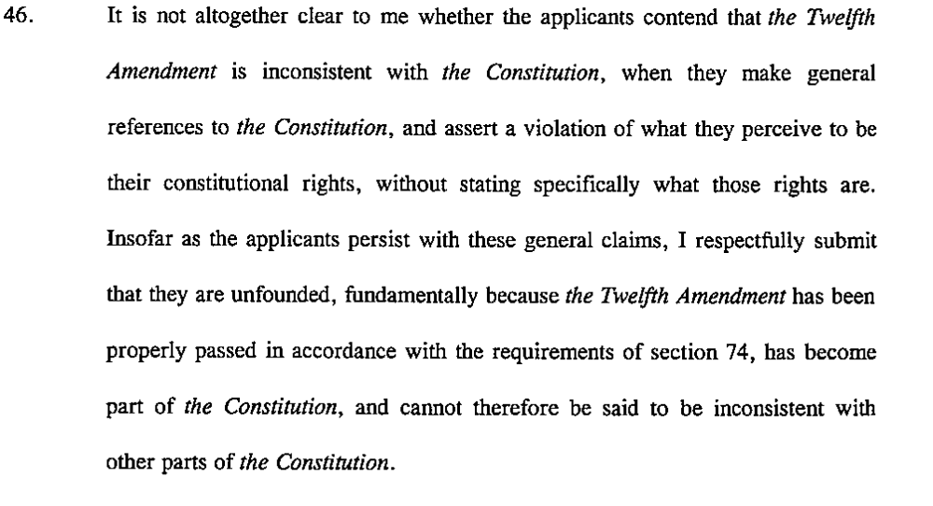

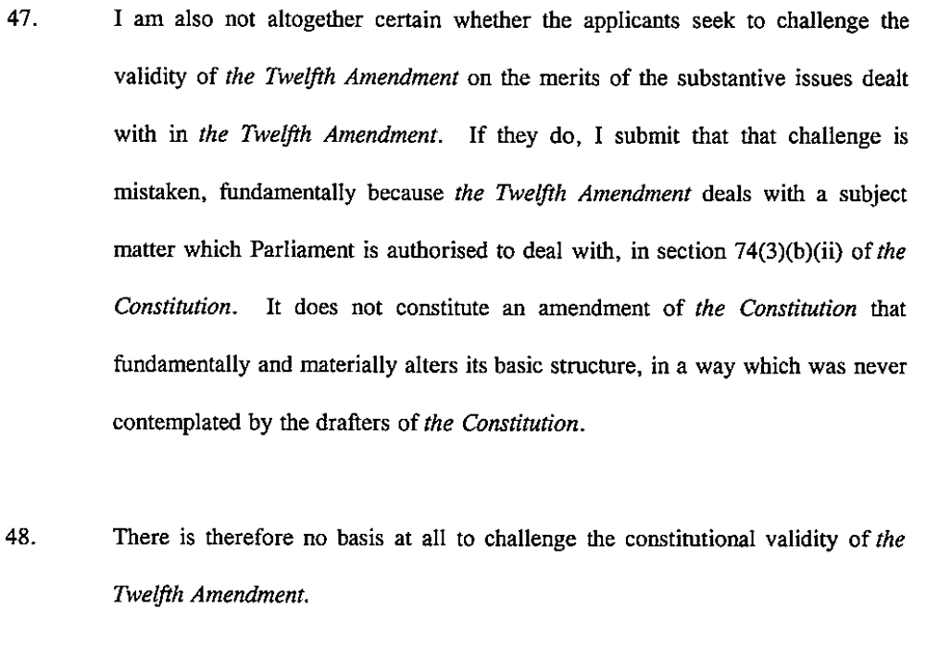

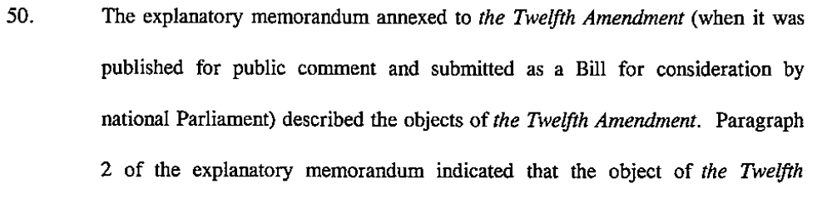

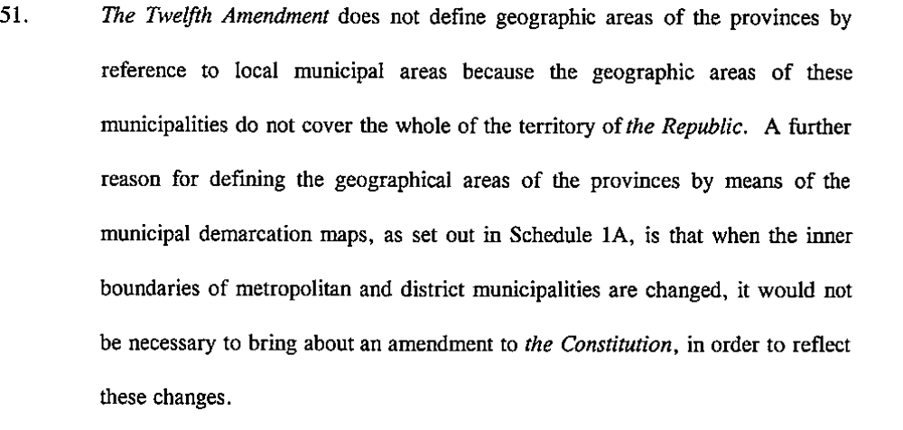
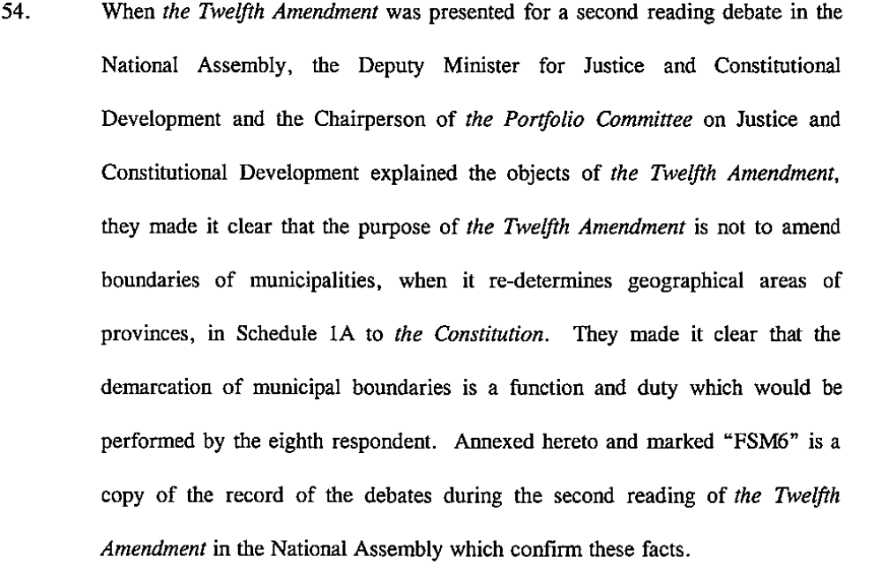
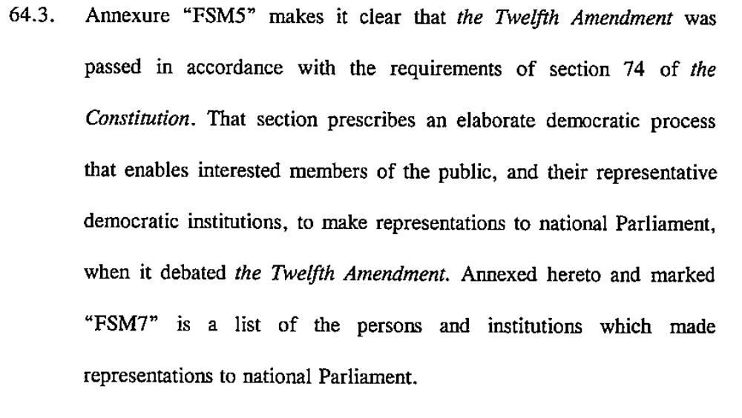
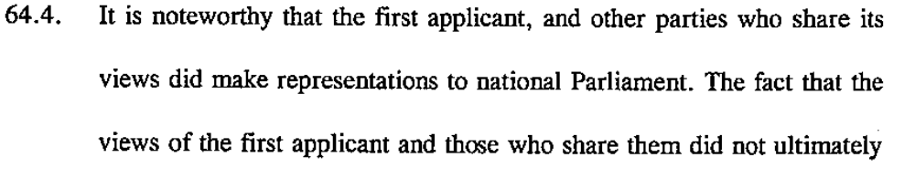
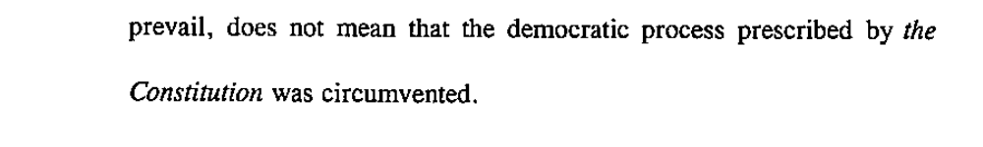

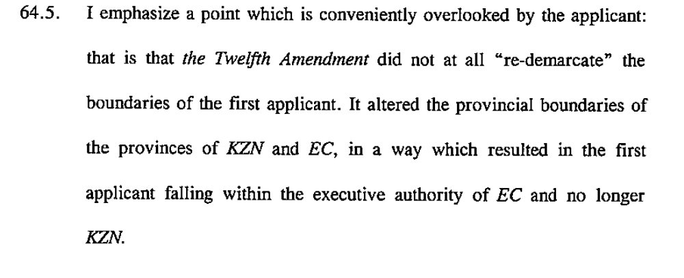

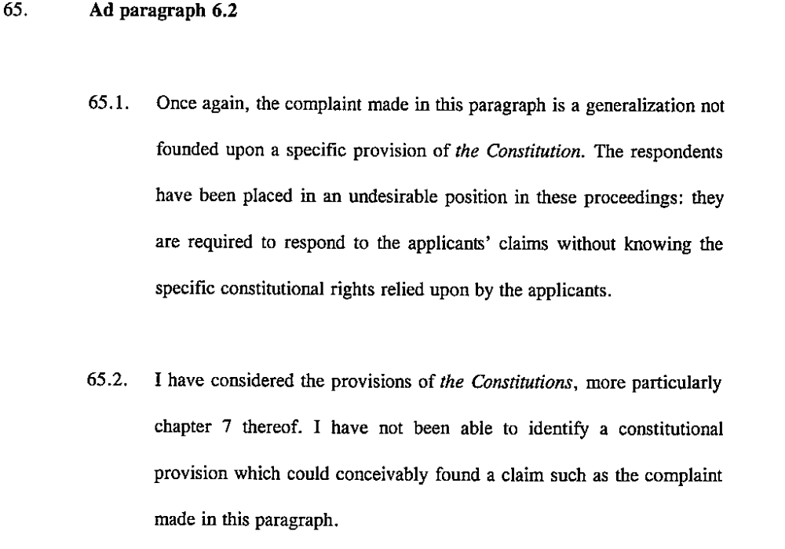
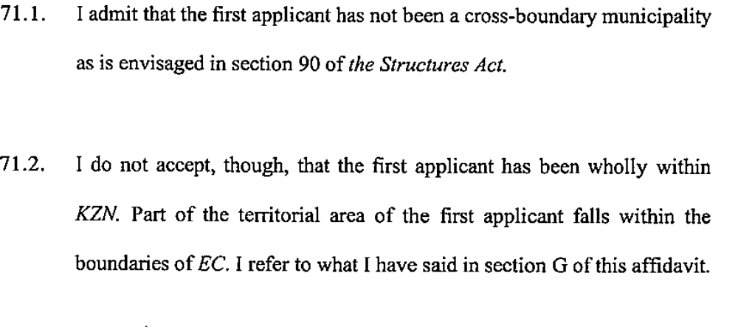

6. Literature Review
This research engages with at least four bodies of literature
- Political geography of demarcation and disputes resolution (international and local literature)
Yvonne G. Muthien and Meshack M. Khosa, ‘The kingdom, the Volkstaat and the new south Africa’: Drawing South Africa’s New regional Boundaries , in Journal of Southern African studies, vol 21, No 2 June 1995

M.M. Khosa and Y.G. Muthien , ‘The expert, the public and the politician: drawing South Africa’s New Provincial Boundaries”, South African Geographical Journal, 79, 1 (April 1997), pp. 1-12

M.M. Khosa and Y.G. Muthien (eds), Regionalism in the new South Africa (Adershot, Ashgate, 1998)

M.M. Khosa and Y.G. Muthien , Demarcating the New Provinces: a critical reflection on the process, in Regionalism in the New South Africa, Ashgate

R Griggs, The Boundaries of a New South Africa, Boundary and Security Bulletin, 2(4), Durham, January 1995.
Maano Ramutsindela, unfrozen Ground: South Africa’s contested spaces, Ashgate Publishers

Maano Ramutsindela, Resilient geographies: land, boundaries, and the consolidation of the former bantustans in post-1994 South Africa, in The Geographical Journal vol 173 (1), 2007

Maano Ramutsindela & Simon , the politics of territory and place in post apartheid South Africa, Vol 25 (3), Journal of Southern African studies

Maano Ramutsindela, “the survival of apartheid’s last town council”

E. Ritchken, ‘Leadership and conflict in Bushbuckridge: struggles to define moral economies within the context of rapidly transforming political economies’ (Phd thesis, University of the Witwatersrand, 1994)

Van Warmelo, Preliminary survey of the Bantu Tribes of South Africa (Pretoria, Government Printer, 1935)

R. Fox, ‘Regional proposals : their constitutional and geographical significance’, in A. Lemon (ed), the Geography of change in South Africa (Chichester, Wiley, 1995), pp. 19-41

A. Markusen, Regions: the Economics and Politics of Territory(Rowman and Littlefield Publishers, New Jersey, 1987

Gore C (1984) Regions in Question: Space, development theory and regional policy. London : Methuen

Paasi, 1991 deconstructing regions: notes on the scales of spatial life, Environment and Planning A, 23, 239-256

Slater, D (1989) “Peripheral capitalism and the regional problematic”, in R Peet and N Thrift(eds) New Models in Geography volume two. London : Unwin Hyman

Slater, D(1997) “spatial politics/social movements: questions of (b)orders and resistance. London: Routledge

Pile, S and M Keith (1997) “introduction”, in S pile and M Keith (eds) Geographies of Resistance. London: Routledge

Matatiele Municipality and Others v President of the Republic of South Africa and Others (1) CCT73/05

Policy documents

-Municipal Structures Act of 1998
- Local Government: Municipal Demarcation Act, No. 27 of 1998.”
-Interim Constitution 1993
-Constitution second amendment
-Constitution twelfth amendment
-Cross-boundary amendment act
-Presidential coordinating committee
-Report by the department of local government to Presidential coordinating ---committee on cross-boundary municipalities
-Project consolidate document
-Trengove commission report
-Steyn commission report
-Republic of South Africa (1996) Constitution of the Republic of South Africa Fourth Amendment bill. Pretoria: government Printer

Questions this literature deals with?
- What criteria to use when demarcating regions?
- Is the task of demarcation to be accomplished by politicians, experts or the public? (what is the right extent of the involvement of each one of these actors? )
- Regionalism in a divided society… Nationalism and regionalism.. Unitary versus federal state…
- Materialist conception of regionalism (regions formed by the expansion of capital, hence the unevenness) versus culturalist conception ( regions formed by social and political practices, a matter of struggles )
- Competing claims of territorial dispensations: unitary. Federal, kingdoms, the voltstaat
- How boundaries get infused with meaning… how boundaries create identities that become difficult to undo?
- How tensions between demarcation, inequality and social segregation work?
- How regionalism can be transformed into nationalism (if a region demands secession)? Moderate regionalism, radical regionalism, nationalism…. What influences the emergence of regional consciousness?
- Stages in the formation of regions… shape, symbolic meaning…
- What are other historic boundary disputes, how were they resolved, and how social commentators have assessed the solutions? ( East Griqualand during apartheid (Steyn commission), Kokstad (Northern Cape)
- How electoral politics influence demarcation… in general and in SA, references to 1993-2007)

- Literature on border dissents in Post apartheid South Africa ( How local communities respond to the State?...)
Mcebisi Ndletyana, Municipal elections 2006: protests, independent candidates and cross-border municipalities, in State of the nation 2007

Maano Ramutsindela & Simon , the politics of territory and place in post apartheid South Africa, Vol 25 (3), Journal of Southern African studies

Sagie Narsiah and Brij Maharaj, Borders of dissent in South Africa: the Bushbuckridge saga, Transformation 40 1999

Richard A Griggs, the security costs of party political boundary demarcations: the case of South Africa, in African Security review Vol 7 No 2 1998

V.G Hiemstra, ‘Hiemstra Commission. Report on transborder clashes between subjects of Gazankulu and Lebowa (Pretoria 1985)

Levin, R M (1996) “ Politics and land reform in the Northern Province: a case study of the Mojapelo land claim”, in M

Lipton, M de Klerk and M Lipton (eds) Land, Labour and Livelihoods in Rural South Africa, Volume Two: KwaZulu-Natal and Northern Province. Durban: Indicator Press

Baumann, T (1998) “Mlala Development Centre –local economic development: a civil society perspective”, in Case studies on LED and Povert. Pretoria: Department of Constitutional Affairs

National Land Committee (1990) The Bantustans in Crisis, Johannesburg: Westro Publications

Walt, E(1982) South Africa –A land divided. Durban: Black Sash.

Patrick Bond, Local economic development and the municipal services crisis in Post-apartheid South Africa, the case of Stutterheim, Urban Forum 9(2), 159-196

Cameron, RG, The democratization of South African local government, A tale of three cities, Pretoria, JL Van Schaik,

In the media

Griggs, R (1997) “Voting makes a lot more sense”, Mail and Guardian, July 25
On the internet
- Don’t concentrate on Khutsong only, 01 March 2006
- Khutsong blanketed by police
- Khutsong voters urged to make their mark
- Election to go ahead in khutsong
- Khutsong, my personal hell (mail and guardian)
- Khutsong protest case postponed 16 March 2007 (Sapa)
- Khutsong issue stable for now 5 March 2007 (Sapa)
- Khutsong violence condemned 8 March 2007 (Sapa)
- Khutsong learners expected back at school (5 March 2007)
- More people arrested for khutsong violence (04 March 2007)
- Masondo condemns violent protest in North West(03 March 2007)
- ANC denies divisions in Khutsong amid chaos(02 March 2007)
- Protesting khutsong learners dispersed(02 March 2007)
- Khutsong rioters out on bail (05 March 2007)
- ANC denies divisions amid chaos (2 March 2007) Sapa
- Merafong residents did not spur violence: Mogale (2 March 2007)
- ANC blames members for violent North West protests(01 March 2007)
- Angry residents petrol bomb homes in Khutsong (1 March 2007)
- Khutsong residents battle to stay part of Gauteng (26 February 2007)
- Violent protests break out in Khutsong (1 March 2007)
- Province of little hope (10 March 2007) Mail and guardian on line
- Government listens but does not always agree, Citizen (9 March 2007
- Gauteng, North West tackle cross-border disputes (4 March 2005- BuaNews)
- Khutsong: Government won’t budge (28 April 2006)
- Mufamadi welcomes Khutsong court challenge(16 March 2007 - Sapa)
- 24 December 2005 Capeargus online by Linda Daniels…SACP spokesperson reacting to the signing into law of the twelfth amendment and the repeal act…
- Khutsong residents call on Zuma to intervene…(02 March 2007-Sapa)
- Khutsong turns to constitutional court (24 April 2007-Sapa)
- Khutsong mass meeting expected this morning(20 April 2007)
- Unruly gang barricades roads, stones motorist in Khutsong, citizen 25 April 2007

- Literature on tensions involved in a participatory and representative form of democratic system (what is the status of communities’ submissions in a participatory democracy? How far has the State to go with consultation?). Participatory procedures guaranteed in the constitution

Newham, G (1996) “Fortune smiles on sunshine province”, in Democracy in action 10(3)

Matatiele Municipality and Others v President of the Republic of South Africa and Others (1) CCT73/05

- Literature on social movements: the conditions of successful grassroots mobilization, on what depend the success of local communities’ resistance to the State?
Mayer, M (1995) “social movement research in the United States : a European perspective”, in S M Lyman (ed) social movements: critiques, concepts, case studies. London: Macmillan.

Foweraker, J(1995) Theorizing social movements. London: Pluto Press

Escobar, A and S Alvarez (1992) “Introduction: theory and protest in Latin America today”, in Escobar and S Alvarez(eds) The making of Social Movements in Latin America: identity, strategy and democracy. Boulder: Westview Press

Cohen, JL (1985) “strategy or identity: new theoretical paradigms and contemporary social movements”, Social Research 52

Addison, G(1997) “ The politics of exclusion”, Leadership, August.

Shefner, J (1995) “Moving in the wrong direction in social movement theory”, theory and society 24

Touraine, A (1985) “An introduction to the study of social movements”, Social Research 52

Bushbuckridge Border Crisis Committee (1997) An open letter to the State President: Nelson Mandela

1. How the State organize the national territory (logic, implementation, ideals, etc)
How does the post apartheid government conceptualize provincial and municipal boundaries? ( What functions ? What identities? What criteria? Are objectives consistent with implementation ? ) Discussion of the SA case study, Namibia, and others… In general, but specific to SA)

- “the refusal of the state to revisit the issue of boundaries is a clear indication of its intention to freeze spatial meanings and to impose its own conception of space” Sagie Narsiah and Brij Maharaj, Borders of Dissent in South Africa, Transformation 40 1999, p. 51
- In so doing, the people of BBR –through the surrogate of the BBCC – are attempting to impose their meanings of territoriality. In such a way the map engineered by a panel of experts is being infused with local democratic content. The apartheid state never allowed black people to engineer space in this way” Maharaj 46

geographical identity imposed by the state
Competing meanings of territoriality (BBR wants to impose its meaning of territoriality) … Transformation 40
- Boundaries “create the territorial spaces in which we live, distribute power to people who influence our lives, determine where we vote, create tax bases, construct regional identities, facilitate or impede easy transport, and determine access to public services” ( Griggs, R(1997)
- “with the proclamation of the Bantustans in the early 1970s, the regime introduced the parameter of ethnic nationalism which had never existed before”
- Meanings of territoriality…

“Historically, the ANC which has a virtual monopoly on power in the region, has never favoured a regional dispensation. The policy inclination of the ANC has been that of a unitary state” 47
- The conflict was highlighted by what many subsequently saw as a last-ditch attempt by Mpumalanga Premier Matthews Phosa to get the Senate to rule on the issue. In his address to the Senate, Phosa argued that: “ … the issue of the finalization of border disputes, and specifically the areas in question on the border of Mpumalanga and the Northern Province, needs to be addressed. We can no longer starve these communities of good governance and services. (Cited in Hansard August 22, 1996: 2807)48
- “finding itself in a catch 22 situation, government has basically resorted to a constitutional position, namely that the boundaries as agreed upon prior to the Final Constitution remain extant. In so doing, it has also tried to ensure that other communities in the region do not motivate for border changes” 49

- “ the creation of these artificial spatial premise of the apartheid state’s four provinces and the nine ‘development regions’ of the 1980s.” 51

“ the process of region demarcation has erased the ‘grand apartheid’ schema of Bantustan balkanization. However, the spatial inscription which prescribes the separation of areas of abject poverty from areas of affluence persists. It has been the contention of this paper that the struggle of the people of BBR is rooted in the material conditions of their existence. It is apparent that service provision in the area is highly inefficien and in many ways not different from their experience under apartheid” 51

“While BBC has largely failed in its primary objective, it has won some significant concessions from the state. Perhaps the most significant is the proposed provision of services across regional boundaries” 52

“ in effect, the entire process of regional demarcation has been shown to be a product of political expediency rather than democratic consultation” 52
- “ although the demarcation process was the most inclusive to date, the limited time allowed for the demarcation process, lack of effective participation from ordinary people, the technicist nature of the commission, and party political tinkering after the process had been completed, are some of the major weaknesses in the process which led to the drawing of the boundaries of the nine provinces” 303 the kingdom…
- “ the alterations of the proposed commission map, by political parties at the World Trade Centre behind closed doors, concealed vested white minority interests and ethnic claims, and reveal the complexity of meshing traditional and democratic structures” 303
“ moreover, separating tasks of delimiting boundaries, and of deciding the structures and powers of provinces was a serious flaw in the process” 303

- “ there are no “natural” political boundaries: regional, national or political boundaries are produced by social and political processes” 304 the kingdom…

- “ contrary to the materialist conception, Paasi argues that: ‘regional cultures, subcultures, and consciousness are partly formed by social practices and relations autonomous to the logic of capital’ (Paasi, 1991 deconstructing regions: notes on the scales of spatial life, Environment and Planning A, 23, 239-256)

“ the boundaries of a region are set by the particular nature of political, economic and social struggles. For Paasi(1991), the study of regionalism should focus on how regions emerge, are transformed, and disappear in the course of regional formation” 2

Institutionalization of regions ordered in multiple ways: stages: territorial shape, symbolic shape, institutions and establishment (Paasi, 1991)
Battle over the provincial location of East Griqualand (in Natal or in East Cape…the majority black wanted East Cape, the minority white, Natal; the commission recommended the area to be demarcated in East Cape…) Cfr Steyn Commission during apartheid moved East Griqualand from the jurisdiction of the Cape province to Natal.
demarcating the new SA: critical reflexion…

Electoral politics greatly influenced the logic of demarcation.
demarcating the new SA: critical reflexion…

Most political parties had reservations or did not like the proposal from the commission.
“ the commission was accused of having produced ‘a hastily conceived single map’, which given the time constraints was ‘unrealistic and dangerous’ and the negotiators were urged ‘not to impose an undemocratic map on the country’(The Star, 4 August 1993)
demarcating the new SA: critical reflexion…

“The commission was unanimous in its criticisms of the time frame it was allowed. However, given the command of resources and the potential of the establishment groups to dominate the process, alongside a silent African minority on the level of establishment procedures, a longer period of public hearings could not by itself guarantee a voice to the majority on this issue. The commission itself recommended further investigation and consultation on contested demarcation boundaries”
demarcating the new SA: critical reflexion…

“having presented its map to the public for scrutiny and satisfied no single party or interest group, the commission clearly came under considerable pressure from public opinion and the press…” 42

“ the realization that delimitation should preferably not be undertaken during periods of social and political upheavals led the commission to recommend soft and flexible boundaries for the regions” 43

“ the realization that delimitation should preferably not be undertaken during periods of social and political upheavals led the commission to recommend soft and flexible boundaries for the regions” 43

Weaknesses of the demarcation process:
- contradictory compendium of criteria used to determine boundaries
- limited time allowed for demarcation… more time would have allow to embark on a national popularization campaign to get local communities involved… as a first exercice in democracy, this would have demonstrated to ordinary people that their voices count in the new South Africa…
- Uneven participation: “most of the disadvantaged and disfranchised African communities were not aware of the delimitation process and did not request an opportunity to be heard. Established white organizations and privileged communities had access to substantial resources and hence dominated the process”
- Underrepresentation of African communities…
- underrepresentation and limited participation of the black communities have to be contextualized: their exclusion from mainstream institutional political processes under apartheid, lack of infrastructure to produce technical submissions (given illitacy and the commission’s inability to foster greater participation, also SA was standing at the threshold of far-reaching changes and to delay the first democratic electiosn with purist attitudes might have been considered trite under the circumstances” 50
- Demarcation did not alter existing magisterial boundaries… did not alter the underlying relations of inequality in society…
- Political tinkering after the process has been completed by an independent professional commission acceptable to all political parties…
- “ the experience of the commission reflects the poverty of ‘public participation’ and democracy under the existing system as establishment groups continue to dominate the transition process, and painstaking public consultation makes way for political expediency or immediate trade-offs. The integrity and legitimacy of the demarcation process was certainly compromised by the political horse-trading between political parties”…

“ In contrast to the South African experience of drawing boundaries, the delimitation of boundaries in Namibia, according to David Simon, reflected ‘dispassionate analysis and local opinion” rather than ‘central political priorities’ (Simon, 1993, p. 74)

Emphasis on what demarcation policies have to pursue…(reduction of territorial disparities in the social and economic development, etc…productions relations to be taken into account,

“the fundamental premise of redrawing the internal geography of a country should be the reduction of territorial disparities in the social and economic development; redistribution of resources between places/regions; geographical monitoring of macro-economic policy (as national economic plans can have differential regional outcomes); and the prevention of negative forms of competition between regions”53

“ besides, any spatial policy which ignores production relations will not only fail, but also add to uneven development, which may set scenes for more confrontations and conflicts in the future” 53

“With three centuries of land expropriation and plunder in South Africa, there are dangers that regional contestation might take on an ethnic and chauvinistic character. At the heart of drawing boundaries, the priority should be to facilitate the reconstruction and development of society and to ensure that the poorest, most marginalized people become beneficiaries in the new political and economic dispensation” 53

Ethno-regionalism considerations in demarcating… adoption of existing geo-economic boundaries by the CDDR as a basis for the new provincial ones…functional regional (rather than territorial…)planning the dominant planning paradigm…( what is the dominant territorial planning paradigm in South Africa ? ) (What are the key considerations for territorial planning… for territorial demarcation…)
What are the criteria used in subsequent demarcations (Magisterial demarcation, the formation of economic development regions, the interim constitution, the demarcation act, the twelfth amendment, etc…) what results have those considerations produced in the ground…

“ a change in the political system, with whose meanings and values maps are shot through, is likely to be reflected in the restructuring of the state and a re-mapping of political geography, in accordance with the political aspirations, needs and priorities of the new order (Harley 1988)” in Changing meaning …

“ at the negotiating table, where the ruling National Party (NP) and the unbanned African National Congress (ANC) were the main players, the apartheid internal map, designed to foster the balkanization of the country, was the subject of much debate. The aspirations of the national liberation movement (led by the ANC) required changes in the internal map of the country” 291 in Changing meaning…

“ the apartheid state turned boundaries into geopolitical instruments for creating racial and tribal areas, and presented these boundaries as ‘protective shells’ for the ‘different nations’ found in the country” 292

Acknowledgement of the failure of the Bantustan policy… “ Following this acknowledgement, nine development regions were demarcated, which transcended the boundaries of the four provinces of the Cape, Natal, Orange Free State and the Transvaal.” 292

“ although the state presented these regions as necessary for economic growth, job creation and the provision of basic needs (Du Toit 1982; Thomas 1986; Lemon 1987), the political motive was to lay the foundation for a confederation of states( South Africa 1983) 292

This research engages at least four bodies of literature namely the political geography debate over the significance of internal boundaries, the literature on local communities’ resistance to State-imposed demarcation, the debate on tensions internal to a democracy that is both representative and participatory, and the scholarly discussion on the conditions for the success of social movements.

- Political geography literature on the significance of boundaries
- General studies
- Studies specific to certain regions
Also distinction between national and international boundaries….
Yvonne G. Muthien and Meshack M. Khosa, ‘The kingdom, the Volkstaat and the new south Africa’: Drawing South Africa’s New regional Boundaries , in Journal of Southern African studies, vol 21, No 2 June 1995

M.M. Khosa and Y.G. Muthien , ‘The expert, the public and the politician: drawing South Africa’s New Provincial Boundaries”, South African Geographical Journal, 79, 1 (April 1997), pp. 1-12

M.M. Khosa and Y.G. Muthien (eds), Regionalism in the new South Africa (Adershot, Ashgate, 1998)

M.M. Khosa and Y.G. Muthien , Demarcating the New Provinces: a critical reflection on the process, in Regionalism in the New South Africa, Ashgate

A. Markusen, Regions: the Economics and Politics of Territory(Rowman and Littlefield Publishers, New Jersey, 1987

Gore C (1984) Regions in Question: Space, development theory and regional policy. London : Methuen

Paasi, 1991 deconstructing regions: notes on the scales of spatial life, Environment and Planning A, 23, 239-256

Slater, D (1989) “Peripheral capitalism and the regional problematic”, in R Peet and N Thrift(eds) New Models in Geography volume two. London : Unwin Hyman

Christopher A J 1994 The Atlas of apartheid Routledge, London

Demarcation Board 1999a Circular to all municipalities and affiliates of SALGA 8 September, Pretoria

Demarcation Board 1999b Investigation report NW1a1, Pretoria

De Wet C 1995 Moving together, drifting apart: betterment planning and villagisation in a south African homeland, Witwatersrand universitiy Press, Johannesburg

Dorling D and Fairbairn D1997 Mapping: ways of representing the world Longman, Harlow

Duncan S and Savage M 1989 Space, scale and locality Antipode 21 179-206

Griffiths I L 1978 South Africa divided Geographical Magazine 51 92-8

Harley J B 1988 Silences and secrecy: the hidden agenda of cartography in early modern Europe Imago Mundi 40, 57-67

Harvey D 2001 Spaces of capital: towards a critical geography Routeledge, New York

Hendricks F T 1990 The pillars of apartheid: land tenure, rural planning and the chieftancy Univesity of Upssala, Upssala

Klingle M 2006 Changing spaces –nature, property, and power in Seattle, 1880-1945 Journal of Urban History 32 197-230

Lefebvre H 1991 The production of space Blackwell, Oxford

Lemon A 1990 Imposed separation: the case of South Africa in Chilholm M and Smith D eds Shared space: divided space Unwin Hyman, London

Letsoalo E M 1982 Survival strategies in rural Lebowa: a study of geography of poverty Unpublished masters thesis, university of the Witwatersrand, Johannesburg

Levin R and Weiner D 1997 From Apartheid to development in Levin R and Weiner D eds No more tears: struggles for land in Mpumalanga, South Africa Africa World Press, Trenton NJ 2-25

Merrett C 1984 The significance of the political boundary in the apartheid state, with particular reference to Transkei South African Geographical Journal 66 79-93

Paasi A 2005 Generations and the ‘development’ of border studies Geopolitics 10, 1-9

Pickles J and Weiner D 1991 Rural and regional restructuring of apartheid: ideology, development policy and the competition for space Antipode 23, 2-32

Platzky L and Walker C 1985 The surplus people: forced removals in South Africa Ravan Press, Johannesburg

Reintges C and McCarthy J 1992 Reconstructing political geography in south Africa in Rogerson C and McCarthy J eds Geography in a changing South Africa Oxford University Press, Cape Town 111-22

Alexander A.., 1982: Local government in Britain since reorganization. Allen and Unwin, Londong

Allanic B., 2001 : Borderlands: From dumping grounds to attractive residential settlements, Paper presented in Johannesburg (IFAS) on the 11th of June, seminar Power and territories.

Anderson J., 1996: The shifting stage of politics: New medieval and post-modern territorialities ? In: Anderson J., Brook C. and Cochrane A. (eds), A Global World? Re-ordering Political Space, pp. 65-112. Oxford University Press, Oxford.

Badie B., 1995: La fin du territoire. Essai sur le desordre international et sur l’utilite sociale du respect. Fayard, Paris.

Barlow M., 1981: Spatial dimensions of urban government. Research Studies Press, Chichester.

Barlow M., 1991: Metropolitan Government. Routeledge, London

Barlow, M 1995: Greater Manchester : Conurbation complexity and local government structure. Political geography 14: 379-400

Barlow, M. 1997: Administrative systems and metropolitan regions. Environment and planning C: Government and policy 15: 399-411

Bekker S. et al., 1997: Local government transition in five eastern seaboard South African towns. Politikon 24(1): 38-56

Cashden B., 2002: Local government and poverty in South Africa. In : Parnell S.

Pieterse E., Swiling M. and Wooldridge D(eds), Democratising local government: the South African experiment, pp. 159-180. University of Cape Town Press, Cape Town.

Claval P. and Sanguin A.-L.(eds), 1997: Metropolisation and politique. L’harmattan, Paris

Coates B.E. et al., 1986: urban inequalities, Market Processes and Local Government. In: A. Blowers, C. Brook, P. Dunleavy and L. Mcdowell(eds), Urban change and conflict: an interdisciplinary Reader, pp. 122-130. Harper and Row, London.
Coulbois P. and Jung J., 1994: Amenagement du territoire: une methode. Les exemples de l’Allemagne, de l’Autriche et de la Suisse, La Documentation Francaise, Paris

Crouzel Y., 1999: La chefferie traditionnelle face a la democratization des pouvoirs locaux. Afrique Contemporaine 192:30-39

Donaldson S.E., 2001: Amalgamation of the former homeland border-township of Seshego and the conservative apartheid city Pietersburg during transition. The South African Geographical Journal 83(3): 208-213

Giraut F. , 2000: Innovation territoriale et referent identitaire. Du renouveau des provinces nigeriennes a celui des ‘pays’ francais. In : Chaleard J.-L. et Pourtier R(eds), Politiques et dynamiques territoriales dans les pays du Sud, pp. 77-108. Pub. De la Sorbonne, Paris

Gottmann J., 1980: Center and Periphery, Spatial variations in Politics. Sage Publications, Beverly Hills.

Graaf de V., 1986: The present state of urbanization in the south African Homelands and some future scenario’s. University of Stellenbosch-Dpt of Sociology, Occasional paper 11

Guyot S., 2001: Evolution of political territories and post-apartheid challenges of management of the Port Shepstone area. Paper presented on the International symposium on government, governance and urban territories in Southern Africa, 15p, Lusaka (University of Zambia), 21-22 November

Harrison P. and Naidoo J., 2000: chimera or guiding vision ?: Local economic development and the town of Port Shepstone in Kwazulu-Natal. Urban Forum 11(1): 119-131

Higgins D., 1986: The process of reorganizing local government. Canadian Journal of Political Science 19: 217-242

Jaglin S. and Dubresson A. (eds), 1993: Pouvoirs et cites d’Afrique noire. Decentralisations en questions, Karthala, Paris

2. Literature on local communities’ resistance to State-imposed demarcation
1. Shlomo Hasson and Eran Razin, What is hidden behind a municipal boundary conflict, Political geography quarterly, vol. 9, No. 3, July 1990, 267-283

Mcebisi Ndletyana, Municipal elections 2006: protests, independent candidates and cross-border municipalities, in State of the nation 2007

Maano Ramutsindela & Simon , the politics of territory and place in post apartheid South Africa, Vol 25 (3), Journal of Southern African studies

R Griggs, The Boundaries of a New South Africa, Boundary and Security Bulletin, 2(4), Durham, January 1995.
Maano Ramutsindela, unfrozen Ground: South Africa’s contested spaces, Ashgate Publishers

Maano Ramutsindela, Resilient geographies: land, boundaries, and the consolidation of the former bantustans in post-1994 South Africa, in The Geographical Journal vol 173 (1), 2007

Maano Ramutsindela & Simon , the politics of territory and place in post apartheid South Africa, Vol 25 (3), Journal of Southern African studies

Maano Ramutsindela, “the survival of apartheid’s last town council”

Sagie Narsiah and Brij Maharaj, Borders of dissent in South Africa: the Bushbuckridge saga, Transformation 40 1999

Richard A Griggs, the security costs of party political boundary demarcations: the case of South Africa, in African Security review Vol 7 No 2 1998

V.G Hiemstra, ‘Hiemstra Commission. Report on transborder clashes between subjects of Gazankulu and Lebowa (Pretoria 1985)

Levin, R M (1996) “ Politics and land reform in the Northern Province: a case study of the Mojapelo land claim”, in M

Lipton, M de Klerk and M Lipton (eds) Land, Labour and Livelihoods in Rural South Africa, Volume Two: KwaZulu-Natal and Northern Province. Durban: Indicator Press

Baumann, T (1998) “Mlala Development Centre –local economic development: a civil society perspective”, in Case studies on LED and Povert. Pretoria: Department of Constitutional Affairs

National Land Committee (1990) The Bantustans in Crisis, Johannesburg: Westro Publications

Walt, E(1982) South Africa –A land divided. Durban: Black Sash.

Patrick Bond, Local economic development and the municipal services crisis in Post-apartheid South Africa, the case of Stutterheim, Urban Forum 9(2), 159-196

Cameron, RG, The democratization of South African local government, A tale of three cities, Pretoria, JL Van Schaik,

E. Ritchken, ‘Leadership and conflict in Bushbuckridge: struggles to define moral economies within the context of rapidly transforming political economies’ (Phd thesis, University of the Witwatersrand, 1994)

Van Warmelo, Preliminary survey of the Bantu Tribes of South Africa (Pretoria, Government Printer, 1935)

In the media

Griggs, R (1997) “Voting makes a lot more sense”, Mail and Guardian, July 25
On the internet
- Don’t concentrate on Khutsong only, 01 March 2006
- Khutsong blanketed by police
- Khutsong voters urged to make their mark
- Election to go ahead in khutsong
- Khutsong, my personal hell (mail and guardian)
- Khutsong protest case postponed 16 March 2007 (Sapa)
- Khutsong issue stable for now 5 March 2007 (Sapa)
- Khutsong violence condemned 8 March 2007 (Sapa)
- Khutsong learners expected back at school (5 March 2007)
- More people arrested for khutsong violence (04 March 2007)
- Masondo condemns violent protest in North West(03 March 2007)
- ANC denies divisions in Khutsong amid chaos(02 March 2007)
- Protesting khutsong learners dispersed(02 March 2007)
- Khutsong rioters out on bail (05 March 2007)
- ANC denies divisions amid chaos (2 March 2007) Sapa
- Merafong residents did not spur violence: Mogale (2 March 2007)
- ANC blames members for violent North West protests(01 March 2007)
- Angry residents petrol bomb homes in Khutsong (1 March 2007)
- Khutsong residents battle to stay part of Gauteng (26 February 2007)
- Violent protests break out in Khutsong (1 March 2007)
- Province of little hope (10 March 2007) Mail and guardian on line
- Government listens but does not always agree, Citizen (9 March 2007
- Gauteng, North West tackle cross-border disputes (4 March 2005- BuaNews)
- Khutsong: Government won’t budge (28 April 2006)
- Mufamadi welcomes Khutsong court challenge(16 March 2007 - Sapa)
- 24 December 2005 Capeargus online by Linda Daniels…SACP spokesperson reacting to the signing into law of the twelfth amendment and the repeal act…
- Khutsong residents call on Zuma to intervene…(02 March 2007-Sapa)
- Khutsong turns to constitutional court (24 April 2007-Sapa)
- Khutsong mass meeting expected this morning(20 April 2007)
- Unruly gang barricades roads, stones motorist in Khutsong, citizen 25 April 2007

3. Literature on tensions internal to a representative and participatory system of democracy

Newham, G (1996) “Fortune smiles on sunshine province”, in Democracy in action 10(3)

Matatiele Municipality and Others v President of the Republic of South Africa and Others (1) CCT73/05

4. Literature on conditions for the success of social movements

Mayer, M (1995) “social movement research in the United States : a European perspective”, in S M Lyman (ed) social movements: critiques, concepts, case studies. London: Macmillan.

Foweraker, J(1995) Theorizing social movements. London: Pluto Press

Escobar, A and S Alvarez (1992) “Introduction: theory and protest in Latin America today”, in Escobar and S Alvarez(eds) The making of Social Movements in Latin America: identity, strategy and democracy. Boulder: Westview Press

Cohen, JL (1985) “strategy or identity: new theoretical paradigms and contemporary social movements”, Social Research 52

Addison, G(1997) “ The politics of exclusion”, Leadership, August.

Shefner, J (1995) “Moving in the wrong direction in social movement theory”, theory and society 24

Touraine, A (1985) “An introduction to the study of social movements”, Social Research 52

Bushbuckridge Border Crisis Committee (1997) An open letter to the State President: Nelson Mandela

Slater, D(1997) “spatial politics/social movements: questions of (b)orders and resistance. London: Routledge

A large section of this literature tackles uneasy geopolitical questions such as: What socio-political objectives drive internal demarcation in a particular State? Which criteria should be used in dividing a territory into administrative sub-units? How should processes of demarcation be carried out? How do such processes react to inevitable political interference, expects’ recommendations, public participation? How unavoidable boundary disputes are to be addressed?
Scholars agree on the fact that internal boundaries are not natural phenomena. Muthien and Khosa put it clearly: “there are no “natural” political boundaries: regional, national or political boundaries are produced by social and political processes” (Muthien&Khosa, 1995: 304). As socially constructed realities, boundaries prove to be “inherently contingent”, and so are rules and procedures that produce them (Maano & Simon, Politics of territory, p.479). In spite of and precisely because of this fundamental arbitrariness, conventions have emerged on how to carry out territorial demarcation in accordance with some predefined political goals. The definition and the nature of such goals are a matter of political contention. South African local communities that resist State demarcation are engaged in a process of political negotiation and would like their territorial identity to prevail. The legitimacy and the effectiveness of such engagement will be examined on a case by case basis as the research considers Bushbuckridge, Khutsong and Matatiele cases.
In a specific country, sub-national entities referred to as provinces, regions, districts or municipalities may be established for reasons such as “administrative convenience, geopolitical accommodation of regionally distinct ethnic or other communities, social control, devolution or decentralization of certain powers and functions ‘closer to the people’ as a form of democratization, or in order to facilitate the immanent ‘development’ efforts of the state” (Maano & Simon, 1998: 479). Muthien and Khosa think that demarcation should be carried out in a way that fosters “the reduction of territorial disparities in the social and economic development; redistribution of resources between places/regions; geographical monitoring of macro-economic policy (as national economic plans can have differential regional outcomes); and the prevention of negative forms of competition between regions”( Muthien & Khosa, 1998:53). Economic factors are so vital that “any spatial policy which ignores production relations will not only fail, but also add to uneven development, which may set scenes for more confrontations and conflicts in the future” ( Muthien & Khosa, 1998:53). Muthien and Khosa insist that in a “divided land” or transitional societies as South Africa, “the priority should be to facilitate the reconstruction and development of society and to ensure that the poorest, most marginalized people become beneficiaries in the new political and economic dispensation” ( Muthien & Khosa, 1998:53). According to Barlow, the demarcation of local government areas must conform three basic principles: “1. the size and shape of government areas should be compatible with their functions, so as to assure efficiency in providing services. 2. The spatial extent of government areas should provide with an adequate fiscal capacity to perform their functions. 3. Government areas should correspond to prevailing patterns of community”( Barlow 1981 cited in Shlomo Hasson & Eran Razin, 1990:269). The demarcation of new local government in England was guided by principles such as “sensitivity and correspondence to demographic and socio-economic changes; efficiency in the provision of services; local autonomy and comprehensibility, i.e. a system that could be easily understood (Redcliffe-Maud, 1969; Alexander, 1982). In case of conflict between guiding principles, members of the commission agreed to adopt a very clear position: “We would certainly not hold to a boundary dividing independent areas that ought to be administered as one coherent unit. But we decided that, generally, we would propose boundaries for the new units differing from those of present authorities only when the advantage appeared unquestionable (Recliffe-Maud, 1969: para. 74). The CDDR also complained to have been faced with a compendium of contradictory criteria that rendered their task the most complicated ( Muthien & Khosa, 1997:43?). (discuss criteria outlined in the municipal demarcation act… as well as the constitution…)
Regional planners distinguish a functional spatial delineation from a territorial one ( W.B. Stohr and D.R.F. Taylor(eds), 1981; D.Simon, 1990) ) Whereas the former model emphasizes on planning a region in such a way that it significantly contributes to the national welfare, the other insists on each region’s capability to provide for integrated development of its own inhabitants. As the CDDR endorsed existing geo-economic boundaries inherited from the apartheid development regions, it is contended that “functional regional planning, which has a long pedigree in South Africa, has remained the dominant planning paradigm despite the socio-political transition” (Ramutsindela & Simon, 1998: 485). ( is there any link between such categorization and the forms of the State (federal or unitary?)

Regionalism…. And identities etc
Do internal boundaries really matter ?

2. Resistance to State demarcation

“vociferous opposition to the recommended demarcation came from black communities of the Northern Cape, who felt themselves part of the Western Cape, and in Kokstad the commission came under severe intimidation” 42 demonstration of farmers… demarcating the new SA: critical reflexion…

“a large number of delegations from all over the Northern Cape, led by the Surplus People’s Project, protested against their demarcation in the Northern Cape” 43

Maano and Simon

How unhappy local communities resist (forms and contents of the dissent…, )
-how claims for extended participation are made… or collide with representation i
-how mobilization and organization shape resistance and its outcome…

Vocabulary

He summarizes it cogently
Demise of apartheid
Stringent limitations
It places the commission
White wings laid claims to parts of the regions…
Ripple effects
Community wrath
Strifle in Khutsong
Widespread unrest
Violent torn Khutsong
Defiance campaign
Against the provincial transfer…
A leadership in exile…
Tumultuous protests
Arson attack… (crime of deliberately setting fire to something, especially to somebody’s building)
1993 demarcation process= political parties territorial “horse-trading”
Geostrategic manipulation of peoples and territories…
The constitutional process for re-demarcation has been circumverted
Constitutional principles of cooperative government in the management of the dispute over the re-demarcation of Matatiele
Without purporting to be exhaustive
Averments
The interim constitution came into force…
It cannot sensible be argued that …
The boundaries were cast into stones
I am not altogether certain whether…
At best, this raises the issue of non-compliance with the demarcation act…
No provision could conceivably found such claim
A point conveniently overlooked by the applicant… the legislation did not re-demarcate… it alter provincial boundaries….
In the discharge of its mandate…
An account that charted the history of different peoples…
Territorial units
Sub-national boundaries
Bitter liberation struggles
Vanguards parties of liberation
Having the intent to restructure social relations of production, distribution and consumption
Erstwhile colonial elite
Swapo having jettisoned its previous socialist stance
Reconfiguring the country’s internal political geography…

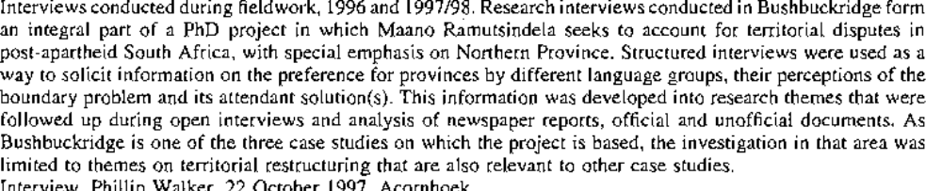

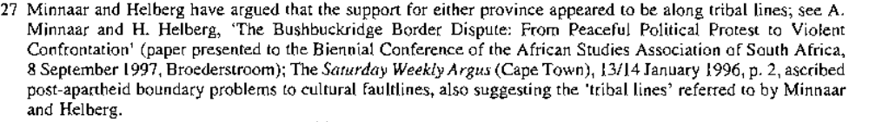

1. All disputed areas

- 14 affected areas
- Grigualand
- Namaqualand
- Taung/Kuruman/Kudumane
- Matatiele
- Groblerland
- Khutsong
- Moutse
- 16 cross boundary municipalities
- Bushbuckridge

2. Security costs attached to border dissents

3. Commissions on boundaries
- Republic of South Africa, Report of the Commission of Enquiry into The Taung/Kuruman/Kudumane Border Dispute, April 1997
- Trengore commission
-Steyn commission
- CDDR

Contested terrains : cities and hinterlands in post-apartheid boundary delimitations
Frederic Giraut & Brij Maharaj

South African Land Policy : The legacy of History and current options
Hans P. Binswanger and Klaus Deininger

Resilient geographies : land,m boundaries and the consolidation of the former bantustans in post-1994 South Africa
By Maano Ramutsindela

The Boundaries of a New South Africa
By Richard A Griggs

Contested terrains : cities and hinterlands in post-apartheid boundary delimitations
Frederic Giraut & Brij Maharaj

“ while the municipal demarcation board was largely successful in eliminating the political geography of apartheid at a macro-scale, this paper suggests that the greater challenge for government and policy makers is to reduce the socio-spatial and economic inequalities which appears to be still very high and perhaps increasing.” 39

“ the restructuring of local government has been primarily influenced by economic, technological, political and ideological change, and can modify spatial patterns of development and disparities (Razin, 2000, p.7) 39

“ Boundary changes are often associated with a redistribution of political power and resources, with some institutions and parties benefiting, and others being disadvantaged (Alexander, 1982; Hasson and Razin, 1990; Keating,m 1995; Cameron, 1999)39

“ in a process of territorial restructuring, there are potential areas of dispute, which often reveal local, regional and national geopolitical stakes (Hasson and Razin, 1990)” 39

“ the conflicts engendered, the negotiations, compromises, and coalitions generated constitute important areas of research, and is the focus of this paper” 39

what did characterise apartheid local government ? “ a complex process of functional inclusion, spatial separation, and political exclusion” (Swilling et al., 1991, p.175)

The LGTA of 1994 constituted “an institutional base for the disbanding of race-based municipalities, scrapping of apartheid laws relating to local government, and the establishment of transitional local councils( Khan and Maharaj, 1997)... About 1,260 local authorities were merged to form 843 municipalities.

Problems with the LGTA :
- not necessarilly support for the notion “ one city, one tax base”
- “in many areas, the spatial inscription which prescribes the separation of areas of abject poverty from areas of affluence persists” (Narsiah and Maharaj, 1999). ( “ for example, there was a tendency to exclude settlements on the periphery of the metropolis which would lower the per capita tax base, and place a strain on service delivery capacity (Wooldridge, 2002, p.132). Furthermore, hastily drawn municipal boundaries and negotiated ward boundaries produced fragmented system, with metropolitan areas divided into impractical substructures, and some small towns and rural areas cut up like a patchwork quilt (Cashden, 2002, p.162)...
- The white paper on local gov came with the notion of DLG... in an attempt to address these problems... (issue of shape, size and boundaries was directly linked to socio-economic dynamics...)

“there was considerable contestations over the delimitation of new local government boundaries (Cameron , 1999).

- there were two perspectives regarding metropolitan government:
- those interested with growth : “ metropolitan gov would play a pivotal role in promoting economic development because it provides a more effective regional infrastructure for reproducing labour power as well as promoting production and distribution.
- - those interested with equity : metropolitan would promote more equitable land use, ensure fairer taxation, improve efficiency, service provision and capacity; reduce socio-spatial inequalities and foster rational planning (PLANACT, 1992; Government Gazette, 13/3/98)
“ a key concern was that megacities reduced efficiency and equity, and were also remote from the communities they were supposed to serve” 41

Boundary contestations in Durban :
criteria considered in the adoption of the boundaries:
-the restructuring and amalgamation of black and white local authorities
-the future financial viability of the metropolitan area
-the functionality of the metropolitan system in economic, spatial and social terms
-the redistribution of resources and uplitment of disadvantaged areas.

“ there were a few dissenting voices, especially from smaller, affluent white local authorities who were reluctant to give up the power and privileges of the old order”
e.g. the borough of Westville, whether to include or exclude tribal authority located on the edge of the existing metro boundary... , a major problem was attempting to differentiate between urban and rural areas,

“ it was clear from the Durban and other experience that it was possible to manipulate transitional interim measures by excluding settlements on the periphery of the metropolis which would lower the per capita tax base, and place a strain on service delivery capacity; demarcating local boundaries to create (or perpetuate) stark differences in per capita tax base between localities (Wooldridge, 2002. p.132).... “ many boundaries had been hastily drawn and were unviable and unsustainable, both administratively as well as in terms of service delivery. Also, in many traditional authority areas there was no accountable or democratic local government. Hence, there was an urgent need for a new demarcation process” p. 44

In terms of the Municipal demarcation Act (1998), these were the criteria for delimitation of metro boundaries

- a conurbation featuring areas of high population density; and intense movement of people, goods and services; extensive development; and multiple business districts and industrial areas
- a centre of economic activity with a complex and diverse economy
- a single area for which integrated development planning is desirable
- having strong interdependent social and economic linkages between its constituent units ( Sutcliffe, 2002, p. 2)
“ while these criteria can never be regarded as scientific, they nevertheless try to capture certain objective considerations” 44

“ the demarcation of the present boundary (Durban) has not helped to resolve all of the problems associated with service delivery and infrastructure in areas outside the urban core, especially in informally settled areas. Poverty, inadequate housing and infrastructure, land tenure, unemployment, crime, a lack of skills and environmental problems continue to manifest themselves in these areas, which remain functionally linked to the Metro core.” 44

The Technical Task Team (TTT) in developping its boundary proposal considered the following criteria :
- sustainable service delivery
- interdependence of people
- communities and economies
- financial viability
- administrative capacity
- and political acceptability

“ the new inclusion would not contribute significantly to the rates' base of the city, but will add to the existing backlog in the delivery of basic services. “ 45

“ there was also suspicion that the MDB's draft proposals had political undertones” 45
“ the metro was keen to expand its economic base as this would strengthen its ability to deliver, and was concerned about incorporating additional areas that could become financial/economic liabilities” 45

MDB <>Durban Metro
“ while acknowledging functional linkages with the surrounding communities, the metro was aware that some of these may not necessarilly identify themselves with the DMA. Furthemore: Whilst functional considerations, various planning and development initiatives show a strong relationship between the DMA and these communities, some strong non technical factores may need to be considered in the incorporation of these areas into the DMA” 46

“ affuent metro authorities , like that in Durban were opposed to the spatial extension of their boundaries because of the costs of the providing services and infrastructure in the deprived margins”

“ once again, it is evident that even in small towns attempts were made to exclude former African or Bantustan areas in order to retain areas of white privilege. In some cases displaced urban areas were also excluded from TLCs” 47

“ the new local government demarcation process has been driven by the “wall to wall” principle in order to form large sized municipalities. So the doctrine of the municipal Demarcation Act of 1998 is at odds with, and a radical departure from, the Local Government Transitional Act of 1994, which proclaimed the administrative urban/rural dichotomy. A key issue was whether the functional urban units (including those that were displaced) now fitted into a single municipality.”

“ the resistance of traditional authorities tot he demarcation process is an expression of the political opposition between regionalist and centralist parties with their rural and urban support base in KwaZulu-Natal (Crouzel, 1999; Ramutsindela, 2001). in fact the political survival of traditional leaders demands a demarcation that does not divide their juridictions and which does not include them in an area where traditional authority could be undermined” 48

“ a key concern was the costs associated with municipal rates” 48
“ the struggle of farmers against metropolitan inclusion was similar to that of the tribal authorities. It is therefore evident that in this new phase of demarcation, the issue of rural/urban dichotomies still feature strongly, despite the fact that the principle of the amalgamation was accepted. Rather than using rigid dichotomies to define administrative areas and institutional jurisdictions, it would be better to view rural and urban as either end of a spatial-developmental-political-institutional nexus” 49

“ critical issues in the process of municipal restructuring and consolidation include efficiency, democracy, distribution and development (Keating, 1995, p.117) or as Barlow (1997, p.400) expresses it efficiency, effectiveness, and equity”

“however, local territorial restructuring is also political – it involves political choices and political processes in pursuit of political goals ( Higgins, 1986, p.221)

“ Also, as Keating (1995, p.129) has argued , a boundary change shifts burdens and opportunities and creates fears and uncertainties. It is evident from this paper that boundary demarcations shaped the political conjunctures of power at local government level in post-apartheid South Africa (Cameron, 1999, p.4)

“ in Durban, the shape of the metropolitan area set the scene for heated conflict and protracted debate between urban and rural constituencies as well as traditional leaders” 49

“ the simultaneous transformation of both the social and spatial structure of South African society is a contested area of struggle and will ultimately be determined by the complex and diverse interaction of various social, economic and political contingencies at different spatial scales” 49

books to look for :

Wooldridge D., 2002 : Introducing Metropolitan Local Government in South Africa. In : S. Parnell, E. Pieterse, M. Swilling and D. Wooldridge (eds), Democratizing local government : the South African Experiment, pp. 127-140. University of Cape Town Press, Cape Town

Sutcliffe M. 2002: Municipal Demarcation Board. Paper presented at the French-South African Conference on Territorial Innovation, January, Grenoble, France.

Sancton A., 1996: Reducing costs by consolidating municipalities: New Brunswick, Nova Scotia and Ontario. Canadian Public Admnistration 39: 267-289

Seethal C., 1991: Restructuring the local state in South Africa: Regional Services Councils and crisis revolution. Political Geography Quartely 10 (!): 8 – 25

Razin E. , 2000: The impact of local government organisation on development and disparities – a comparative perspective. Environment and Planning C: Government and Policy 18: 17 – 31

Pillay U., 1999 : Demarcating South Africa's metro areas : a cautionary lesson from the Durban Metropolitan Area. In : R.Cameron (ed), Democratisation of South African Local government, pp. 201-223. JL van Schaik, Pretoria.

Pillay U., 1994: Local government restructuring, growth coalitions, and the development process in the Durban Functional Region, c.1984-1994. Urban Forum 5: 69-86

Narsiah S. and Maharaj B., 1999: The creation of “real” spaces: Regions and regionalism in the new South Africa. Space and Polity 2(1): 225-248

Keating M., 1995: size, efficiency and democracy : consolidation, fragmentation and public choice. In Judge D., Stoker G. and Wolman H (eds), theories of urban politics, pp. 117 -134. Sage Publications, London.

Christopher A.-J., 1994: The Atlas of Apartheid, Routledge, London.

Bond P. 1998: Local economic development and the municipal services crisis in post apartheid South Africa. The case of Stutterheim. Urban Forum 9(2): 159-196

Harrison P. and Naidoo J., 2000: Chimera or guiding vision ? : Local economic development and the town of Port Shepstone in KwaZulu-Natal. Urban Forum 11(1): 119 – 131

Guyot S., 2001 : Evolution of political territories and post apartheid challenges of management of the Port Shepstone area. Paper presented on the International symposium on government, governance and urban territories in Southern Africa, 15p, Lusaka (University of Zambia), 21 -22 November.

Giraut F. 2000 : Innovation territoriale et referent identitaire. Du renouveau des provinces nigeriennes a celui des pays francais. In Chaleard J.-L. Et Pourtier R. (eds), Politiques et dynamiques territoriales dans les pays du sud, pp.77 – 108. Pub.dela Sorbonne, Paris.

Bekker S. et al., 1997: Local government transition in five eastern seaboard South African towns. Politikon 24 (1): 38 – 56.

Allanic B., 2001 : Borderlands: From dumping grounds to attractive residential settlements, Paper presented in Johannesburg (IFAS) on the 11th June, Seminar power and territories.

The resilience of Territorial Conflict in an Era of Globalisation
David Newman, Department of Politics and Government, Ben Gurion University,
Beer Sheva, Israel 84105.

Are boundary disputes “territorial conflicts” ?

The deterritorialization debate ... and the counter deterritorialization debate...
ethno-territorial conflict
political territoriality

“ the symbolic and non-tangible dimensions of territorial behaviour which explain the intense feelings of attachment and belonging to specific territories, and over which there is no willingness to compromise or move towards conflict resolution;” 1

“The territorial discourse within political geography has experienced a renaissance during the past two decades.2 An important framework for understanding the role of territory as a key factor in the political organization of space, and as a basis for the re-emergence of political geography as a bona fide discipline after three decades of shunning due to its “guilt by association” with the German school of Geopolitik,3 was provided by Soja in what proved to be a seminal paper published by the Association of American Geographers in 1972.4 Soja identified three main functional realms of territorial organization – the control over the distribution of resources, the maintenance of order and authority, and the legitimization of order through societal integration.” 2

“ But while territory is shown to retain its relevance, it is accepted that we require a much deeper understanding of the complexities underlying territorial behaviour than that offered by the traditional geographical discourse, and to some extent of the contemporary political science discourse, of fixed and rigidly bordered spaces.”3

About the so-called “emotional attachment to territory”....
“Territory constitutes an important component of our individual, group and national identities, not simply because our State territories are delimited by fixed boundaries but because territory has a symbolic dimension which determines our attachment and affiliation to particular spaces and places, attachments which are taught – consciously and sub-consciously - through processes of political and territorial socialization.”5

“Israel Palestine is an excellent example of how territorial configurations undergo continuous modification in response to the changing environmental and political realities. Notions of partition and division have been central to the territorial discourse since the 1930s14 and remain the core territorial questions to be resolved.”5

Post Westphalian world ?

“Globalization does not lead to a reduction in the significance of territory per se, but it does lead to a new, more complex, understanding of the multi-dimensional, and dynamic, components of territory as a mechanism through which society is bordered, ordered and controlled.18 Territorial ordering remains an essential component of human behaviour. We seek to control the spaces within which we live, to make them as exclusive as possible, and this is as true of the State spaces within which "our" groups practice sovereignty and political control, as it is of the municipal and neighbourhood spaces within which we attempt to influence the quality of life characteristics, as it is of our desire to control and defend our private and personal spaces.” 6

“ Reterritorialization, as contrasted with deterritorialization, is the process through which territorial configurations of power are continually ordered and reordered. It is not something new. It has been taking place continuosly as new states are created and others are vanquished. At certain times, such as the periods following the two world wars or the break up of the Soviet Union, the tangible territorial reconfiguration and restructuring of the world political map has provided us with socalled “new world orders”, but this is no more than a sharp change in the intensity of an ongoing process at a given time contingent on specific political events” 6-7

“uti poseditis”

“The resolution of ethno-territorial conflicts is, more often than not, resolved around these contemporary realities, a continuation of the uti poseditis principle which came into being with the Westphalian State system and which, despite all globalization impacts, has not disappeared along with the nation state.22 Historical claims to sovereignty, especially those based on priority considerations, are used as part of the political polemic and the need to self justify the territorial claim in the face of a counter claim. But it is generally the contemporary political and territorial realities which serve as the basis for bargaining
and compromise between states seeking conflict resolution. The historical discourse may serve to socialize, to create territorial attachments between diaspora communities and their "former"”8

territories, but in the real world of power hegemonies based on effective territorial control and demographic majorities, the impact of the historic arguments only has a limited influence in the decision making process.

Within the Israel/Palestine context, the establishment of settlements to extend territorial control and ownership has constituted one of the most discussed political geographical themes of the Arab-Israel conflict in general, and of Israeli activity in the West Bank in particular.23 Settlements have played, and continue to play, a major role in the delimitation of boundaries between separate Israeli and Palestinian territories. Functionally, settlement has fulfilled an important political role by extending maximum territorial control, laying the seeds for future claims to sovereignty. While Israelis are reticent to use the term, establishing civilian settlements in this way is part of a process
of landscape colonization through which territories are brought under long term control by the dominant power and/or those aspiring to future statehood and hegemony. It is accomplished by implanting civilian populations expected to sink roots and develop a sense of bonding with the territory in question. Future generations born within these communities would perceive this to be their "natural homeland" Just 30 years after the establishment of the first West Bank settlements, there are already settler families with a third generation born to parents themselves born in the 1970s in these new communities and who have spent their entire lives within this region. These “new” territorial facts have become, for the younger settlers, part of a natural process, through which the location of their residence is seen as being fixed rather than recently implanted.

The construction and superimposition of physical boundaries also create new geographic facts that change the political realities and which have to be taken into account in any process of negotiated conflict resolution. Imbued with political significance by governments, all boundaries are artificial and can be changed at will, through agreement between neighbouring politico-territorial entities, or through unilateral imposition on the part of the stronger power. However, once created, boundaries become almost mythical, inasmuch as they determine the sovereign and inviolable limits of the state, not to be transgressed by external powers. These "facts", the location of settlements and the imposition of boundaries constitute the geographical realities that serve as the default basis for territorial negotiations. Geographical features are thus seen to have a dynamic of their own, feeding into the next round of negotiations and decision making, rather than simply constituting the passive outcome of those decisions. This should not be understood as a return to geographic determinism. The spatio-political realities are social constructions. They can be removed or changed just as they have been created, but that does not detract from the fact that their existence has an impact on the way in which decisions are made. They cannot simply be ignored as though they didn’t exist.” (9-10)

“While public discourse tends to focus on the national scale of territorial conflict, such as the demarcation of state borders or the relationships between neighbouring states, it is at the local and micro scales of territorial behaviour where the vast majority of people are impacted. This is as true of the local territorial behaviour with respect to daily life practices, such as municipal, health and education districting and competition for scarce resources, as it is the way in which national and ethnic conflicts are played out at this level through processes of spatial segregation, separation and mutual exclusion.”11

“It is their readiness to defend their “homeland” territories to which they lay claim through historical priority (which group can trace its roots back further to this territory), or duration (which of the groups can demonstrate continuous residence over a longer and uninterrupted period of time)29 which explains much territorial conflict. Processes of political and territorial socialization have helped create national identities within which territory forms a major component of identity construction. Homeland territories are special places, the location of historical and mythical events in the nations history, imbued with exclusive significance, constituting the core of the self-determination
experience. Ethno-territorial conflicts demonstrate that it is much more difficult to
share territory than it is to share power (although the two are often parallel processes). If a particular place is part of my historical narrative, then it cannot be, at one and the same time, part of your historical or national experience. At the symbolic level, political territories are mutually exclusive. This primordial attachment to territory lies at the root of much contemporary ethnoterritorial conflict, even for people who operate within a global and trans-boundary world, but for whom the “homeland” territory remains central to their own ethnic and national identities..”13

symbolic and metaphysical attachment to territory, defined as intangible or relational values by others...

“it has been argued that territorial changes with high relational importance are the most likely to involve violence”, as indeed is the case with respect to the West Bank (“ the historic and religious heartland of the ancient Land of Israel”) or Jerusalem ( “the eternal capital of the Jewish people, never again to be divided”)” 13

“This is consistent with the logic that indicates that conflict is more likely when issues are less tangible or divisible, when territories are perceived as exclusively “belonging” to one group of people and that all others are usurpers” 13

construction of political homelands =/ religious attachment to territory ... applies to sacred or holy places.
“ the religious attachment to the land is much more than the construction of political homelands. The inherent belief that the land was given to a specific people by divine promise makes it the most intangible of all features” 14.

“ Increasingly, issues of identity lie at the root of boundary conflicts as much, if not more , than the extent to which the demarcation of the line enables one state to control valuable and scarce natural resources -such as water, oil, minerals etc; Where territorial lines cross both the resource and identity interface at one and the same time, the potential for boundary conflict is greatest, since minority groups do not necessarily benefit from the potential economic benefits of the natural resources. The demarcation, delimitation and ultimate location of boundaries are a function of power relations”18

“ International boundaries are the legacy of contemporary state formation. Despite the opening of boundaries in Western Europe, the territorial legacy of partition, division and boundary superimposition remains a prominent component in the world political map. All resulted from, or gave rise to, conflict at one stage. Many have been resolved peacefully over time, while others remain the source of ongoing conflict and ethno-territorial tensions, claims and couter claims.” 18

“A recent Belgian film, entitled “the Wall” demostrates, somewhat absurdly, the bordering process and the way in which barriers can be created to reflect existing differences and socially constructed territorial identities, creating walls, barriers, division and conflict where a single functional space existed” 21

“ creating a physical border in the heart of “borderless” Europe, in the city of the EU institutions, is a cynical look at the way in which such lines can be manipulated to perpetuate difference, and hence enmity and ethnic tensions, as powerful social constructions on the part of power elites” 21

“The process through which territorial conflicts are resolved reflect all three of the characteristics discussed in the previous section of the paper: territorial scale, territorial symbolism, and the bordering process. Studies in conflict resolution have shown that it is the intangible and symbolic factors which are the most difficult to resolve between belligerents. This is as true of territorial factors as it is of other political conflict characteristics. When territory is presented as a discourse about tangible goods, it can be resolved through a process of quantification, bartering and exchange, resulting in the contraction or expansion of state territory.50 Settlements can be dismantled, compensation can be offered to refugees, borders can be relocated, and territorial parcels can be offered in exchange for territory annexed by the other side. But it is much more difficult, in some cases impossible, to resolve conflicts around the symbolic dimensions of territory. Historical and homeland spaces are so tied up with the formation of national identities
that the symbolic components of territorial conflict remain indivisible.”22

“But conflict resolution does not only take place at the aggregated level of the nation or the state. As noted above, power relations determine, and are determined by, patterns of residential segregation and the extent to which their daily behavior brings them into mutual contact in the housing market, the workplace or, by default, in centers of social and cultural activity. Thus, patterns of inter-ethnic interaction at the micro level are directly affected by the outcome of peace negotiations, though they do not normally appear on the negotiation agenda. In virtually all such conflicts, existing patterns of ethno-national segregation encourage even greater separation in homogeneous and
exclusive national territories, contrasting strongly with the political polemics and public statements of leaders with utopian notions of future cooperation, integration and normalization of relations.” 24

“Thus territorial compartmentalization and the segregation of ethnic groups results from, and contributes to, conflict and mutual antagonism.” 24

“Finally, conflict resolution should also recognize the potential of borders to function as bridges, as contrasted with the traditional barrier perception of the boundary. Walls and fences are normally constructed as a means of ethno-territorial separation between peoples. They may provide a limited amount of physical security in terms of safety, but they also constitute artificial constructions which make the “other” side invisible. Invisibility breeds ignorance which, in turn creates a new dimension of fear – fear of the unknown emanating from the other side of the border. In a world where many borders are becoming increasingly permeable, borders should be seen as places of potential interaction, points of contact and transition between two neighbouring territorial or social
entities.” 25

“Borders would remain as the territorial demarcators of state control (or whatever is left of sovereignty), citizenship and, in some cases, national identity, but would become increasingly permeable in terms of the daily practices of the borderland residents enabling interaction and cooperation rather than barriers and separation. This is where the two discourses – the global opening of borders, and the “primordial” closing and separation of territories, meet. It is the point where the territorial dialectic of the globalization argument is most strongly felt.” 26

“Rather than take territory out of the debate, it is argued that territory should be brought back in, but in a way which broadens the discussion to include factors which have not figured prominently in the discourse on territorial and border conflicts in the past. In particular, attention should be paid to the different scale dimensions of territorial behaviour, with ethnic and national conflict expressing itself at the local level of daily
practices and patterns of segregation. Equally, the symbolic dimensions of territorial attachment and socialization reflect the intensity with which many territorial conflicts are contested, over and beyond the tangible and quantifiable dimensions of territory as a resource which can be exchanged and bartered as part of the conflict resolution process. All territorial organization and its associated process of bordering are social and political constructions and, as such, continue to function as powerful mechanisms of control and ordering – at a variety of spatial and political levels.”

“All territorial organization and its associated process of bordering are social and political constructions and, as such, continue to function as powerful mechanisms of control and ordering – at a variety of spatial and political levels.” 26

“ Ethnoterritorial conflicts have not disappeared from the face of the world political map. If these conflicts are to be resolved, it is necessary to reach a deeper understanding of the way in which the multidimensionality of territorial behaviour is played out through a complex system of power relations.” 27

Ardrey, Robert. 1966. The Territorial Imperative. Atheneum: New York.

Forsberg, Tuomas. Ed., 1995. Contested Territory: Border Disputes at the Edge of the Former Soviet Empire. Edward Elgar: Aldershot.30

Forsberg, Tuomas. 2002. `The ground without foundation?: territory as a social construct’, Geopolitics, 8
(2): 7-24.

Klemencic, Mladen. 2000. `The boundaries, internal order and identities of Bosnia and Herzegovina', Boundary and Security Bulletin, 8 (4): 63-71.

Lemon, Anthony. 2002. `South Africa's internal boundaries: the spatial engineering of land and power in the twentieth century', In The Razors Edge: International Boundaries and Political Geography, edited by Clive Schofield et al, 303-322. London: Kluwer Academic Publishers.

Martinez, Oskar. 1994. The dynamics of border interaction: new approaches to border analysis', In World Boundaries Vol I: Global Boundaries, edited by Clive Schofield, 1-15. London: Routledge.

Motyl, Alexander. 2001. `Reifying boundaries – Fetishizing the nation: Soviet legacies and elite legitimacy in post-Soviet states', In) Right-Sizing the State: The Politics of Moving Borders, edited by B. O’Leary, I. Lustick & T. Callaghy, 201-221. Oxford: Oxford University Press.

Murphy, Alexander B. 1989. `Territorial policies in multiethnic states’, Geographical Review, 79: 410-421.

Murphy, Alexander B. 1990. `Historical justifications for territorial claims', Annals of the Association of American Geographers 80: 531-548.

Murphy, Alexander B. 2002. `National claims to territory in the modern state system: geographical considerations', Geopolitics, 7 (2): 193-214.

Newman, David. 1998a. `Metaphysical and concrete landscapes: the geopiety of homeland
socialisation in the "Land of Israel"', In Land and Community: Geography in Jewish Studies, edited by Harold Brodsky, 153-184. Maryland: University Press of Maryland.

Newman, David. 2002b. `Boundaries’, In A Companion to Political Geography, edited by John Agnew, Katharyne Mitchell and Gerard Toal, 123-137. Oxford, UK: Blackwell.

Newman David, and Anssi Paasi. 1998. `Fences and neighbours in the post-modern world: boundary narratives in political geography', Progress in Human Geography, 22 (2):186-207.

Paasi, Anssi 1995. `Constructing territories, boundaries and regional identities’, In Contested Territory: BorderDisputes at the edge of the Former Soviet Empire, edited by Tuomas Forsberg, 42-61. Elgar:Aldershot, UK.

Paasi, Anssi. 1996. Territories, Boundaries and Consciousness. New York: John Wiley.

Paasi, Anssi. 1998. ‘Boundaries as social processes: territoriality in the world of flows’,
Geopolitics, Vol 3 (1): 69-88.

Paasi, Anssi. 2002. `Territory’, In A Companion to Political Geography, edited by John Agnew, Katharyne Mitchell and Gerard Toal, 109-122. Oxford: Blackwell.

Pringle, Dennis. 1997. `Globalization, reterritorialization and national identity’, Geopolitics, 3 (3): 1-13.

Sack, Robert. 1986. Human Territoriality: Its Theory and History. Cambridge: Cambridge University Press.

Samaddar, Ranabir, Rada Ivekovic, Sanjay Chaturvedi and Stefano Bianchini. 2004. Partitions. Reshaping States and Minds. London: Frank Cass.

Shapiro, Michael, and H. Alker, editors., 1996. Challenging Boundaries: Global Flows, Territorial Identities, Minneapolis: University of Minneapolis Press.
Sibley, David. 1995. Geographies of Exclusion: Society and Difference in the West. London: Routledge.

Soja, Edward. 1971. The Political Oragnization of Space. Commission on College Geography, Resource Paper No. 8. Washington DC: Association of American Geographers.
Taylor, Peter J. 1994. `The state as a container: territoriality in the modern world system,'” Progress in Human Geography 18: 151-62.

Taylor, Peter J. 1996. `Territorial absolutism and its evasions.' Geography Research Forum 16: 1-12.

Van Houtum, H. (2002) `Borders, strangers, doors and bridges', Space and Polity, 6(2), 141-146.

Van Houtum, H & Van Naerssen, T (2002) Bordering, Ordering and Othering, Tijdschrift voor
Economische en Sociale Geografie, 93 (2): 125-136.

Vasquez, John A. 1983. “The tangibility of issues and global conflict: a test of Rosenau’s issue area typology,’ Journal of Peace Research 20: 179-192.

Vasquez, John A, and Marie Henehan. 2001. `Territorial Disputes and the Probability of War, 1816-1992,' Journal of Peace Research, 38 (2): 123-138.

Tuan, Yi-Fu. 1976. `Geopiety: A theme in man’s attachment to nature and place’, In Geographies of the
Mind, edited by David Lowenthal and M. Bowden, 11-39. New York: Oxford University Press.

Yiftachel, Oren. 2001. `Right sizing” or “right shaping”? Politics, ethnicity and territory in plural states’, In Right-Sizing the state: The Politics of Moving Borders, edited by B. O’Leary, I. Lustick & T. Callaghy, 358-387. Oxford: Oxford University Press.

South African Land Policy : The legacy of History and current options
Hans P. Binswanger and Klaus Deininger

Resilient geographies : land,m boundaries and the consolidation of the former bantustans in post-1994 South Africa
By Maano Ramutsindela

The Boundaries of a New South Africa
By Richard A Griggs

Expressions:

-attempts to define “urban” and “rural” are fraught with problems
-this theme looms large in the constitution
-gracious and constitutionally acceptable goodbye however sad, and harsh and invidious expulsion

  - these warnings are substantiated, albeit dramatically worse than even the study anticipated

Robert Cameron, Democratisation of south African local government : a tale of three cities, JL van Schaik Academic, 1999

“ boundary demarcation was arguably the most heated and controversial part of the entire local government democratization process. In many areas local forums were unable to reach agreement about the boundaries for elections. In addition, provincial MECs also deviated from their demarcation boards’ recommendations in the country’s three largest metropolitan areas, namely Cape Town, Durban and Johannesburg. All three disputes landed up in the Special Electoral Court for final binding decisions. The most celebrated of these cases was in the Western Cape, where the provincial government successfully took the national government to the constitutional court over the centre’s attempted intervention in the local boundary dispute, yet lost the subsequent Electoral Court decision” 1

“ boundaries are not artificial constructs; they delineate political power. Although often couched in technical language, demarcation is a profoundly political process. Furthemore, with the country standing on the brink of a further redemarcation of local government boundaries, the issue of demarcation appears set to take centre stage once more. It appears that this will be an ongoing process in South Africa” 2

Other authors that have covered the issue of the democratization of local gov : Cloete, 1995; Cameron, 1996a ; Pimstone, 1997)

Primary focus of this book: the critical process of demarcation as part of the local government democratization exercise in South Africa 2

“ South African boundary demarcation has, in many aspects, occurred in a rather isolated context, yet there is much that we can learn from international experience about the principles and guidelines which shape demarcation” 2

“Higher-tier governments’ reasons for rationalizing local government are often couched in technical language but motivated by drawing their electoral map to their advantage. This often remains implicit. Resistance to change is another important political variable””

Why people resist to change? what are the socio-economic factors involved ?

“ Alexander (cited in Hasson and Razin, 1990: 281) states : ‘ in the structure of subnational government, boundaries are not only spatial and geographic. They also delineate the allocation of functions and the distribution of political power” 4

“ boundaries changes by definition redistribute power, with some parties and organizations standing to lose power and others standing to gain power. The NP won national elections in South Africa in both 1948 and 1953 with a minority of the vote. This was due to constituency boundaries being loaded in favour of rural voters, who were largely NP supporting ( Heard, 1974)” 4

“Boundaries also influence citizens’ access to local government services. Incorporation with richer authorities often means a better standard of services. Conversely, inclusion with a poorer local government can lead to a lower standard of services. There is also contestation around financial implications of different boundaries. Communities will vigorously oppose being incorporated into higher tax jurisdictions” 4

“why is the book focusing on metropolitan areas ? “ 4

“the fight for political power was the most intense in the major metropolitan areas, precisely because the stakes and resources were so much higher. As will be shown in the comparative case studies, political temperatures reached fever pitch around the demarcation of metropolitan boundaries”

International literature on local gov reorganization and spatial dimensions of restructuring….

“ however, South African studies on local government demarcation are virtually non-existent. There is no systematic literature available on boundary demarcation in this country. The only published work is my own article in 1996, which was only a 20 page study of the Transitional Metropolitan Substructure (TMS) boundary dispute in the Cape Metropolitan Area (CMA) (Cameron, 1996a).” 5

This research is path finding work….

Local government can broadly be divided into six categories :
-Structural reform : territorial division and organization
-functional reform : reallocation of tasks between various levels of government
-financial reform : modification of the local taxation system and changes in the grant system
-organisational reform : reshaping of local administrative structures and new forms of city management
-decision making reform… corporate planning and long-term budgeting
-autonomous action by local authorities in modifying the financing of local services such as the setting of fees and charges
6

“ a study of demarcation is a study primarily of the first type of reorganization, namely structural and institutional reform” 6

“ The local government commission for England (LGC, 1993: 15) argued that : structure cannot sensibly be reviewed separately from finance and function. All of the elements that determine any organization’s effectiveness must be considered together: strategy, systems, skills, manaegement style, staffing and the shared values that knit the organization together “ 6

Major categories of demarcation criteria:
-technical criteria ( technical consolidation considerations): economies of scale, settlement boundaries, financial viability, administrative capacity, the improvement of local services, economic competitiveness, compactness, the reshaping of intergovernmental relations and the need for equity/resource distribution policies
-subjective boundary criteria : wishes and concerns of local voters : the will of the community, the urban-rural community debate, the use of referenda, citizen participation, and the relationship between size and democracy
-less formal variables which underpin boundary demarcation and often implicit : political factors, interference by political parties to ensure boundary demarcation outcomes that would be favourable to their electoral interests… gerrymandering… and resistance to change 9

“Resistance to change was a prominent factor. Technical considerations were ultimately overshadowed by political considerations when it came to the final boundary decision” 10

“ the next section offers analytical comment and insight into why things turned out the way they did in Durban and how political factors seem to have informed and mediated what essentially should have been a purely technical process. A concluding section cautions one against the folly and danger of such a political approach in attemps to reconfigure the political and economic landscape of Durban” 11

“what is important is the change from a three-level hierarchical intergovernmental system to a three-sphere system. The notion of a sphere must be looked at within the context of cooperative governance which makes each sphere distinctive, interdependent and interrelated. This has uplifted local government from a subordinate level of government to a significant sphere in its own right” 11

“the role of demarcation boards, the application of criteria. Gerrymandered options. Metropolitan-local considerations, resistance to change and party political factors are amongst the important factors examined. The conclusion is that party political considerations of provincial governments ( all controlled by different political parties) rather than technical factors, ultimately shaped the final outcome of boundary configurations in all three cities” 12

“ this book is about demarcation and most of the primary research undertaken was in this field. However, serious students of demarcation should also be interested in the effects of the process and for this reason a brief look is taken at governance issues” 12

- Local government boundary demarcation and international overview

“ Most suburban municipalities resist incorporation into metropolitan areas because it will invariably lead to higher taxes and a loss of autonomy. Countries in which amalgation may only occur with the specific consent of local councils are rare, the USA being a notable example. Most Western European countries require that central government consult with local councils and sometimes local groupings, but it is not obliged to heed their wishes” 23

“ in the 20th century, more restricted annexation laws were passed, which reflected increasing fringe-area resistance to being incorporated with older cities. Many states gave fringe-area residents a greater say in the annexation process, by granting them the exclusive authority to initiate annexation proceedings and by requiring separate favourable ratification votes in both the annexing city and the area proposed for inclusion” 24

“ there does not appear to be sufficient evidence to prove that either a single tier or two-tier system of metropolitan government is the superior model. As Kiernan & Walker ( 1983: 245) put it, “ on the evidence of Winnipeg’s experience, institutional reform may well be intrinsically incapable of producing major political change” 28

“ Skaburskis ( 1992: 168 – 169 ) suggests that the contentiousness of boundary proposals may be reduced if central government sets forth a set of guidelines and objectives that will be pursued through the restructuring process. Stating objectives and applying them to the resolution of boundary changes can reduce political interference by central and provincial government “ 28

“ The local Government Commission (LGC) ( 1993 : 8) stated that the right balance between the “efficiency” and “ democracy” objectives has been the object of every local government reform in England. In 1972 the Conservative Government argued that where the arguments between efficiency and democracy were evenly balanced, their preference was for the latter ( LGC, 1993 : 7) 29

“ these spatial behaviour studies attempt to map the areas of influence of urban centres by analyzing economic and social activity, showing the socio-economically interdependent areas for which cities provide marketing and financial facilities. This requires a great deal of knowledge, not only about the spatial distribution of settlements, but also the spatial patterns of socio-economic activity. It requires systematic research into behavioural relationships between spatially defined groups, economic transactions, employment catchment areas, spending patterns cultural linkages and recreational habits” 42

“ the improvement of services is a goal of boundary reorganization, although it is not always expressed as a direct demarcation criterion. Has rationalization strengthened local government : has greater financial viability and the ability to attract professional staff led to the improvement of services” 49

“ According to Rowat ( 1980 : 595), the number of basic units of local government may be so great that it is impossible for the senior government to control, supervise or even deal with them effectively. Sharpe ( 1988: 101 – 102) notes that central government is interested in rationalization from the point of view of easing the coordination and management burden of the centre. This is often a reason for boundary reorganization” 50

“ Furthermore, it is argued that local government is an appropriate site of redistribution because local authorities that adopt redistributive policies will find themselves losing their richer ratepayers, who object to paying higher taxes to fund local social security systems, and instead attracting less well-off citizens” 51

“In a fragmented local government system there is a battery of measures that can be used to exclude potentially high-cost residents, while including those with sufficient resources. Among the more important of these are zoning and subdivision powers which include minimum lot sizes, the regulation of the value, type and size of dwelling and minimum building requirements ( see, for example Wood, 1966; Ross et al. , 1991: 275).” 52

“ the argument is that for a metropolis to be internationally competitive there should be governmental control over a territorial base and population resources comparable to those of its political competitors. Fragmented government, multiple administration and bureaucracy and the lack of area-wide strategic planning and policy-making are thought to weaken a metropolis vis-à-vis its competitors. The economic competitiveness argument is said to strengthen the case for metropolitan government ( Barlow, 1991 : 299 – 300)

“Boundaries of cities are thus critical for the future competitiveness of local authorities. There has accordingly been a move in the last ten years to promote growth in cities. There has been a marked increase in intercity competition to attract mobile capital at national, continental and global levels and local governments have responded with an array of economic development policies”55

“ While the economic competitiveness argument is rather persuasive, it is often asserted rather than demonstrated. It also does not directly engage with the public choice argument that fragmentation encourages capital to the place where it will be the most productive. It can be questioned whether globalization in its economic investment variant has, as yet, had a major impact on many developing countries, including South African cities. Clearly, more empirical research is needed to test the validity of the economic competitiveness model “56

“ one of the most problematic criteria to operationalise is that of the will of the community. Cope et al. ( 1997: 52) note that there are three key dimensions of community identity that are of relevance to local government restructuring:

- affective community identity – identities are formed by what people feel about the communities they say they belong to and is often based on tradition
- Effective community identity – identities are formed by what people do, based on their functional activities ( such as travel-to-work pattern)
- Deliberative community identity – identities are formed by what people choose ( whether fully informed or not), based on their expressed preferences for particular structures of community governance” 56

“ the notion of community is notoriously difficult to define” 57
First meaning: traditional community, based on affective solidarity and an attachment to place which overrides other loyalties. The traditional community would be suspicious of technocratic consolidation options and prefer small and traditional units. The second meaning of community is an extension of private space, which can be created and recreated to suit the needs of individuals…. The third meaning of community is a space for social interaction in which political exchange can take place but where there is enough social solidarity to guarantee cohesion and legitimacy to political outcomes…” 57

“Forms of consultation take place in practice and resistance to change has occurred. Legislation has accordingly met with failure in this regard in countries such as France, Greece and Luxembourg. However, in most cases these consultations involve eliciting the opinion of the community only, and the competent authority can override them. These consultations may involve the municipality itself ( Greece, Spain, Netherlands, Poland, Portugal), or simply an expert committee to the prefect (Greece) or a special council to the Minister of the Interior, comprising members nominated by representatives of the two municipal levels ( Denmark) ( Council of Europe, 1994: 37)

In some, mainly Western European, countries great efforts were made to persuade authorities to merge of their own free will, but amalgamations were often enforced against local wishes. In Southern Europe, local opposition to amalgamation, supported in some cases by court rulings, has protected small local authorities against amalgamation( Norton, 1994: 37-38)

The most recent boundary exercise which relied on community opinion was in England…how to elicit the community opinion ?
-identity – how well do proposals reflect community identities
-accessibility – will services be more or less accessible to individual communities if particular proposals are implemented?
-responsiveness –what opportunities exist for responsive local government reflecting community preferences under the different proposals put forward
-democracy –to what extent will different proposals allow democratic units, accountable to their constituent communities, to be introduced or maintained?

“ one of the most common ways through which the community can be consulted is through referenda. In the USA structural changes, in most cases, require voter approval or referenda. In theory, a state can abolish and supersede a local authority but there are practical limitations upon this. The electorate, through its right to determine the state constitution by referendum, has in many cases limited the powers of its legislature over local authorities ( Norton, 1994: 393-396)

The most common protection is the requirement that local consolidations be approved by referenda, often by multiple majorities. This requires separate majorities in both the central city and the area to be incorporated (Owen & Willbern, 1985: xxii). It is argued that the relative success of the Canadian and European structural reform efforts is largely explained by the lack of referendum requirements. Conversely, the almost universal referendum requirement is the principal reason for the failure of most reorganization proposals in the USA (Owen & Willbern, 1985: xxv – xxvi)

The advantage of the referendum is that it promotes popular participation in policy-making. However, Owen & Willbern (1985: xxxi) argue that the inclusion of a referendum alters the areas and sequence of debate, as well as prematurely forestalling the possibility of negotiations and compromise. Instead, as soon as the text of the ballot proposition has been determined, the referendum requirement largely sets the character of the discussion , ‘freezing’ the debate into a litany of arguments for or against the single, fixed reform proposal, which has passed beyond the point of flexibility and compromise. Finally, it is natural that opponents of reorganization use the referendum as a deliberate strategy to defeat reform. The greatest effort is devoted to the campaign, trying to reach and convince voters who have little knowledge about the proposal, who do not have the skills and sophistication to judge it, and who are predisposed to react negatively to change. 62

Less formal variables underpinning boundary reform
“ attempts by political parties to maximize their ability to win local government elections is another major, yet often unarticulated, reason for reorganization . Examples of this type of reorganization occur when a ruling party is faced with local government structures largely in the hands of opposition parties. Such party political motivation influenced structural changes in English local government in 1963, 1973 and 1986 ( Sharpe, 1988: 103; see also Paddison, 1983: 253 -254). This can take the form of proposing boundaries based on political rather than on technical considerations (as in the recent reform in Scotland) or changing commission’s boundary recommendations to boost the party’s electoral chances ( as the Conservative Party did with the Redcliffe-Maud commission in England).”

“Alexander ( cited in Hasson & Razin, 1990: 181) states : “ In the structure of subnational government, boundaries are not only spatial and geographic. They also delineate the allocation of functions and the distribution of political power”. Boundary changes by definition redistributive power, with some parties and organizations standing to lose power and others standing to gain power.” 67

Resistance to boundary reform
“resistance by members of an organization towards change is a common phenomenon. There is a natural inclination in many people to view the existing situation as the accepted framework. In the case of local government, resistance to change is strong when established local authorities are to be incorporated into larger units ( Leemans, 1970). Resistance to change can also be acute if a merger between local authorities is perceived by one of the parties as a takeover ( Leach & Stroker, 1997: 27)

“ Boundary reforms have the side effect of arousing local political and territorial rivalries. They affect the interests of politicians, bureaucrats and residents. Keating (1995: 117-118) points out that there are strong vested interests at stake in reorganization. The interests of local government elites may be different from those of their citizens. Different classes, ethnic groups and neighbourhoods may have conflicting interests. Business interests may be divided between small, local and larger businesses. Smith ( 1985:77) notes that final boundary decisions will be determined by the pressure which vested interests can generate” 69

“Strong metropolitan government can also be seen by higher-level governments as a rival and a threat to their authority” 69

“Local government restructuring is hardly a major vote winner, so there is little political benefit to restructuring local government boundaries. Reallocation of functions to higher levels of government or increased financial grants have often been used in preference to structural reform” 70

“ the third category of boundary criteria includes the less formal variables underpinning boundary reform. It is clear that boundary reorganization can never be couched in technical or rational language only. The question of power is never too far from the surface. A fundamental question that needs to be asked of proposals for boundary reform is : “ Who are the beneficiaries and who are the losers?” The reasons for party political positioning, attempted gerrymandering and resistance to change can all be explained with reference to this question. It could be argued that at the end of the day power relationship, rather than technical consideration, will ultimately decide boundaries” 73

- The pre-interim and interim phase : the democratization of South African local government

“ the final section is an evaluation of the local government reform process and ends with a general conclusion which looks at the winners and losers of the democratization process and policy framework within which boundary demarcation took place” 75

“ a major problem with RSCs was that they failed to transcend the parameters of the apartheid city. Despite the money they pumped into black areas, RSCs –because of their racial bias –failed to attain mass-based support” 81

“The reasons for the fundamental shift in policy are beyond the scope of this book, but it can be briefly mentioned that the De Klerk administration thought that the whites had a much better chance of striking a favourable deal in 1990 than if they waived a further ten years” 81

“ Strong central government was regarded as the most effective guarantee of the realization of “second generation rights” which include the right to health, shelter. Nutrition and so on ( Lodge, 1988 : 19)” 84

“ the local government negotiations, therefore, were largely deliberations between the NP’s decentralized vision and the ANC’s centralist vision and the end result was a compromise between these two contending positions.” 84

“ The LGNF was established on 22 March 1993. The mission of the Forum was ‘to contribute to the democratization of local government and the bringing about of a democratic, non-racial, non-sexist and financially viable local government system (LGNF, 1993a:4)” 84

According to the LGTA, “he board’s functions were “ at the request of the Administrator, to investigate and make recommendations in writing to him or her regarding any demarcation, redemarcation, or withdrawal of the demarcation of any areas pertaining to local government affairs, including the area of any negotiating forum and the area of jurisdiction of any local government body, transitional council or transitional metropolitan substructure and the delimitation of wards within the area of jurisdiction of any local government body, transitional council or transitional metropolitan substructure ( Section 11 (6) (a)).”

“ key issues facing our cities –disparities in service provision, rapid urban growth, the housing crisis and inefficient apartheid city structure –cannot be effectively addressed by lower-tier authorities, whose focus is too small. The ANC believes that the metropolitan tier would be an appropriate tier to address these issues. This tier will control the primary sources of urban finance and be responsible for allocating funds for development and services. It will coordinate the provision of city-wide services and allow democratic control over broader development decisions. It will set the policy framework for that metropolitan area, within which the lower tier(s) will operate ( ANC, 1992 : 6)” 93

“ the interim phase commenced with elections for the TMCs, TMss, TLCs and rural local government structures. Section 179(1) of the Interim constitution stated that local government elections had to take place at intervals of not less than three and not more than five years, provided that the first democratic local government elections took place on the same day. However, the Constitution was amended to allow for staggered elections as KwaZulu-Natal and Western Cape provinces were not ready because of demarcation disputes ( which will be discussed extensively in the case studies)” 95

“ these provisions indicated that the hierarchical intergovernmental system was retained in the Interim Constitution . Local government remained the lowest cog of the intergovernmental system, subject to national and provincial control” 97

“ the NP pushed strongly for ward councils with extensive functions, powers and taxing powers during the negotiating phase. Its strategy was that whites’ interests could be protected through decentralization to such councils. Even within the context of integrated local authorities, most ward councils, given past residential patterns, would be primarily white. With their own budgets and sources of revenue, whites could continue living in exclusive areas and not contribute significantly to the upliftment of poorer black areas in cities and towns ( Cameron, 1994: 36) 98

“ Parliament or a provincial legislature should not encroach on the powers, functions and structure of local government to such an extent as to compromise the fundamental status, purpose and character of local government” 100

“the short-term priority was to provide services to a level that met basic health and functional requirements ; the medium-term aim was to provide services for sustained economic activity, while the long-term goal was to provide services to a level that promoted equal and equitable access to all local citizens. According to one of the LGNF participants, this meant repairing all services within 10 years and equalsing service delivery within 15 years” 103

“ Many of the functions which the RDP aimed to upgrade were local government responsibilities such as water, electricity, transport and health. Local government was the key implementation agency and has been described as the “hands and feet” of the RDP. The conclusion in the White Paper states : “ Daunting challenges face government in implementing the programme set out in this paper. Perhaps the most crucial is the establishment of credible and effective local government in both urban and rural areas. Without this, implementation of development programmes will be seriously hindered” 106

“ in the pre-interim phase, the RDP office operated on a “carrot and stick” approach. Local authorities which democratized and became development oriented were eligible for funds. Conversely, local authorities which did not democratize were not eligible for funds” 106

“ what concerns this chapter is that local government, the key implementing agency of the RDP, was in a state of disarray in many parts of the country. The state of local government finance ( which has been described in the previous section) was a major impediment in this regard” 106

“ Minister Delport was particularly aggrieved that he was unable to entrench strong ward councils with financial powers in the constitution. This implies, of course, that the NP came off second best in the negotiation process. This view was not shared by all. Experienced political analyst, Professor Hermaann Giliomee, suggested that the ward delimitation formula overrepresenting minorities was a much better deal than anything that the NP negotiated at central level , where enforced power-sharing mechanisms were abandoned by the party in favour of a policy of federalism, which at the end of the day turned out to be a rather weak form of federalism ( personal communication and ‘Cabinet divided over Nats ‘future’, in Cape Times, 16 September 1993). “ 108

“ what also needs to be stressed is that demarcation process took place in highly politicized circumstances. The pre-interim process involved the creation of local government negotiating forums and transitional local government models. Party political fighting bedeviled the creation of functioning pre-interim local government models. Likewise, the interim phase was about the demarcation of boundaries for election purposes. Temperatures began to rise as political parties began pushing particular boundary configurations which they thought would be to their electoral advantage” 109

“It was into this highly politicized environment, characterized by party-political acrimony and serious disputes about inclusion/exclusion into local government boundaries, that demarcation boards, at least nominally independent, had to operate. It was always going to be an extremely difficult task. This book now moves on to the case studies which will show that there was serious political contestation around most of the boundaries under discussion” 109

Robert Cameron, Boundary demarcation in the Cape of Storms

“resistance to change was a prominent factor. It is also pointed out that technical considerations were ultimately overshadowed by political considerations when it came to the final boundary decision” 114

“Because of this boundary dispute, the then Provincial Administrator for the Cape, Kobus Meiring, refused to recognize the CMNF officially, and said that the Demarcation Board should investigate the boundaries ( Cape Times, 31 March 1994).”

“the vexing question was whether the so-called fringe areas –Paarl/Wellington/Franchhoek environs, Stellenbosh and Helderberg Basin ( Strand, Somerset West and Gordon’s Bay) should be included in the metropole”. The majority of the CMNF representatives thought they should be, and in fact clearly allocated seats to representatives from these areas. The statutory side of the fringe areas declined to take up their seats, although the non-statutory side in at least one of the fringe towns participated in the CMNF hearings” 117

“the board accepted the principle that administrative boundaries are dynamic phenomena, subject to change in accordance with changing needs and demands in society. It was felt that the current situation was very fluid and boundaries should therefore not remain static for a long period. The Board therefore decided to recommend a boundary which should be able to accommodate metropolitan development and growth for three to five years, whereafter the existing boundary should be reviewed” 119

“Proponents of the larger boundary argued that the fringe towns were inextricably linked with the metropolitan area economically and in respect of services . The fringe municipalities disputed the alleged economic interdependence between the fringe towns and the core area, by arguing that the fringe areas were dependent upon the core area for only 13% of manufacturing inputs. The fringe area was also dependent on the market of the core area for the sale of only 20% of its ouputs” 120

“the board recognized that financial viability was one of the most important criteria, but was hamstrung by the lack of available financial statistics. It was therefore not possible to ascertain who was cross-subsidising whom. Another impediment was the absence of a comprehensive needs analysis survey” 122

“ The LGTA did not make any specific provision for public opinion to be a consideration in demarcation of boundaries. The board, however, decided to take congnisance of the different opinions in the respective communities, provided that such opinions did not contravene any of the statutory criteria” 122

“ the major concern of the fringe areas was that they would have weak representation if they were included in the metropolitan government, since the fringe area represented only 20% of the total population of the wide area, and they would consequently not be able to influence development priorities significantly. It was also argued that the inclusion of the fringe area in the metropolitan authority would lead to the former bodies losing many of their powers, duties and functional to the latter body.”123

“the board did, however, suggest that consideration should be given to the establishment of non-racial, democratically constituted ward councils as a way of reducing resistance in the Helderberg Basin against incorporation into the metropolitan ares” ( pp. 82-83)” 123

“ in conclusion, the board weighed the evidence for historic and economic interdependence and came to the conclusion that the Helderberg Basin should be part the CMNF and the CMC.Conversely, it was found that the Paarl/Wellington/Franschhoek and Stellebosch areas were not sufficiently historically and economically bound with the core area to justify inclusion into the CMC’s area of jurisdiction (pp. 88 – 89)” 124

“ the majority and minority reports approached this demarcation exercise from different premises. The Majority Report placed a large emphasis on economies of scale and democratic participation considerations, and also took the interdependent socio-economic area into account” 126

“ the minority report was perhaps correct in saying that the majority Report’s reliance on economies of scale considerations were too vague. Their functionalist approach was a more precise starting point, although it was also not without its problems. As Leemans ( 1970: 111-112) pointed out, different local government functions have different catchment areas, and it is necessary to select some functions as determinants. The minority report chose the functions which it thought were important (4 out of 25) and argued its case for the larger boundary around the catchment area of these four functions. As pointed out, other functions did not necessarily conform to this catchment area” 127

On disputes in Heldeberg, Somerset West and Gordon’s Bay, Strand local authority… p.128

“ the Helderberg Action Group was specifically formed to oppose the inclusion of the area into the metropole. In a referendum held in Gordon’s Bay, 98% of ratepayers voted against inclusion in the metropole ( Weekend Argus, 8 – 9 October 1994). The non statutory caucus of the Helderberg Towns ( which was largely ANC oriented), however, supported the proposals.

At a public meeting called in Somerset West to protest against the decision , 600 residents threatened to ‘take the law into their own hands’ if included in the metropole. The MEC for Local Government, Peter Marais, was shoulted down when he attempted to address the meeting and was forced to abandon his speech. He, in turn, lambasted Somerset West residents for their ‘rudeness and undemocratic conduct’ and implicitly accused them of racism. The speech by the Chair of the Demarcation Board, Professor Fanie Cloete, was also constantly disrupted ( Cape Times, 6 and 11 December 1994; Cape Argus, 6 December 1994).

The Western Cape ANC was also not particularly happy with the proposals. Earlier drafts of the demarcation Board’s report were leaked to the Western Cape ANC, who were irked by the exclusion of Paarl/Wellington/Franschhoek and Stellenbosch from the metropole ( despite the fact that the ANC’s Paarl branch was opposed to that town’s inclusion in the metro). The ANC’s western Cape regional local government department issued a statement vehemently objecting to these proposals ( Cape Times, 29 July 1994; 19 August 1994).

The Somerset West and Gordon’s Bay local authorities eventually agreed to be included in the metropole, but the Strand local authority launched court action to prevent its inclusion into the metropole ( Cape times, 24 November 1994). This led to the postponement of the proclamation of the pre-interim CMC boundary ( Sunday Times, 6 November 1994).

Meanwhile, protestors from the non-statutory caucus who favored inclusion in the metro began a sit-in at the Strand municipal offices in protest against ratepayers’ money being used to fund the court case. This led the local authority to announce that the funding for the case would come from private voluntary sources ( Cape Times, 28 November 1994)

There was also dispute around councilor nominations for both the metropolitan council and its substructures, which delayed the democratization process even further.

The boundary decision

Minister Marais submitted the Board’s outer proposals to the Provincial Committee, consisting of three statutory representatives and three ANC-aligned non statutory representatives. The Board’s report was accepted, although the Minister said that it was one of the most ‘severe’ tests for local government since its inception ( Cape Times, 8 October 1994). ( 128 -129)

The establishment of the CMC with substructures was finally proclaimed on 6 February 1995. This included Strand, but its existing local authority was not dissolved because of the pending court case ( Proclamation No. 18). The CMC and 39 TMSs were established and the representatives of statutory and non-statutory organizations were named. The CMNF agreement in respect of the CMA was only proclaimed on 7 April 1995 ( Proclamation No. 75). p.129

In September 1995 the Strand local authority lost its lengthy court battle to stop its inclusion into the CMA area ( Weekend Argus, 16-17 September 1995). Its white council was dissolved and replaced by a pre-interim structure. p.129

Resistance to change
“ community resistance to local government boundary reorganization was a major feature of the saga of the demarcation of the CMC’s boundary. The opposition was predominantly while and, in the case of Somerset West and Gordon’s Bay, middle class in nature. ( Strand has lower socio-economic profile). This resistance was partly due to the concern of fringe towns and surrounding areas that their ‘rural’ character would be subsumed if they were included in the metropolitan local authority. It was also partly due to concerns about loss of autonomy. What particularly irked fringe towns was that democratic considerations were not a statutory criterion and that technical recommendations could run roughshod over local preferences.” 129

“ what facilitated agreement in the multi-party provincial committee was that the Board’s proposals were ( though not intentionally) a political compromise in that there was something for both major political parties. The NP, the ruling provincial party, could point to the exclusion of the Paarl/Wellington and Stellenbosch areas, while the ANC could claim the inclusion of the Helderberg Basin as a victory. Both parties were unhappy that their preferred demarcation options were not adopted by the Board, so neither party could claim a clear-cut victory either. The NP, being the majority party, could claim that two of the three contested areas had been excluded from the metropole, while the ANC, the minority party, could claim victory in one of the three areas.” 130

“Part I of this chapter can be concluded by saying that despite strong technical submissions by both the majority and Minority Reports, party political considerations ultimately decided the outcome of the CMC boundary debate” 130

“ the CMA was characterized by bands of wealth and poverty, coinciding largely with the boundaries of Group Areas and of racially based local government structures.” 134

“Ultimately, the Board decided not to try at all costs to ensure that all TMSs were of the same size, as this would have effectively prevented the amalgamation of larger black areas with WLAs. This was considered contrary to the objectives of the LGTA” 135

“the fact that local government in the CMA was the most fragmented of South Africa’s metropolitan areas ( there were approximately 69 different forms of local structures in the region)” 137

“ existing racial and class boundaries created by apartheid must be broken down through major changes to boundaries” 137

“ the traditionally NP-supporting Tygerberg local authorities in the north and east of the CMA totally rejected the bipolar model’s contention that they should combine with one another and Khayelitsha. One major reason given was that of affordability. Proposals of Goodwood ( 1994 ), Bellville (1994) and Parow ( 1994a) Town councils made provision in different proposals for the incorporation of unincorporated coloured areas into their jurisdiction. Goodwood ( 1994) argued that it only had sufficient capacity to deal with these problems of coloured areas. Bellville(1994) argued that the incorporation of BLAs such as Khayelitsha, which in the short term had little hope of financial viability, into its jurisdiction would seriously affect its tax base. It argued that only through CMC could Khayelitsha be uplifted . Parow ( 1994a) argued that Khayelitsha should stay a city in its own right and be retained as an entity on its own. It should be managed by the CMC until it was viable and sustainable. Kuilsrivier ( 1994a; 1994b) and Durbanville(1994a) Town Councils supported this position” (138).

“ Some of these local authorities’ submissions did not deal with the issue of Khayelitsha at all in their initial submissions. However, it soon became clear at the public hearings that Khayelitsha was the most burning demarcation issue. The Chair of the Board asked these Tygerberg authorities who, if they were not prepared to accept Khayelitsha, should then take responsibility for it…” 138

“ the Board rejected stand-alone black and coloured towns” 139

“ the board was caught between two contradictory imperatives in this regard. Incorporation of poorer areas meant a smaller number of TMSs, which would naturally be bigger in size. However, a number of Board members felt that smaller local authorities were more efficient and accountable. Nevertheless the Board, in the last instance, felt it was its historic mission to integrate all disadvantaged areas with existing WLAs” 139

“ the demarcation board submitted its report to the Provincial MEC for local Government, Peter Marais, in mid-February 1995 and it was subsequently made available for public comment. The report was vehemently rejected by most Tygerberg local authorities, who argued, inter alia, that the proposed Tygerberg TMS was not financially viable, the size of the TMSs were too large to be efficient, the Board had underestimated Khayelitsha’s population considerably and the costs of amalgamating Tygerberg authorities would be excessive ( Durbanville 1995; Goodwood, 1995; Bellville, 1995; Parow, 1995). It was also stated that the report concentrated on the needs of black areas and ignored those of coloured areas ( Parow, 1995). It was formally rejected by the NP. The chairman of the Bellville region of the NP said that the Board’s recommendation that Bellville and Khayelitsha be joined to form a new Tygerberg municipality did not represent the majority view and was “ irresponsible” (Cape Argus, 28 February 1995). There were also calls for the dismissal of the demarcation board and its replacement with politically co-accountable members ( Goodwood, 1995). The report was, however, supported by the CTCC, the non-statutory delegation of the CMNF, the ANC and the Lingelethu-West Town Council ( Cape Times, 14 March 1995; Cape Argus, 30 March 1995; Lingelethu-West Town Council, 1995)” 141

“ on 23 May 1995 the original boundary announcement was made by the Minister ( just over three months after the board’s report

Answering affidavit of first to third respondents

Before interim constitution, there existed a skewbald system of local government… No 20

  - the first step in transforming local government was enactment of the LGTA ( Local Government Transitional Act )
  - pre-interim phase commenced with the first local elections conducted in terms of the interim constitution 22
“The first local government elections conducted in terms of the Interim Constitution and the LGTA took place on 1 November 1995, throughout the Republic, except in Kwa-Zulu Natal Province where they were held on 26 June 1996, and Western Cape Province where they were held on 29 May 1996. Approximately 1 200 municipalities, with different designations, were established before the local government elections in 1995 and 1996. I emphasize that before the first local government elections, the system of local government was confined to urban areas. There was no local government of significance in rural areas.” 23
  - in terms of LGTA, these local government structures were created: transitional metropolitan councils, transitional metropolitan sub-structures and transitional local councils, or local government coordinating committees
  - after first local government elections commenced the interim period, and the second step in transforming local government. Establishment of municipal demarcation board.
  - Next local election held on 5 December 2000
  - 284 municipalities were established as the work of the municipal demarcation board…
  - Approximately 1200 municipalities were established before the first local elections in 1995 and 1996
  - In 1998, there was need to provide for a way to accommodate socially linked and economically interdependent municipalities that fell in adjoining provinces. This led to constitution second amendment. On or about 28 September 1998, the bill passed into law. The law came into operation on 7 october 1998.
“On 23 June 2005, the Re-Determination of the Boundaries of Cross-Boundary Municipalities Act, 6 of 2005, was promulgated. It came into force with effect from 27 June 2005. The purpose of that Act was to further authorise the re-determination of cross-boundary municipalities. Schedule 1 of that Act describes the local, district and metropolitan municipalities whose boundaries were re-determined.” 39
- - “My Department undertook an investigation of delivery of services in cross-boundary municipalities in order to identify the nature and extent of the problems, and recommend the possible solutions which may be devised to resolve those problems. The relevant investigation was done and the report compiled in December 2001. A copy of that report is annexed hereto, marked “AA6”.” 44
    - - “In paragraph 8 of annexure “AA6”, the report recommended a way forward that would resolve the political, legal and practical difficulties which arose from the administration of cross-boundary municipalities. The report recommended that provincial boundaries should be re-aligned in order to dis-establish cross-boundary municipalities. The following passage of the report reflects the motivation by my department to dis-establish cross-boundary municipalities” 46
- - “On 1 November 2002, the report on cross-boundary municipalities prepared by my department (annexure “AA6”) was discussed by the PCC. Annexed hereto, marked “AA7”, is the copy of the minutes of the PCC. I draw attention to paragraph 4.3.8 of the minutes, which shows that the PCC took a policy decision that cross-boundary municipalities should be done away with.” 48
- - “At the end of the meeting of the PCC, I prepared and issued a press statement informing the public about the policy decision which was taken by the PCC. A copy of the relevant media statement is annexed hereto, marked “AA8”.”
- - “During November 2003 my department conducted investigation on the provincial boundaries of provinces which had cross-boundary municipalities. Technical work was also done, with a view to provide me with possible advice on how provincial boundaries of provinces affected by cross-boundary municipalities could be altered. Thereafter my department prepared a report on its work and its recommendations. A copy of that report is annexed hereto and marked “AA9”. That report discusses various options on locating areas which constituted cross boundary municipalities into provinces and reasons therefor. The options which were discussed in respect of Merafong and the reasons therefor appear on pages 3, 4, 8, 33 and 41 to 45 of annexure “AA9”.” 49
- - “A report, known as “Project Consolidate” was prepared, after the wholesale review was done. A copy of that report is annexed hereto, marked “AA10”.” 50
- “The applicants do not dispute the need for the promulgation of the Twelfth Amendment and the Repeal Act in order to re-draw the boundaries of the provinces to dispense with cross-boundary municipalities. In fact, they accept that the dis-establishment of cross-boundary municipalities is an important initiative, and that national government was entitled to pursue that initiative in order to remove barriers to service delivery in municipalities, including cross-boundary municipalities. Their concern is that the boundaries of the provinces of North West and Gauteng were re-drawn in such a way that Merafong became part of the North West Province instead of becoming part of Gauteng Province. In the sections that follow I shall explain reasons why boundaries of the two provinces were re-drawn in such a way that Merafong became part of North West Province and not Gauteng Province.” 79
- pre-interim phase
- interim phase
- final phase commencing with the adoption of the constitution by the constitutional assembly
“During the demarcation of municipal boundaries it became clear that no consideration was given to the criteria such as the interdependence of people, communities and economies at local level when provincial boundaries were determined in the 1993 Constitution. The costs of continuing the notion of cross-boundary municipalities far outweigh the cost of aligning provincial boundaries with municipal boundaries and thereby do away with the notion of cross-boundary municipalities.”46
Annexes to the affidavit by first to third respondents:
  - report by the department of local government on cross boundaries municipalities submitted to the president coordinating council
  - the minute of the pcc
  - in 2004, report of the department of local government on the performance of municipalities. Report called “project consolidate”
Chronic of the bill:
- -On 26 August 2005: the third respondent gave public notice of her intention to introduce the Constitution Twelfth Amendment Bill, 2005 (“the Bill”), in the National Assembly.
- -26 August 2005: The Bill was published in, amongst others, Government Gazette No 27962 of 26 August 2005.
- - on 30 September 2005: the third respondent informed in writing the Speaker of the National Assembly of her intention to introduce the Bill in the National Assembly.
- - on 30 September 2005: At the same time, the third respondent addressed similar letters to the Speakers of the various provincial legislatures advising them of her intention to introduce the Bill in the National Assembly.
- - On 27 September 2005, the third respondent addressed a letter to the chairperson of the National Council of Provinces (“the NCOP”) informing him, amongst others, of the purpose of the Bill.
  - 26 September 2005: As appears from Annexure “AA11”, members of the public were invited to submit written comments or representations on the Bill to the third respondent, and to do so by no later than 26 September 2005. In annexures “AA14” and “AA15”, the Speakers of the provincial legislatures of Gauteng and North West Provinces were invited to submit written comments or representations on the Bill from their provincial legislatures to the third respondent by no later than 26 September 2005.
- On or about 30 September 2005, the third respondent submitted the Bill to the Speaker of the National Assembly for the purposes of tabling and introducing the Bill in the National Assembly. In terms of section 74(6)(a) of the Constitution, written representations on the Bill which were received by the third respondent were also submitted to the Speaker. A copy of the letter of the third respondent to the Speaker confirming the submission of the Bill for tabling in the National Assembly and also submitting written representations on the Bill received from interested parties is annexed hereto, marked “AA20”.

- - On or about 30 September 2005 : On the same date, the third respondent informed the chairperson of the NCOP of the publication of the Bill in the Government Gazette of 26 August 2005. In terms of section 74(6)(b) of the Constitution, the third respondent submitted to the chairperson of the NCOP written comments on the Bill received by her from interested parties. A copy of the letter of the third respondent to the chairperson, confirming the submission of the written representations on the Bill by interested parties is annexed hereto, marked “AA21”.

- - On 19 October 2005, my department and also the department of Justice and Constitutional Development briefed the Portfolio Committee on the provisions of the Bill as well as the Repeal Bill.

- - on 21, 25 and 28 October 2005, and also on 2 November 2005: I am aware that the Portfolio Committee met for the purposes of receiving submissions from any interested member of the public and also deliberating on the provisions of the Bill and the Repeal Bill. On 2 November 2005 the Portfolio Committee voted on the Bill and proposed amendments to it.

- - 15 November 2005: The second reading debate in the National Assembly on the Bill, as amended by the Portfolio Committee took place on 15 November 2005. The Deputy Minister of Justice and Constitutional Development addressed the National Assembly on the Bill and explained its objective. The chairperson of the Portfolio Committee also addressed the National Assembly on the Bill and further explained the objects sought to be achieved by it. Members of the political parties represented in National Assembly spoke on the Bill and expressed their view thereon. The transcript of the second reading debate on the Bill in the National Assembly is annexed hereto, marked “AA29”.
-15 November 2005 : After deliberations in the National Assembly, 267 out of 400 members of the National Assembly voted in favour of the Bill.( this is about the 12th amendment bill)
Concerning the repeal bill:
- - On or about 26 August 2005, I published the Repeal Bill in, amongst others, the Government Gazette, No 27969 of 26 August 2005.

- -21 September 2005: I submitted the Repeal Bill to the Speaker of the National Assembly and the chairperson of the NCOP, as was required by Joint Rule 159 of the joint rules of Parliament. I refer, in this regard, to my letters to the Speaker and the chairperson, dated 21 September 2005, confirming the submission of the Repeal Bill to them. Copies of those letters are annexed hereto, marked “AA34” and “AA35”.
- On or about 23 September 2005, my department caused to be published a general notice which gave public notice of my intention to introduce the Repeal Bill in the National Assembly, as was required by Rule 241(1)(c) of the National Assembly Rules. A copy of the public notice is annexed hereto, marked “AA36”. The Repeal Bill was introduced in the National Assembly on 20 October 2005, as appears from the extract of the parliamentary paper annexed hereto, marked “AA37”.
-On 7 December 2005: the Portfolio Committee on Provincial and Local Government Affairs voted on the Repeal Bill and proposed amendments to it. A copy of the amendments to the Repeal Bill, proposed by the Portfolio Committee is annexed hereto, marked “AA38”. I also refer to an extract of the Portfolio Committee’s report, dated 7 December 2005, describing the amendments proposed by the Portfolio Committee. That report is annexed hereto, marked “AA39”
- On 13 December 2005: The Select Committee on Local Government and Administration met. It deliberated on the Repeal Bill and agreed to support it. A copy of the Parliamentary report reflecting the deliberations of the Select Committee and its decision to support the Repeal Bill, dated 13 December 2005, is annexed hereto, marked “AA41”.
- On 14 December 2005: The Repeal Bill was considered by the NCOP at its sitting on 14 December 2005. After deliberations on the Repeal Bill, the NCOP supported the Repeal Bill and voted in favour of it. Annexed hereto, marked “AA42”, is the relevant copy of the parliamentary paper confirming the deliberations of the NCOP and its vote in favour of the Repeal Bill.
-23 December 2005: After the Bill and the Repeal Bill were passed by the National Assembly and the NCOP, they were referred to the first respondent for his assent. The Twelfth Amendment was assented to by the Acting President on 23 December 2005. It was thereafter published in Government Gazette No 28364 of 23 December 2005. A copy of the Twelfth Amendment published in the said Government Gazette is annexed hereto, marked “AA43”. The Repeal Act was assented to by the Acting President on 23 December 2005. It was thereafter published in Government Gazette No 28363 of 23 December 2005.
other cross-boundary municipalities which were demarcated and established across the boundaries of the North West and Northern Cape Provinces: Phokwane Municipality, Ga-Segonyana Municipality, Kgalagadi District Municipality and Francis Baard District Municipality.
cross-boundary municipalities established across the provincial boundaries of Gauteng and Mpumalanga Provinces: Ekurhuleni Metropolitan Municipality, Metsweding Distrct Municipality and Kungwini Local Municipality.
- A substantial portion of North west was transferred to northern cape: “That re-determination had an impact on how the geographic boundaries of the Province of Gauteng and North West Province were to be determined, in order to dis-establish Merafong as a cross-boundary municipality.” (84)
- Major reason for demarcating merafong in North west : “The geographical boundaries of Gauteng and North West Provinces were re-determined in such a way that the Province of North West should not lose further geographical areas and inhabitants, having regard to the geographical areas and inhabitants it had already lost to the Province of the Northern Cape. That meant that Merafong would, in its entirety, become part of the North West Province.”(85)

Equitable share criteria :
- 86 One of the primary considerations which was taken into account in re-drawing the boundaries of Gauteng and North West Provinces, in a way which resulted in Merafong becoming part of the North West Province, was the distribution of the equitable shares which both provinces would be entitled to, in terms of the applicable Division of Revenue Act enacted every year pursuant to section 214 of the Constitution. The distribution of equitable share to provinces is one of the important financial instruments through which provinces are able to provide services to their inhabitants and support that municipalities are able to provide municipal services to their local communities equitably, and on a sustainable basis.
- 87. One of the primary considerations which is ordinarily taken into account in determining the equitable share of each province is the number of inhabitants in the provinces. Gauteng Province has a substantial number of inhabitants, compared to those of the North West Province. Its equitable share greatly exceeds that of North West Province. I refer to the comparative schedules of the Divisional Revenue Acts of 2006 and 2007 which indicates the allocation of the equitable shares to various provinces, including Gauteng and North West Provinces, and also allocations to various municipalities. Copies of the schedules are annexed hereto and marked “AA45” and “AA46”.
At stake was “ the viability of North West” as a province. (88), and also the ability of Gauteng to render services, especially to informal settlements in a sustainable manner (89)
The rationality of the decision to demarcate Merafong in North West :
“I have been advised, and respectfully submit, that there was a rational basis for Parliament to re-draw the boundaries of Gauteng and North West Provinces in such a way that resulted in Merafong to become part of the North West Province. Parliament was entitled to ensure that the North West Province remained viable, as one of the nine provinces established under the Constitution and was entitled to receive its equitable share of the revenue required by each of the provinces to provide services to its inhabitants.”
The rationality of the decision as far as the gauteng legislature is concerned:
“I have also been advised, and also submit, that Parliament was entitled to ensure that the Province of Gauteng should no longer continue to be over-burdened in a way which would promote further informal settlements within its geographical areas and thereby put further strains on its resources to provide services to persons within informal settlement areas.” 92
Measures taken to make sure service delivery is not adversely affected in Merafong after its demarcation in North West :
- premiers of the two provinces concluded “ implementation protocols”

- Service level agreements ( signed by various departments in both provinces)

- In May and June 2007, the department of local government undertook an assessment of performance in former cross boundary municipalities. The result : a number of wards are functioning adequately, except Khutsong because of continuing protest action and violent riots.

- Gov has special plans but Because of the continuing violent riots in Khutsong it is not practically feasible to put into effect the special plans which national government has devised.

Could the provincial delegation to the NCOP legitimately change its mind?
- “I therefore submit that the negotiating mandates furnished by the provincial legislatures to their provincial delegations in the NCOP could legitimately change as a result of the negotiations in the NCOP, and arising therefrom the provincial legislatures were entitled to give final mandates to their provincial delegations which may well have been different to the negotiating mandates they had previously given.” 100
- What is at stake ? Merafong Demarcation Forum claims to be an organization that is fighting for democracy to prevail in Merafong… the State contests this.
The Merafong Demarcation Forum also sought to stop elections from taking place in 2006. “I am aware that the deponent of the founding affidavit in this application also deposed to a founding affidavit in an application instituted by several applicants in the Transvaal Provincial Division, under case no. 5673/2006 in which they sought to stop the conduct of local government election in Merafong in March 2006. That application was dismissed by the full court of that Division.”
In his founding affidavit, the department refers to unlawful conduct of members of this organization ( Merafong Demarcation Forum)

MDF believes that the decision to demarcate their municipality had been taken as earlier as 2004. Gov contests this, saying no objective facts have been shown.

At stake is the section 118(1) of the constitution ( according to the community). The state contests this.
At stake is the chapter 2 of the constitution ( according to the community). The state contests this…

Was the decision to demarcate Merafong in north west rational or irrational ?

Merafong had to be demarcated in North West in order to promote service delivery( gov), the community contests this.
Reasons for demarcating Merafong into North West: Merafong was included in the geographical area of North West Province for the reasons that I have already given. Those reasons show that the inclusion of Merafong in the North West Province would promote the viability of the province to continue to provide services to its inhabitants by means of, amongst others, the equitable share which it would obtain from national government. They also show that the inclusion of Merafong in the North West Province would be a useful addition to the economic development of that province. ( from gov)
Gov saying: service delivery has not been adversely affected as a result of their current demarcation into North West. If there is evidence of the contrary, let them bring it to our attention and the relevant departments will address the problem…

“109.6. It is thus not surprising that the applicants have not produced evidence at all to show that service delivery in Merafong has adversely been affected as a result of the commencement of the Twelfth Amendment and the Repeal Act. In the event that applicants contend otherwise, I invite them to give details so that those matters can properly and lawfully be addressed by the relevant provincial governments and national departments.”
There was already a decision by the NEC to demarcate Merafong in North West as earlier as 2004 ( community). No, replies the state. No evidence on that. Yes the NEC has been concerned about the fact that some of these boundaries have obstructed to proper service delivery. But it has not made any decision on this matter. ( gov)

One key argument of the community is that demarcation decisions are party driven, and in this case, the party already made a decision. The consultation was only a charm. The state denies this…The community refer to the contents of “Annexure 7”.

A central debate in the court was whether the process was party driven or not ? ( Just as the case of disbanding the scorpions…. A central question was whether the process was party driven or not)
Part of the strategy to oppose the state is to say this decision was already made within the party. State organs are just used as “rubber stamps” … The response of the state is to deny that the party made the decision…

Merafong is to be demarcated in its entirety in one province. Separating it in different areas would have a negative impact on its economic, social and institutional stability as well as the development of Merafong as a whole.

Marches held in Westonaria and Merafong in September 2005. Did cosatu, sacp and local branches of the anc support these marches ? The state says it is not aware of this support.

MEC of local gov promised to continue to engage with the community constructively, but on conditions that the community does not involve in violent behaviors ( violent protests, destruction of property, threats to lives of elected councilors…). The MEC said that it had become difficult for him to continue to engage constructively with the community.

Service delivery was the issue over which the community had fear… but steps had been taken to prevent any bad consequence. Besides, social services, legal documents (from home affairs), health services, education are issues of national competence, or issues of concurrent national and provincial competence, these services will not affect the community by virtue of its location in either province. (The State)

Water and sanitation are services of functional local competence. These services will have to be provided by the municipality itself. Their quality will not depend on provincial location.

Employment… this challenge is not unique to Merafong

The aim of the twelfth amendment act was not to re determine the boundaries of Merafong. It aimed at a realignment of provincial boundaries of Gauteng and North West that resulted in Merafong in its entirety being demarcated in North West. That is why it was not necessary for the municipal demarcation board to make an inquiry on the municipal boundaries…

Participatory democracy, referred to by the community, does not mean that the will of the community must prevail ( 128)

The will of the community was heard. The fact the will of the community did not prevail does not mean that the will of the community was not heard. ( The State)

The first to third respondents request that the application be dismissed…

In the event of the court finding that the state did not comply with constitution 118, the an order of suspension of 24 months would be appropriate for the interest of good governance.

“There is therefore no threat to the delivery of services in Merafong ”

Gauteng Provincial Legislature…

Documents to look for:
- schedules of the Divisional Revenue Acts of 2006 and 2007 ( infos on the equitable shares of provinces)
- Implementation protocols signed by the premiers of the two provinces….(AA 47, AA48)
- Transvaal provincial division n0 5673/2006 case that sought to obstruct the conduct of local government elections in 2006 in Merafong.
- Founding affidavit of the department of local government,

